LAB Manual

PART A

**Experiment No.08**

**A.1 Aim:**

Write a program to apply 2 level decomposition using LPF and HPF filter Banks on given image.

**A.2 Prerequisite:**

1 Matlab programming syntax (Refer the Matlab manual).

2. Knowledge of fundamentals of wavelet and decomposition using filter banks and subsampling.

2. Availability of Soft copy of your Photograph for experiment.

**A.3 Outcome:**

**After successful completion of this experiment students will be able to**

1. Apply 2 level of decomposition using LPF and HPF filter banks and down sampling on given image.
2. Differentiate the availability of Low and high frequency areas at various location
3. Identify applications of transforms studied.

**A.4 Theory:**

**A.4.1. Introduction of Wavelet**

* Wavelet
  + A small wave
* Wavelet Transforms
  + Convert a signal into a series of wavelets
  + Provide a way for analyzing waveforms, bounded in both frequency and duration
  + Allow signals to be stored more efficiently than by Fourier transform
  + Be able to better approximate real-world signals
  + Well-suited for approximating data with sharp discontinuities
* Fourier Transform (FT)
  + One way to find the frequency content
  + Tells how much of each frequency exists in a signal
* **Limitation of Fourier Transform**

FT Only Gives what Frequency Components Exist in the Signal. The Time and Frequency Information can not be Seen at the Same Time. Time-frequency Representation of the Signal is Needed.

Short Time Fourier Transform (STFT) provides the time and frequency information

* **Drawback of STFT**
* Unchanged Window
* Dilemma of Resolution
  + Narrow window -> poor frequency resolution
  + Wide window -> poor time resolution
* Heisenberg Uncertainty Principle
  + Cannot know what frequency exists at what time intervals

The drawbacks of STFT is resolved using Wavelet where the dynamic window is used for signal analysis.

Multi resolution Analysis of images can be done using Wavelets, using the concept of arithmetic coding, level of decomposition of images using filter banks.

* **Multiresolution Analysis** 
  + Analyze the signal at different frequencies with different resolutions
  + Good time resolution and poor frequency resolution at high frequencies
  + Good frequency resolution and poor time resolution at low frequencies
  + More suitable for short duration of higher frequency; and longer duration of lower frequency components
* **An example of 2 level decomposition using filter bank.**

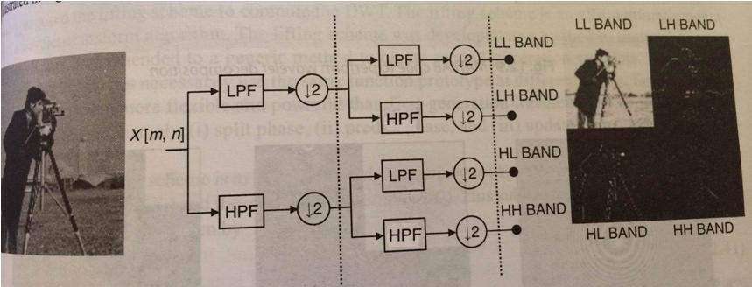

Figure 1: Use of Filter Banks for decomposition

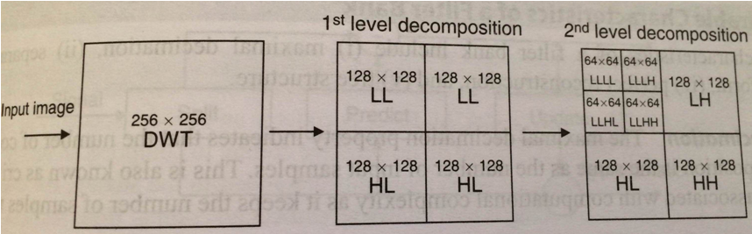

Figure 2: 2 level decomposition of an Input Image

**A.5 Procedure/Algorithm:**

**A.5.1:**

**TASK 1:**

1. Read the i/p image

2. Resize the image to convert it into square matrix.

3. Apply combination of Filter Banks and down sampling to decompose the image for 2 levels.

4. Display the decomposed images for particular level and display in same matrix

5. Observe the presence of High and low frequency areas in all bands.

6. Further decompose the image to the 2nd level

7. Observe the presence of High and low frequency areas in all bands.

8. Save and close the file and name it as **EX7_Task1_your Roll no.m**

**********************

PART B

|  |  |
| --- | --- |
| Roll No. B032 | Name: Naman Garg |
| Class : Btech CS B | Batch : B2 |
| Date of Experiment:09-09-2020 | Date of Submission:12-09-2020 |
| Grade : | Time of Submission: |
| Date of Grading: |  |

**B.1 Software Code written by student:**

img=imread('gg.jpg');

img=rgb2gray(img);

img=imresize(img,[256,256],'nearest');

final_res=decomposition(img,256);

final_res2=final_res;

final_res(1:128,1:128)=decomposition(final_res(1:128,1:128),128);

subplot(1,3,1);imshow(uint8(img));title('Input');

subplot(1,3,2);imshow(uint8(final_res2));title('1');

subplot(1,3,3);imshow(uint8(final_res));title('2');

function final_res=decomposition(img,size)

lpf=(1/9)*ones(3);

% Low Pass on Image (L)

final_res=zeros(size,size);

res=zeros(size,size);

for i=2:size-1

for j=2:size-1

res(i,j)=sum(double(img(i-1:i+1,j-1:j+1)).*lpf,'all');

end

end

res=imresize(res,[size/2,size/2],'nearest');

% LL

res2=zeros(size/2,size/2);

for i=2:size/2-1

for j=2:size/2-1

res2(i,j)=sum(double(res(i-1:i+1,j-1:j+1)).*lpf,'all');

end

end

final_res(1:size/2,1:size/2)=res2;

hpf=[-1 -2 -1;0 0 0;1 2 1]+[-1 0 1;-2 0 2;-1 0 1];

%LH

res3=zeros(size/2,size/2);

for i=2:size/2-1

for j=2:size/2-1

res3(i,j)=sum(double(res(i-1:i+1,j-1:j+1)).*hpf,'all');

end

end

final_res(1:size/2,size/2+1:size)=res3;

% H

res4=zeros(size);

for i=2:size-1

for j=2:size-1

res4(i,j)=sum(double(img(i-1:i+1,j-1:j+1)).*hpf,'all');

end

end

res4=imresize(res4,[size/2,size/2],'nearest');

% HL

res5=zeros(size/2,size/2);

for i=2:size/2-1

for j=2:size/2-1

res5(i,j)=sum(double(res4(i-1:i+1,j-1:j+1)).*lpf,'all');

end

end

final_res(size/2+1:size,1:size/2)=res5;

% HH

res6=zeros(size/2);

for i=2:size/2-1

for j=2:size/2-1

res6(i,j)=sum(double(res4(i-1:i+1,j-1:j+1)).*hpf,'all');

end

end

final_res(size/2+1:size,size/2+1:size)=res6;

end

**B.2 Input and Output: *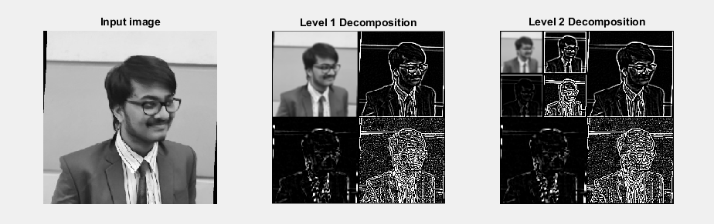***

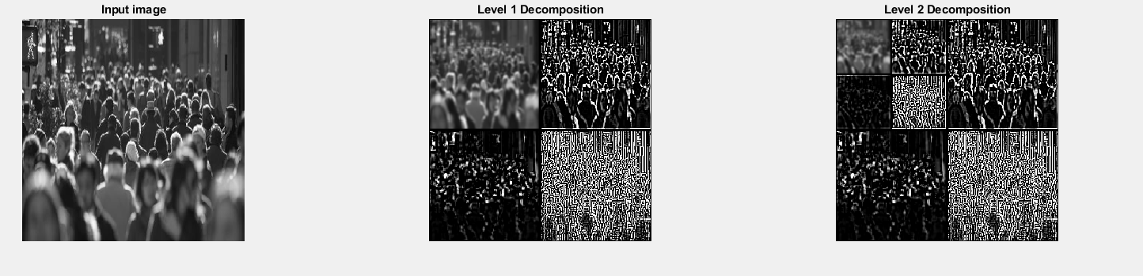

**B.3 Observations and learning:**

Wavelet transform is useful in providing time and frequency representation together. With the sub sampling property, the performance of the Wavelet transform can be achieved using iterative filter bank structures.

Every time the filter bank is iterated, the number of samples for the next stage is halved so that only one sample is left at the end. The iteration is halted at the point once the number of samples becomes smaller than the length of the scaling filter or the wavelet filter and length of the longest filter determines the width of the spectrum of the scaling function.

In the first level of decomposition, the image is split into 4 sub-bands, namely the HH, HL, LH and LL sub-bands. The HH sub-band gives the diagonal details of the image; the HL and LH sub-bands give the horizontal and vertical features respectively.

The LL sub-band is the low-resolution residual consists of low frequency components and its sub-bands are further split at higher levels of decomposition. Sub-bands after two levels of wavelet decomposition are shown in the outputs above. Apart from efficient multiresolution representation and sub sampling, wavelets exhibit interesting characteristics such as sparsity and high energy compaction. These features are particularly useful in image denoising and compression.

**B.4 Conclusion:**

* Applied 2 level of decomposition using LPF and HPF filter banks and down sampling on given image.
* Differentiated between the availability of low and high frequency areas at various locations.
* Identified applications of transforms studied.

**B.5 Question of Curiosity**

What is multiresolution analysis? How it can be achieved using Image pyramid and filter banks?

Multiresolution analysis incorporates and unifies techniques from a variety of disciplines, including sub-band coding from signal processing, quadrature mirror filtering from digital speech recognition, and pyramidal image processing. As its name implies, multiresolution theory is concerned with the representation and analysis of signals (or images) at more than one resolution. The appeal of such an approach is obvious—features that might go undetected at one resolution may be easy to detect at another.

Image Pyramid

A powerful, yet conceptually simple structure for representing images at more than one resolution is the image pyramid. Originally devised for machine vision and image compression applications, an image pyramid is a collection of decreasing resolution images arranged in the shape of a pyramid. As can be seen in Fig. 7.2(a), the base of the pyramid contains a high-resolution representation of the image being processed; the apex contains a low-resolution approximation. As you move up the pyramid, both size and resolution decrease. Base level J is of size 2j x 2j or N x N, where J = log2N, apex level 0 is of size 1 x 1, and general level j is of size 2j x 2j, where 0<=j<=J. Although the pyramid shown in Fig. 7.2(a) is composed of J + 1 resolution levels from 2j x 2j to 20 x 20, most image pyramids are truncated to P + 1 levels, where 1<=P<=J and j = J — P,...,J — 2, J — 1, J. That is, we normally limit ourselves to P reduced resolution approximations of the original image; a 1 x 1 (i.e., single pixel) approximation of a 512 x 512 image, for example, is of little value. The total number of pixels in a P + 1 level pyramid for P > 0 is

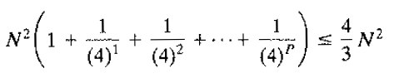

Figure 7.2(b) shows a simple system for constructing two intimately related image pyramids. The Level j — 1 approximation output provides the images needed to build an approximation pyramid (as described in the preceding paragraph), while the Level j prediction residual output is used to build a complementary prediction residual pyramid. Unlike approximation pyramids, prediction residual pyramids contain only one reduced-resolution approximation of the input image (at the top of the pyramid, level J — P). All other levels contain prediction residuals, where the level j prediction residual (for J-P+1<=j<=J) is defined as the difference between the level j approximation (the input to the block diagram) and an estimate of the level j approximation based on the level j — 1 approximation (the approximation output in the block diagram).

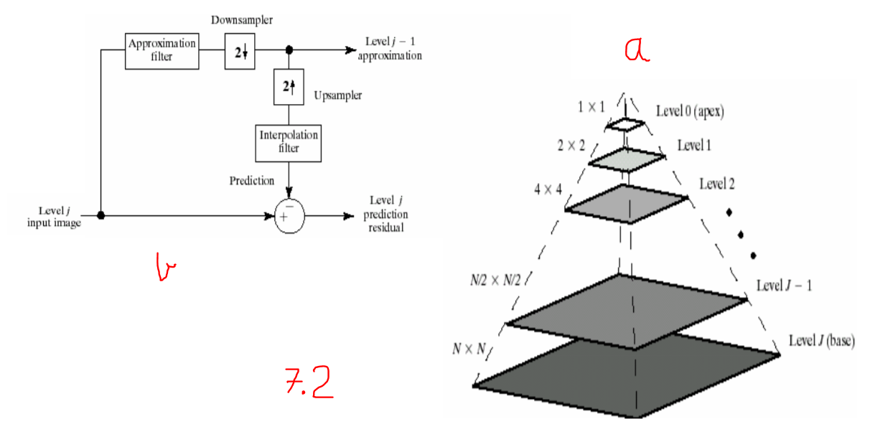

Filter banks

Another important imaging technique with ties to multiresolution analysis is sub-band coding. In sub-band coding. an image is decomposed into a set of bandlimited components. called sub-bands. The decomposition is performed so that the sub-bands can be reassembled to reconstruct the original image with-out error. The decomposition and reconstruction are performed by means of digital filters.

We note that 1-D orthonormal and biorthogonal filters can be used as 2-D separable filters for the processing of images. The separable filters are first applied in one dimension (e.g., vertically) and then in the other (e.g., horizontally). Moreover, down-sampling is performed in two stages—once before the second filtering operation to reduce the overall number of computations. The resulting filtered outputs are called the approximation, vertical detail, horizontal detail, and diagonal detail sub-bands of the input image, respectively. These sub-bands can be split into four smaller sub-bands, which can be split again, and so on.



