LAB Manual

PART A

(PART A : TO BE REFFERED BY STUDENTS)

**Experiment No.08**

**A.1 Aim:**

Write a program to apply 2 level decomposition using LPF and HPF filter Banks on given image.

**A.2 Prerequisite:**

1 Matlab programming syntax (Refer the Matlab manual).

2. Knowledge of fundamentals of wavelet and decomposition using filter banks and subsampling.

2. Availability of Soft copy of your Photograph for experiment.

**A.3 Outcome:**

**After successful completion of this experiment students will be able to**

1. Apply 2 level of decomposition using LPF and HPF filter banks and down sampling on given image.
2. Differentiate the availability of Low and high frequency areas at various location
3. Identify applications of transforms studied.

**A.4 Theory:**

**A.4.1. Introduction of Wavelet**

* Wavelet
  + A small wave
* Wavelet Transforms
  + Convert a signal into a series of wavelets
  + Provide a way for analyzing waveforms, bounded in both frequency and duration
  + Allow signals to be stored more efficiently than by Fourier transform
  + Be able to better approximate real-world signals
  + Well-suited for approximating data with sharp discontinuities
* Fourier Transform (FT)
  + One way to find the frequency content
  + Tells how much of each frequency exists in a signal
* **Limitation of Fourier Transform**

FT Only Gives what Frequency Components Exist in the Signal. The Time and Frequency Information can not be Seen at the Same Time. Time-frequency Representation of the Signal is Needed.

Short Time Fourier Transform (STFT) provides the time and frequency information

* **Drawback of STFT**
* Unchanged Window
* Dilemma of Resolution
  + Narrow window -> poor frequency resolution
  + Wide window -> poor time resolution
* Heisenberg Uncertainty Principle
  + Cannot know what frequency exists at what time intervals

The drawbacks of STFT is resolved using Wavelet where the dynamic window is used for signal analysis.

Multi resolution Analysis of images can be done using Wavelets, using the concept of arithmetic coding, level of decomposition of images using filter banks.

* **Multiresolution Analysis** 
  + Analyze the signal at different frequencies with different resolutions
  + Good time resolution and poor frequency resolution at high frequencies
  + Good frequency resolution and poor time resolution at low frequencies
  + More suitable for short duration of higher frequency; and longer duration of lower frequency components
* **An example of 2 level decomposition using filter bank.**

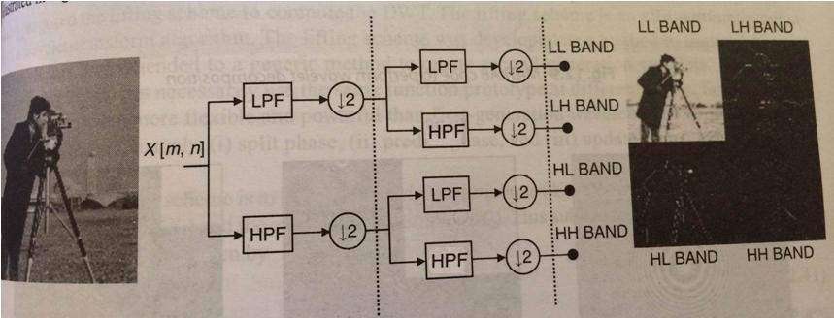

Figure 1: Use of Filter Banks for decomposition

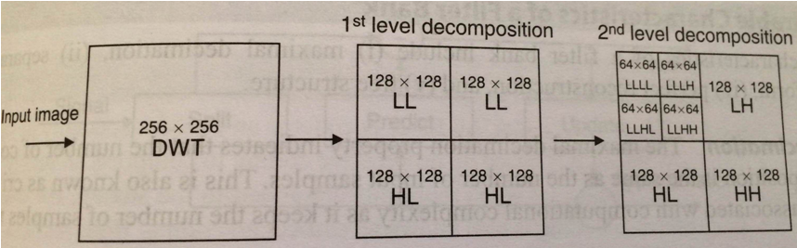

Figure 2: 2 level decomposition of an Input Image

**A.5 Procedure/Algorithm:**

**A.5.1:**

**TASK 1:**

1. Read the i/p image

2. Resize the image to convert it into square matrix.

3. Apply combination of Filter Banks and down sampling to decompose the image for 2 levels.

4. Display the decomposed images for particular level and display in same matrix

5. Observe the presence of High and low frequency areas in all bands.

6. Further decompose the image to the 2nd level

7. Observe the presence of High and low frequency areas in all bands.

8. Save and close the file and name it as **EX7_Task1_your Roll no.m**

**********************

PART B

(PART B : TO BE COMPLETED BY STUDENTS)

***(Students must submit the soft copy as per following segments within two hours of the practical. The soft copy must be uploaded on the Blackboard or emailed to the concerned lab in charge faculties at the end of the practical in case the there is no Black board access available)***

|  |  |
| --- | --- |
| Roll No. | Name: |
| Class : | Batch : |
| Date of Experiment: | Date of Submission |
| Grade : | Time of Submission: |
| Date of Grading: |  |

**B.1 Software Code written by student:**

***(Paste your Matlab code completed during the 2 hours of practical in the lab here)***

**B.2 Input and Output:**

***(Paste your program input and output in following format, If there is error then paste the specific error in the output part. In case of error with due permission of the faculty extension can be given to submit the error free code with output in due course of time. Students will be graded accordingly.)***

**Input Images:**

**Output Images:**

1. **For each level of decomposition as per the procedure discussed in section A.5.**

**B.3 Observations and learning:**

***(Students are expected to comment on the output obtained with clear observations and learning for each task/ sub part assigned)***

**B.4 Conclusion:**

*(****Students must write the conclusion as per the attainment of individual outcome listed above and learning/observation noted in section B.3)***

**B.5 Question of Curiosity**

***(To be answered by student based on the practical performed and learning/observations)***

***What is multiresolution analysis? How it can be achieved using Image pyramid and filter banks?***

************************