**Program 7**

**PART-A**

**A.1 Aim:** Implement factorial,fib,Armstrong,

Implement tic toe game(use random)

Form Processing with PHP

**A.2 Prerequisite:** HTML, CSS, Javascript, Basic programming language

**A.3 Outcome:**

After successful completion of this experiment students will be able to

1. Understand basic PHP programming

2. Understand and implement PHP as server side code for form processing

**A.4 Theory:**

1. Xampp is the most popular PHP development environment for Windows, OS X, and Linux platforms. Xampp stands for Cross platform(x), Apache(a), Maria db(m), PHP(p), Pearl(p) which is a software distribution server which makes developer’s work eaiser for testing and deploying by creating a local web server.

## ****How to install Xampp?****

It is completely free and easy to install Apache distribution containing MySQL, PHP, and Perl. First, download XAMP from <https://www.apachefriends.org/download.html>. In the first page, select the components you want to install.

1. 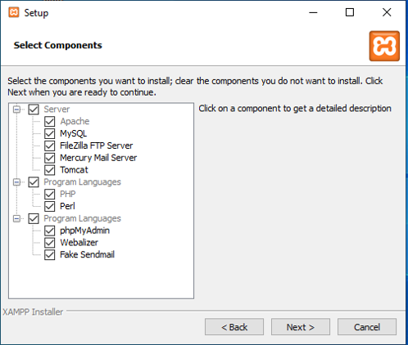

Select the installation directory so that all the components that you choose will be installed in this directory.

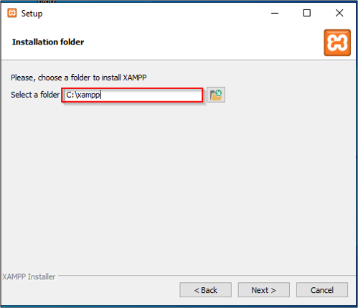

## ****How to run PHP program in Xampp step-by-step?****

* Write php program in a notepad/sublime text and save it as file.php or any other name.

After completion of the installation, you can use the XAMPP Control Panel to start/ stop all servers.

* Start Mysql and Apache servers.

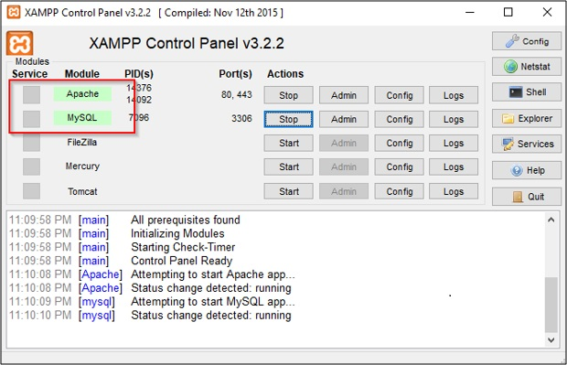

* Copy file.php to htdocs (C:/Program Files/XAMPP/htdocs)
* You can also create any folders inside htdocs folder and save our codes over there.

In order to get the dashboard for localhost: search [http://localhost](http://localhost/) in any browser.

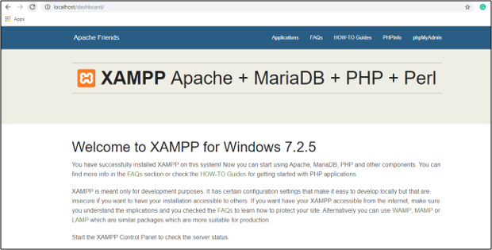

* Now to run your code, open browser and type localhost/file.php then it gets executed.

2. You need to work with basic html form. Under form action write name of the **php file** that generates response

3. The server side code for form validation and processing username, email, preferences should be written in the **php file**

4. Sample code for empty username password

function Login()

{

if(empty($_POST['username']))

{

$this->HandleError("UserName is empty!");

return false;

}

if(empty($_POST['password']))

{

$this->HandleError("Password is empty!");

return false;

}

$username = trim($_POST['username']); /// Jst to remove trim the strings

$password = trim($_POST['password']);

}

4. Sample code to retrieve multiple checkbox values

<form action="#" method="post">

<input type="checkbox" name="check_list[]" value="C/C++"><label>C/C++</label><br/>

<input type="checkbox" name="check_list[]" value="Java"><label>Java</label><br/>

<input type="checkbox" name="check_list[]" value="PHP"><label>PHP</label><br/>

<input type="submit" name="submit" value="Submit"/>

</form>

<?php

if(isset($_POST['submit']))

{

if(!empty($_POST['check_list']))

{

// Loop to store and display values of individual checked checkbox.

foreach($_POST['check_list'] as $selected)

{

echo $selected."</br>";

}

}

}

?>

Output Expected on the browser:

You NAME :………………..

Your email:___________________

Your Gender: ___________________

Your preferred courses: ___________, ______________, ____________

**PART B**

**(PART B: TO BE COMPLETED BY STUDENTS)**

**(Students must submit the soft copy as per following segments within two hours of the**

**practical. The soft copy must be uploaded on the Blackboard or emailed to the concerned**

**lab in charge faculties at the end of the practical in case the there is no Black board access**

**available)**

**B.1 Software Code written by student:**

**(Students must paste the code here)**

**B.2 Input and Output**

**(Students must paste input and output here)**

**B.3. Observations and Learning**

**(Students are expected to comment on the output obtained with clear observations and learning for each task/ sub part assigned**

**B.4. Conclusion**

**(Students must write the conclusion as per the attainment of individual outcome listed above and learning/observation noted in Sec. B.3)**