**NAMAN GARG B032 BTECH CS B**

**Program 8**

**PART-A**

**A.1 Aim:** Implement cookies in PHP,

Implement sessions in PHP

Implement number guess game with sessions

**A.2 Prerequisite:** HTML, CSS, Javascript, Basic programming language

**A.3 Outcome:**

After successful completion of this experiment students will be able to

1. Understand and implement PHP as server side code for form processing with sessions and cookies

**A.4 Theory:**

* Cookies are stored on the user’s browser, and are sent to the server on every relevant request
* The $_COOKIE superglobal makes a cookie a key- value pairing

Store user information as a value with a known key

Never assume a cookie has been set. Always check with isset($_COOKIE[$cookie_name]) before trying to use the cookie’s value

* To set a cookie in PHP:

setcookie(name, value, expire, path, domain);

* Sessions store user data on the server

Limited only by server space

Cannot be modified by users

* Sessions are identified by a session id: often a small cookie!

Ex:

<?php session_start();

if (isset($_SESSION["count"])) {

$_SESSION["count"] += 1;

echo "You\'ve visited here {$_SESSION['count']} times";

}

else {

$_SESSION["count"] = 1; echo "You\'ve visited once";

}

?>

* Call session_start() at top of **every** page to start session
* Access data using the $_SESSION superglobal, just like

$_COOKIE, $_GET, or $_POST

* Remove an individual element of the $_SESSION superglobal
* unset($_SESSION[‘key_name’]);
* Destroy the entire session, remove all data
* Use the function session_destroy()

**PART B**

**(PART B: TO BE COMPLETED BY STUDENTS)**

**(Students must submit the soft copy as per following segments within two hours of the**

**practical. The soft copy must be uploaded on the Blackboard or emailed to the concerned**

**lab in charge faculties at the end of the practical in case the there is no Black board access**

**available)**

**B.1 Software Code written by student:**

**(Students must paste the code here)**

**Lab8_Task_1.html**

<!DOCTYPE html>

<html lang="en">

<head>

<title>Login Page</title>

</head>

<body>

<h1>Session Login</h1><hr>

</header>

<br>

<form name="myForm" action="http://localhost/Lab8_Task_1.php" method="post">

<table>

<tr>

<td>Username:</td>

<td><input type="text" name="username" id="username" autofocus required /></td>

</tr>

<tr>

<td>Password:</td>

<td><input type="password" name="password" id="password" required/></td>

</tr>

</table>

<input type="checkbox" name="rememberme" value="rememberme">Remember Me<br>

<input type="submit" name="login">

</form>

</body>

</html>

**welcome.php**

<?php

session_start();

echo "Welcome ".$_SESSION["username"];

$_SESSION["mynum"]=rand(1, 10);

// $_SESSION["mynum"]=3;

$_SESSION["count"]--;

$c=$_SESSION["count"];

echo "<h2>Number Game</h2>";

echo "You have total 3 attempts to guess the number [Between 1 & 10].<br><br>";

echo "Attempts left: $c";

echo '<form name="myGame" action="http://localhost/Lab8_Task_2.php" method="post">';

echo "Enter the number: ";

echo "<input type='number' name='num' id='num' autofocus required /><br>";

echo "<input type='submit' name='check'><br>";

echo "</form>";

?>

**Lab8_Task****_1.php**

<?php

$myname="myname";

$mypass="mypass";

if(isset($_POST["login"]))

{

$user=$_POST["username"];

$pass=$_POST["password"];

if($myname==$user and $mypass==$pass)

{

if(isset($_POST["rememberme"]))

{

$cookie_exp = time()+60*60*24*30;

setcookie("username", $user, $cookie_exp);

}

session_start();

$_SESSION["username"]=$user;

$_SESSION["count"]=4;

header("location:welcome.php");

}

else

{

echo "INVALID CREDENTIALS<br>";

echo "<a href='Lab8_Task_1.html'>Login</a>";

}

}

else

{

header("location:Lab8_Task_1.html");

}

?>

**Lab8_Task_2.php**

<?php

session_start();

if($_POST["num"]==$_SESSION["mynum"]){

echo "Number was guessed correctly<br>";

}

else if($_SESSION["count"]<=1){

echo "3 attempts over. Session destroyed.<br>" . $_SESSION["mynum"] . " Was the number";

session_destroy();

echo "<a href='Lab8_Task_1.html'>Login</a>";

}

else{

echo "Wrong guess. <a href='welcome.php'>Try again</a>";

}

?>

**B.2 Input and Output**

**(Students must paste input and output here)**

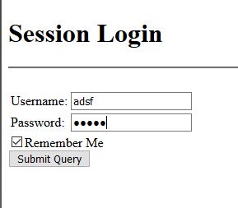

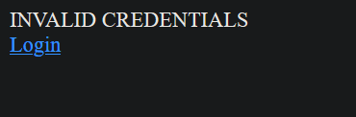

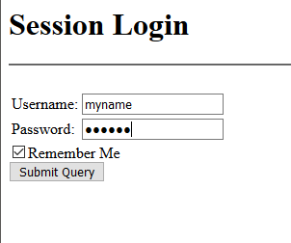

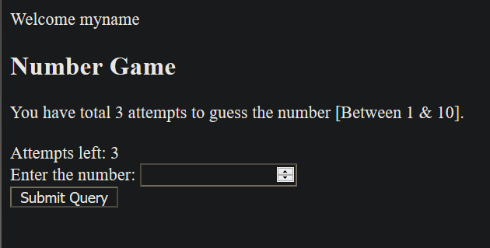

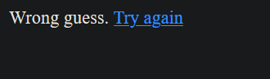

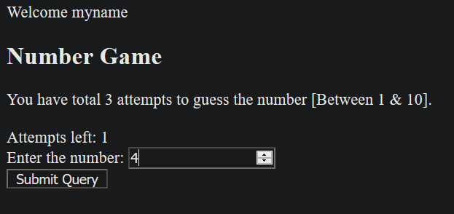

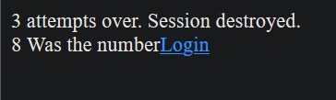

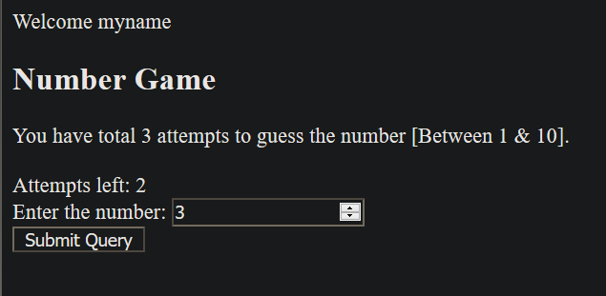

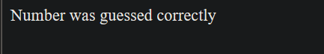

**B.3. Observations and Learning**

Understood and implemented PHP as server-side code for form processing with sessions and cookies

**B.4. Conclusion**

Form processing and cookies can be used with PHP on the server side.