TED AggreData
Software Architecture Document

Version 1.02

Revision History
Date | Version | Description | Author
06/01/2011 | 1.00 | Initial Version | Pete Arvanitis
06/24/2011 | 1.01 | Use Case Realizations Added | Pete Arvanitis
3/15/2012 | 1.02 | Updated Architecture Description to reflect shift to Spring Services | Pete Arvanitis
Table of Contents
1. Introduction 4
1.1. Purpose 4
1.2. Scope 4
1.3. Definitions, Acronyms, and Abbreviations 4
1.4. References 4
1.5. Overview 4
2. Architectural Representation 5
3. Architectural Goals and Constraints 5
3.1. Security 5
3.2. Use of Off-the-Self Products 5
3.3. External Integration 5
4. Use-Case View 6
4.1. High Level Use Case Diagrams 6
4.1.1. Application Session Management 6
4.1.2. User and Group Management 7
4.1.3. Activation and Data Posting 8
4.1.4. Data Retrieval 9
4.1.5. Server Functions 9
4.1.6. Third Party Application 10
4.2. Use-Case Realizations 11
4.2.1. Use Case: UC1 Login 11
4.2.2. Use Case: UC2 Logout 11
4.2.3. Use Case: UC3 Register 12
4.2.4. Use Case: UC1 Receive Posted Data 12
5. Logical View 14
5.1. Server Packages 14
5.2. Client Packages 15
5.3. Entities 16
6. Process View 17
6.1. Application Thread 17
6.2. Post Data Thread (REST Example) 18
6.3. List of Process Threads 19
7. Deployment View 20
8. Implementation View 21
8.1. Application Layers 21
8.2. File Structure 21
8.3. Database Model E-R Diagram 22

Introduction
TED AggreData, developed for Center Street Technologies, is a web application designed to facilitate scheduling of information sharing events as they relate to a legal action. Its intent is to serve as a ‘common middle’ for heterogeneous scheduling systems used by the various stakeholders (firms, lawyers, consultants and clients) involved in the action.

Purpose
This document provides a comprehensive architectural overview of the system, using a number of different architectural views to depict different aspects of the system. It is intended to capture and convey the significant architectural decisions which have been made on the system.

Scope
This document provides the architectural overview of the TED AggreData application.

Definitions, Acronyms, and Abbreviations
- Registered User – a system role. A registered user is able to log into the AggreData system to view their data and administer their account
- Administrator – a system role. An administrator is an extension of a registered user. In addition to administer their own account, the administrator can administer all other user accounts.
- TED 5000 “Gateway” – Also referred to as just a TED 5000. These are the TED 5000 products sold by The Energy Detective. They have a 3rd party post option that will allow energy data to be posted to the AggreData Server
- Location- The location of one or more TED 5000’s. A TED 5000 can only belong to one location.
- Group - A grouping of one or more locations. Locations can belong to more than one group.

References
- TED 5000 3rd Party Post API
- TED 5000 API

Overview
The main organization of the document is based on RUP’s 4+1 Architectural Views. Each view describes the TED AggreData implementation and its impact on the overall architecture.

Architectural Representation
The TED AggreData web application architecture is based on a multi-layered architecture written in as a Java Web Application using the Google Web Toolkit to provide the front-end.
- Use-Case View – This section outlines the Requirements by referencing the significant use cases of the system and mapping them to the corresponding use case realizations.
- Logical View – This section describes the architecturally significant parts of the design model such as its decomposition into subsystems and packages. And for each significant package, its decomposition into classes and class utilities.
- Process View – This view is used to describe the various processes (single threads of control) and process groups that make up the system.
- Deployment View - This section explains the physical (hardware) configurations on which the software is deployed and run
- Implementation View – This section describes the overall structure of the implementation model, the decomposition of the software into layers and subsystems in the implementation model, and any architecturally significant components.

Architectural Goals and Constraints

Security

Security will be managed by the application itself

Access to workflows will be based on user roles.

Use of Off-the-Self Products

The system will be a web application deployed to java servlet container. For development purposes we will be developing against a Jetty server

The database will be MySQL 5.x

The Google Web Toolkit (GWT) will be used for building the user interface

Bone Connection Pool will be used for JDBC management

External Integration

TED5000 Units in the field will post data to TED AggreData using their built-in 3rd Party Post Feature (including Activation)

Third party applications will communicate with the TED AggreData server using a REST API

TED AggreData will poll the National Weather Service for Weather Information

Use-Case View

High Level Use Case Diagrams

Application Session Management

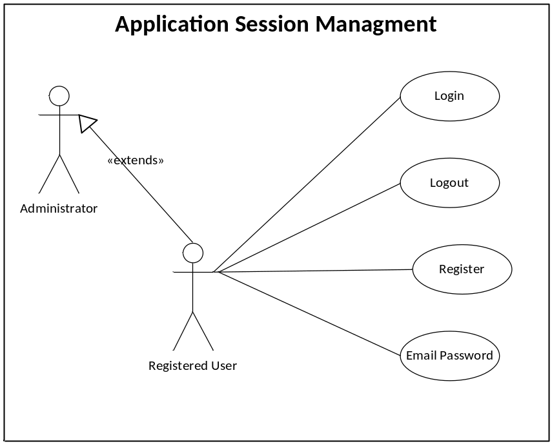

These are the major use cases involved in registering and logging into the system. All users will be able to perform these functions. The Administrator role is just an extension of the registered user role w/ additional privileges in regards to user and group management.

User and Group Management
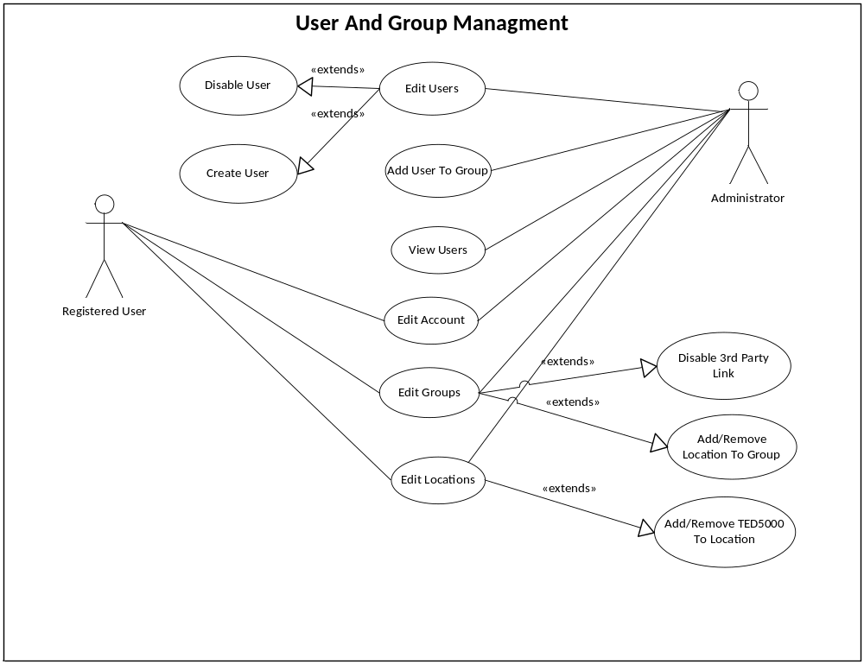

These are the major use cases that allow users to manage their account and to create groups and locations. Please refer to the Logical View to see the relationships between TED5000 units, Groups, and Locations.

Activation and Data Posting
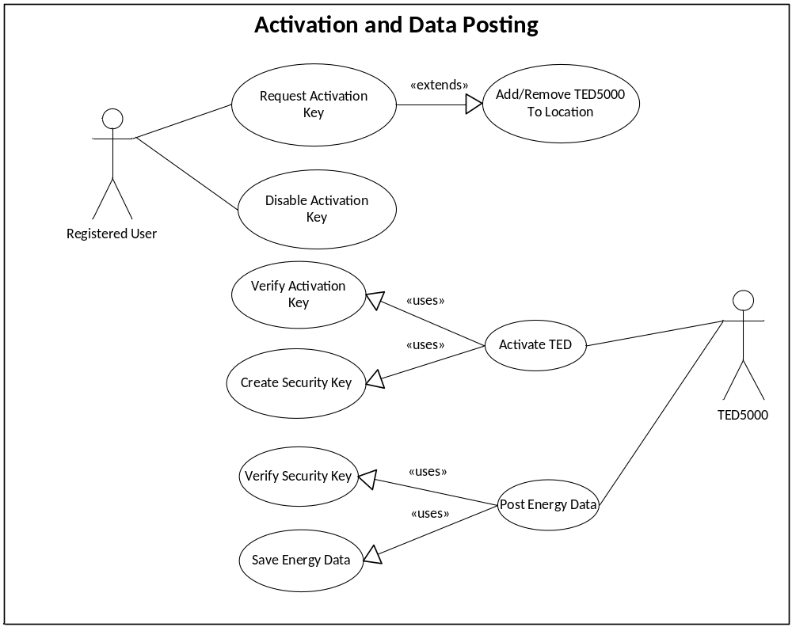

These are the use-cases involved with allowing a TED 5000 to be activated against this server and to post data to it.

Data Retrieval
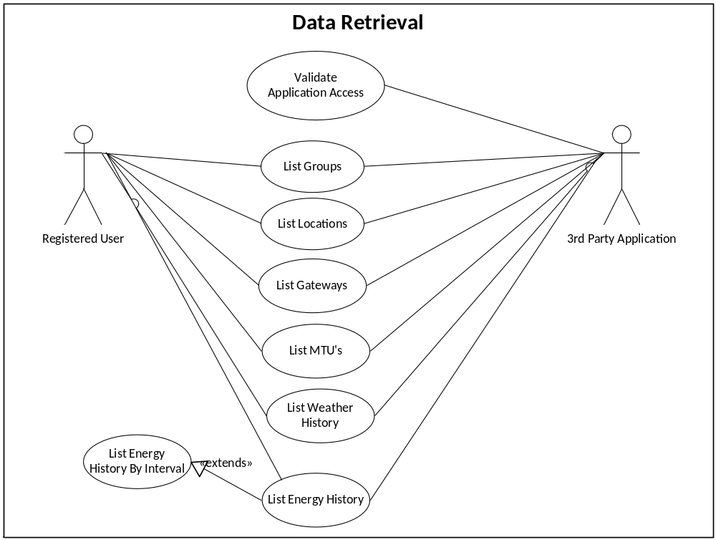

These are the use-cases involved with retrieving energy data from the AggreData system, either through the default GUI or a third-party widget.

Server Functions
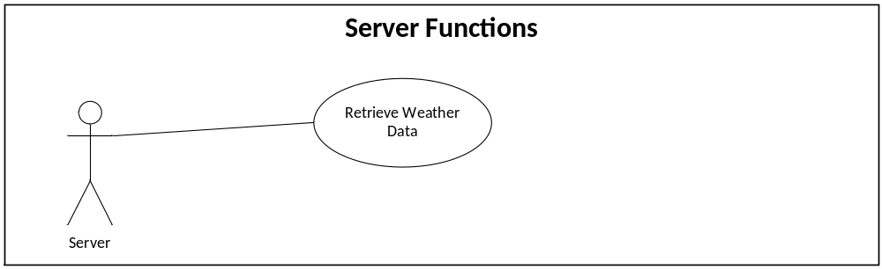

Timed server functions to support the Application.

Third Party Application
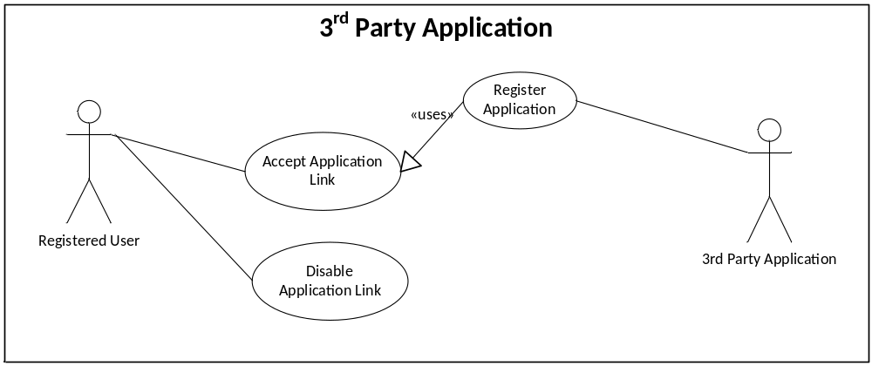

Use cases involved with allowing a third-party application to access data stored in the AggreData system

Use-Case Realizations

Use Case: UC1 Login

Primary Actors
- Registered User

Use Case Description
Scope: TED AggreData Web Application
Level: User Goal
Context of Use: A user wishes to log into the AggreData system via its main interface
Minimal Guarantees: The user is presented with a login screen
Success Guarantees: The user is logged into the AggreData System
Preconditions:
- User is already registered
- User provides valid credentials

Triggers: User logs in from the main login page
Main Success Scenario:
- User enters username and password on the login page
- Server validates the user’s credentials
- Server logs in the user and takes them to the main application page.

Extensions:
2a. Invalid User: User is returned to the login page and is presented with an error message.

Use Case: UC2 Logout

Primary Actors
- Registered User

Use Case Description
Scope: TED AggreData Web Application
Level: User Goal
Context of Use: A user wishes to log out of the AggreData system.
Minimal Guarantees: The user session is destroyed.
Success Guarantees: The user session is destroyed.
Preconditions:
1. User is logged in with a valid session

Triggers: User selects “Log Out” from the application menu.
Main Success Scenario:
- User session is destroyed
- User is taken to “Login Page”

Use Case: UC3 Register

Primary Actors
- New User
- Registered User

Use Case Description
Scope: TED AggreData Web Application
Level: User Goal
Context of Use: A TED5000 owner wants to register as a User in the AggreData server
Minimal Guarantees: The user is taken back to the login screen
Success Guarantees: The user becomes a ‘registered user’ in the system
Preconditions:
- The “New User” is not previously enrolled in the application as a user (email address is not already registered w/ the system)

Triggers: User logs in from the main login page
Main Success Scenario:
- User is directed to the registration page (either directly or by clicking “Join”)
- User enters email address, name, and other demographic information
- User passes CAPTCHA challenge to prove it is not an automated script
- User is sent a confirmation email
- User is taken to their “Main Dashboard” page

Extensions:
2a. Duplicate Email Address: Error message displayed and user is offered the ability to have their password sent to the email address

Use Case: UC1 Receive Posted Data

Primary Actors
- TED 5000 Device
- Registered User

Use Case Description
Scope: TED AggreData Web Application
Level: System Goal
Context of Use: TED5000 posts energy data to the application
Minimal Guarantees: TED5000 energy post request received and processed by the application
Success Guarantees: Energy data will be written to the database
Preconditions:
- TED5000 device is registered to a user account
- TED5000 has been activated against this server to post data

Triggers: TED5000 POST’s XML to the server
Main Success Scenario:
- TED5000 posts XML to the server
- Server authenticates that the TED5000 is registered in the system
- Server authenticates that the security key sent w/ the XML is the valid security key for that gateway
- Server parses the XML and writes the energy data to the database
- Server returns a 200 status code letting the TED5000 devices know the data has been successfully received
Extensions:
2a. TED 5000 Not Registered: A 499 Unsupported Media response code will be sent.
3a. Security element XML validation failed. A 401 Unauthorized response code will be sent.

Logical View

Server Packages
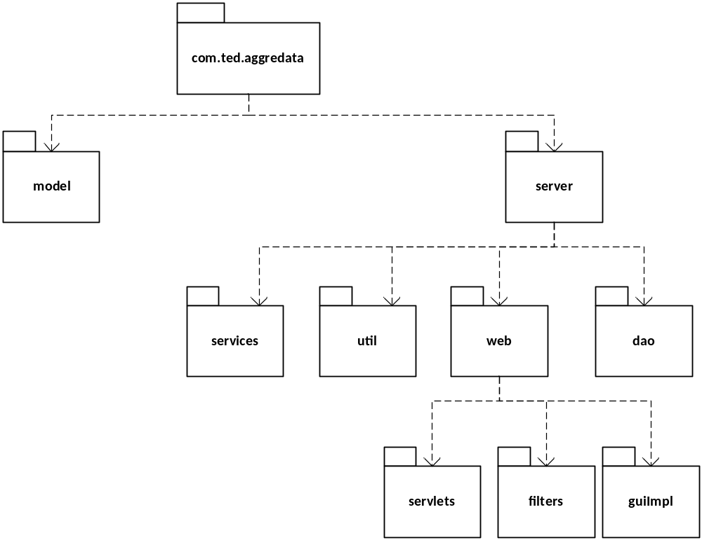

- model – contains the model beans for the application
- server.dao – contains the database persistence for the application (using JPA and Hibernate)
- server.util – generic server side utility classes
- server.services – Spring services that implement the business logic
- server.servlets – Implementation of direct access servlets (REST API)
- server.filters – container filter implementations (e.g. custom Authentication/Authorization)
- server.guiImpl – GWT Implementations

Client Packages
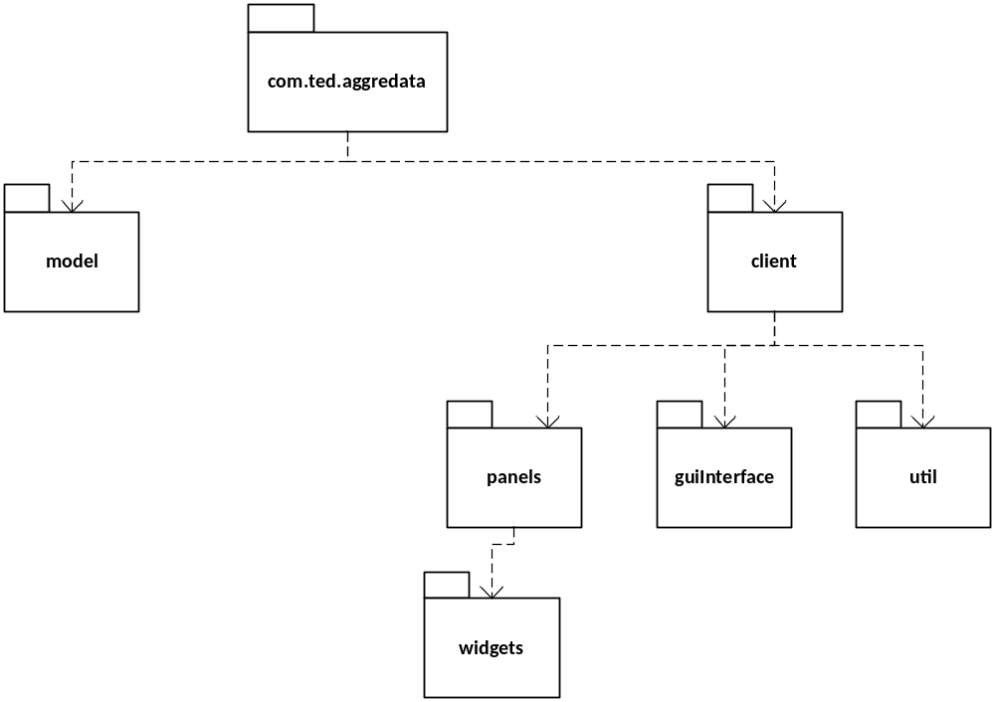

These are the packages that exist on the GWT client side GUI

- Model – (Shared w/ Server) Bean objects representing data.
- cilient.panels – the panels that make up the various screens of the client applications
- client.panels.widgets – reusable widgets that may exist on one or more panels
- client.guiInterface – Contains the GWT Interfaces required to communicate with the server
- client.util – general utility classes

Entities

The primary objects in the application are Users, Groups, Locations, and TED5000’s.

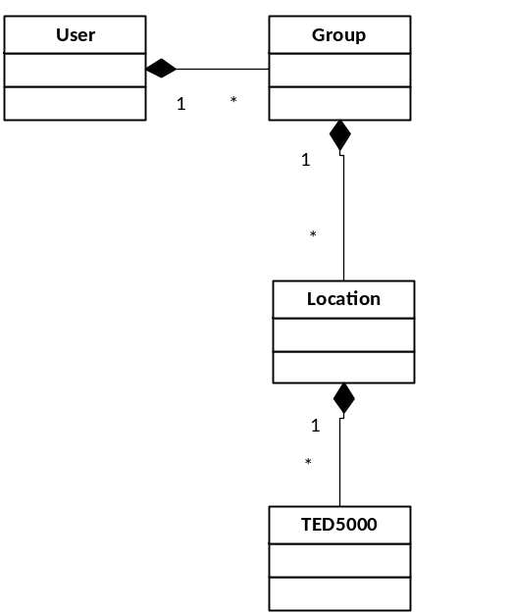
- A user represents an application user

- A user may create one or more groups. Groups contain locations. A location may belong to one or more groups.

- A location contains one or more registered TED5000’s. A TED5000 can only belong to one location. All posted historical data is bound to a specific TED5000.

Process View

Application Thread
This is a high level overview of how the application thread will generally handle a request.

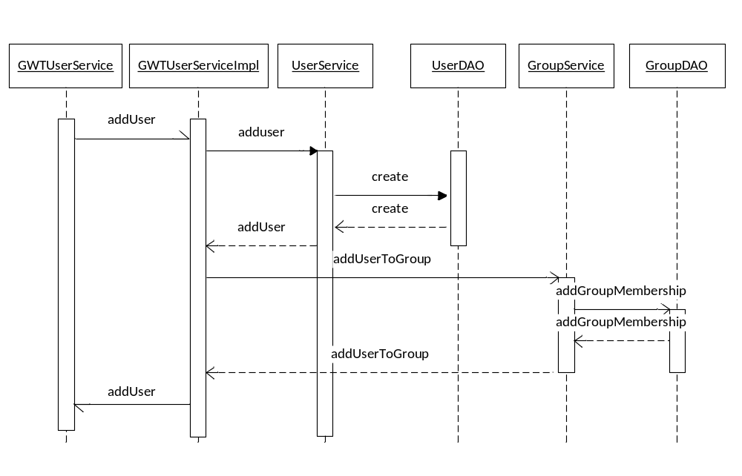

The above example walks through the scenario of creating a new user via the GUI and adding them to a default group.

- The GUI begins the request by calling the GWT Service that provides a façade for user accounts
- The GWT Service executes client side by making an asynchronous call to the server via its Service Impl
- The ServiceImpl is responsible for executing all of the commands (at a high level) that implement a specific use case (e.g. “Add User”)
- The ServiceImpl makes one or more calls to Spring services which implement more granular functions (single logic unit)
- The Services make use of one or more DAOs for to load or persist objects.

Post Data Thread (REST Example)
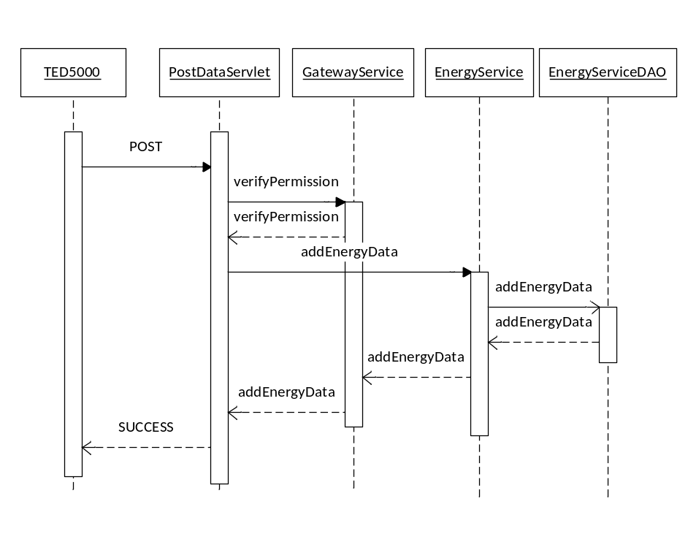

Much like the standard GUI thread, Post Data makes use of a servlet that executes high level methods to implement the use case logic. Like the GWT Service Impl, there should be relatively few lines of code in the servlet.

- The PostDataServlet parses the XML data
- The PostDataServlet calls one or more Spring Services to execute the business logic
- The Spring Services call one or more DAO to persist the data
- The PostDataServlet returns a “200” HTTP response indicating that the data was written successfully.

List of Process Threads

The threads in the system may invoke one or more servlets to handle the requests. However, each thread is independent of each other, meaning that it would be possible to load balance by thread type if in a clustered environment.

- Main Application Thread – Servlet instance(s) that handle all calls from the GUI portion of the application
- Activation Thread – Servlet instance(s) that handle all requests for TED 5000 activation
- PostData Thread – Servlet instance(s) that handle all requests to post data from TED 5000 units.
- REST API – Servlet instance(s) that handle requests from 3rd party applications
- Weather Thread – Built in application thread (singleton) that requests data from NWS

Deployment View
TED AggreData will be built as a WAR web application and an XML configuration file. The WAR file will contain:
- Server-side java classes
- Static web files including images and GWT generated artifacts
- Any dependent libraries required for deployment

The WAR file will be deployed on any standard Java Servlet Container including:
- Apache Tomcat
- Jetty
- JBOSS
- WebLogic

The XML configuration file will need to be visible on the WAR file’s CLASSPATH.

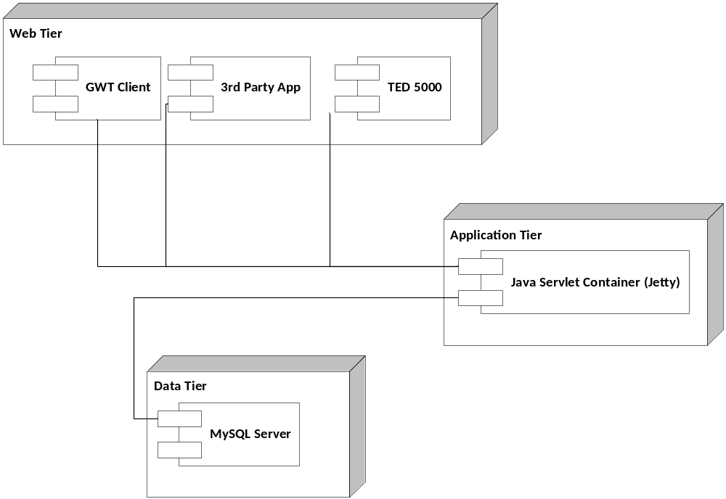

Implementation View

Application Layers

The TED AggreData application will be split into 4 separate layers:
- Client Side UI layer – Implemented as a GWT application
- Servlet Layer /REST API Layer
- Application Logic Layer (Spring Services)
- Model Layer (DAOs/JPA/Hibernate)

The implementation of the application will follow best practices implementation for standard web applications
- GWT 2.x will be used to implement the User Interface.
- The REST API, Activation and Data Post will be implemented as Servlets
- Spring Services will implement the core granular logic. Major business cases will be split up into separate Spring Services (Façade Pattern)
- Object persistence will be implemented using direct JDBC connections to connecting via the Bone Connection Pool. Direct JDBC was chosen since very little data will need to be cached and the majority of the workload will require fast access and pass-through to the historical times-tamped energy data.

File Structure

The high level file structure will follow the Maven Standard Directory Layout as described here:
http://maven.apache.org/guides/introduction/introduction-to-the-standard-directory-layout.html

Individual source directories will follow the classic path file structure used by Java (each package is a folder).

Database Model E-R Diagram

