Міністерство освіти і науки України Національний університет «Львівська політехніка»

Кафедра ЕОМ



Звіт

до лабораторної роботи № 3

з дисципліни «Моделювання комп’ютерних систем» на тему:

«Поведінковий опис цифрового автомата Перевірка роботи автомата за допомогою стенда Elbert V2 – Spartan 3A FPGA»

Варіант №8

Виконав: ст. гр. КІ-201 Головко І.О.

Прийняв: ст. викладач каф. ЕОМ Козак Н.Б.

Львів - 2024

**Мета роботи**: на базі стенда реалізувати цифровий автомат для обчислення значення виразів.

Мій варіант - №8

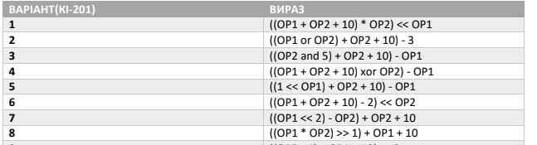

Рис. 1 - скріншот заданого варіанту

**Виконання роботи**

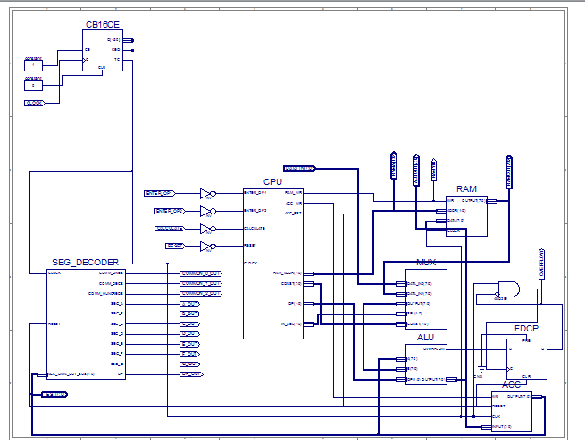

Рис. 2 - Top Level

Файл ACC.vhd:

| library IEEE; use IEEE.STD_LOGIC_1164.ALL;  entity ACC is  Port ( WR : in STD_LOGIC;  RESET : in STD_LOGIC;  CLK : in STD_LOGIC;  INPUT : in STD_LOGIC_VECTOR (7 downto 0);  OUTPUT : out STD_LOGIC_VECTOR (7 downto 0)); end ACC;  architecture ACC_arch of ACC is  signal DATA : STD_LOGIC_VECTOR (7 downto 0); begin  process (CLK)  begin  if rising_edge(CLK) then  if RESET = '1' then  DATA <= (others => '0');   elsif WR = '1' then  DATA <= INPUT;   end if;  end if;  end process;     OUTPUT <= DATA;  end ACC_arch; |
| --- |

Файл ALU.vhd:

| library IEEE; use IEEE.STD_LOGIC_1164.ALL;  entity ALU is  Port ( A : in STD_LOGIC_VECTOR(7 downto 0);  B : in STD_LOGIC_VECTOR(7 downto 0);  OP : in STD_LOGIC_VECTOR(1 downto 0);  OUTPUT : out STD_LOGIC_VECTOR(7 downto 0);  OVERFLOW: out STD_LOGIC); end ALU;   architecture ALU_Behavioral of ALU is  signal ALUR: STD_LOGIC_VECTOR(15 downto 0) := (others => '0');  signal Carry: STD_LOGIC := '0'; begin  process(A, B, OP)  begin  case (OP) is  when "01" => ALUR <= ("00000000" & A) + ("00000000" & B);  when "10" => ALUR <= std_logic_vector(to_unsigned((to_integer(unsigned(("00000000" & A))) * to_integer(unsigned(("00000000" & B)))),16));  when "11" => ALUR <= std_logic_vector(unsigned(("00000000" & A)) srl to_integer(unsigned(B)));  when others => ALUR <= ("00000000" & B);  end case;  end process;  OUTPUT <= ALUR(7 downto 0);  OVERFLOW <= ALUR(8) OR ALUR(9) OR ALUR(10) OR ALUR(11) OR ALUR(12) OR ALUR(13) OR ALUR(14) OR ALUR(15);  end ALU_Behavioral; |
| --- |

Файл CPU.vhd:

| library IEEE; use IEEE.STD_LOGIC_1164.ALL;   entity CPU is  port( ENTER_OP1 : IN STD_LOGIC;  ENTER_OP2 : IN STD_LOGIC;  CALCULATE : IN STD_LOGIC;  RESET : IN STD_LOGIC;  CLOCK : IN STD_LOGIC;  RAM_WR : OUT STD_LOGIC;  RAM_ADDR : OUT STD_LOGIC_VECTOR(1 DOWNTO 0);  CONST : OUT STD_LOGIC_VECTOR(7 DOWNTO 0);  ACC_WR : OUT STD_LOGIC;  ACC_RST : OUT STD_LOGIC;  IN_SEL : OUT STD_LOGIC_VECTOR(1 downto 0);  OP : OUT STD_LOGIC_VECTOR(1 DOWNTO 0)); end CPU;   architecture CPU_arch of CPU is  type STATE_TYPE is (RST, IDLE, LOAD_OP1, LOAD_OP2, RUN_CALC0, RUN_CALC1, RUN_CALC2, RUN_CALC3, RUN_CALC4, FINISH);  signal CUR_STATE : STATE_TYPE; signal NEXT_STATE : STATE_TYPE;  begin  SYNC_PROC: process (CLOCK)  begin  if (rising_edge(CLOCK)) then  if (RESET = '1') then  CUR_STATE <= RST;  else  CUR_STATE <= NEXT_STATE;  end if;   end if;  end process;      NEXT_STATE_DECODE: process (CLOCK, ENTER_OP1, ENTER_OP2, CALCULATE)  begin  NEXT_STATE <= CUR_STATE;    case(CUR_STATE) is  when RST =>  NEXT_STATE <= IDLE;  when IDLE =>  if (ENTER_OP1 = '1') then  NEXT_STATE <= LOAD_OP1;  elsif (ENTER_OP2 = '1') then  NEXT_STATE <= LOAD_OP2;  elsif (CALCULATE = '1') then  NEXT_STATE <= RUN_CALC0;  else  NEXT_STATE <= IDLE;  end if;  when LOAD_OP1 =>  NEXT_STATE <= IDLE;  when LOAD_OP2 =>  NEXT_STATE <= IDLE;  when RUN_CALC0 =>  NEXT_STATE <= RUN_CALC1;  when RUN_CALC1 =>  NEXT_STATE <= RUN_CALC2;  when RUN_CALC2 =>  NEXT_STATE <= RUN_CALC3;  when RUN_CALC3 =>  NEXT_STATE <= RUN_CALC4;  when RUN_CALC4 =>  NEXT_STATE <= FINISH;  when FINISH =>  NEXT_STATE <= FINISH;  when others =>  NEXT_STATE <= IDLE;  end case;   end process;   OUTPUT_DECODE: process (CUR_STATE)  begin  case (CUR_STATE) is  when RST =>  RAM_WR <= '0';  RAM_ADDR <= "00";  CONST <= "00000000";  ACC_WR <= '0';  ACC_RST <= '1';  IN_SEL <= "00";  OP <= "00";  when LOAD_OP1 =>  RAM_WR <= '1';  RAM_ADDR <= "00";  CONST <= "00000000";  ACC_WR <= '0';  ACC_RST <= '1';  IN_SEL <= "00";  OP <= "00";  when LOAD_OP2 =>   RAM_WR <= '1';  RAM_ADDR <= "01";  CONST <= "00000000";  ACC_WR <= '0';  ACC_RST <= '1';  IN_SEL <= "00";  OP <= "00";  when RUN_CALC0 =>   RAM_WR <= '0';  RAM_ADDR <= "00";  CONST <= "00000000";  ACC_WR <= '1';  ACC_RST <= '0';  IN_SEL <= "01";  OP <= "00";  when RUN_CALC1 =>   RAM_WR <= '0';  RAM_ADDR <= "01";  CONST <= "00000000";  ACC_WR <= '1';  ACC_RST <= '0';  IN_SEL <= "01";  OP <= "10";  when RUN_CALC2 =>   RAM_WR <= '0';  RAM_ADDR <= "01";  CONST <= "00000001";  ACC_WR <= '1';  ACC_RST <= '0';  IN_SEL <= "10";  OP <= "11";  when RUN_CALC3 =>  RAM_WR <= '0';  RAM_ADDR <= "00";  CONST <= "00000000";  ACC_WR <= '1';  ACC_RST <= '0';  IN_SEL <= "01";  OP <= "01";  when RUN_CALC4 =>   RAM_WR <= '0';  RAM_ADDR <= "00";  CONST <= "00001010";  ACC_WR <= '1';  ACC_RST <= '0';  IN_SEL <= "10";  OP <= "01";  when IDLE =>  RAM_WR <= '0';  RAM_ADDR <= "00";  CONST <= "00000000";  ACC_WR <= '0';  ACC_RST <= '0';  IN_SEL <= "00";  OP <= "00";  when others =>   RAM_WR <= '0';  RAM_ADDR <= "00";  CONST <= "00000000";  ACC_WR <= '0';  ACC_RST <= '0';  IN_SEL <= "00";  OP <= "00";  end case;  end process; end CPU_arch; |
| --- |

Файл MUX.vhd:

| library IEEE; use IEEE.STD_LOGIC_1164.ALL;  entity MUX is  PORT(  SEL: in STD_LOGIC_VECTOR(1 downto 0);  CONST: in STD_LOGIC_VECTOR(7 downto 0);  --CONST1: in STD_LOGIC_VECTOR()  DATA_IN0: in STD_LOGIC_VECTOR(7 downto 0);  DATA_IN1: in STD_LOGIC_VECTOR(7 downto 0);  OUTPUT: out STD_LOGIC_VECTOR(7 downto 0)  ); end MUX;  architecture Behavioral of MUX is begin  process (SEL, DATA_IN0, DATA_IN1, CONST)  begin   if (SEL = "00") then  OUTPUT <= DATA_IN0;  elsif (SEL = "01") then  OUTPUT <= DATA_IN1;  else   OUTPUT <= CONST;  end if;  end process; end Behavioral; |
| --- |

Файл RAM.vhd:

| LIBRARY ieee; USE ieee.std_logic_1164.ALL;   ENTITY RAMTest IS END RAMTest;   ARCHITECTURE behavior OF RAMTest IS   COMPONENT RAM  PORT(  CLOCK: IN std_logic;  WR : IN std_logic;  ADDR : IN std_logic_vector(1 downto 0);  DATA : IN std_logic_vector(7 downto 0);  OUTPUT : OUT std_logic_vector(7 downto 0)  );  END COMPONENT;    signal CLOCK: std_logic := '0';  signal WR : std_logic := '0';  signal ADDR : std_logic_vector(1 downto 0) := (others => '0');  signal DATA : std_logic_vector(7 downto 0) := (others => '0');  signal OUTPUT : std_logic_vector(7 downto 0);   BEGIN    uut: RAM PORT MAP (  CLOCK => CLOCK,  WR => WR,  ADDR => ADDR,  DATA => DATA,  OUTPUT => OUTPUT  );    clock_proc: process  begin  CLOCK <= not CLOCK;  wait for 1ps;  end process;   stim_proc: process  begin  WR <= '1';  ADDR <= "00";  DATA <= "11111111";  wait for 2ps;  WR <= '0';  assert OUTPUT = DATA report "OUTPUT != DATA when ADDR = 00 and WR = 0" severity FAILURE;  DATA <= "00000000";  wait for 2ps;  assert OUTPUT = x"FF" report "OUTPUT != x'FF' when ADDR = 00 and WR = 0" severity FAILURE;  ADDR <= "01";  WR <= '1';  DATA <= x"AF";  wait for 2ps;  assert OUTPUT = x"AF" report "OUTPUT != x'AF' when ADDR = 01 and WR = 1" severity FAILURE;  wait;  end process;  END; |
| --- |

Файл SEG_DECODER.vhd:

| library IEEE; use IEEE.STD_LOGIC_1164.ALL; use IEEE.STD_LOGIC_ARITH.ALL; use IEEE.STD_LOGIC_UNSIGNED.ALL;   entity SEG_DECODER is  port( CLOCK : IN STD_LOGIC;  RESET : IN STD_LOGIC;  ACC_DATA_OUT_BUS : IN STD_LOGIC_VECTOR(7 DOWNTO 0);  COMM_ONES : OUT STD_LOGIC;  COMM_DECS : OUT STD_LOGIC;  COMM_HUNDREDS : OUT STD_LOGIC;  SEG_A : OUT STD_LOGIC;  SEG_B : OUT STD_LOGIC;  SEG_C : OUT STD_LOGIC;  SEG_D : OUT STD_LOGIC;  SEG_E : OUT STD_LOGIC;  SEG_F : OUT STD_LOGIC;  SEG_G : OUT STD_LOGIC;  DP : OUT STD_LOGIC); end SEG_DECODER;  architecture Behavioral of SEG_DECODER is   signal ONES_BUS : STD_LOGIC_VECTOR(3 downto 0) := "0000";  signal DECS_BUS : STD_LOGIC_VECTOR(3 downto 0) := "0001";  signal HONDREDS_BUS : STD_LOGIC_VECTOR(3 downto 0) := "0000";  begin  BIN_TO_BCD : process (ACC_DATA_OUT_BUS)  variable hex_src : STD_LOGIC_VECTOR(7 downto 0) ;  variable bcd : STD_LOGIC_VECTOR(11 downto 0) ;  begin  bcd := (others => '0') ;  hex_src := ACC_DATA_OUT_BUS;   for i in hex_src'range loop  if bcd(3 downto 0) > "0100" then  bcd(3 downto 0) := bcd(3 downto 0) + "0011" ;  end if ;  if bcd(7 downto 4) > "0100" then  bcd(7 downto 4) := bcd(7 downto 4) + "0011" ;  end if ;  if bcd(11 downto 8) > "0100" then  bcd(11 downto 8) := bcd(11 downto 8) + "0011" ;  end if ;    bcd := bcd(10 downto 0) & hex_src(hex_src'left) ; -- shift bcd + 1 new entry  hex_src := hex_src(hex_src'left - 1 downto hex_src'right) & '0' ; -- shift src + pad with 0  end loop ;   HONDREDS_BUS <= bcd (11 downto 8);  DECS_BUS <= bcd (7 downto 4);  ONES_BUS <= bcd (3 downto 0);     end process BIN_TO_BCD;    INDICATE : process(CLOCK)  type DIGIT_TYPE is (ONES, DECS, HUNDREDS);     variable CUR_DIGIT : DIGIT_TYPE := ONES;  variable DIGIT_VAL : STD_LOGIC_VECTOR(3 downto 0) := "0000";  variable DIGIT_CTRL : STD_LOGIC_VECTOR(6 downto 0) := "0000000";  variable COMMONS_CTRL : STD_LOGIC_VECTOR(2 downto 0) := "000";    begin  if (rising_edge(CLOCK)) then  if(RESET = '0') then  case CUR_DIGIT is  when ONES =>  DIGIT_VAL := ONES_BUS;  CUR_DIGIT := DECS;  COMMONS_CTRL := "001";  when DECS =>  DIGIT_VAL := DECS_BUS;  CUR_DIGIT := HUNDREDS;  COMMONS_CTRL := "010";  when HUNDREDS =>  DIGIT_VAL := HONDREDS_BUS;  CUR_DIGIT := ONES;  COMMONS_CTRL := "100";  when others =>  DIGIT_VAL := ONES_BUS;  CUR_DIGIT := ONES;  COMMONS_CTRL := "000";  end case;    case DIGIT_VAL is --abcdefg  when "0000" => DIGIT_CTRL := "1111110";  when "0001" => DIGIT_CTRL := "0110000";  when "0010" => DIGIT_CTRL := "1101101";  when "0011" => DIGIT_CTRL := "1111001";  when "0100" => DIGIT_CTRL := "0110011";  when "0101" => DIGIT_CTRL := "1011011";  when "0110" => DIGIT_CTRL := "1011111";  when "0111" => DIGIT_CTRL := "1110000";  when "1000" => DIGIT_CTRL := "1111111";  when "1001" => DIGIT_CTRL := "1111011";  when others => DIGIT_CTRL := "0000000";  end case;  else  DIGIT_VAL := ONES_BUS;  CUR_DIGIT := ONES;  COMMONS_CTRL := "000";  end if;    COMM_ONES <= not COMMONS_CTRL(0);  COMM_DECS <= not COMMONS_CTRL(1);  COMM_HUNDREDS <= not COMMONS_CTRL(2);    SEG_A <= not DIGIT_CTRL(6);   SEG_B <= not DIGIT_CTRL(5);   SEG_C <= not DIGIT_CTRL(4);   SEG_D <= not DIGIT_CTRL(3);   SEG_E <= not DIGIT_CTRL(2);   SEG_F <= not DIGIT_CTRL(1);   SEG_G <= not DIGIT_CTRL(0);   DP <= '1';     end if;  end process INDICATE;  end Behavioral; |
| --- |

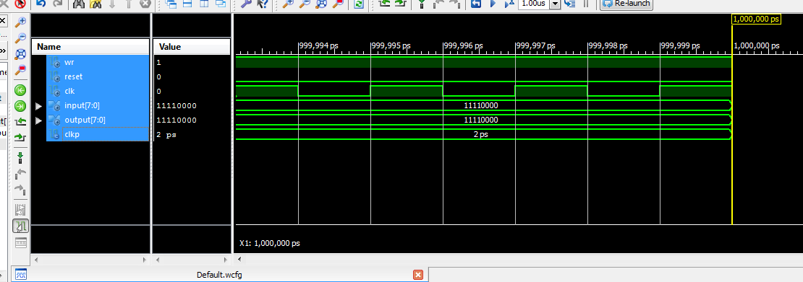

Рис. 3 - часова діаграма ACC

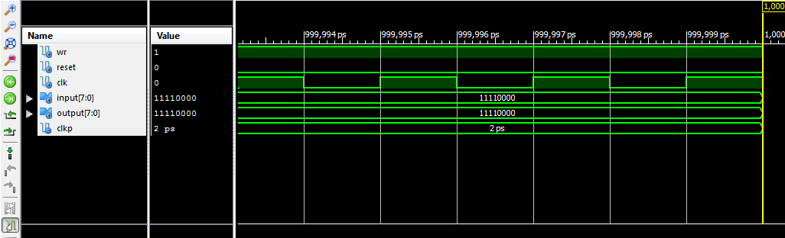

Рис. 4 - часова діаграма ALU

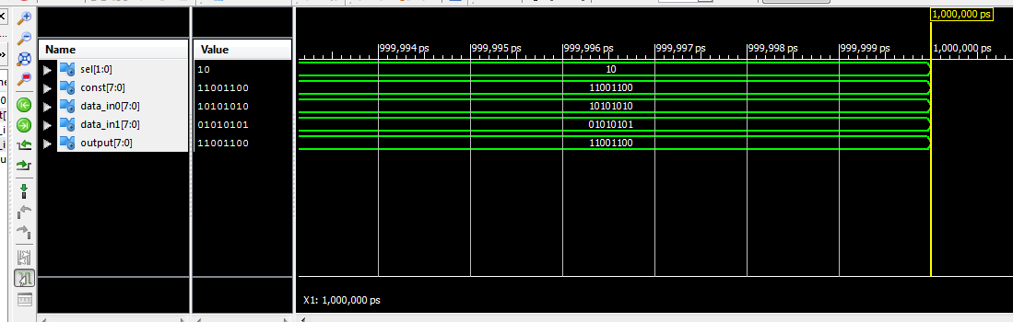

Рис. 5 - часова діаграма MUX

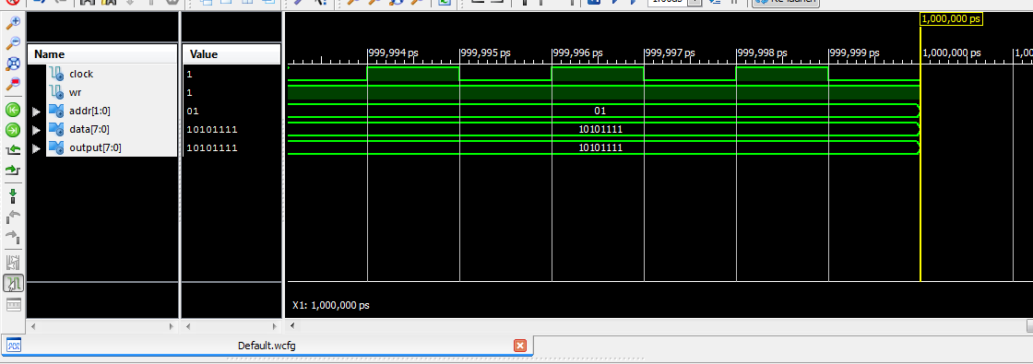

Рис. 6 - часова діаграма RAM

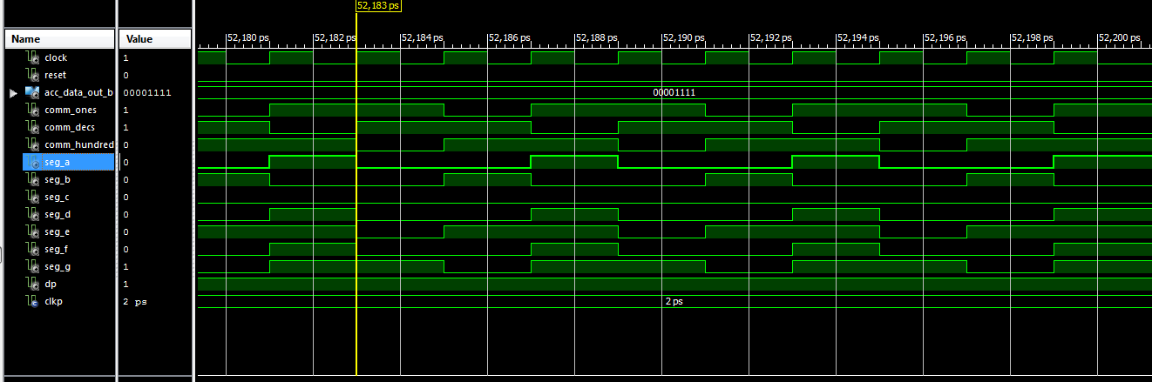

Рис. 7 - часова діаграма SEG_DECODER

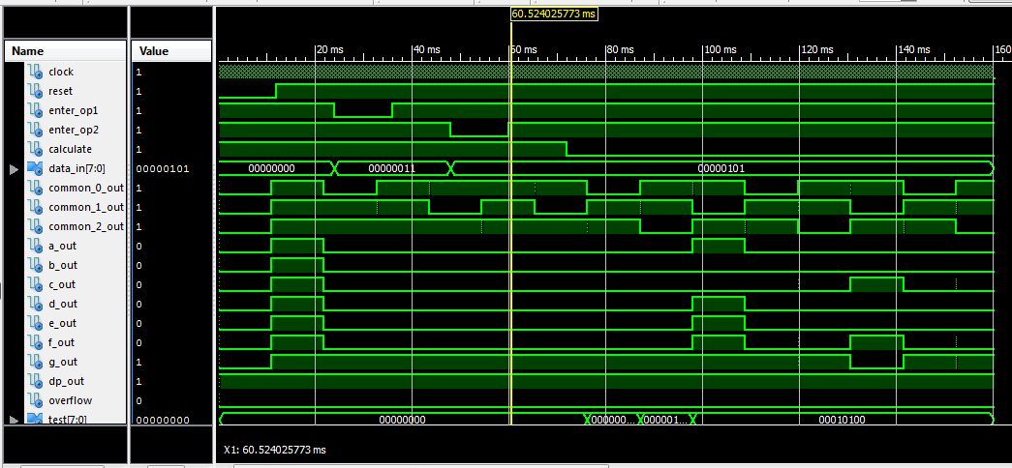

Рис. 8 - часова діаграма TopLevel

Файл TopLevelTest.vhd:

| LIBRARY ieee; USE ieee.std_logic_1164.ALL; USE ieee.numeric_std.ALL; LIBRARY UNISIM; USE UNISIM.Vcomponents.ALL; ENTITY TopLevel_TopLevel_sch_tb IS END TopLevel_TopLevel_sch_tb; ARCHITECTURE behavioral OF TopLevel_TopLevel_sch_tb IS    COMPONENT TopLevel  PORT( CLOCK : IN STD_LOGIC;   RESET : IN STD_LOGIC;   ENTER_OP1 : IN STD_LOGIC;   ENTER_OP2 : IN STD_LOGIC;   CALCULATE : IN STD_LOGIC;   DATA_IN : IN STD_LOGIC_VECTOR (7 DOWNTO 0);   COMMON_0_OUT : OUT STD_LOGIC;   COMMON_1_OUT : OUT STD_LOGIC;   COMMON_2_OUT : OUT STD_LOGIC;   TEST: OUT STD_LOGIC_VECTOR(7 downto 0);  A_OUT : OUT STD_LOGIC;   B_OUT : OUT STD_LOGIC;   C_OUT : OUT STD_LOGIC;   D_OUT : OUT STD_LOGIC;   E_OUT : OUT STD_LOGIC;   F_OUT : OUT STD_LOGIC;   G_OUT : OUT STD_LOGIC;   DP_OUT : OUT STD_LOGIC;   RAMOUT: OUT STD_LOGIC_VECTOR(7 downto 0);  ALUOUT: OUT STD_LOGIC_VECTOR(7 downto 0);  RAMA: OUT STD_LOGIC_VECTOR(1 downto 0);  RAMWR: OUT STD_LOGIC;  OVERFLOW : OUT STD_LOGIC);  END COMPONENT;   SIGNAL CLOCK : STD_LOGIC := '0';  SIGNAL RESET : STD_LOGIC;  SIGNAL ENTER_OP1 : STD_LOGIC;  SIGNAL ENTER_OP2 : STD_LOGIC;  SIGNAL CALCULATE : STD_LOGIC;  SIGNAL DATA_IN : STD_LOGIC_VECTOR (7 DOWNTO 0);  SIGNAL COMMON_0_OUT : STD_LOGIC;  SIGNAL COMMON_1_OUT : STD_LOGIC;  SIGNAL COMMON_2_OUT : STD_LOGIC;  SIGNAL A_OUT : STD_LOGIC;  SIGNAL B_OUT : STD_LOGIC;  SIGNAL C_OUT : STD_LOGIC;  SIGNAL D_OUT : STD_LOGIC;  SIGNAL E_OUT : STD_LOGIC;  SIGNAL F_OUT : STD_LOGIC;  SIGNAL G_OUT : STD_LOGIC;  SIGNAL DP_OUT : STD_LOGIC;  SIGNAL OVERFLOW : STD_LOGIC;  SIGNAL TEST: STD_LOGIC_VECTOR(7 downto 0);  SIGNAL TEST2: STD_LOGIC_VECTOR(7 downto 0);  signal RAMOUT: STD_LOGIC_VECTOR(7 downto 0);  signal ALUOUT: STD_LOGIC_VECTOR(7 downto 0);  signal RAMA: STD_LOGIC_VECTOR(1 downto 0);  signal RAMWR: STD_LOGIC;   -- constant CLOCK_period : time := 166ns;  constant CLKP: time := 12ms;--24ms;  BEGIN   UUT: TopLevel PORT MAP(  CLOCK => CLOCK,   RESET => RESET,   ENTER_OP1 => ENTER_OP1,   ENTER_OP2 => ENTER_OP2,   CALCULATE => CALCULATE,   DATA_IN => DATA_IN,   COMMON_0_OUT => COMMON_0_OUT,   COMMON_1_OUT => COMMON_1_OUT,   COMMON_2_OUT => COMMON_2_OUT,   A_OUT => A_OUT,   B_OUT => B_OUT,   C_OUT => C_OUT,   D_OUT => D_OUT,   E_OUT => E_OUT,   F_OUT => F_OUT,   G_OUT => G_OUT,   DP_OUT => DP_OUT,   OVERFLOW => OVERFLOW,  TEST => TEST,  RAMOUT => RAMOUT,  ALUOUT => ALUOUT,  RAMA => RAMA,  RAMWR => RAMWR  );    CLOCK_process: process  begin  CLOCK <= '0';  wait for 83ns;  CLOCK <= '1';  wait for 83ns;  end process;  -- *** Test Bench - User Defined Section ***  tb : PROCESS  BEGIN   lp1: for i in 4 to 4 loop  lp2: for j in 2 to 2 loop  TEST2 <= std_logic_vector((to_unsigned(i * j, 8) srl 1) + i + 10);  ENTER_OP1 <= '1';  ENTER_OP2 <= '1';  CALCULATE <= '1';  DATA_IN <= (others => '0');  RESET <= '0';  wait for CLKP;  RESET <= '1';  wait for CLKP;  DATA_IN <= std_logic_vector(to_unsigned(i, 8)); -- A  ENTER_OP1 <= '0';  wait for CLKP;  ENTER_OP1 <= '1';  wait for CLKP;  DATA_IN <= std_logic_vector(to_unsigned(j, 8)); -- B  ENTER_OP2 <= '0';  wait for CLKP;  ENTER_OP2 <= '1';  wait for CLKP;  CALCULATE <= '0'; -- START CALCULATION  wait for CLKP* 7;  assert TEST = TEST2 severity FAILURE;  wait for CLKP;  end loop;  end loop;    WAIT; -- will wait forever  END PROCESS; -- *** End Test Bench - User Defined Section ***  END; |
| --- |

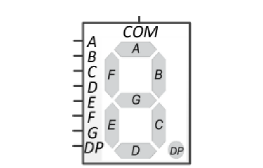

Рис. 9 - семисегментний індикатор

Вхідне число: 02010 = 101002

Сотні: g = 1 (a,b,c,d,e,f = 0)

Десятки: c = 1, f = 1 (a,b,d,e,g = 0)

Одиниці: g = 1 (a,b,c,d,e,f = 0)

**Висновок:** виконуючи дану неймовірну лабораторну роботу та оформлюючи звіт до неї, я навчився реалізовувати цифровий автомат для обчислення значення виразів використовуючи засоби VHDL.