**UPDATE 1: CHANGING THE WAY OF UPLOADING IMAGES TO WEBSITE**

What we have right now:

1. We have pages which has background images (background slideshow):

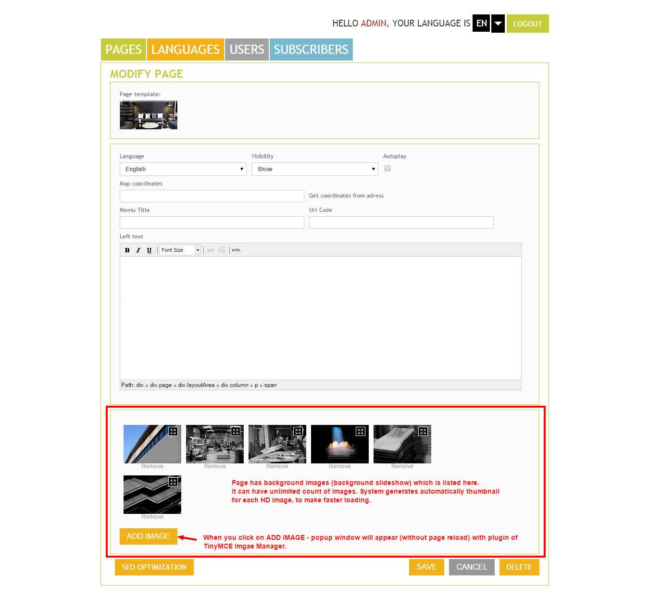

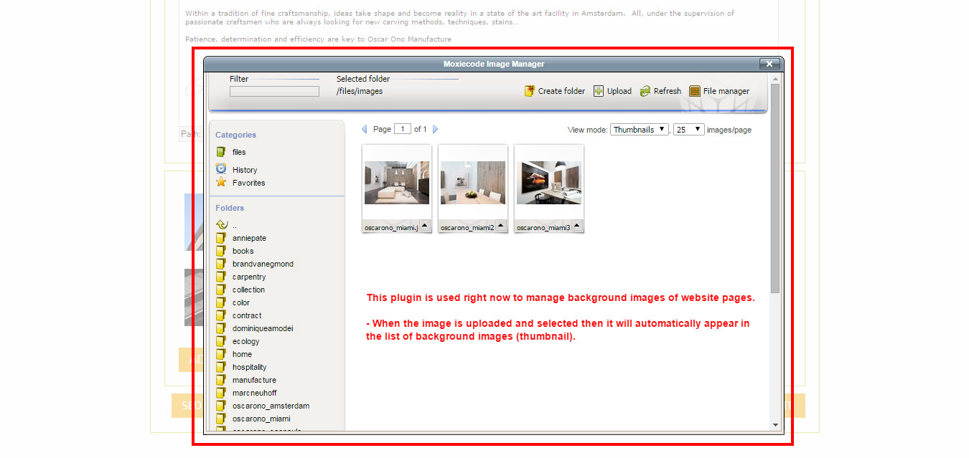



1. We have galleries inside pages. Each gallery can have multiple images:

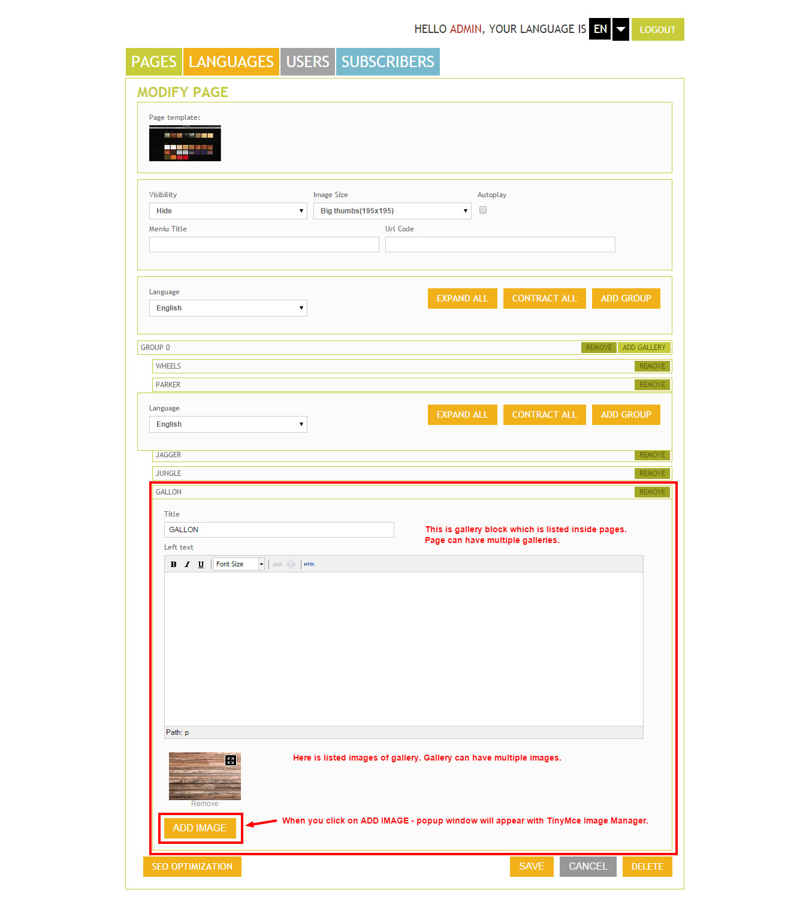



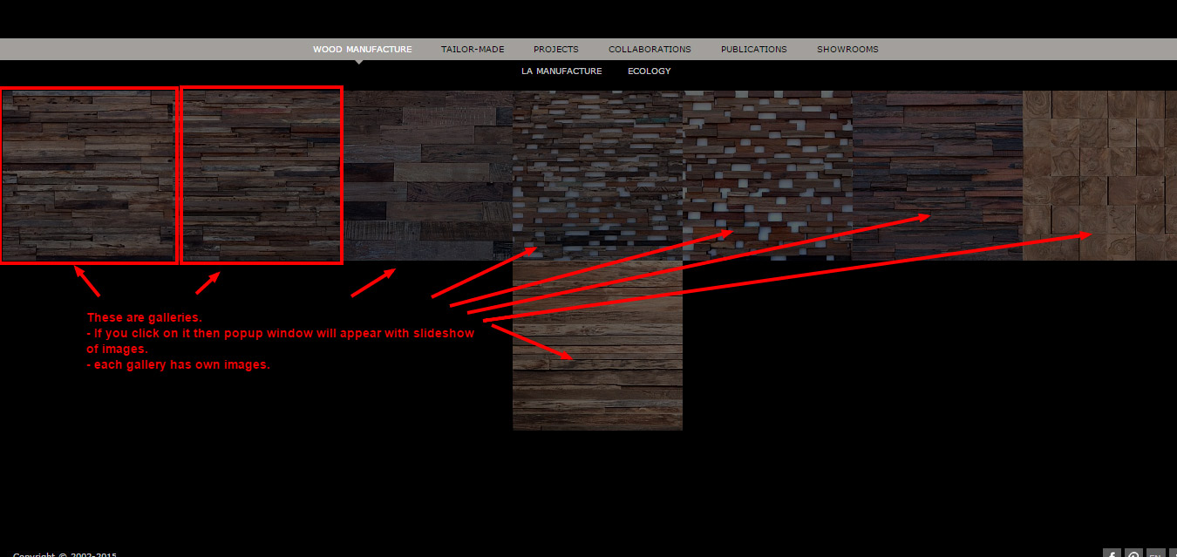

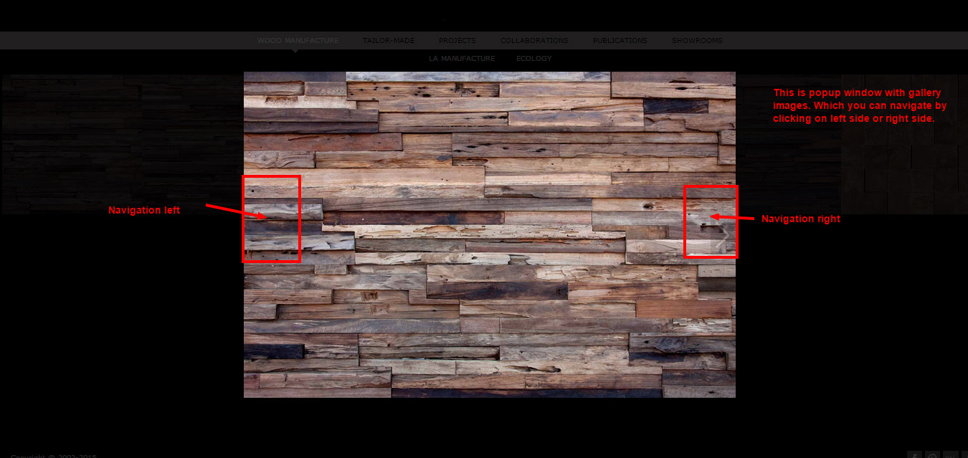

How it should be changed:

1. We want to have the way to upload/delete images directly (simple way) without plugin of TinyMce Image Manager.
2. We want to have possibility to change image name (file name) when uploading image.
3. We want to have possibility to write description for each image. Each image should have multi language description. Description will be visible in front website.

