* Web color

* Map color

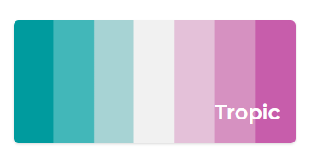

#009B9E,#42B7B9,#A7D3D4,#F1F1F1,#E4C1D9,#D691C1,#C75DAB