# Assignment #5

Introduction

This portion of the class leaves off after our previous course on creating lists. In this assignment, we’ll need to create scrips that utilize dictionaries, and writing to and reading from files.

# Creating our To-Do List Menu

First we are going to tell our program to open any existing To-Do file and allow the user to see any previous entries:

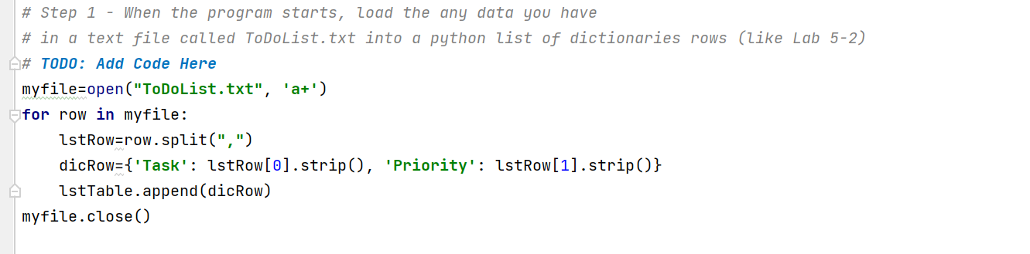

fig1

Then, we will create some code to allow the user to display any tasks and their priorities that they had entered within the program, we are titling our inputs so they can be recalled, and using a dictionary to categorize our items and then creating a list that will grab the additional rows from other entries using a ‘for’ loop:

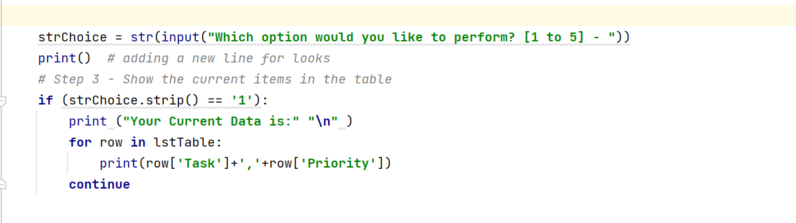

fig 2

Next, we are going to allow the user to include additional items to their To-Do list/file. The dictionary will add the tasks and priority to its library, and then the table will append the entries to itself:

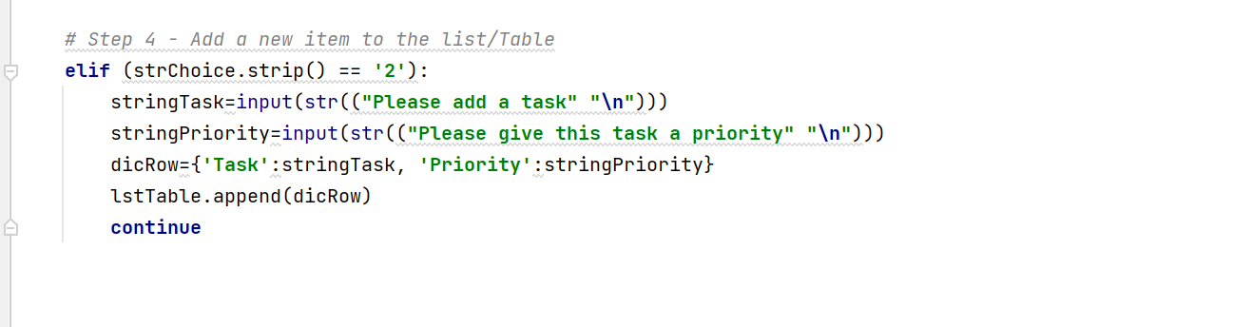

fig 3

Then, we are going to allow the user to remove the last item entered from their To-Do list by using the pop() function. Leaving the pop with no variable, will automatically remove the last entered row: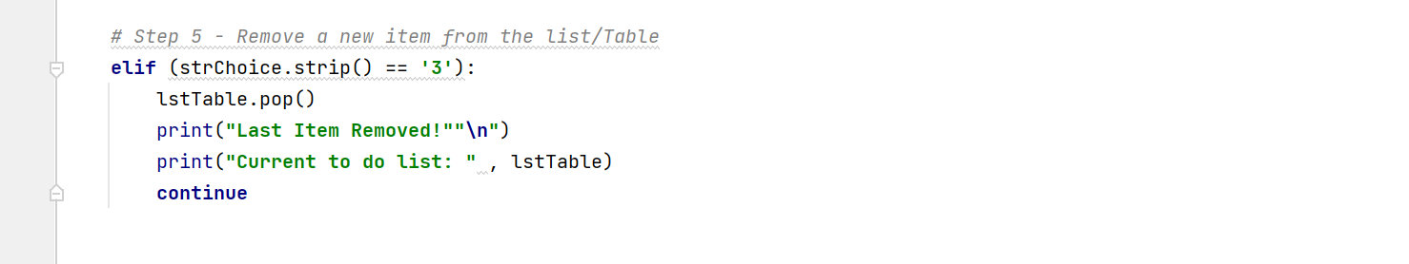

Fig4

Then, write a script to let the user save their entries to their To-Do file: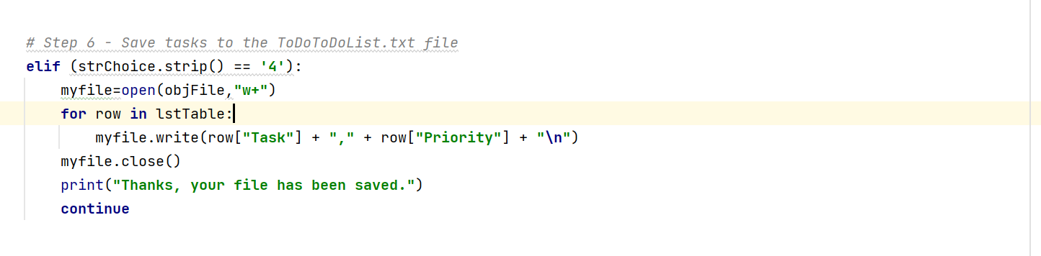:

Fig5

Finally, we create a menu option that will allow the user to exit the program without saving any of their entered data: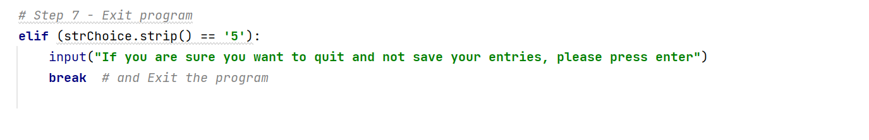

# Summary

This was a pretty fun assignment. It was challenging trying to incorporate what I had learn with lists and incorporating dictionaries. But, this assignment did have me looking at a lot of different resources and finding cool things like the pop() function (I think I violated one of the assignment stipulations), which I think worked well here. I need to carve out a bit more time to fancy up my code, as mine seems a bit rudimentary compared to the examples I was using for study.