CS 504 Software Engineering

HOS08A – CI/CD

Reviewed by Jonathan Koerber on 03/28/2025
Reviewed by Clark Ngo on 04/02/2026
Reviewed by Sumit K C on 06/16/2026

School of Technology & Computing (STC) @ City University of Seattle (CityU)



Before You Start
- Version numbers may not match the most current version at the time of writing. If given the option to choose between the stable release (long-term support) or the most recent, please select the stable release rather than the beta-testing version.
- This tutorial targets Windows users and MacOS users.

Learning Outcomes
- Deploy Static Website on Azure
- CI/CD pipeline

Resources
- Loubser, N. (n.d.-b). Software Engineering for Absolute Beginners: Your Guide to Creating Software Products. O'Reilly Online Learning. https://learning.oreilly.com/library/view/software-engineering-for/9781484266229/
- https://learn.microsoft.com/en-us/azure/static-web-apps/

Instructions
- Create a Word Document.
- Include a snapshot of each step in the document.

Introduction

In this HOS, we will learn about creating a static website on the Azure platform with a CI/CD pipeline.

- Creation of a Static Website

- Login to the GitHub account and click New to create a repository.

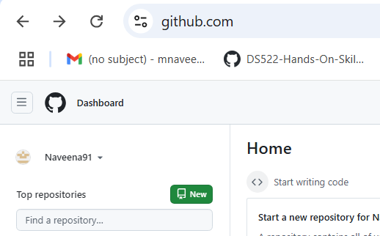

- Enter the details as shown in the following picture and create the repository.

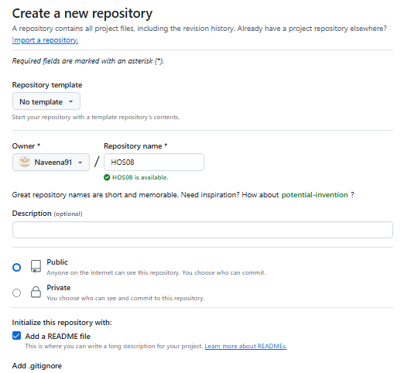

- Clone the repository and add an index.html file with the following tag.

<h1>Hello<h1>

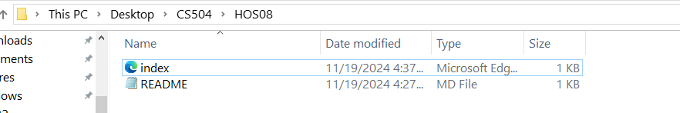

- Push index.html file to the GitHub repository.

- Azure Sign-In

- Click on Azure, and click on Free Account (top right-side corner) and signup with your CityU email.

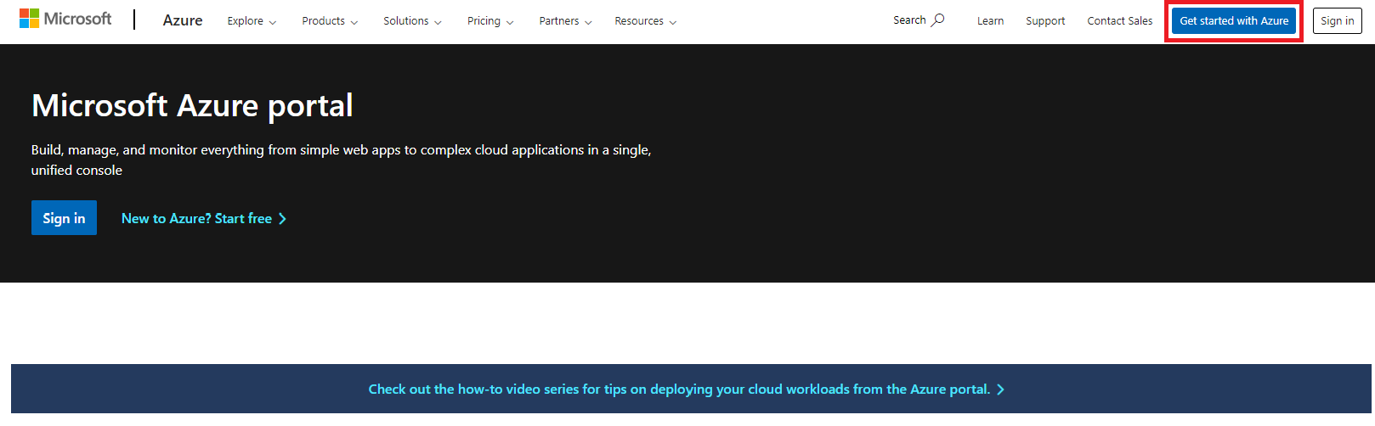

- Click on Start Free and Sign In with your Microsoft Account. Follow the Sign-up process.
For more information on the Sign-In process, follow https://learn.microsoft.com/en-us/training/modules/create-an-azure-account/

- Once the sign-up process is complete, you should see the following page.

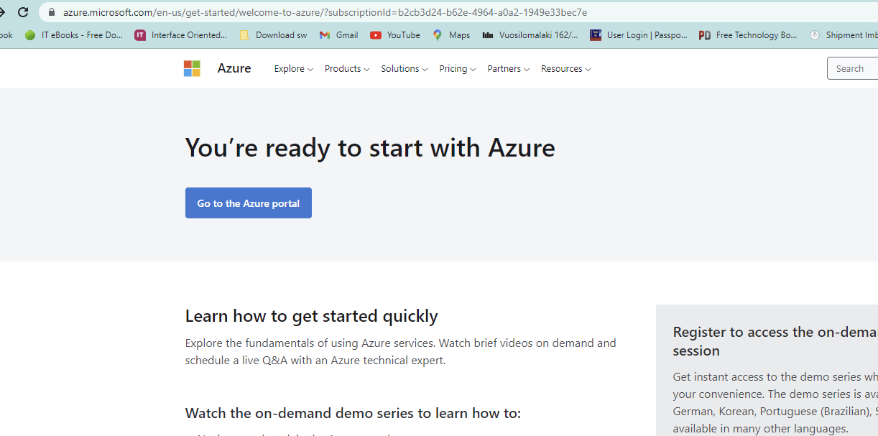

- Click On "Go to the Azure portal" and sign in with your Microsoft account.

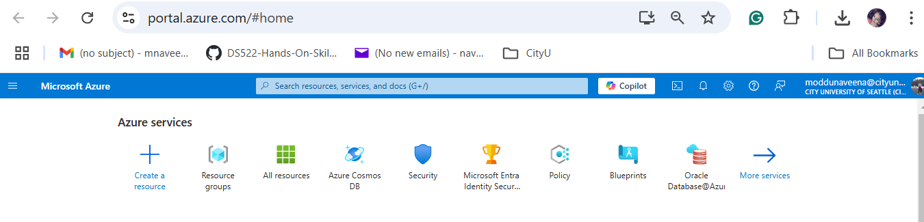

- In the Search bar, enter "Static" and click on Static Web Apps.

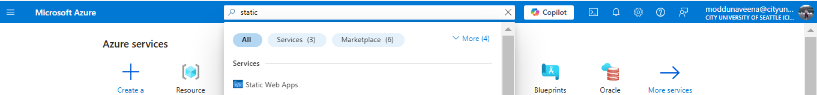
- Select either “Start with an Azure free trial” or “Access student benefits” for a free trial version.

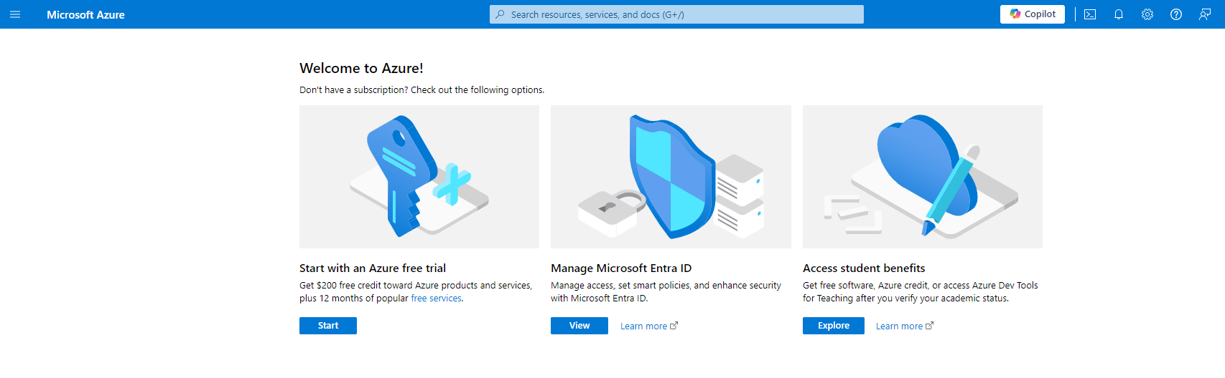

- Select Static Web Apps.

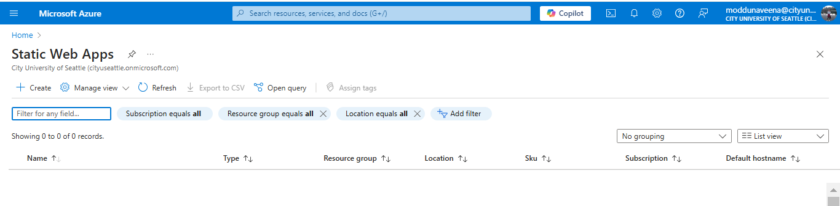
- Click Create and Enter the details as highlighted in the following picture.

- Name: HOS08
- Plan type: Free: For hobby or personal projects
- Region for Azure Functions API and staging environments: West US 2

Important: Select Free, for hobbies or personal projects like the Plan Type; otherwise, you will get charged.

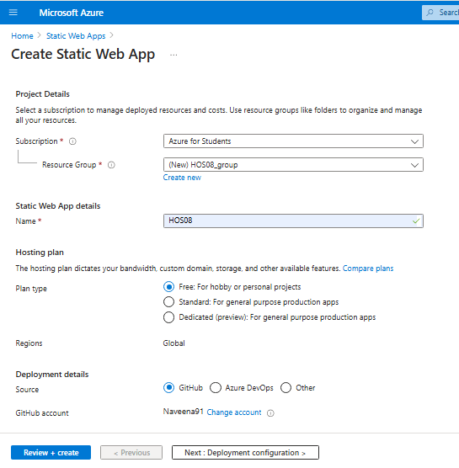

- Click on GitHub and provide your GitHub details.

- Click on Authorize Azure-App-Service-Static-Web-Apps.

- Fill in the details as highlighted in the following picture.

- Organization: Select GitHub Account

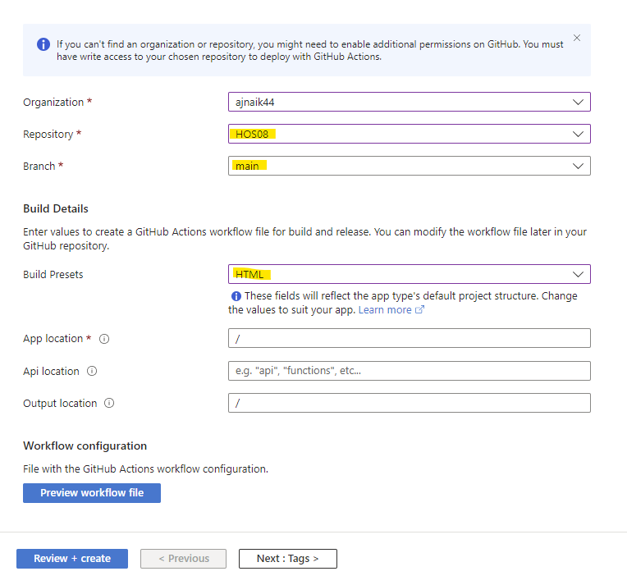

- Click on the Review + Create button.

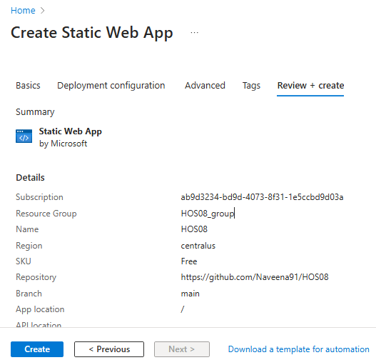

- Click on Create.

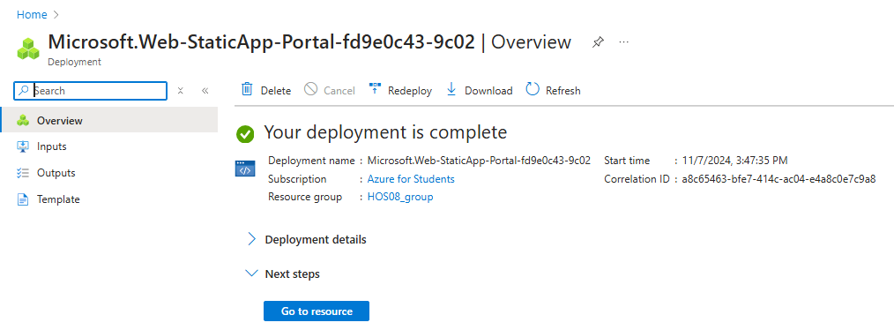

- Click on Go to resource.

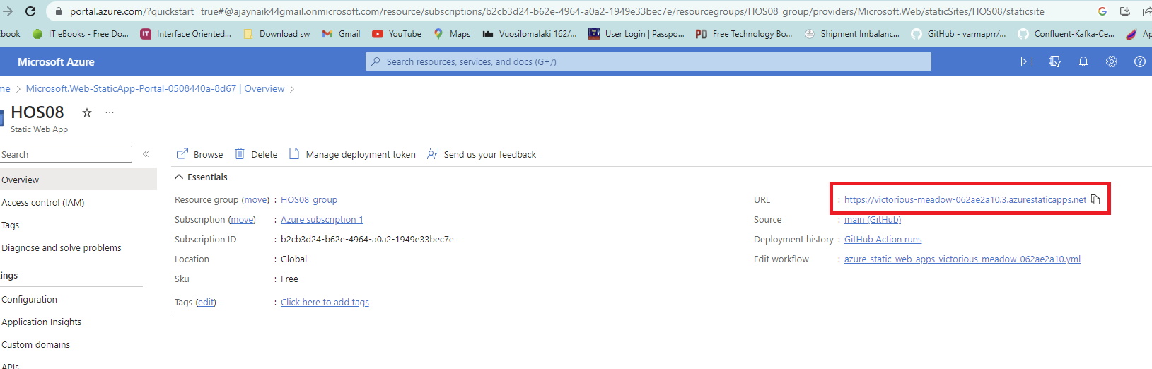

- Copy the URL and open it in a new tab.

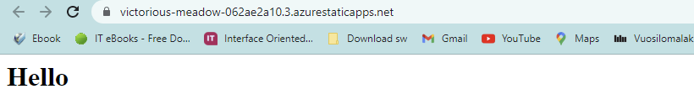

- Open your HOS08 (git branch created as part of step “Creation of a Static Website”).

- In Visual Studio Code, open a new terminal, and type the following command.

git checkout -b development

The following should appear.

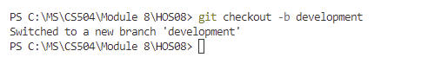

- Modify the index.html file with the following code.

<h1>Hello World!<h1>

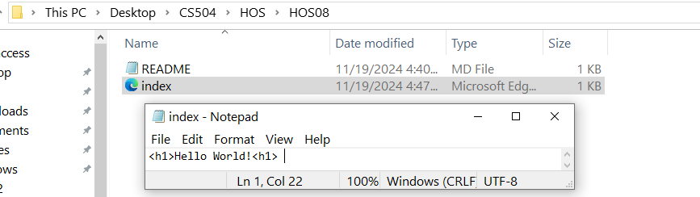

- Enter the following command in the Terminal

git add –all
git commit -m "development branch"
git push -f origin development

The following should appear.

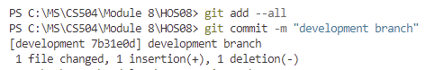
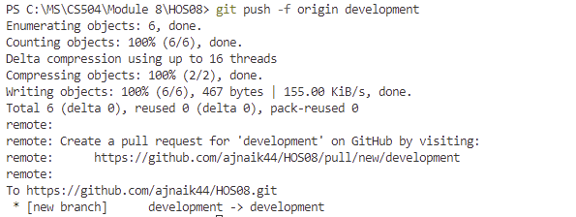

- Go to the GitHub account and click on Pull request.

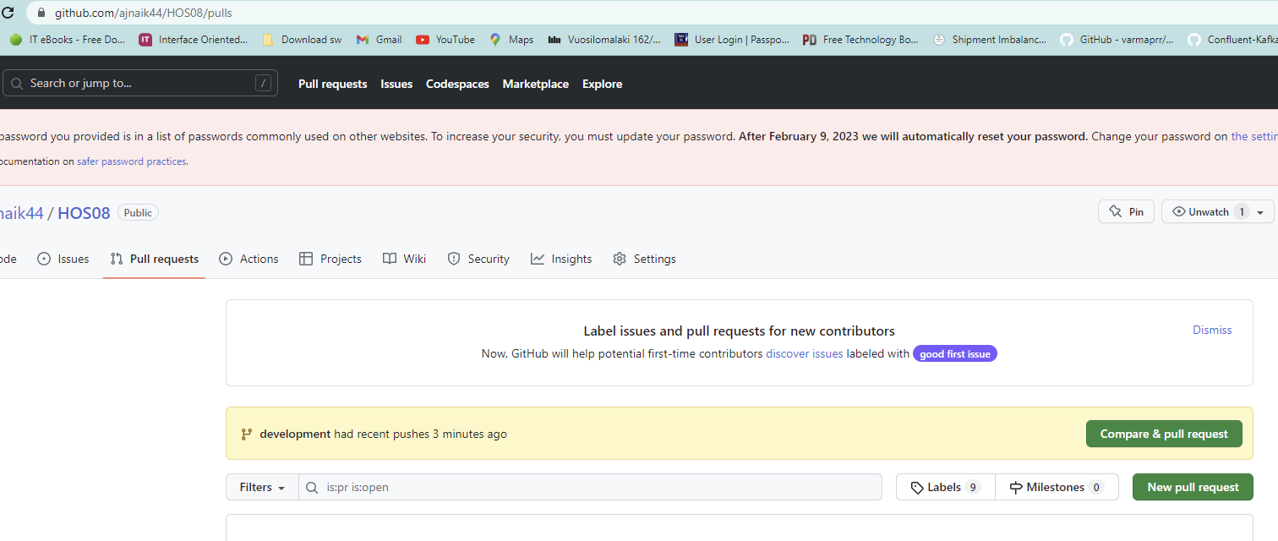

- Click on Compare & Pull Request. Create Pull Request and Merge Pull Request. Then Confirm the merge.

Note: Detailed steps about the merging process are explained in HOS02.

- Click on Actions and wait until all the jobs are completed.

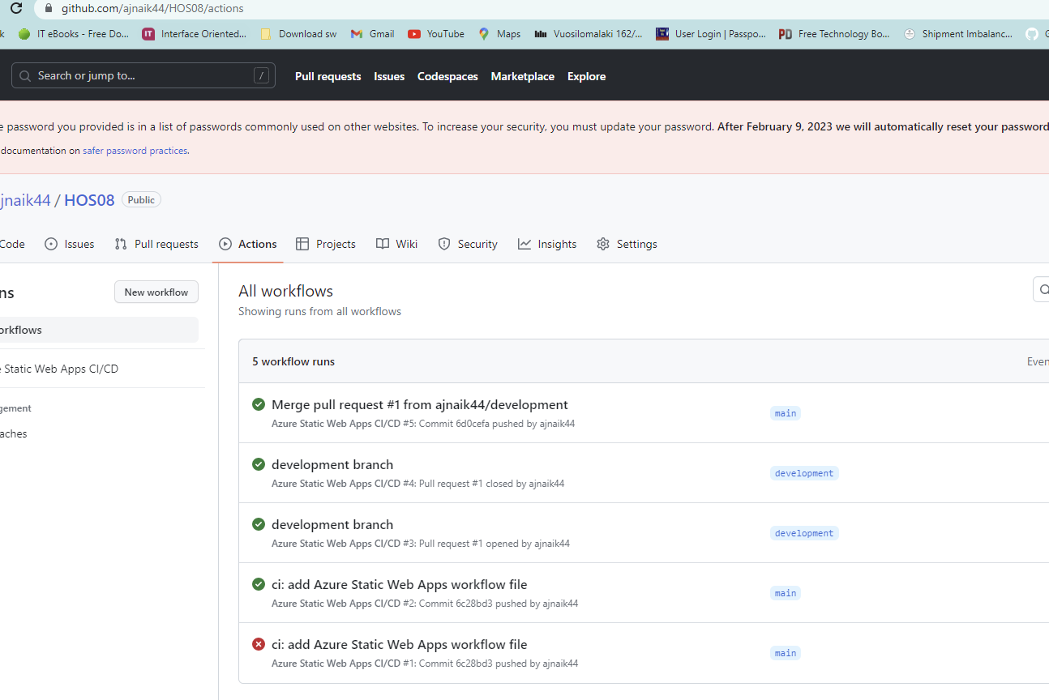

- Go to the Azure Portal, then Static Web Apps, and Select HOS08.

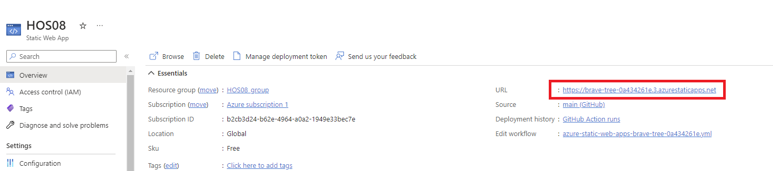

- Copy the URL and open it in the new browser.

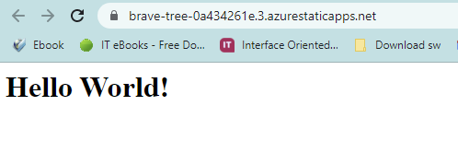

- Once the Web App is running, we will delete the resources we have created.

- Go to the Azure Portal, then Static Web Apps, and Select HOS08.

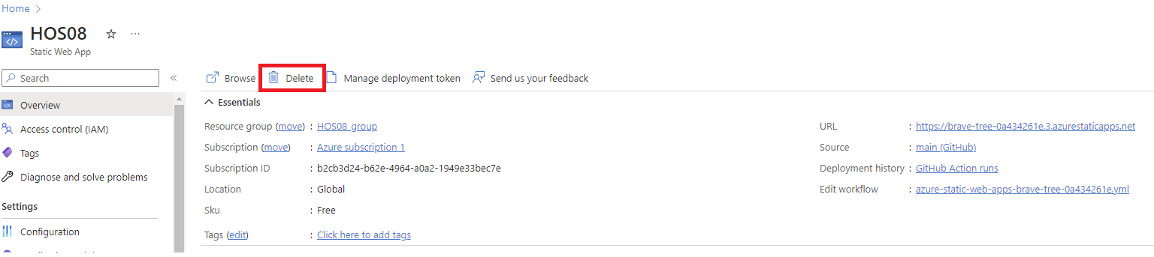

- Click on Delete.

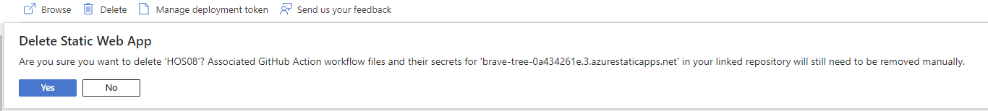

- Click on Yes and wait for the process to complete.

Push your work to GitHub
Please follow the instructions from this link to push your work from Codespaces to GitHub.
OR,
Open the Terminal from the VS Code by hitting the control + ~ key and typing the following command:

Run the following commands to push your work to the GitHub repository:

git add --all
git commit -m "Submission for Module8"
git push

