Azure - Create Static Web App:
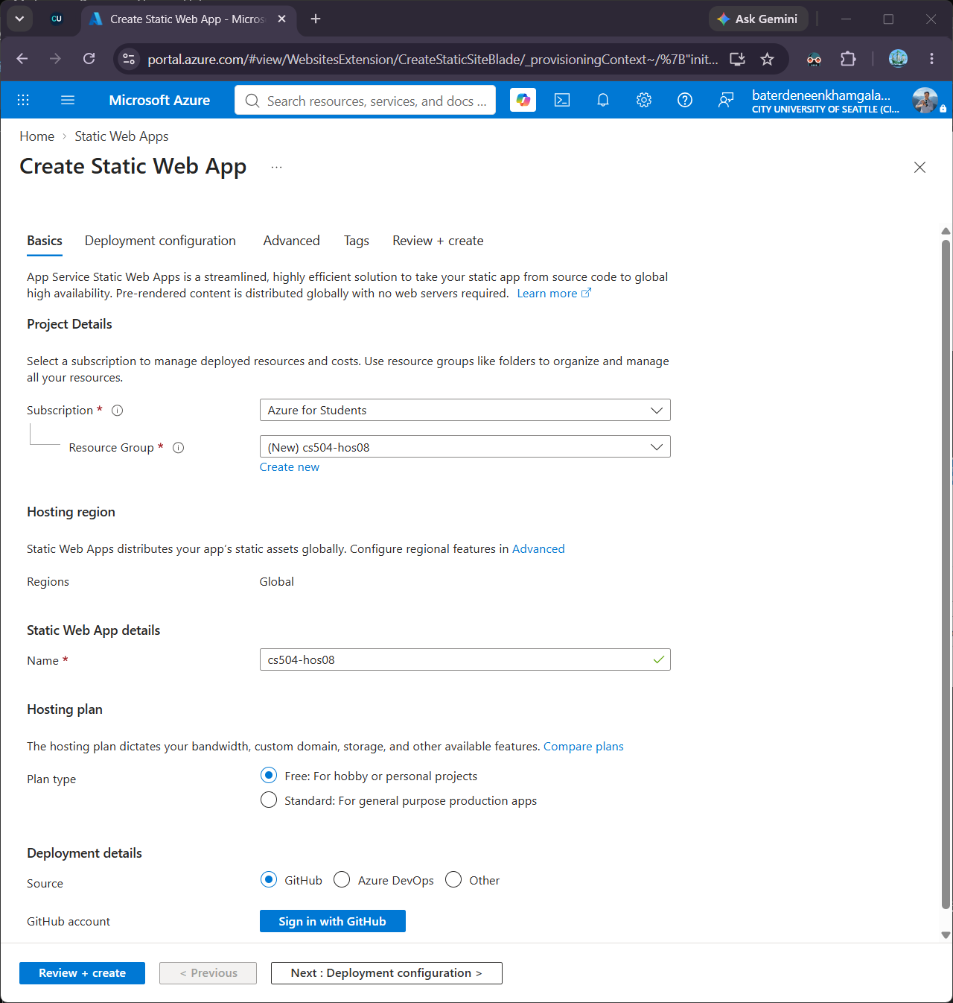

Sign in with GitHub:
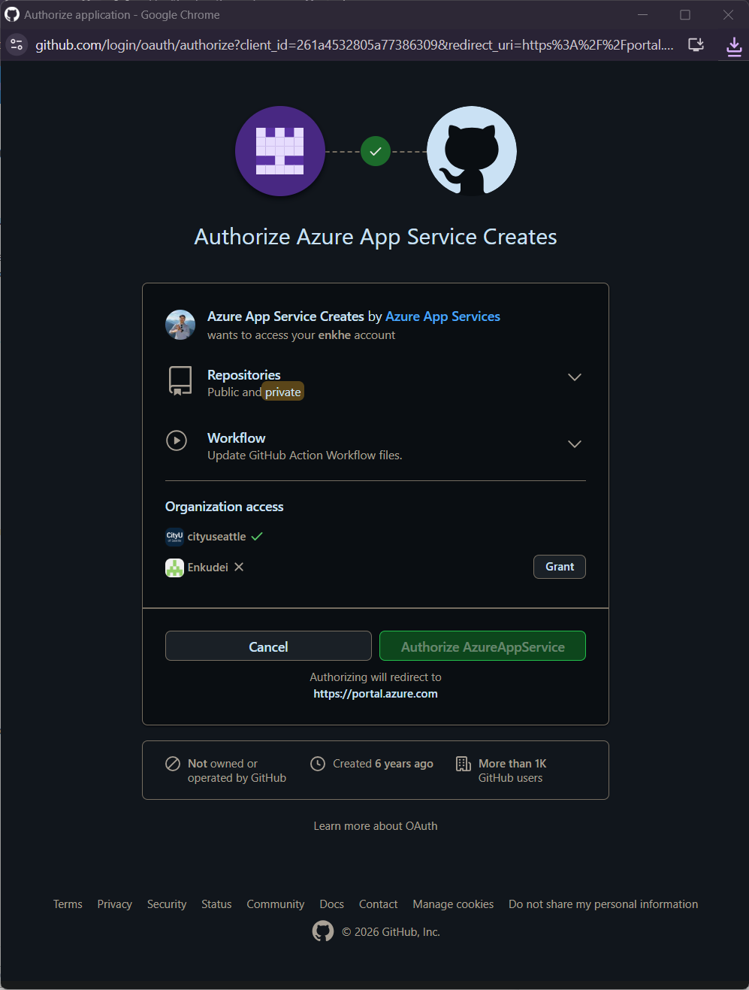

Deployment Details:
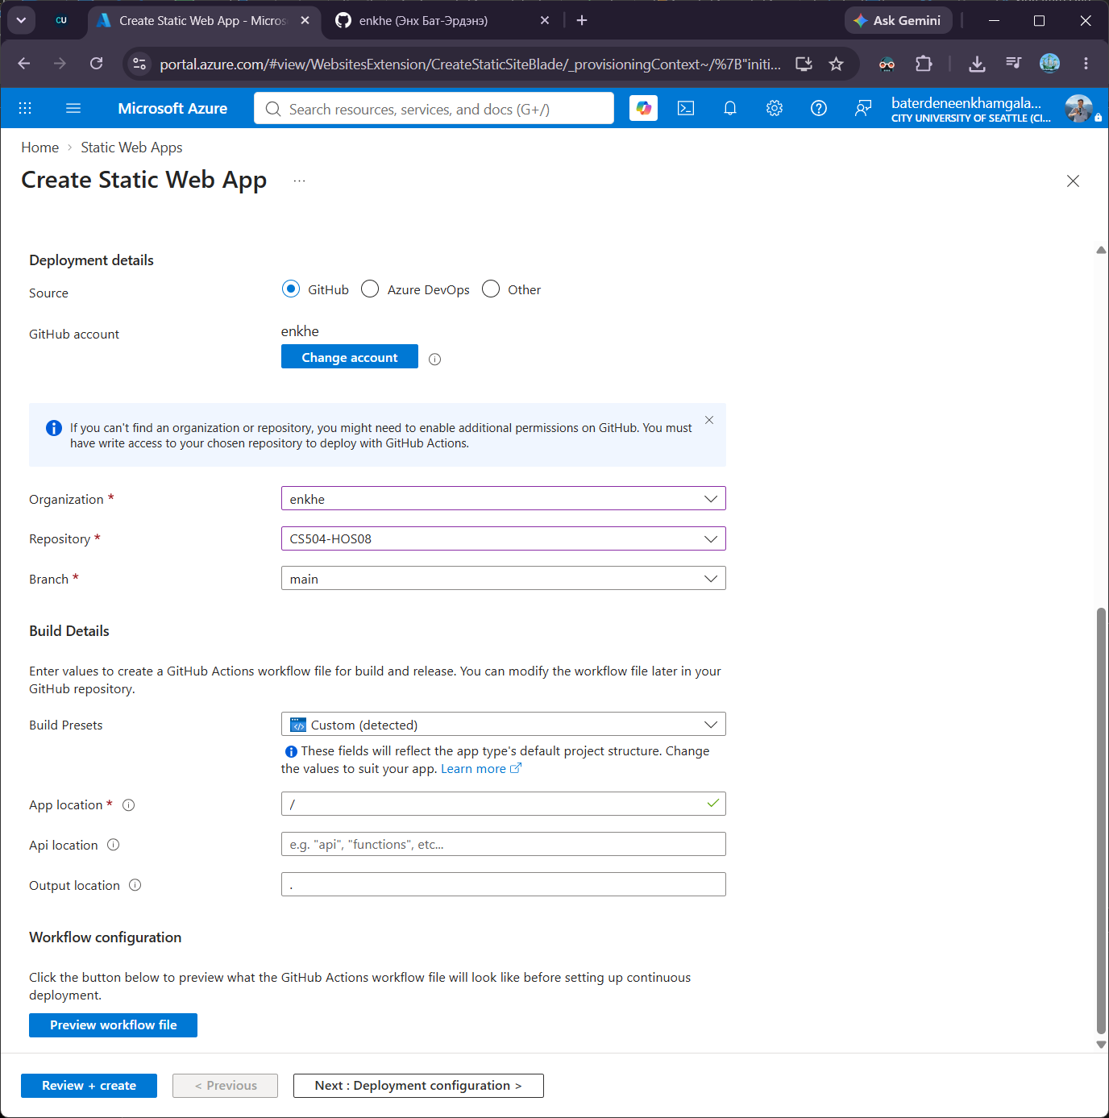

Error with creating Static Web App service:
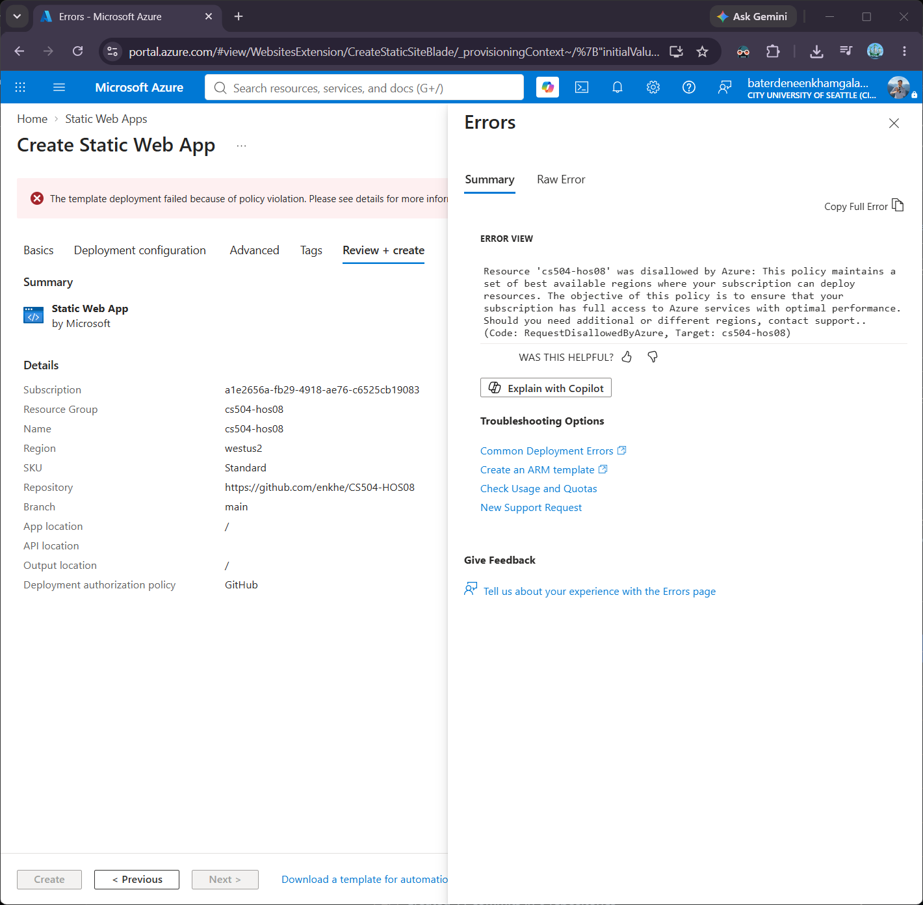

Able to create one from my personal account:
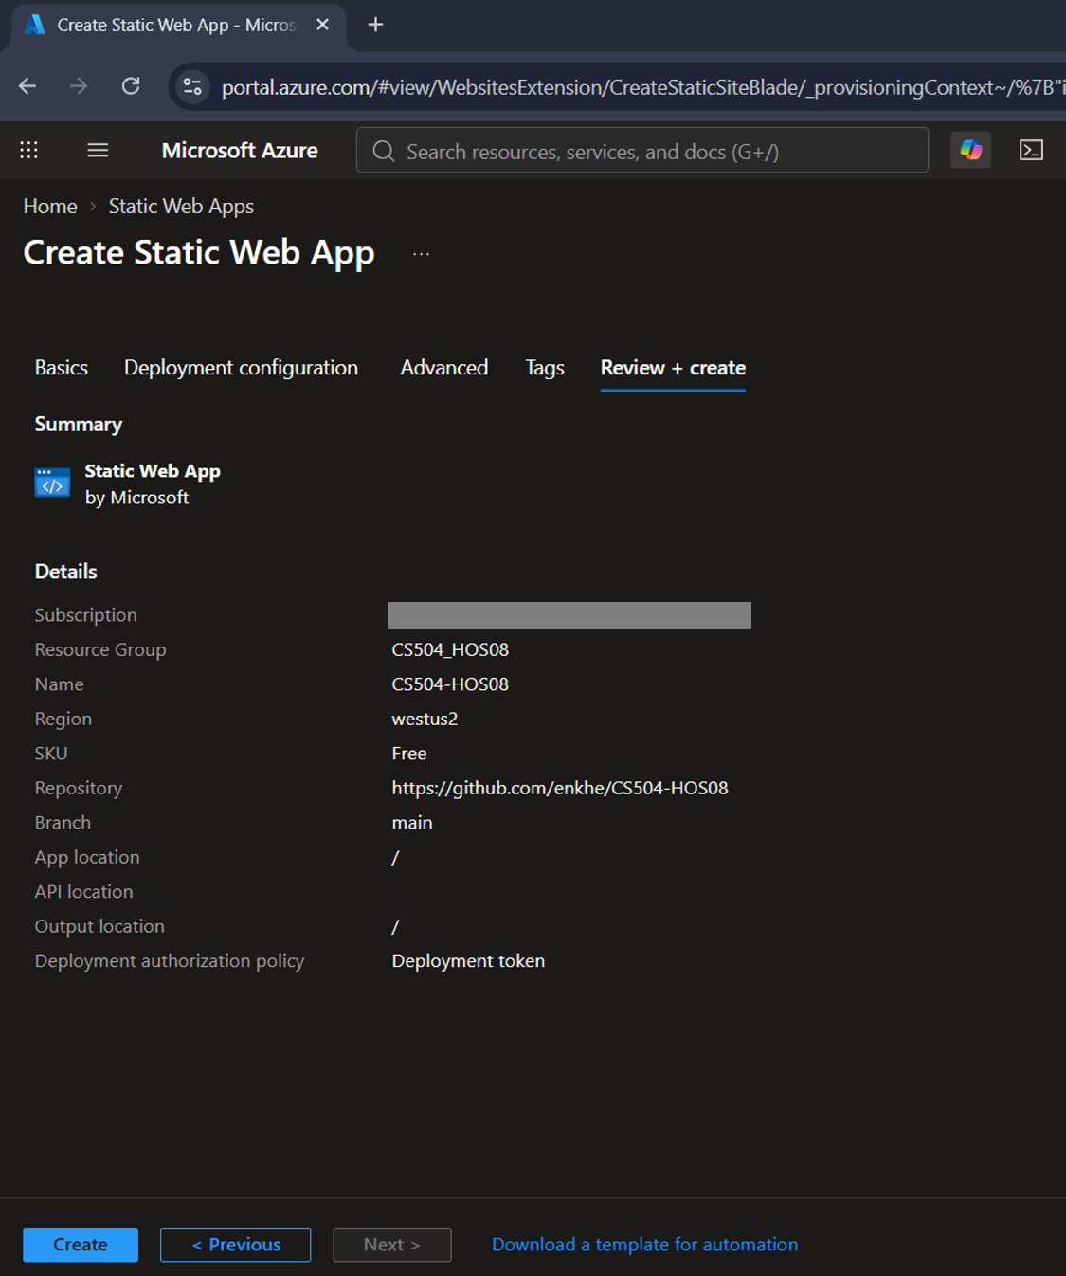
Deployment is comple:
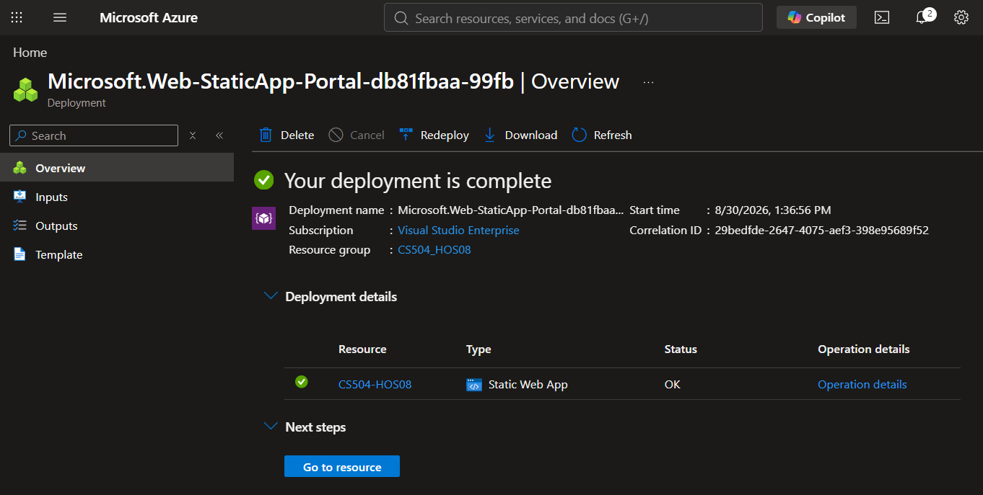

The Static web page is deployed (https://orange-sand-044e8421e.7.azurestaticapps.net/):
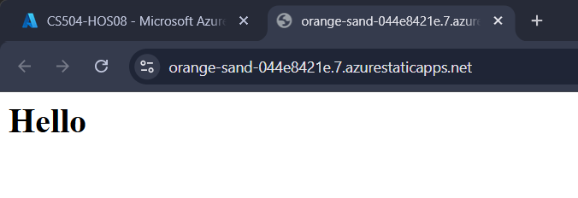

Modified the index html page, and pushed to the development branch:
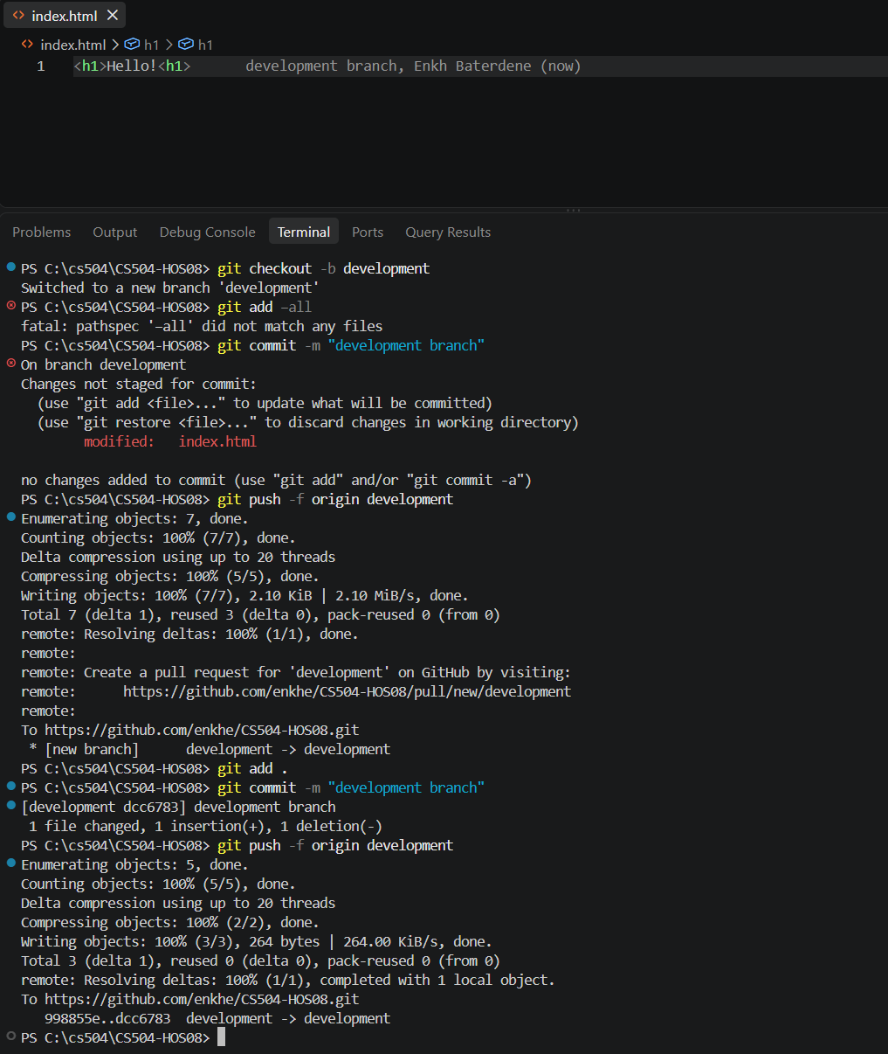

Accept Pull Request:
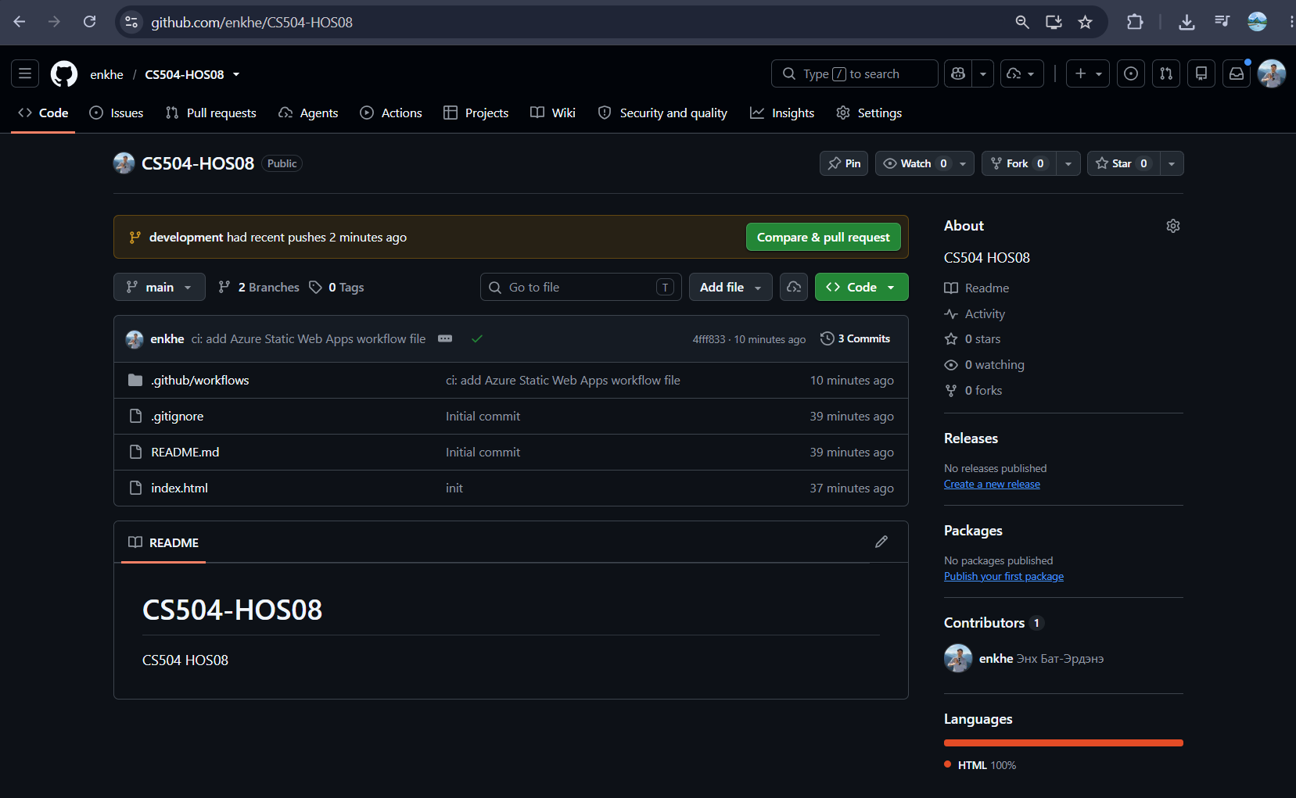
Pull Request, Compare Changes, and Accept to push development branch changes to main:
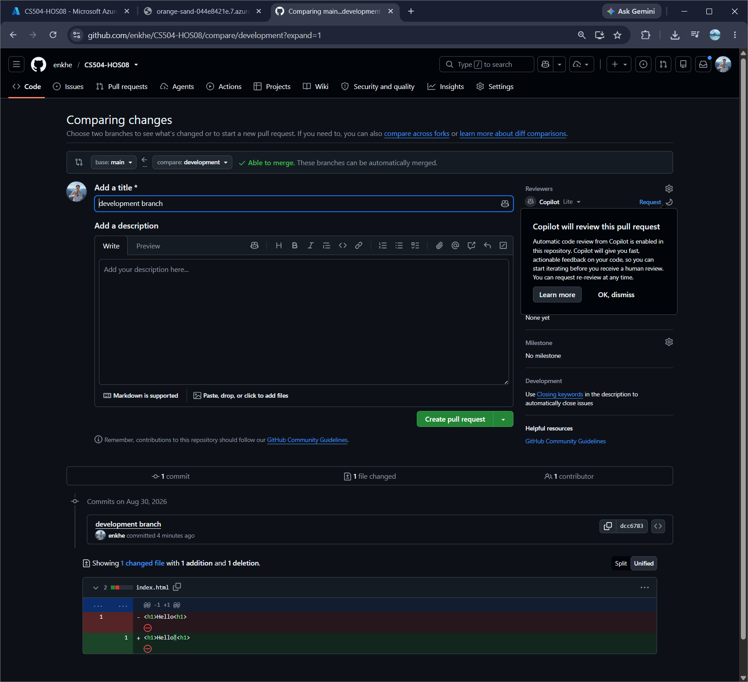
Merge Validations part A:
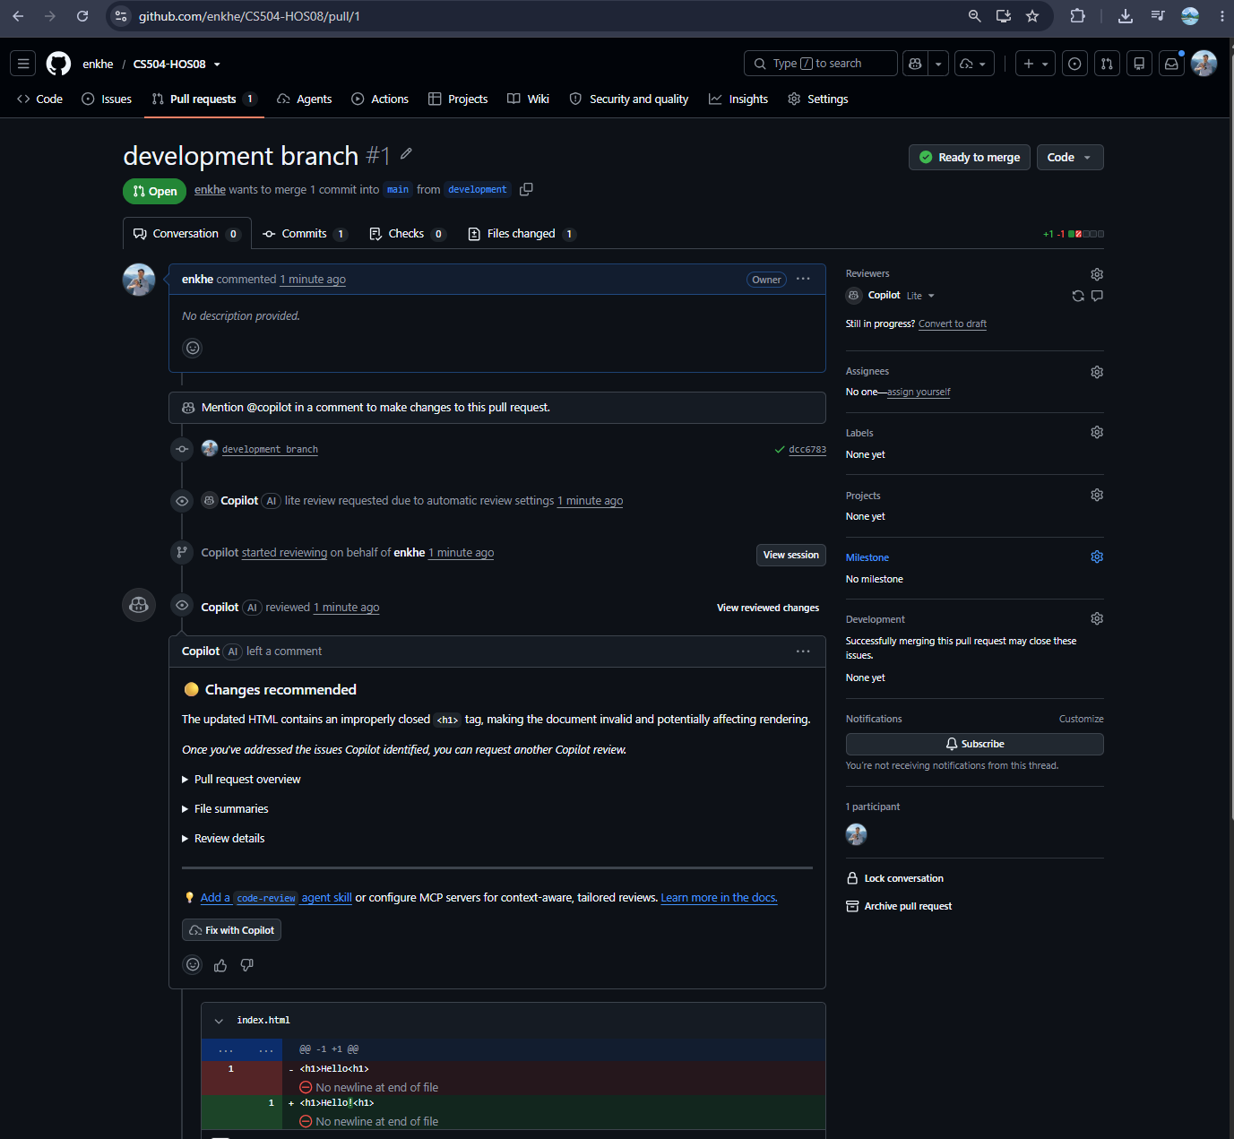

Merge Validations part B:
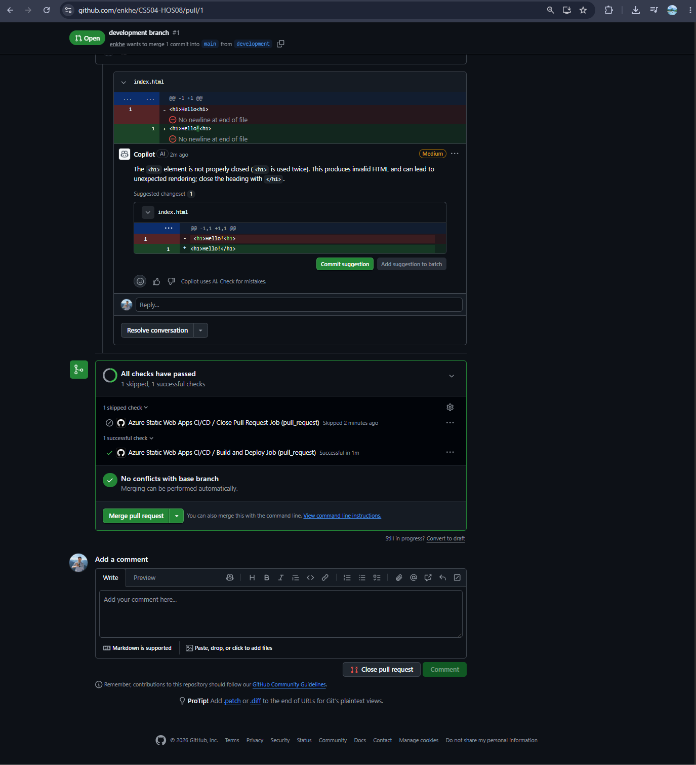

Confirm the Merge:
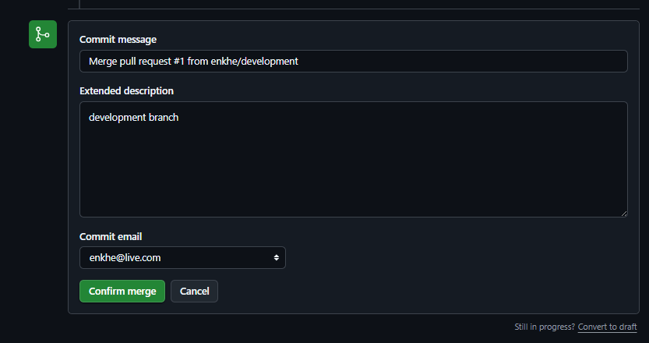

Merge is complete and the feature branch called development can be deleted:


The Static web page is updated:
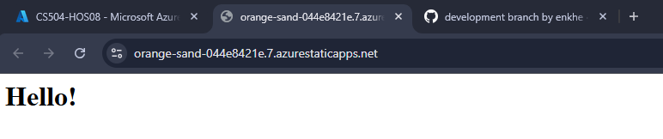

Static Web App Portal View Before Delete:
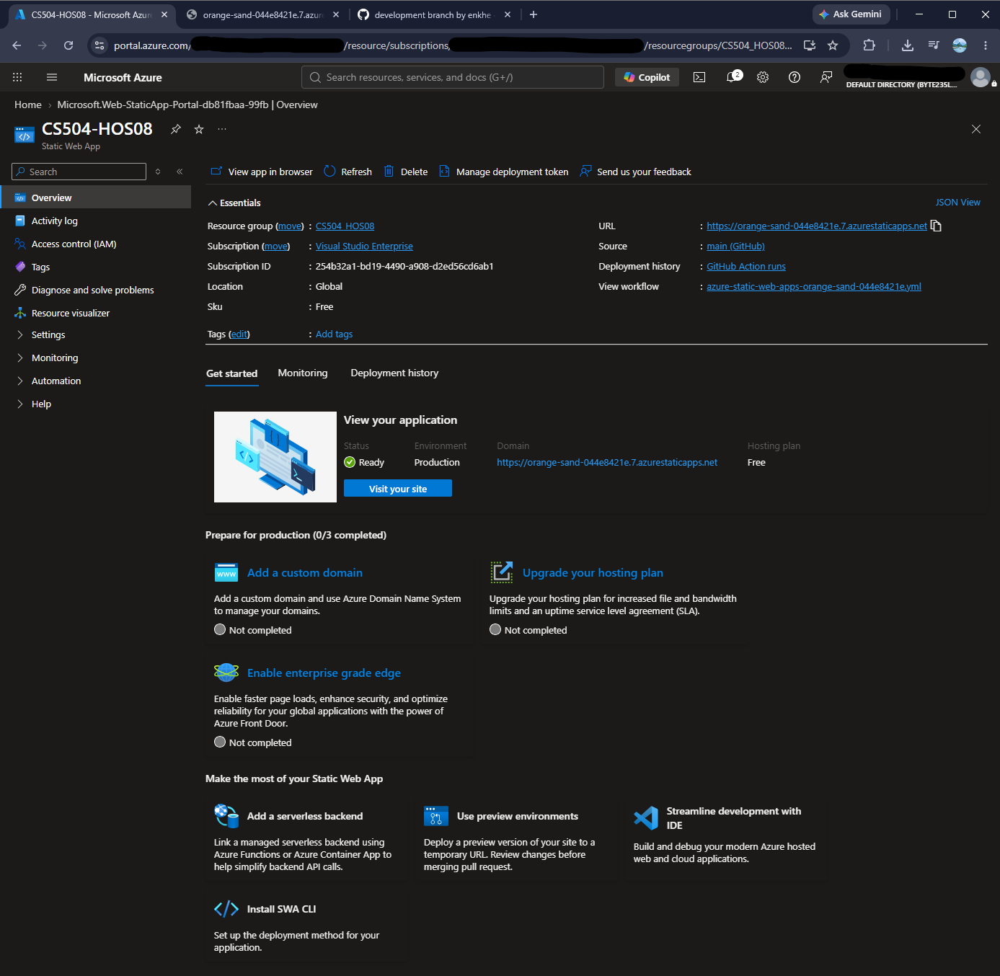

Confirm to Delete the Static Web App Resource from Azure:
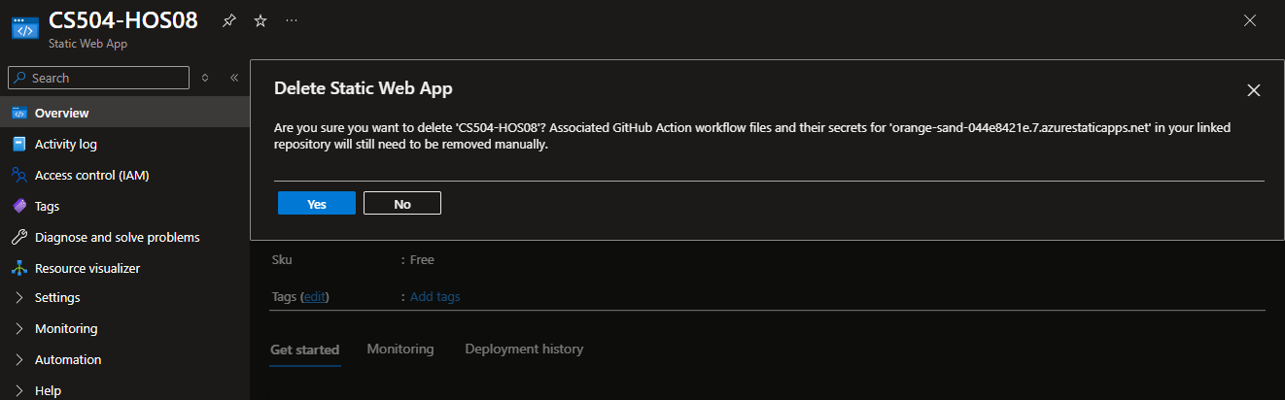

Delete operation is completed:
