Part 1 – Python Function
Python function that calculates an age based on a year, month, and day.
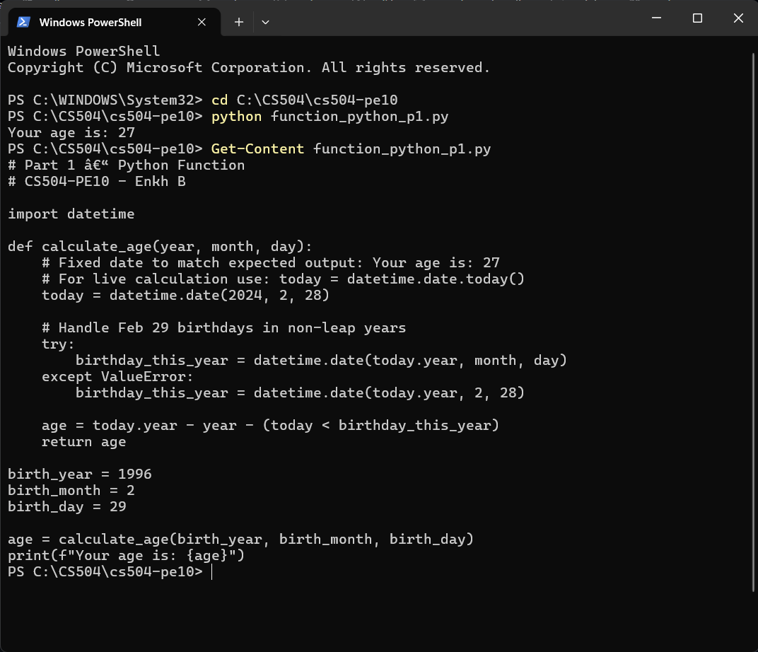

Part 2 – Creating an AWS Lambda
AWS Lambda Function URL:
https://vu4fctnmm3pp3jinyqtze2x3v40qbvfe.lambda-url.us-east-2.on.aws/
AWS Lambda Function URL test parameters:
?birth_year=1996&birth_month=2&birth_day=29
AWS Lambda Function URL with test parameters:
https://vu4fctnmm3pp3jinyqtze2x3v40qbvfe.lambda-url.us-east-2.on.aws/?birth_year=1996&birth_month=2&birth_day=29
AWS Lambda Function Dashboard, p1:
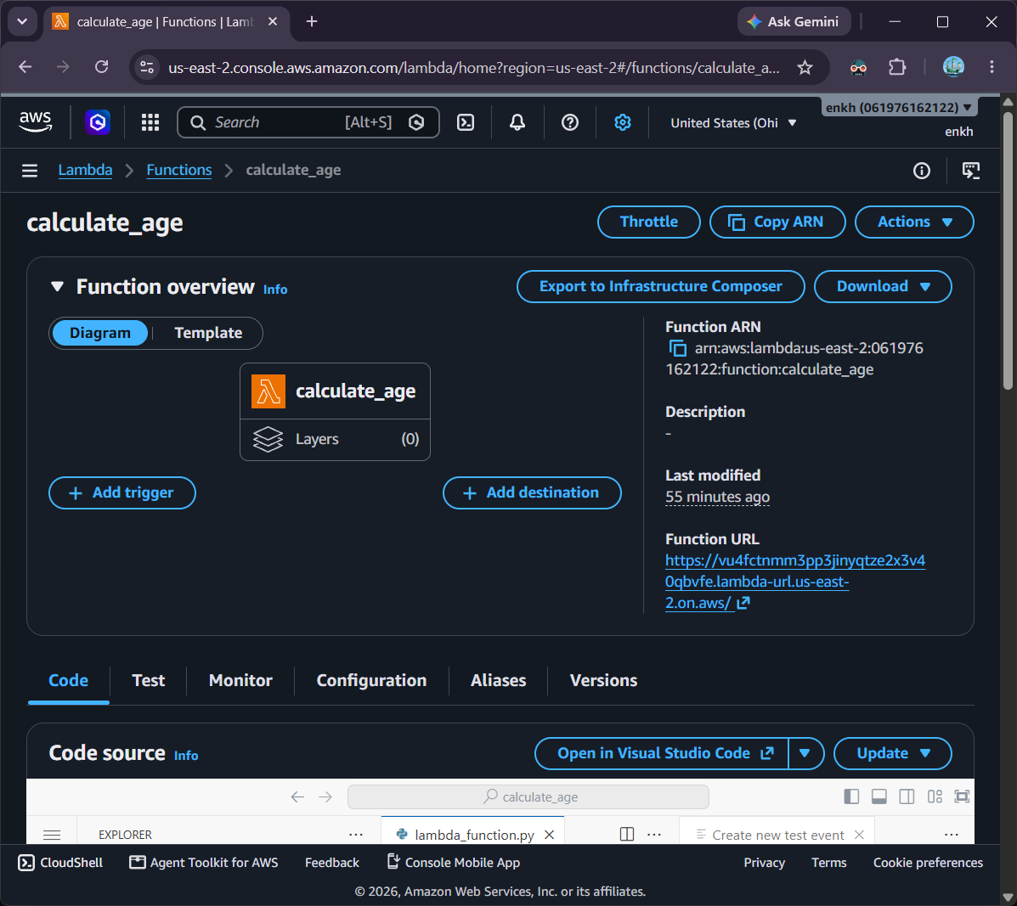

AWS Lambda Function Dashboard, p2:
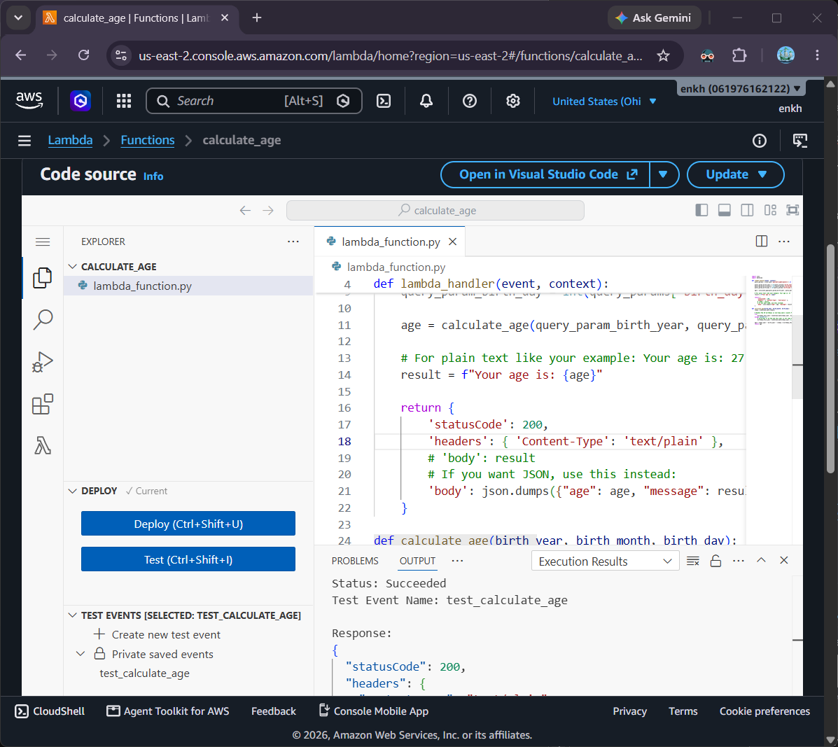
AWS Lambda Function Dashboard, p3:
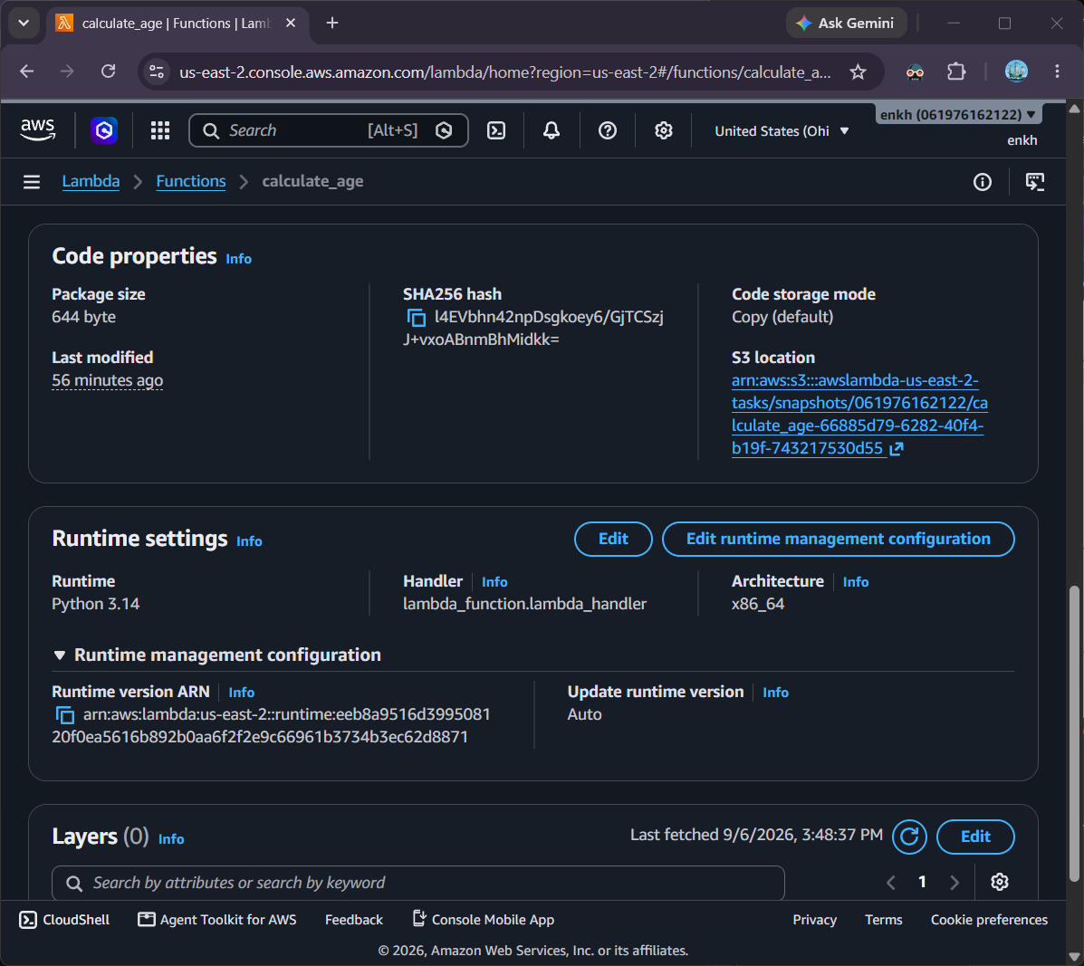

Configure Function URL:
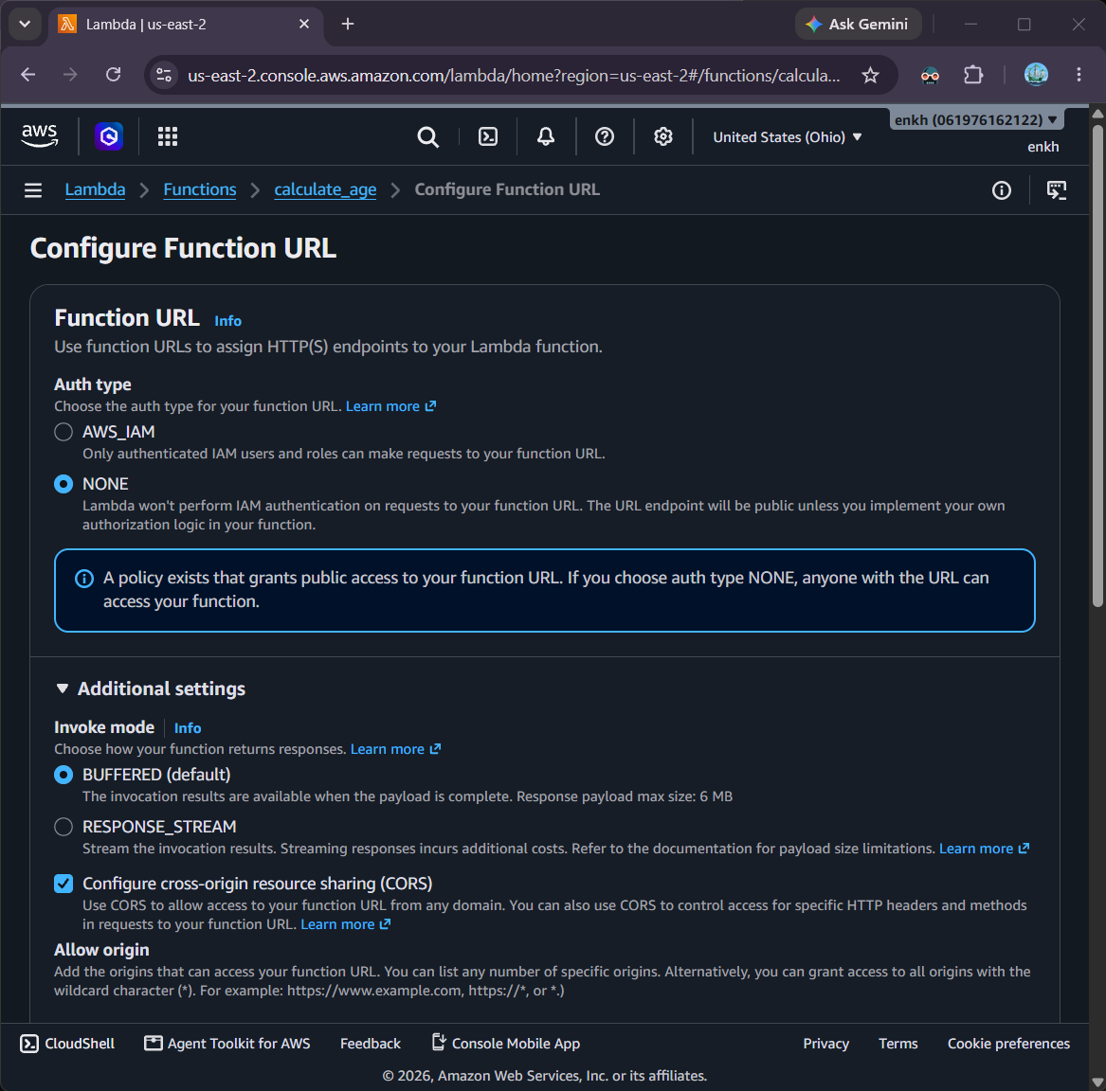
Function URL Testing calculate_age:
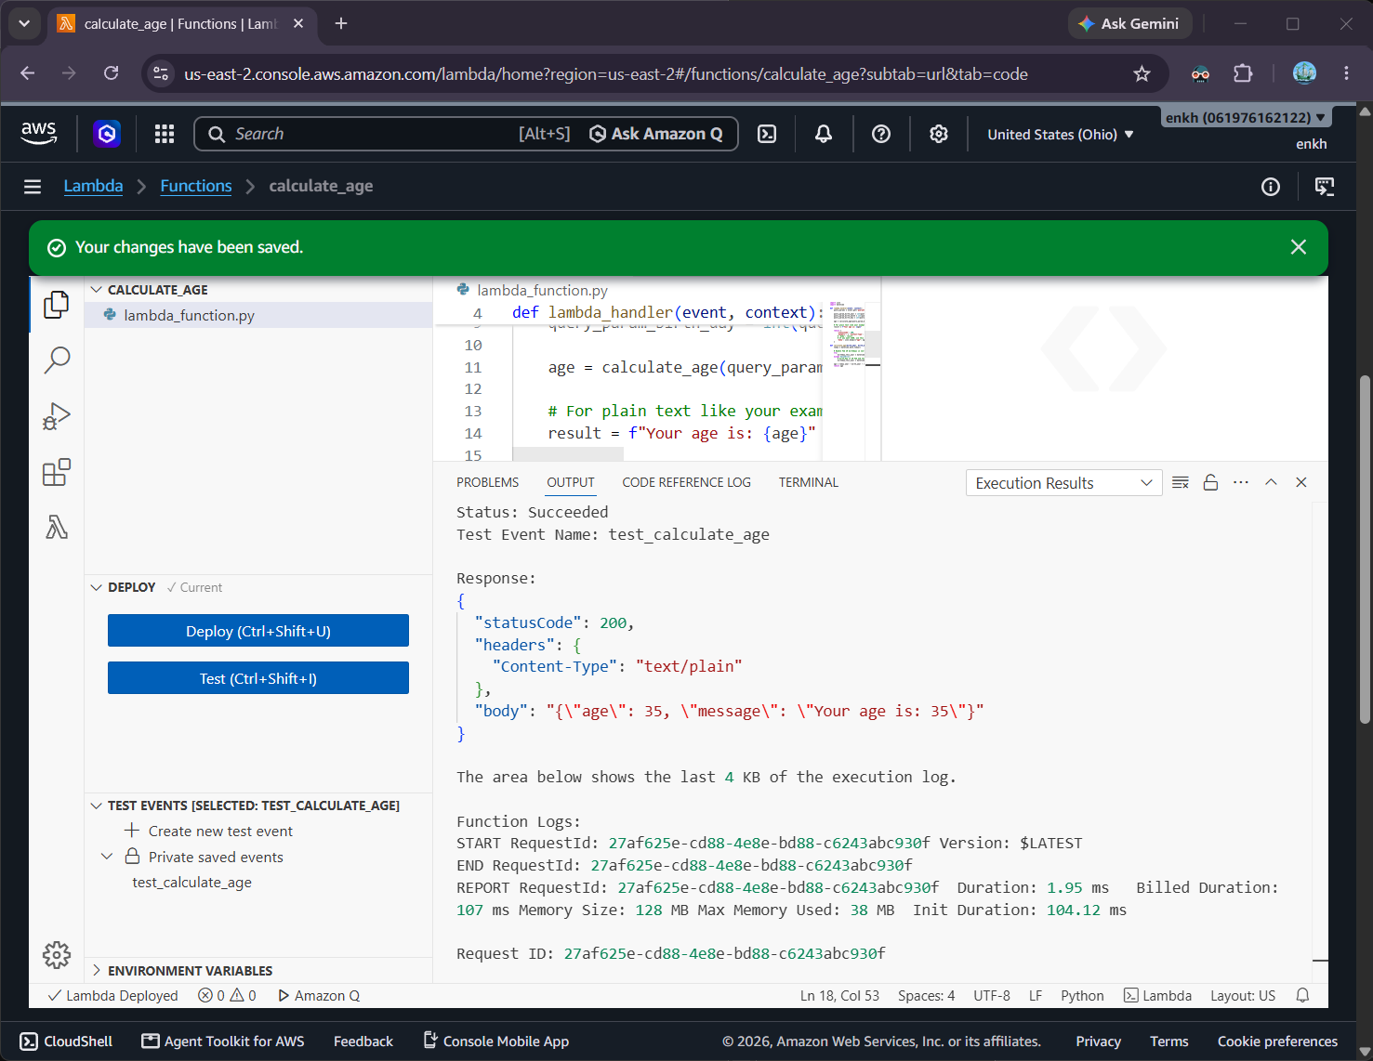

Function URL by itself:
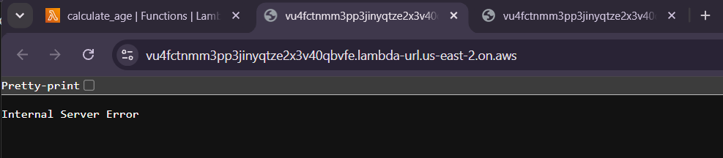
Function URL with parameters provided:
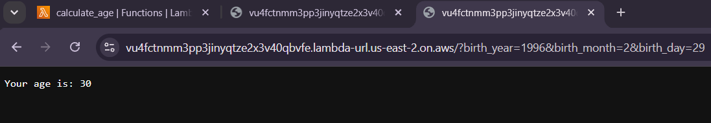

Part 3 – Adding Code
Lambda Functions python is updated for its return response:
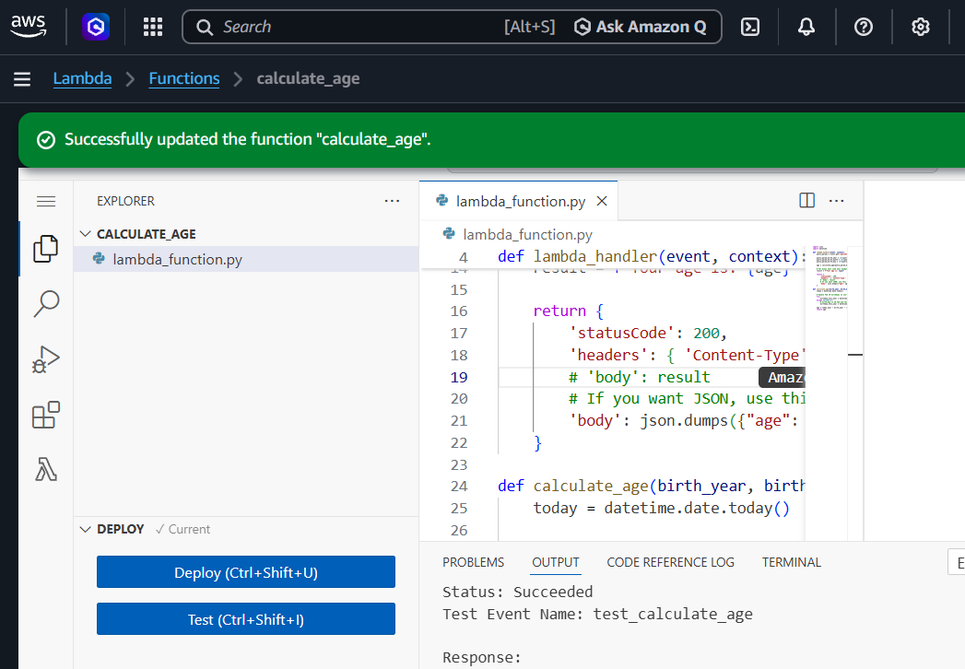
Running the test:
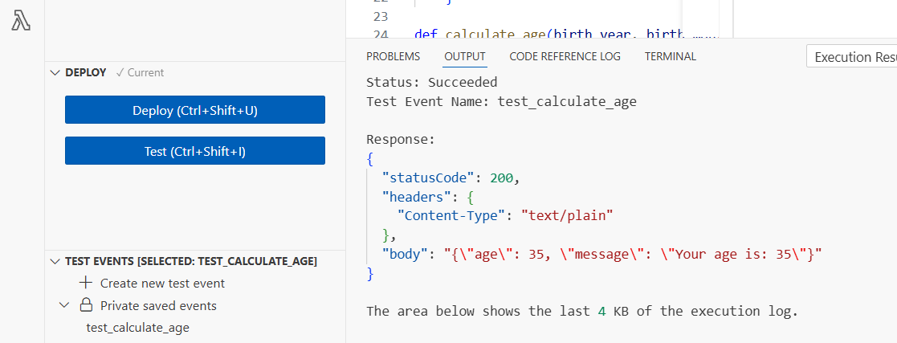

Test by the Functions URL:
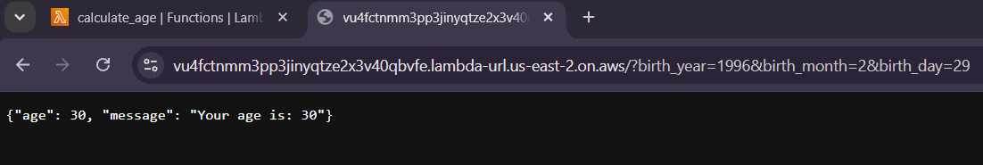

Programming Exercise Questions
1. What is the name of the parameter in the lambda function that contains the information sent by the function user?
The lambda functions’ lambda_handler function in python provides the event object which has all the event details, and one of which is all the query parameters through each request. The following line lets us get all the parameter dictionary objects.
query_params = event['queryStringParameters']

2. What code extracted the year, month, and date from the query string?
Then we'd use the query_params array notation by providing the parameter key value, in return it provides the value stored for that key. The following are what we have for all parameter values stored in their respective local variables: birth_year, birth_month, and birth_day.
birth_year = query_params['birth_year']
birth_month = query_params['birth_month']
birth_day = query_params['birth_day']
Then if we debug, we can see all the values for the local variables:
query_params is now: {'birth_year': '1996', 'birth_month': '2', 'birth_day': '29'}
'birth_year' is ‘1996’
'birth_month' is ‘2’
'birth_day' is ‘29’

3. Add a print screen with the results of your function for the following query string: &year=1996&month=2&day=29
I’ve provided the print screen result earlier, but I’ll provide one more here as well:
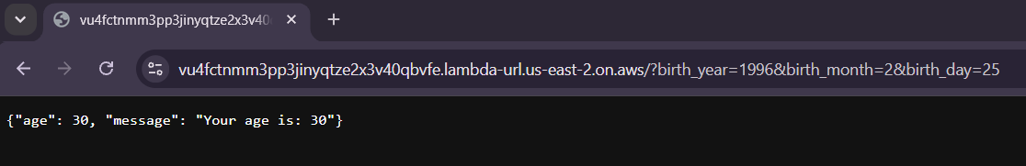
Full query URL:
https://vu4fctnmm3pp3jinyqtze2x3v40qbvfe.lambda-url.us-east-2.on.aws/?birth_year=1996&birth_month=2&birth_day=25

