The Ruby On Rails Architecture

Version: 0.1 (Draft)
Author: liuyongbing
Date: 2009/05/27

One server………………………………………………………………………………...………………Page 2
Two servers………………………………………………………………………………………………Page 4
More servers……………………………………………………………..………………………………Page 5

One server
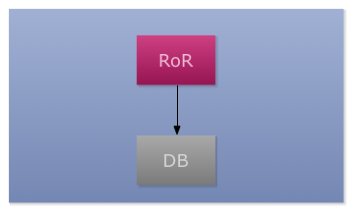
Setup:
Ruby on Rails(RoR) run on modrails (Ref http://www.modrails.com/)
One database for RoR applications

Software:
Linux(CentOS/OpenSUSE) Minimal installation
Ruby(GC patch)
Rails
Other Gems needed by the RoR applications
The RoR server is configure as the Nginx/Apache + Phusion Passenger(modrails)
There is a lots of discussion about RoR application performance.

MySQL/Postgresql header files/lib files for gem install mysql/postgresql
Database: MySQL/Postgresql

Procedures:
- install the Linux(CentOS/OpenSUSE) Minimal installation
- install Ruby
- get the ruby source package from http://www.ruby-lang.org/
the link is ftp://ftp.ruby-lang.org/pub/ruby/ruby-1.8.6-p368.tar.bz2
- the GC patch from http://railsbench.rubyforge.org/svn/trunk/railsbench/
our ruby is 1.8.6 so we choose ruby186gc.patch
$> patch gc.c < ruby186gc.patch
- $>./configure –prefix=/opt/ruby && make && sudo make install
- install ruybgems
$>wget http://rubyforge.org/frs/download.php/56227/rubygems-1.3.3.tgz
$>tar xf rubygems-1.3.3.tgz
$>cd rubygems-1.3.3
$> sudo /opt/ruby/bin/ruby setup.rb
- install rails and other gems
$>export PATH=$PATH:/opt/ruby/bin
$>gem list (check the local gems)
$>gem install rails –v 2.2.2 (install rails version = 2.2.2)
more commands
$>gem –d rails (show the details of gems)
$>gem uninstall rails (uninstall the gems)
$>gem install –l rails-2.2.2.gem (install local gem, make sure it exists in the directory)
tips:
we can tar the gem package by ourself, the gem package is a tar file
it contains data.tar.gz and metadata.gz
tar xf mongrel_upload_progress-0.2.1.gem
gunzip metadata.gz ( get the metadata, we can change it into what we want)
- install passenger(modrails)
$>gem install passenger
$> passenger-install-apache2-module (for Apache module)
$> passenger-install-nginx-module (for Nginx module)
- install database
$>yum install mysql mysql-server mysql-devel (install mysql)
$> rpm –Uvh http://yum.pgsqlrpms.org/reporpms/8.4/pgdg-centos-8.4-1.noarch.rpm
Tools
GCPATCH
http://railsbench.rubyforge.org/svn/trunk/railsbench/
Benchmark
http://railsbench.rubyforge.org/

Two servers
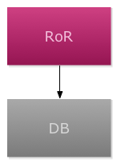
Setup:
Separate the RoR server from Database
One server for RoR server
One server for Database

Software(RoR Server):
Linux(CentOS/OpenSUSE) Minimal installation
Ruby(GC patch)
Rails
Other Gems needed by the RoR applications
The RoR server is configure as the Nginx/Apache + Phusion Passenger(modrails)
MySQL/Postgresql header files/lib files for gem install mysql/postgresql

Software(Database Server):
Linux(CentOS/OpenSUSE) Minimal installation
Database MySQL/Postgresql

Procedure
RoR Server
Reference: 1 server procedure 1-6

Database Server
Reference: 1 server procedure 6

More servers
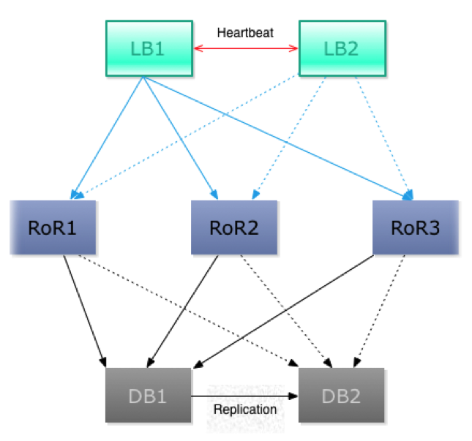
Setup:
Separate the RoR server from Database, With Loadbalancer in the frontend.
Two server for loadbalance, One is for backup/high available
Three server(more) for RoR server
Two server(more) for Database

Software(Load balance Server):
Linux(CentOS/OpenSUSE) Minimal installation
Heatbeat for high available
Pound/Haproxy for load balance

Software(RoR Server):
Linux(CentOS/OpenSUSE) Minimal installation
Ruby(GC patch)
Rails
Other Gems needed by the RoR applications
The RoR server is configure as the Nginx/Apache + Phusion Passenger(modrails)
MySQL/Postgresql header files/lib files for gem install mysql/postgresql

Software(Database Server):
Linux(CentOS/OpenSUSE) Minimal installation
Database MySQL/Postgresql
MySQL-Replication and Postgresql with Slony

Procedure
Load balance Server
Install the hearbeat and pound/haproxy

RoR Server
Reference: 1 server procedure 1-6

Database Server
Reference: 1 server procedure 6

In the future, with HUGE visits, traffic, we can choose the memcache-client for ruby. Here is the documents.

http://www.scribd.com/doc/2203398/Scaling-Rails-with-memcached
http://www.scribd.com/doc/14053905/Scribd-Architecture-Overview
http://poocs.net/2006/3/13/the-adventures-of-scaling-stage-1

