Аman Enlik | lab01

**Database Systems Laboratory Work**

**Relational Model & Keys**

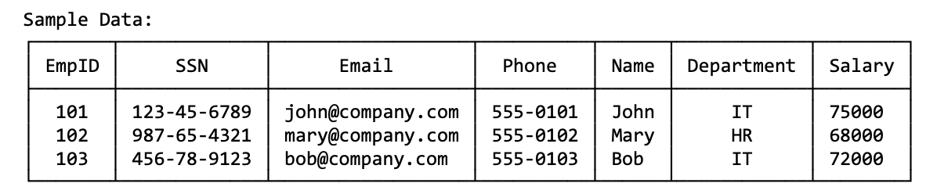**Tasks:**

1. List at least 6 different superkeys (суперключ — любое множество атрибутов, однозначно идентифицирующее строку)

1. {EmpID}
2. {SSN}
3. {Email}
4. {EmpID, Phone}
5. {SSN, Email}
6. {Email, Department, Salary}

2. Identify all candidate keys (Кандидатный ключ — минимально достаточное множество атрибутов.)

1. EmpID
2. SSN
3. Email

3. Which candidate key would you choose as primary key and why?

EmpID -- surrogate (system-generated) identifier: short, stable, independent of personal data, and rarely changes.

4. Can two employees have the same phone number?

In the provided examples, the phone numbers of all three employees are different (555-0101, 555-0102, 555-0103), which means that in this sample there are no duplicates.

However, this is only a sample — not proof of a business rule. In real practice, a phone number may be shared (e.g., an office phone), or an employee may change their number, so without an explicit business rule stating “phone is unique,” uniqueness cannot be assumed.

Conclusion: based on the sample data, there are no duplicate phone numbers; in general, duplicates are possible unless the business rules prohibit them.

*Relation B: Course Registration*

Registration(StudentID, CourseCode, Section, Semester, Year, Grade, Credits)

**Tasks:**

1. Determine the minimum attributes needed for the primary key

**Первичный ключ:**  
(StudentID, CourseCode, Section, Semester, Year)

2. Explain why each attribute in your primary key is necessary

**Why each attribute is necessary in the primary key:**

* **StudentID** — indicates which student is registering.
* **CourseCode** — identifies which course is being registered for.
* **Section** — a course may have multiple sections, so this attribute is required.
* **Semester + Year** — the same course can be offered in different semesters, so without these attributes the registration would not be unique.

3. Identify any additional candidate keys

**Additional Candidate Keys:**

* If the system uses a single attribute such as **TermID** (combining Semester and Year), then a possible candidate key would be **(StudentID, CourseCode, Section, TermID)**.
* Another possible key is **(StudentID, CourseCode, Semester, Year)**, but only if the business rule explicitly states that a student cannot register for more than one section of the same course in the same semester. Since this restriction is not guaranteed, **Section** should normally be included in the key.

**Task 1.2: Foreign Key Design**

**Foreign Key Relationships**

1. **Student → Professor**
   * Student.AdvisorID → Professor.ProfID  
     (Each student has an advisor who is a professor.)
2. **Student → Department**
   * Student.Major → Department.DeptCode  
     (Each student is associated with a department through their major.)
3. **Professor → Department**
   * Professor.Department → Department.DeptCode  
     (Each professor belongs to a department.)
4. **Department → Professor**
   * Department.ChairID → Professor.ProfID  
     (Each department has a chairperson who is a professor.)
5. **Course → Department**
   * Course.DepartmentCode → Department.DeptCode  
     (Each course is offered by a specific department.)
6. **Enrollment → Student**
   * Enrollment.StudentID → Student.StudentID  
     (Each enrollment record refers to a specific student.)
7. **Enrollment → Course**
   * Enrollment.CourseID → Course.CourseID  
     (Each enrollment record refers to a specific course.)

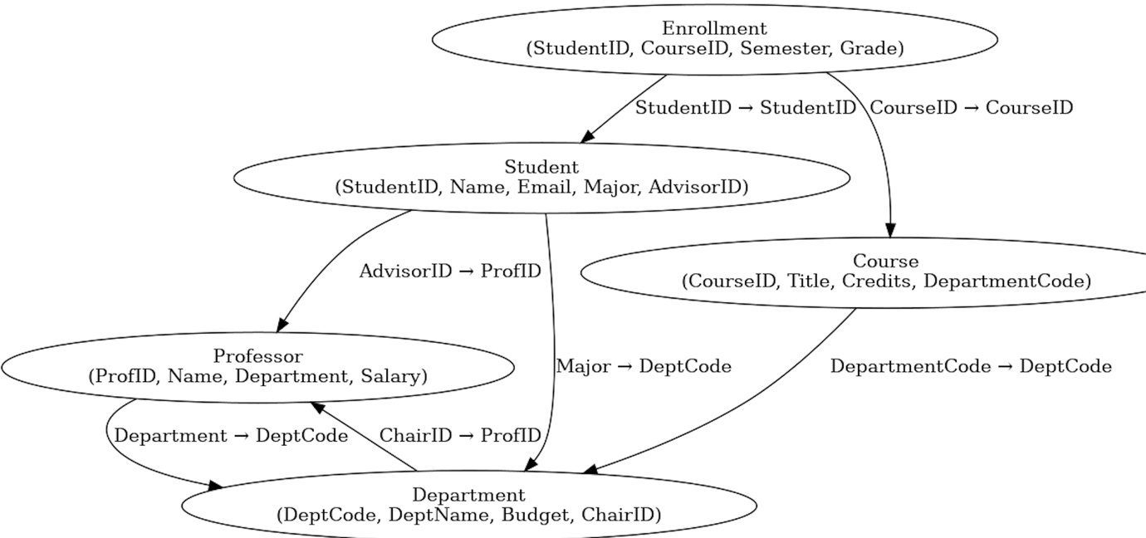

**Part 2: ER Diagram Construction**

**Task 2.1: Hospital Management System**

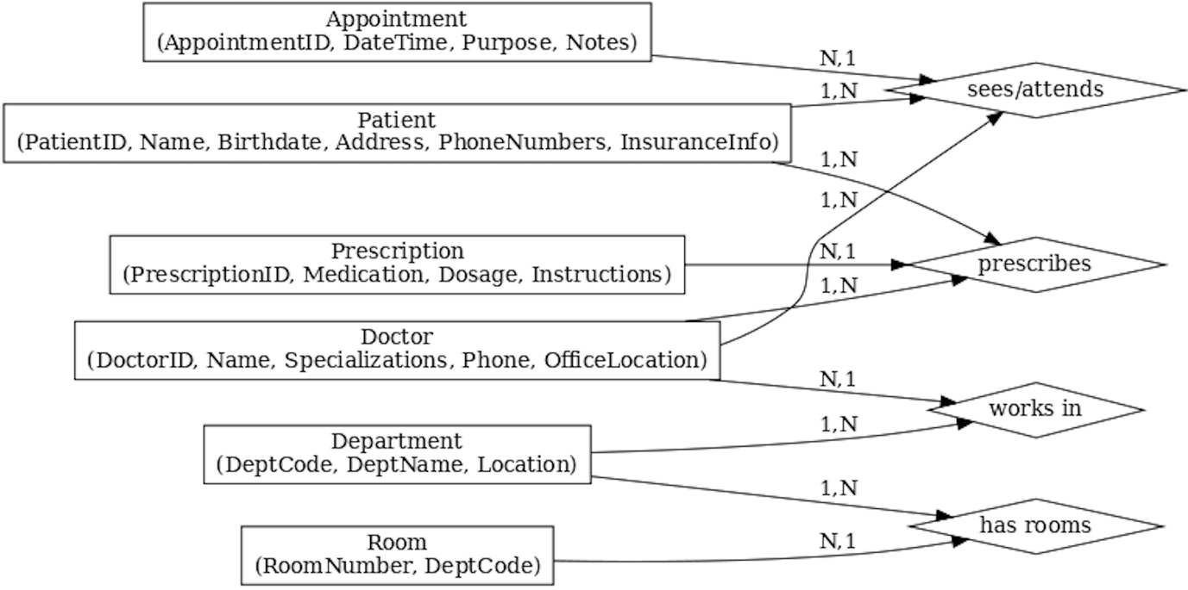

**Task 2.2: E-commerce Platform**