**STACC Task 1 Analysis Report**

**1. Table of Top-7 Producers**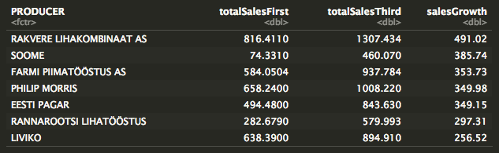

* We didn’t use variable **PRODUCT_GROUP** and assume the **totalSales** value based on all products that produced and sold by the **PRODUCER**
* By sorting the dataframe based on **salesGrowth** variable, we found out the top-7 producer
* **Soome** has one of the lowest sales.sum in first 4 months (totalSalesFirst), but got impressive growth in last 4 months (totalSalesThird)
* **Rakvere Lihakombinaat AS** has the highest salesGrowth and also the highest totalSalesThird

**2. Graph Visualization of Top-7 Producers**

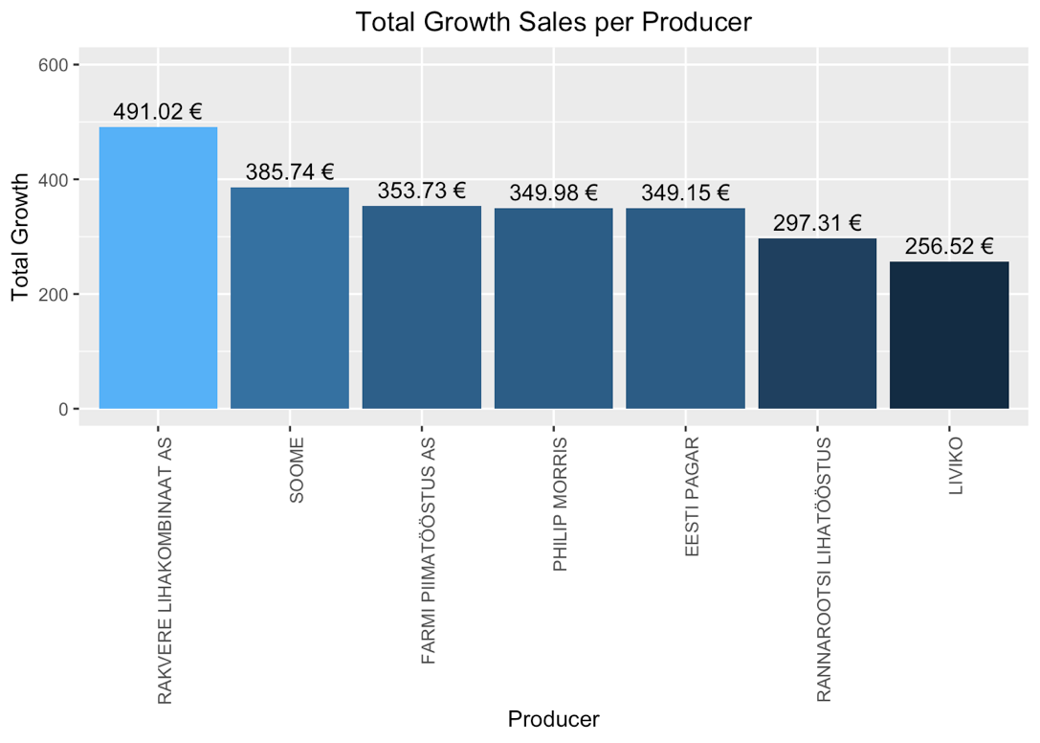

* By visualizing our analysis, it helps to find out top-7 producers with their name, salesGrowth value, and color.