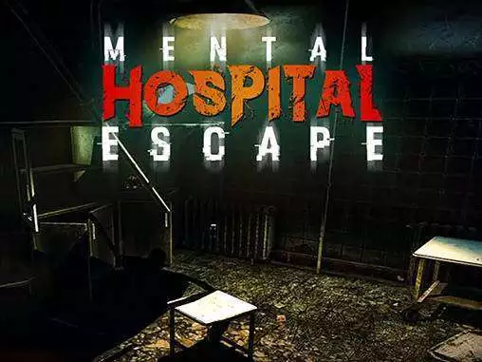

Project Report

Hospital escape

Enming Li | G00379891 | 3D Virtual World

# Introduction

For my project I built a horror game, the player can search in the scene find the items that can help them to escape.

I came up this idea because myself personally I love to play horror games, I enjoy the atmosphere of the horror games and solve puzzles. However, my final project is different than what in the proposal, my origin idea was to build an FPS game, but FPS game require high coding skills and imagination, so I gave up that idea due to lack of the skills.

For my game, I have a main Menu scene, so when the player launches the game, they will be on the main menu screen, and then the player can start the game by click the “Start game” button.

In order to win the game, the play need to find the password that is hiding in the game, and use the password to open the final door, and escape.

There will be no loose game option in my game, because it’s a searching game, player must find items in the game and then escape from the game, if the player couldn’t find the necessary items to help them escape, the player will be stuck in the game until they chose to exit game.

I was thinking to add loose game option in my game, but that didn’t work out eventually, I was trying to add a horror character in the game, the character will start chasing the player and kill the player if the player is in the characters sight. But it didn’t work out.

There are two ways for the player to exit the game, if the player is in the middle of the game, the player can press “Esc” and the pause menu will pop up, the player can exit the game through that menu. Second way if the player won the game, the player could exit the game through the win menu.

# User Interaction

When the player launches the game, the player will land on main menu screen, and then the play can click start game to start the game, the player just needs to walk around the game and find notes that can help them to win the game. There is no quests or challenges in the game, the objectives will be on the note and placed in the game scene, the player will know what they are going to do if they can find notes.

If the player failed to find the objects in the game, the player will be stuck in the game until they decide to quit the game, because there’s no loose option in this game.

If the player successfully finds the password for the final door, the player will win the game after the player walk through the door.

# Project Development

**Building game scene**

I used assets from unity assets store, I found an asset package called “Horror-hospital”, then I start to build my game scene using this package.

I spent few hours to think how I am going to build this game scene, I drew it out on the paper, because my topic is escape, finally I built some rooms, and a long corridor to make the player feels like in a hospital. The package also contains bed, bucket, trolly etc. pretty much everything I need to build the game environment.

I also used bathroom asset package, because it is not included in the first package.

After I finished with building the environments, I start to think about the interactions that the player can make with the game such as locked door, password door, notes to guide the player and some sound effects that can scare the player, because I am building a horror game, the environment is very important.

I have added animations manually for every door in the game, such as open the door, close the door.

The lighting system I have for the game is dark, suit the horror game topic, but I broke the lighting system, even though I remove all the lights, the environment is still bright, so I rather not to touch it anymore, this will reduce the player’s experience.

The logic for my game is like other horror games, the player will be locked in a room, and must find a key to unlock the door, in order to escape this game, the player will have to find the password for the final door, and there is a note hiding in the game for the player to find, and the clue is on the note.

The game has 3 scenes, main menu scene, gameplay scene, and winner scene. When the player launches the game, the player will be in main menu scene, and then click “Start game” to gameplay scene, after the player has won, the player will be direct to winner scene.

**Sound effects Used**

Sound effects is the key element for horror games, a perfect timing sound effect will make huge different to the game.

The player has footstep sound effect when walking.

Every item that the player picks up has sound effect, and everything in the game that the can interact has sound effect.

I also added environment sound effect, which means when player walk through a specific area, the sound effect will be trigger, these sound effects is for more immersive design.

**How the game is won**

The game is won by when the player walks through the “Exit door”, that simple, but also not that simple. Because in order to walk through that door, the player need to find the password first, but the password is hiding in the game somewhere, to find password the player need to find the clue first, the clue also in the game somewhere. That’s the overall game flow.

The game doesn’t have loose option, which means the player won’t lose the game, but if the player couldn’t find any clue, the player will be trapped in the game forever until the player chose to quit the game.

That’s the overall game design.

**Conclusion**

By completing this project, I feel proud of myself, personally I love to play games, and this project gave me chance to understand how the game is developed, it’s not easy, but I really enjoy of building a game.

I learned a lot from this project, at the beginning, I don’t understand the codes, I follow everything from the tutorial videos, and if the codes are different, I lost don’t know what to do after, but now I can read the codes, and I know what I’m doing and how to achieve what I want.

I had a lot issues, nearly giving up, I should call it bugs, I spent two days trying to get one door working properly, issues like the door keep opening and closing, the door is not interactable, the door is opening itself etc. however when I calm myself, and read the codes, compare to different videos, I finally figure it out, I got it working, and for one door working, that mean for all of them working.

The second big issue is trying to get the password door working, the issue was like when the password is correct, the door is not opening, I spent one day to fix that, thanks god it’s working eventually.

The parts that I’m happy about are the doors, because I find the key and open the door, that a sense of achievement. Imagine if you got locked in a room, and you find the way to get out by yourself. That’s exactly my game is like. And the door with the password, same logic, find the clue and solve the problem.

**Future work**

Surely there’s more need to be updated, my game is basic, if I had the skills, I would like to add more features into the game, such as puzzles, enemies and lose state, I would make the environment a lot bigger, because the game was settled in a hospital, so I could build the scene a lot bigger than now.

I will add an enemy to chase the player when player triggers something in the game, and the player will have to hide or die.

That pretty much about the future works.

**References**

Links:

<https://www.youtube.com/watch?v=EG8QVKLWC28&list=PLlcgaDpDEvw05IgKGZo9FYA8Fo38RtAqH> - all the logics, such as doors, different scenes.

<https://assetstore.unity.com/packages/3d/environments/hospital-horror-pack-44045> - package used

<https://assetstore.unity.com/packages/3d/props/interior/old-bathroom-objects-120069> - bathroom package used

<https://pixabay.com/sound-effects/search/close%20metal%20door/?manual_search=1&order=None> - all the sound effects

other reference files will be zipped with the game.