**EIE4122 Deep Learning and Deep Neural Networks**

**Lab 2: RNN and LSTM for Text Analysis**

**A. Objectives and Outcomes**

After finishing this lab, you should be able to perform the following

* Use PyTorch to develop recurrent neural networks (RNN) for sentiment classification.
* Preprocess datasets for sentiment classification, learn how to split training materials, understand the concept of random seed, vocabulary, and embeddings.
* Understand the architecture of RNN, LSTM, bidirectional-LSTM, and multi-layer LSTM.
* Understand the concepts of padding and packing sequences.

**B. Assessment Criteria**

* Ability to build sentiment classification systems based on PyTorch.
* Ability to produce correct results.
* Ability to change the programs and obtain meaningful results.
* Ability to explain the observations and results.
* Clarity of the report.

**C. Submission**

* Copy and paste the graphs and images that you obtain from Google Colab or other Python IDE to a word file and discuss your observations and results.
* **Convert your file to PDF**.
* Submit your report to Blackboard before the deadline specified in Blackboard.

**D. Procedures**

***D.1 Prepare Colab Environment***

1. Colab runs on browsers. You need a Google account to use Colab. If you do not have one, visit https://support.google.com/mail/answer/56256?hl=en.
2. Display the Google Drive (https://drive.google.com/drive/) page in your browser. Create the following directory structure in your Google Drive:

My Drive/Learning/EIE4122/lab2/

After creating the folders, you should see something like this:

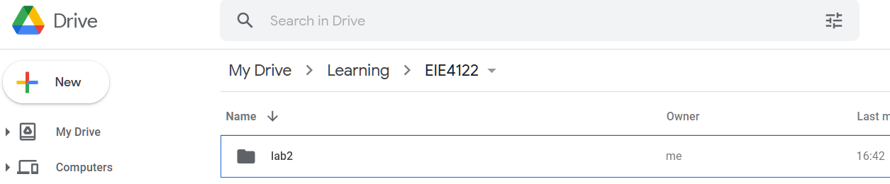

Directory structure in Google Drive

***D.2 Conduct Experiments on Sentiment Classification***

1. Download ‘RNN_SentimentAnalysis.ipynb’ from

<https://github.com/enmwmak/Teaching/tree/main/EIE4122> and drag ‘RNN_SentimentAnalysis.ipynb’ from your computer to “My Drive/Learning/EIE4122/lab2/” in your Google Drive.

Right click ‘RNN_SentimentAnalysis.ipynb’ and open it with Colab lab. Read the materials in the .ipynb file and follow the procedures in the file to conduct the experiment for sentiment classification using a basic RNN network.

1. Download ‘LSTM_SentimentAnalysis.ipynb’ from

<https://github.com/enmwmak/Teaching/tree/main/EIE4122> and drag ‘LSTM_SentimentAnalysis.ipynb’ from your computer to “My Drive/Learning/EIE4122/lab2/” in your Google Drive.

Right click ‘LSTM_SentimentAnalysis.ipynb’ and open it with Colab lab. Read the materials in the .ipynb file and follow the procedures in the file to conduct the experiment for sentiment classification using a upgraded RNN (Mult-layer bidirectional LSTM).

When you conduct the experiments, remember capturing the outputs and results and put them to your

reports.

**References:**

[1] <https://medium.com/deep-learning-turkey/google-colab-free-gpu-tutorial-e113627b9f5d>

[2]<https://github.com/bentrevett/pytorch-sentiment-analysis/blob/master/1%20-%20Simple%20Sentiment%20Analysis.ipynb>

[3]<https://github.com/bentrevett/pytorch-sentiment-analysis/blob/master/1%20-%20Simple%20Sentiment%20Analysis.ipynb>

Hints:

(1) There are two embedding dimensions in this lab: word-embedding dimension and embedding dimension. The former refers to the dimension of the 1-hot-encoding of each word. If you have 1000 words in your vocabulary, the word-embedding (also named INPUT_DIM and vocab_size in the program) dimension is 1000. This dimension can be changed by setting the maximum number of vocabulary (MAX_VOCAB_SIZE). The latter is the dimension of the dense vectors to be input to the RNN layer, which is set to 100 by default (EMBEDDING_DIM = 100).

(2) The RNN layers can be stacked by using the code as follows:

In init(),

self.rnn1 = nn.RNN(embedding_dim, hidden_dim1)

self.rnn2 = nn.RNN(hidden_dim1, hidden_dim2)

Then, in forward()

output1, h1 = self.rnn1(embedding)

output2, h2 = self.rnn2(output1)

-- END --