Where to Open a Coffee Shop in Calgary, Alberta, Canada?

# Steve Ennis

# May 16, 2020

## **Introduction**

Captain Joe Columbian is a lifelong coffee aficionado. He fervently believes he can source, roast, and serve the best coffee in Calgary. He even has a name for the first coffee shop that will start his coffee revolution that will eventually lead to world domination, ‘Cappa Joes’. Captain Joe now needs to find the perfect spot to begin his coffee empire.

## **Cappa Joes Business Problem**

Through Captain Joe’s connections in the Central and South American coffee growing regions, he able to find the rarest and most complex tasting coffee beans in the world. The problem is that these beans are expensive, and he will have to place Cappa Joes in an area where the clientele are more likely to appreciate gourmet coffee and more importantly pay gourmet prices.

## **Cappa Joes Target Clientele**

Joe has found 33 amazing coffee statistics [online](https://disturbmenot.co/coffee-statistics/). One statistic that will drive his business model is that ‘48% of millennials consume gourmet coffee’(Source [Reuters](https://www.reuters.com/article/us-coffee-conference-survey/americans-are-drinking-a-daily-cup-of-coffee-at-the-highest-level-in-six-years-survey-idUSKCN1GT0KU), [CreditDonkey](https://www.creditdonkey.com/coffee-drinking-statistics.html) ). Another statistic for coffeeshop consideration is that ‘79% of Americans make coffee at home’(Source [Reuters](https://www.reuters.com/article/us-coffee-conference-survey/americans-are-drinking-a-daily-cup-of-coffee-at-the-highest-level-in-six-years-survey-idUSKCN1GT0KU)). Cappa Joes needs to target millennials where they live and develop a thriving take out business.

One final selection criterion to keep in mind is market saturation. The ideal number of coffeeshops per person is unknown but for this exercise we will look to the list top 10 most coffee shops of per capita in the United States (Source [MatadorNetwork](https://matadornetwork.com/read/us-cities-coffee-shops-per-capita/)). The number 10 city is Ann Arbor, Michigan with 1 coffee related business per 2825 people. For this study, the threshold will be set at 1 coffeeshop per 3000 people.

## **The Data Sources**

[Open Calgary](https://data.calgary.ca/) is an excellent source for open data about the city of Calgary. Location data for the various communities or neighborhoods within Calgary can be found [here](https://data.calgary.ca/Base-Maps/Wards-and-Communities-Data-Lens/9p3u-cwgk). This source will provide the latitude and longitude data for each neighborhood. Below is an example of the data obtained from the above mentioned source.

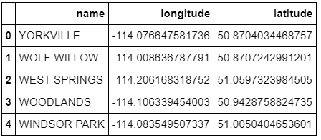

The next data source can also be found on the Open Calgary data portal. Demographic data can be found [here](https://data.calgary.ca/Base-Maps/Wards-and-Communities-Data-Lens/9p3u-cwgk). The Census by Community for 2019 information will be used to extract the population by neighborhood. Below is an example of information taken from the census data.

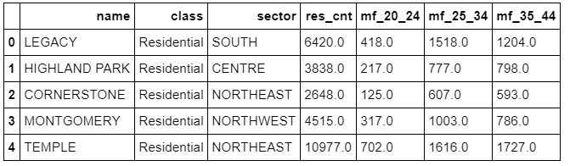

Wikipedia defines [millennials](https://en.wikipedia.org/wiki/Millennials) as being born in the years 1980-1996. This put the age bracket of interest at 24-40 years old. This data is also found in the census information mentioned above.

The final data source to be used is Foursquare location data. This source will provide an understanding of the neighborhoods Cappa Joes is considering opening a coffeeshop. From Foursquare data stats Cappa Joe will be able to understand the amenities in the prospective neighborhoods. Who is the competition? Are there complementary businesses that bring foot traffic such as bookstores, parks, and clothing stores? Below is an example of data obtained from Foursquare.

