Exercise 1

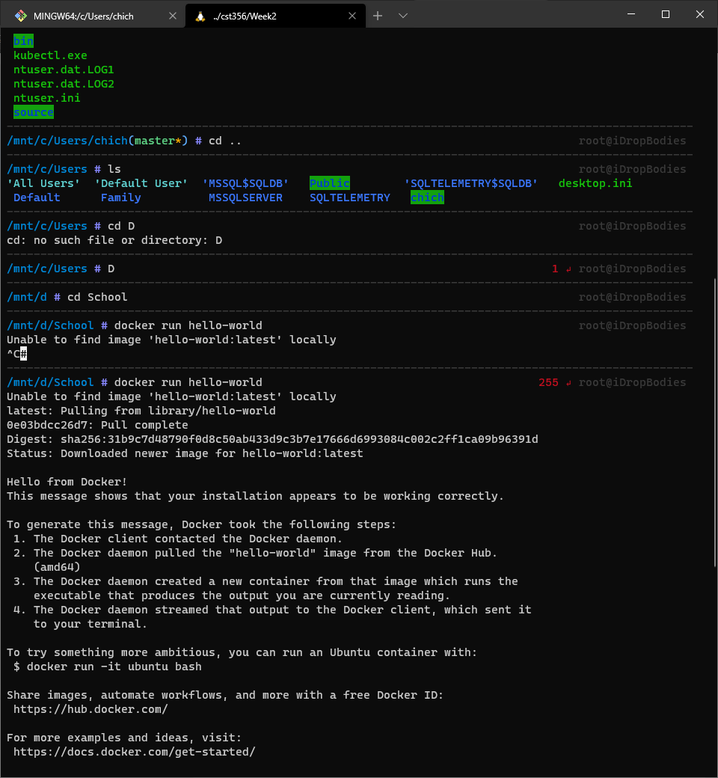

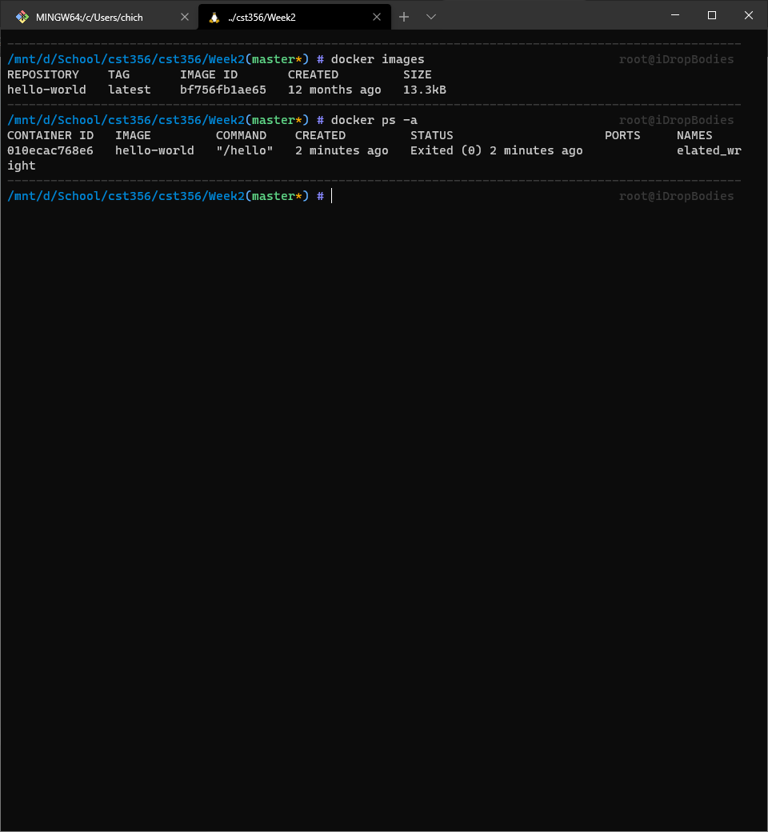

Exercise 2

docker pull alpine

docker run alpine ls -l

docker run alpine echo "hello from alpine"

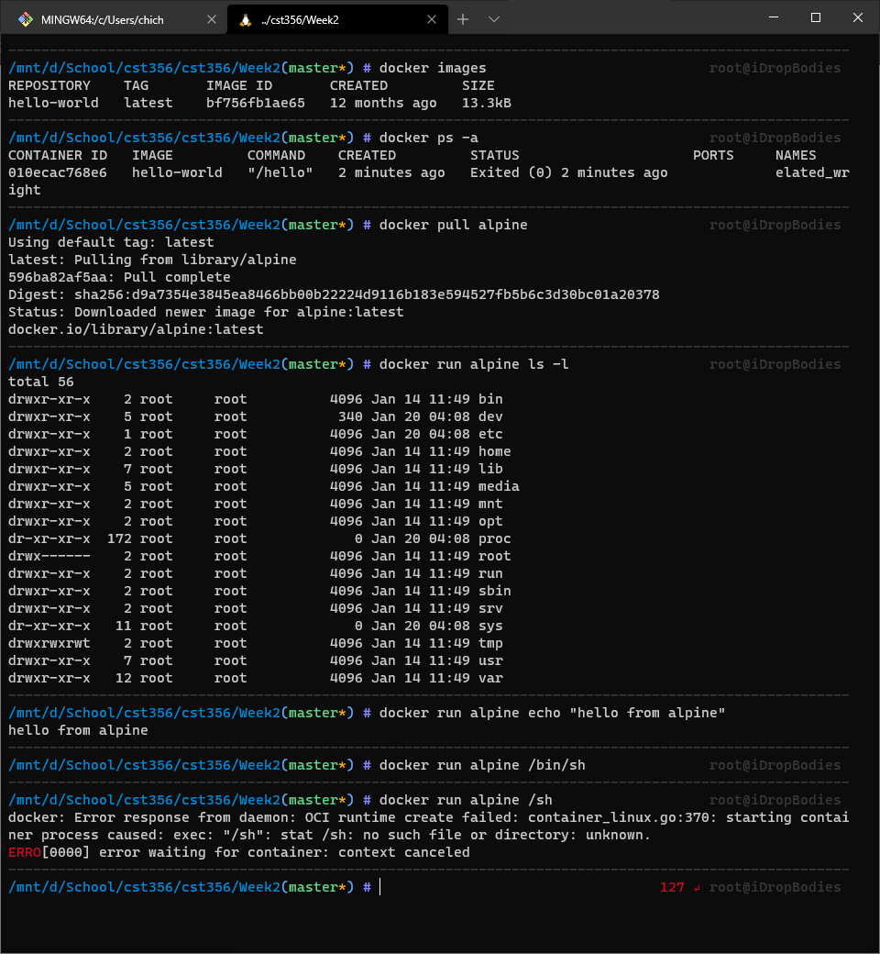

docker run alpine /bin/sh

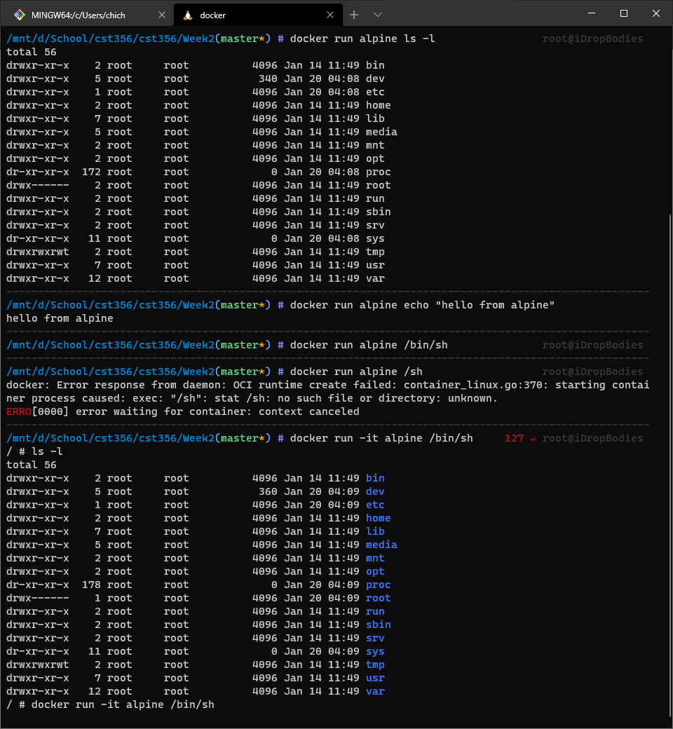

docker ps

docker ps -a

docker run -it alpine /bin/sh

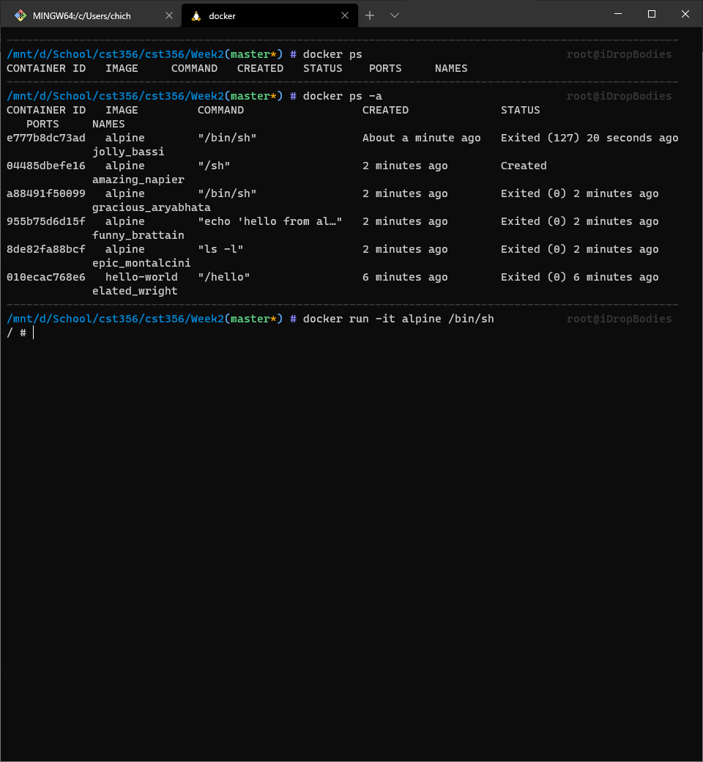

Exercise 3

<https://hub.docker.com/repository/docker/ennoaragon/myfirstapp>

docker run -d dockersamples/static-site

docker ps

docker stop 42287ddec1ba

docker rm 42287ddec1ba

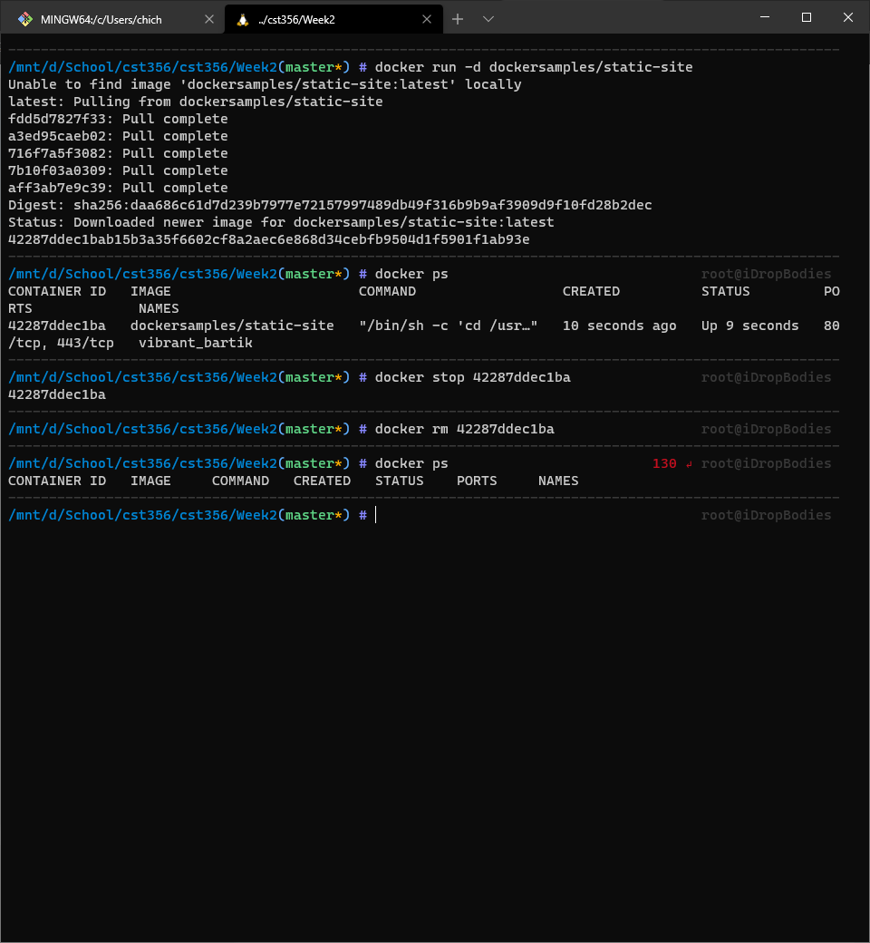

docker run --name static-site -e AUTHOR="Your Name" -d -P dockersamples/static-site

docker-machine ip default

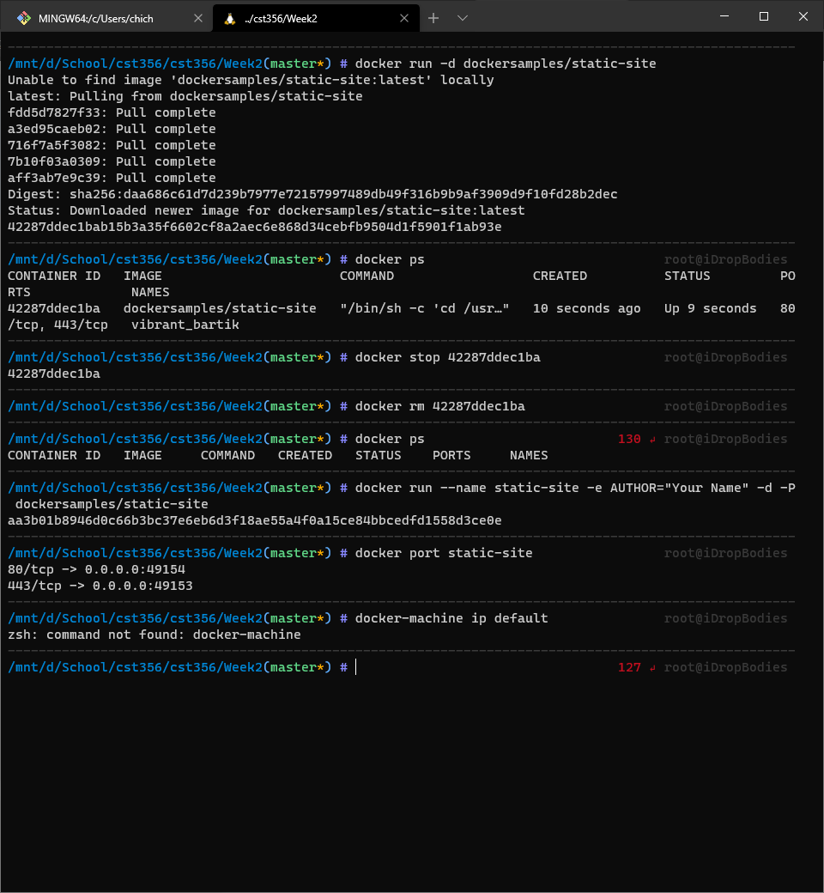

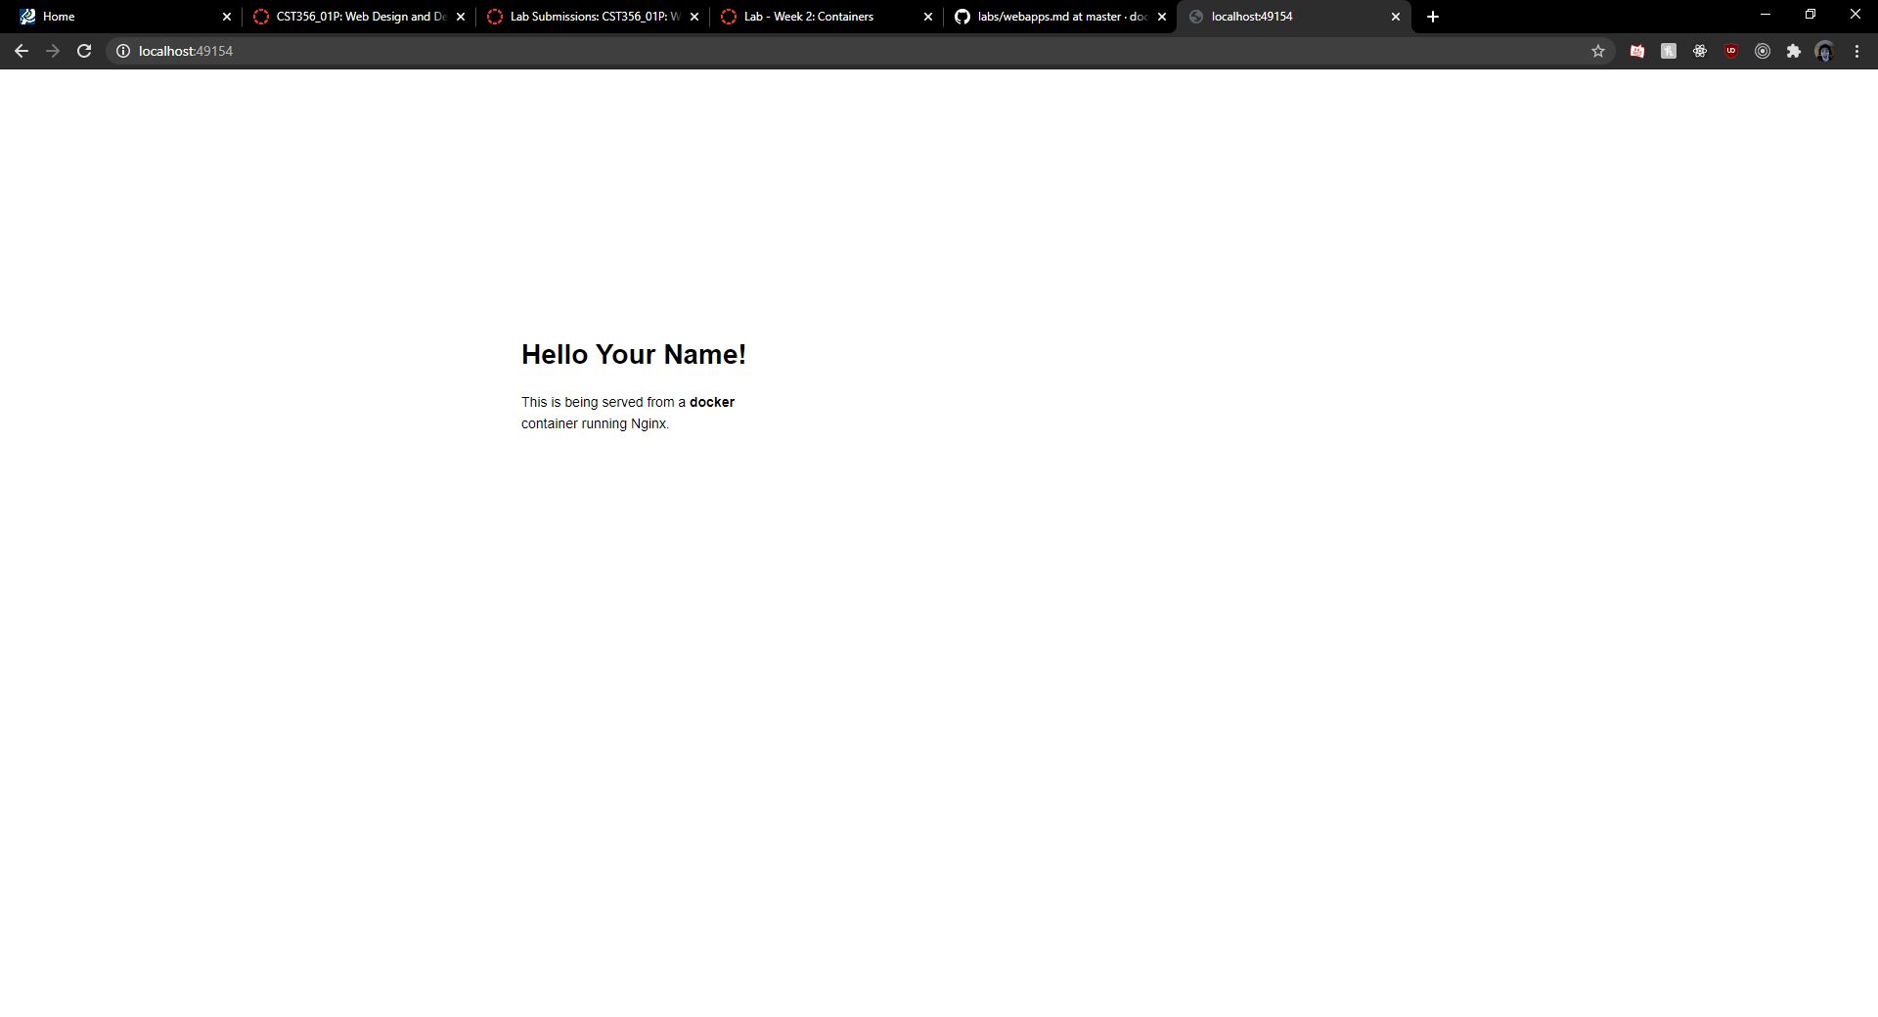

docker run --name static-site-2 -e AUTHOR="Your Name" -d -p 8888:80 dockersamples/static-site

docker stop static-site

docker rm static-site

docker rm -f static-site-2

static-site-2

docker ps

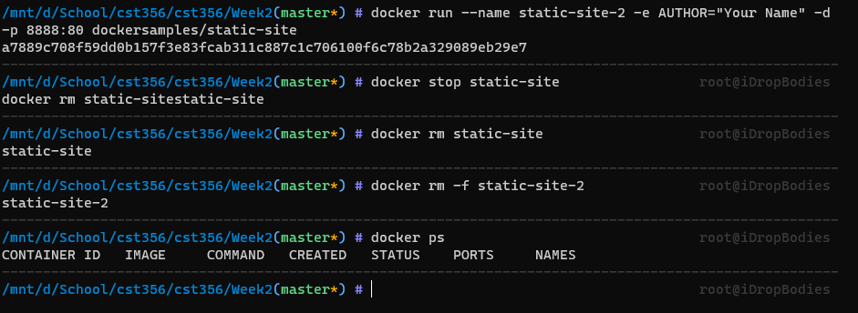

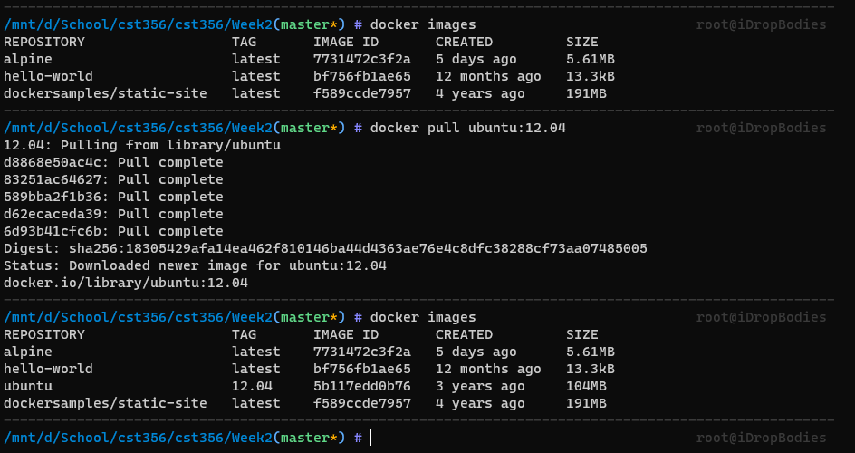

docker build -t ennoaragon/myfirstapp .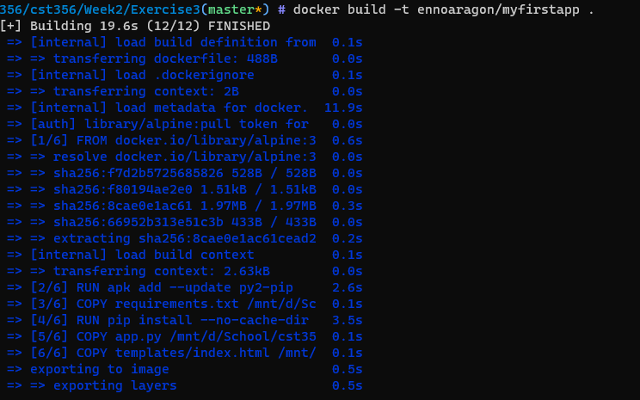

docker run -p 8888:5000 --name myfirstapp ennoaragon/myfirstapp

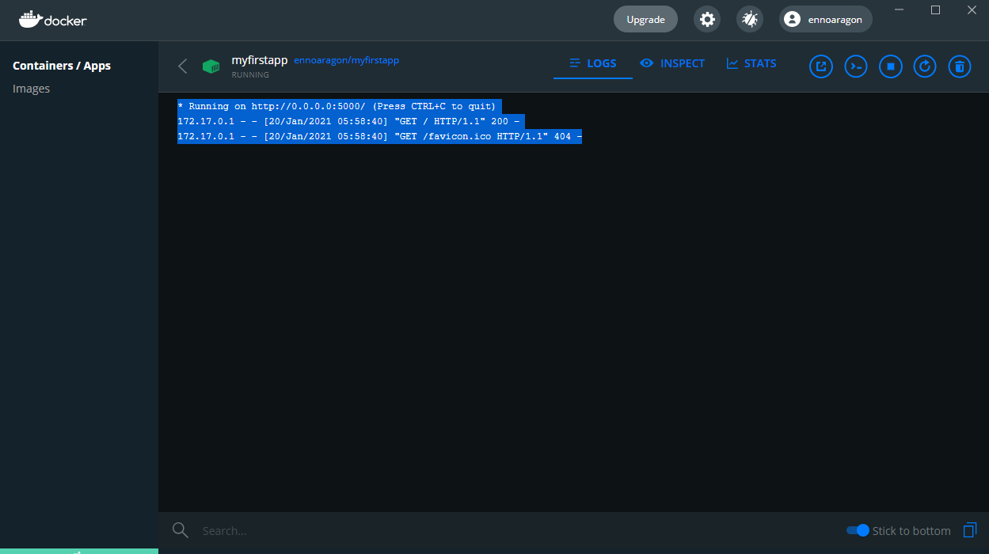



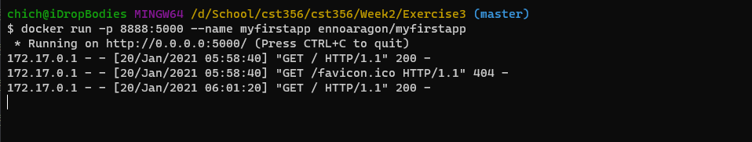

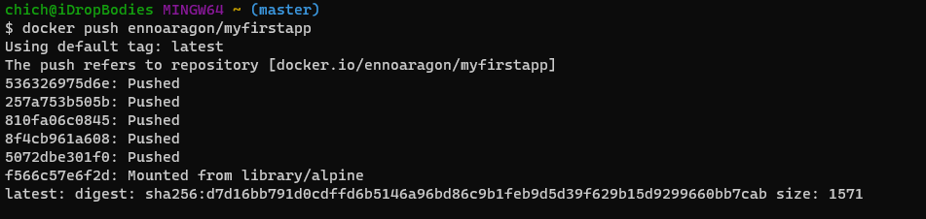

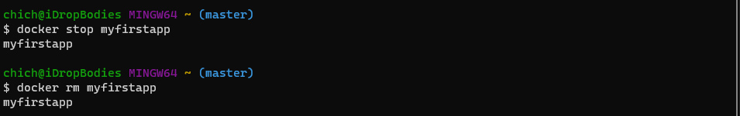

Exercise 4

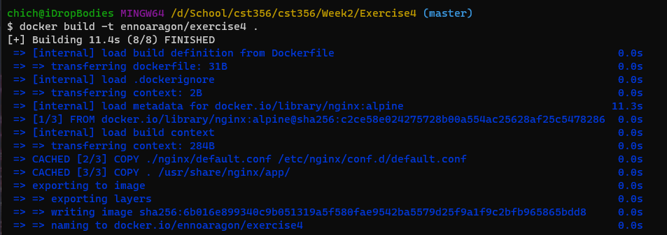

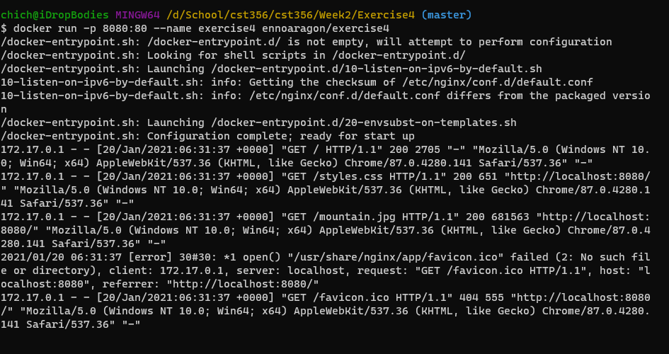

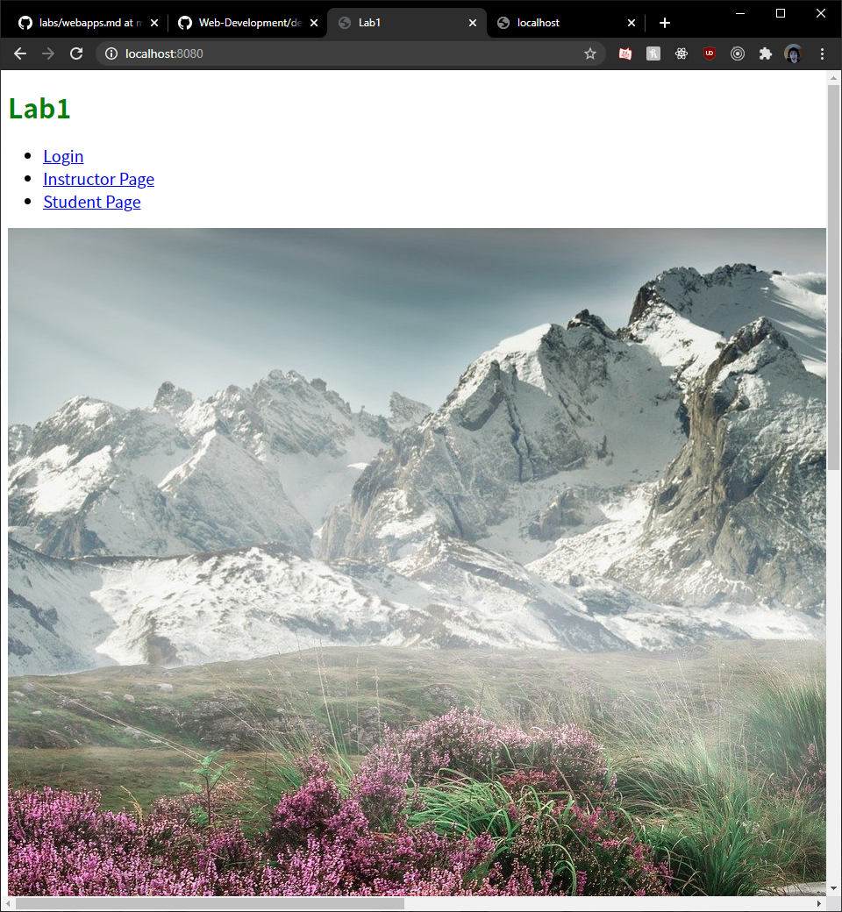

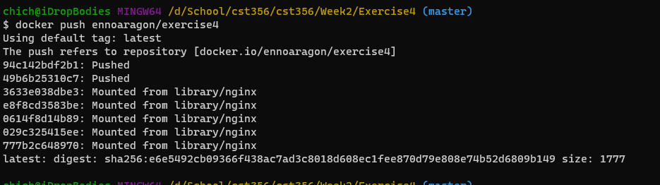

<https://hub.docker.com/repository/docker/ennoaragon/exercise4>