**https://hub.docker.com/r/ennoaragon/week4app**

**docker pull ennoaragon/week4app:1.0**

**Preparation**



Exercise 2

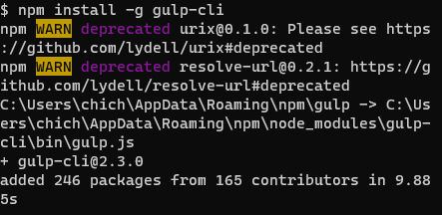



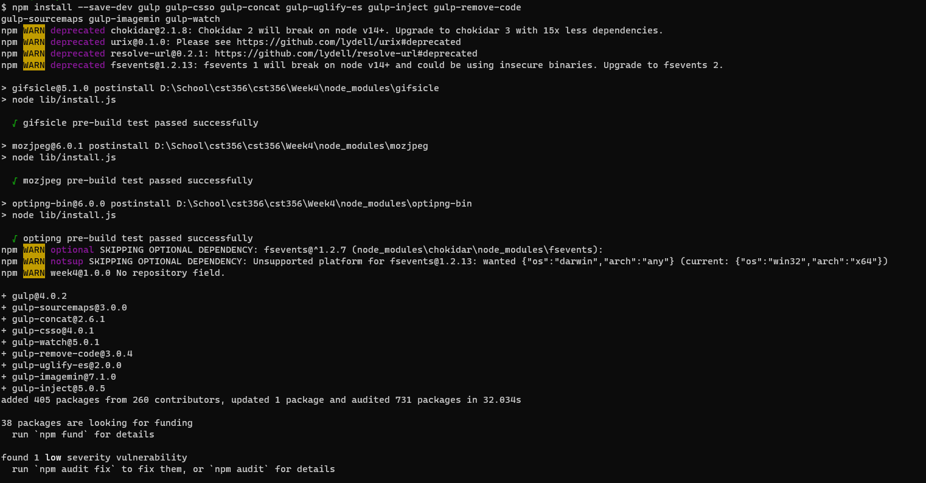

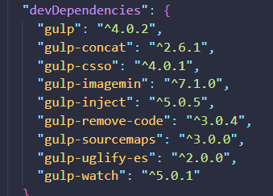

Exercise 3