PART 1: PROJECT METADATA

📋General Project Information

Project ID (number) | Project Title
2448 | Developing a proactive, modernized, holistic approach to ensure optimal health and condition of Hatchery Production.
Project Leads | Collaborations and External Partners
Christoph Deeg (Kristi Miller-Saunders, retired), Karia Kaukinen, Arthur Bass | SEP Hatcheries  Nitinat River Hatchery, Robertson Creek Hatchery, Chehalis River Hatchery, Tenderfoot Hatchery, and Puntledge Creek Hatchery.
Location (if applicable)
Pacific

🐟Geographic and Stock Information
Salmon species (if applicable) | Waterbodies (if applicable)
Chinook | Nitinat, Sarita, Robertson, Maria Slough (Chehalis), Puntledge, and Tenderfoot
Life history phases (if applicable) | Region
Fry, pre-smolt, and smolt | Vancouver Island and Lower Mainland
Stock (if applicable) | Population (if applicable)
Nitinat, Sarita, Robertson, Maria Slough (Chehalis), Puntledge, and Tenderfoot | WCVI, Fraser River, Tenderfoot
Conservation Unit (if applicable)
Click or tap here to enter text.

🎯Project Outputs
List scientific publications and technical reports (with links)
Hatchery Reports (technical reports):
- Year End PSSI_SEP FitChip 2023 Report_Nitinat
- Year End PSSI_SEP FitChip 2023 Report_Robertson
- Year End PSSI_SEP_Nitinat 2024 Final Report
- Year End PSSI_SEP_Robertson 2024 Final Report
- Year End PSSI_SEP_Two Page_PSSI-SEP 2023-2024_Final

- In Season_Nitinat April 9 2024 Report
- In Season_Nitinat Apr22 2024 Report
- In Season_Robertson April 9 2024 Report
- In Season_Robertson Creek Apr 22 Report
- In Season_Summary One Page_PSSI-SEP 2025_Initial Report
- In Season_Summary One Page_PSSI-SEP 2025_Pathogen Data
- In Season_Summary Brief PSSI-SEP 2025_Final
- In Season_Chehalis Brief PSSI-SEP June 2025_Final
- In Season_eRNA Results to Tenderfoot Dec 2025
- PSSI_SEP 2025 Final Report (In progress; To be completed by March 2026)

Peer reviewed publication (in preparation):
”Holistic assessment of health and condition of Chinook during hatchery rearing at two hatcheries, Nitinat River and Robertson Creek“ (Peer Reviewed Journal based off 2023 and 2024 sampling seasons; Bass and Kaukinen to lead; expected 2026)

List datasets generated (with links)
Datasets from the FitChip quantitative PCR were generated from gill tissue and eRNA collected from water samples. The cohort descriptions and movements of fish over the course of the project were recorded, and hatchery data supplied by SEP was incorporated into the database metadata. For the three years in the study, Tissue-SEP 2023/2024/2025; eDNA-SEP 2023/2024/2025, and metadata 2023/2024/2025 are stored in the MGL GitLab repository. Access is available upon request.
Describe dataset locations and data management systems
Datasets are stored on the genomics program PostgreSQL database
List code, programs, or other software created (with links)
Automated Fit-Chip Random Forest classification interface: Carl Llewllyn and Dr. Arash Akbarzadeh
Epicollect5 SEP Database: Kyle Goff and Carl Llewllyn

List communication or social media products
Click or tap here to enter text.
List and describe field work completed
2023: Project Lead and two co-op student technicians conducted field work from April to June over four sampling trips to Nitinat River (April 15, May 1, May 15, and June 1) and Robertson Creek (April 16, May 2, May 16, and June 2) Hatcheries.

2024: Project Lead, lead technician and a co-op student technician conducted field work from January through May over extensive sampling trips to Nitinat River (Jan 23, Feb 27, Mar 19, Apr 9, Apr 23, May 7, and May 21) and Robertson Creek (Jan 24, Feb 28, March 14, Mar 20, Apr 10, Apr 18, Apr 24, May 8, May 22, and May 30) Hatcheries.

2025: Project Lead and lead technician delivered eDNA training to Chehalis, Puntledge/Rosewall, and Tenderfoot Hatcheries. Six days of training and equipment deployment initiated the project through early March. Lead technician assisted Puntledge Creek hatchery staff for two additional days, sampling all cohorts and source water. In addition, Biologist Art Bass supported the Tenderfoot Creek Hatchery staff monthly from Feb 2025 through March 2026.

List and describe samples collected/analyzed (number of samples)
Nitinat 2023: 209 Chinook gills and 51 water samples on Fit-Chips
Robertson 2023: 193 Chinook gills and 46 water samples on Fit-Chips
Nitinat 2024: 650 Chinook gills and 79 water samples on Fit-Chips
Robertson 2024: 530 Chinook gills and 90 water samples on Fit-Chips

Chehalis, Tenderfoot, Puntledge/Rosewall 2025-2026: 611 Chinook gills and 262 water samples on Fit-Chips (analysis ongoing)

PART 3: WRITTEN CONTENT

Highlights

- Idea of the project: Current fish health monitoring at SEP hatcheries is primarily reactive, responding to disease outbreaks. Molecular tools allow the detection of pathogens, disease, stress, and smoltification from minimally invasive gill biopsies via salmon Fit-Chips. Further, non-invasive e(nvironmental)RNA is able to detect infectious agents and stress on population level from water samples. Together, these tools may allow for proactive and adaptive fish health management to improve hatchery operations.

- Key findings:
  - A two-year proof of concept study in collaboration with SEP enhancement hatcheries (Robertson Creek and Nitinat) was followed by a third year with Conservation Hatcheries. Consistent proactive health monitoring of live and moribund sampled fish (gill) was able to identify shifts in stressors and pathogens in cultured cohorts as well as provide insights on smolt readiness for saltwater that showed interannual variation.
  - In the final year, conservation hatchery staff was trained in sterile tissue and water sampling protocols.
  - Simultaneous sampling of eRNA from different water sources utilized in the hatchery identified potential sources of fish infections.
  - Stress assessment via eRNA on a cohort level without the need to assess individual fish deliverd mixed results with some stressors more readily detected than others.
  - Pathogen screening of eRNA samples showed that source water profiles shifted over the rearing season and differed between hatcheries.
  - Through the use of Salmon Fit-Chips, a novel virus (Influenza B-like virus) was discovered after it triggered a molecular signal indicative of a host response to a virus in the absence of any viruses already in the MGL assay panel.
- Implications of these findings
  - Molecular tools provide a means of proactive health monitoring at hatcheries. Specifically, eRNA can provide critical non-invasive insights into cohort health and development, making it particularly useful in the conservation hatchery context. Identifying pathogen presence within cohorts using eRNA and nonlethal or post-mortem gill samples provides important context to hatchery managers and creates opportunities to get ahead of pathogen outbreaks or adaptively manage husbandry.
  - Despite these successes, current sampling and analysis pipelines are labor intensive and could benefit from future research into automatization (e.g. automated eRNA sampling systems).
  - The potential for cohort/population level measures of stress was explored by running eRNA samples on Fit-Chips. This was a partial success, for example the thermal stress signature at Robertson Creek (Figure 6). More refining and baseline work is required to fully implement the tool.

Background
The DFO salmon enhancement program (SEP) is undergoing a modernization process to improve hatchery effectiveness. Specifically, an increased focus is being placed on conservation-based hatcheries. Modernized practices aim to produce high quality rather than quantity of smolts and try to minimize husbandry practices associated with elevated stress or pathogen exposure. One intention is to minimize pathogen infections to reduce transmission risks to wild stocks, fostering better conservation outcomes. Smolt readiness is often critical to survival of hatchery releases, but conventional assessment is invasive, expensive, and slow. Novel molecular tools offer attractive avenues to assess the effectiveness of many of the SEP modernization goals and inform scientifically defensible hatchery operations. To achieve proactive and adaptive management, molecular data can monitor the effects of husbandry, mortality, and treatment in near real-time. In this project we aim to provide near real-time health monitoring based on gill tissue biopsies as well as eRNA through deploying salmon Fit-Chips in collaboration with the following SEP hatcheries: Nitinat River, Robertson Creek, Chehalis River, Tenderfoot creek, Puntledge River, Rosewall Creek.

️ Methods and Findings
Main methods used: Nucleic acids were extracted from salmon gill biopsies collected from hatchery cohorts and were run on the Fluidigm Biomark nanofluidic qPCR platform. Within a single analytical run, this platform allows for assays of 20 infectious agents and 58 salmon genes to be run against 80 gill samples. The salmon gene expression can be statistically analyzed to provide probabilities (0-1) for certain salmon “stressor states” including: food deprivation, imminent mortality, viral disease, smoltification, hypoxia, inflammation, and immune stimulation. Detailed methods for the Fit-Chip laboratory and statistical analysis can be found in Akbarzadeh et al. (2024). Salmon Fit-Chips were also used to analyze the nucleic acids extracted from water filtered at the hatcheries known as e(nvironmental)RNA. Crucially this approach allows for the detection of live pathogens present in the water around the fish or in the hatchery water source, acting as an early warning signal for pathogen exposure and infection. Similar to the stress assessment gill biopsies with Fit-Chips, using the relative ratios of salmon RNAs in the water can inform the stress status of a hatchery cohort on the group level, for instance detecting if fish are mounting an antiviral response indicative of viral infection, suffering from stress such as high temperatures or hypoxia, or if fish are getting ready for the transition to saltwater (smoltification), which dictates the optimal release date from the hatchery. Exploring the use of eRNA by comparing the results of cohort eRNA Fit-Chips results with the stress and pathogen signature of individuals within the cohort was a key objective of the initial phase of the project as it holds great promise for stocks of conservation concern due to the ability to monitor cohort health non-invasively.

Advancements in methodology, technology, and application/Products and tools produced: eRNA salmon Fit-Chips were refined for the non-invasive monitoring of hatchery cohorts. Specifically, pathogens could be assessed effectively while cohort level hypoxia and temperature stress measurements showed promising results in the eRNA Fit-Chips. Other parts of the eRNA Fit-Chips require additional research and development to streamline procedures and reduce variability.

Advancements in communication and knowledge transfer: An automated reporting pipeline was developed to classify Fit-Chip data and produce figures which streamlined data analysis and reporting, providing managers with expedited fish health metrics. While the reporting was not in real-time, this project did provide in season reporting and future iterations of the project would need to address the obstacles to real-time reporting identified throughout the project.

Key results and information generated: Fit-Chip data from eRNA and tissues provide useful information for hatchery managers, making them a promising tool for the future. Specifically, we demonstrate that Fit-Chips can ...
- efficiently track pathogen prevalence and load in fish tissues and eRNA water samples (Figure 1 and 2).
- document pathogen exposure from source waters and cohort tanks across the entire rearing period (Figure 1-3)
- document smoltification progression from gill biopsies which could be used to optimize release timing (Figure 4).
- detect viral disease development signals in gill biopsies associated with known viruses and led to the discovery of a novel virus where no known viruses were detected (Figure 5)
- detect specific stressors simultaneously from eRNA and gill biopsies (Figure 6)

💡Insights
With this project we demonstrate the utility of salmon Fit-Chips for proactive hatchery management through individual level gill biopsies as well as on cohort level through eRNA from water samples. Our data:
- Identifies source water the occasional origin of pathogen exposure and infections (Figure 3)
- Documents several instances of pathogen detections in water prior to detections in tissues (Figure 2)
- Identifies changes in water properties as the likely source of stress (Figure 6)
- Demonstrates that 30% of the mortalities at Chehalis (Maria Slough Chinook) displayed a food deprivation signature as well as low weight to length ratio, suggesting that the fish had ceased feeding weeks prior to their death.
- Documents that smoltification status at release varied substantially between years (Figure 4)
- Documents the association of viral disease development (VDD) signature with known viruses (Figure 5)
- Identified a novel Influenza B-like virus associated with VDD positive fish of unknown impact (Figure 5)
This project informs salmon management by
- Providing an early warning tool for pathogen and stress monitoring from non-invasive eDNA/eRNA samples of specific interest for stocks of conservation concern. This has generated substantial discussion with managers at Tenderfoot Creek hatchery.
- Documenting the effects of water source on pathogen levels and highlighting pathogen vs imprinting tradeoffs:
  - River water → higher pathogen loads early
  - Well water → lower early infections but spikes when switched to mixed water
  - Continuous mixed water → lowest stable pathogen levels.
- Monitoring smoltification progress over the rearing season, demonstrating that this approach could be used to inform release timing decisions
- Monitoring pathogen abundance in source water to, demonstrating that this approach could be used to inform decisions to shift to new water sources
- Providing a single tool to assess multiple stressors cumulatively impacting hatchery reared fish
- Providing a baseline of cohort health against which to evaluate future return success to identify key factors impacting post release survival
Areas of uncertainty remain in
- Addressing the sampling artifact(s) and/or the causes of mismatch in the smoltification, VDD, and imminent mortality panels assessed by eRNA and gill biopsy Fit-Chips
- The impact of the two observed high prevalence viruses PsNV and InfB for which no formal pathogenicity data is available

⏩ Next Steps
Please insert 1-2 paragraphs to summarize:
- Remaining knowledge gaps and recommendations for future studies
- How can/should the project findings be operationalized for salmon conservation and management?

Future optimization for Fit-Chip monitoring of hatchery cohorts will focus on the following:
- Automated eRNA sampling systems installed on rearing tubs to alleviate the burden of sampling and permit more frequent sampling events.
- Improved sample handling and laboratory processing
- Tailored reporting to operational needs of specific hatcheries.
The data from this pilot project could be integrated into salmon conservation management by:
- Integrating molecular data as a standard in hatchery management practices
- Integrate the hatchery database with the molecular reporting pipeline to improve results turnaround.
- Considering the impacts of microbes and pathogens, both positive and negative, within the natal systems for salmon conservation hatcheries. For example, rearing in surface waters may result in increased survival despite (Harstad et al., 2018).

📈 Tables and Figures: Supplemental

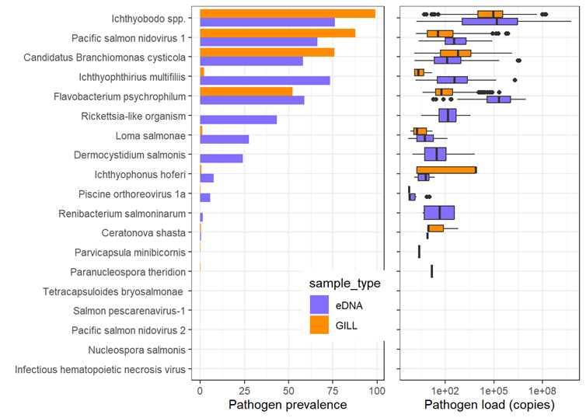
Figure 1. Fit-Chip eRNA validation: Strong correlation in detection of pathogens in hatchery fish and eDNA/eRNA water (Nitinat 2024). Pathogen prevalence and load within gill tissue (orange) or tank water (purple).
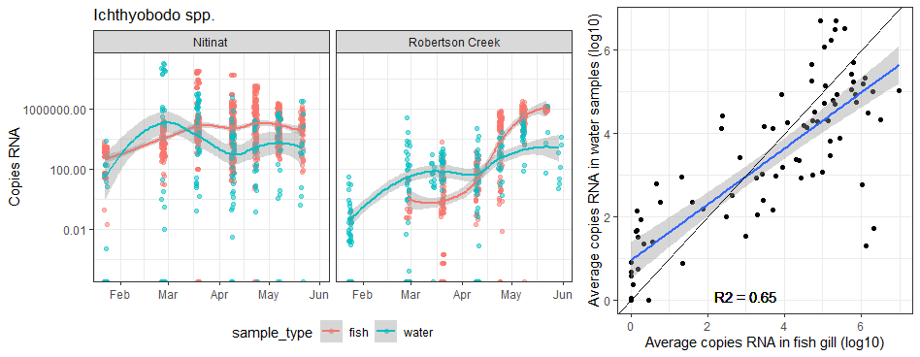
Figure 2. Fit-Chips can track pathogen load in both fish tissues (red) and water samples (blue, eRNA). Ichthyobodo spp loads in water (eRNA) peak before detections in fish gill tissues at two hatcheries (left panels).Ichthyobodo load in gill and water were strongly correlated with each other (right panel).
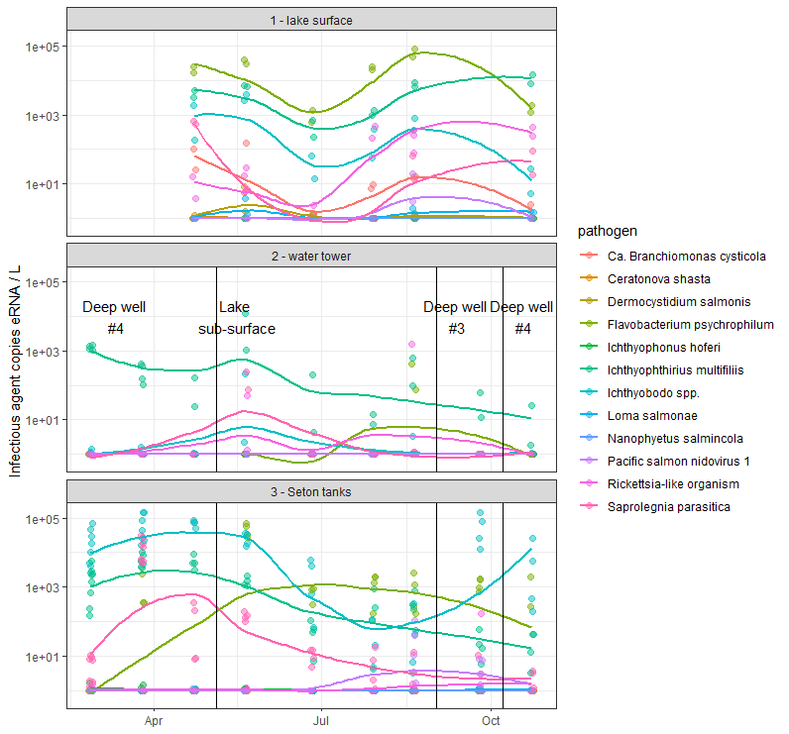
Figure 3. Fit-Chips provide pathogen tracking in source water and rearing tanks over the rearing season (Tenderfoot 2025). Pathogens in lake surface samples showed synchronous seasonal shifts (top). Pathogen concentrations in the water tower fluctuated between the different water sources used (middle panel, vertical lines and text). Pathogen concentrations in the rearing tanks for the study population presumably reflected a combination of influences from source water and the population itself (bottom).
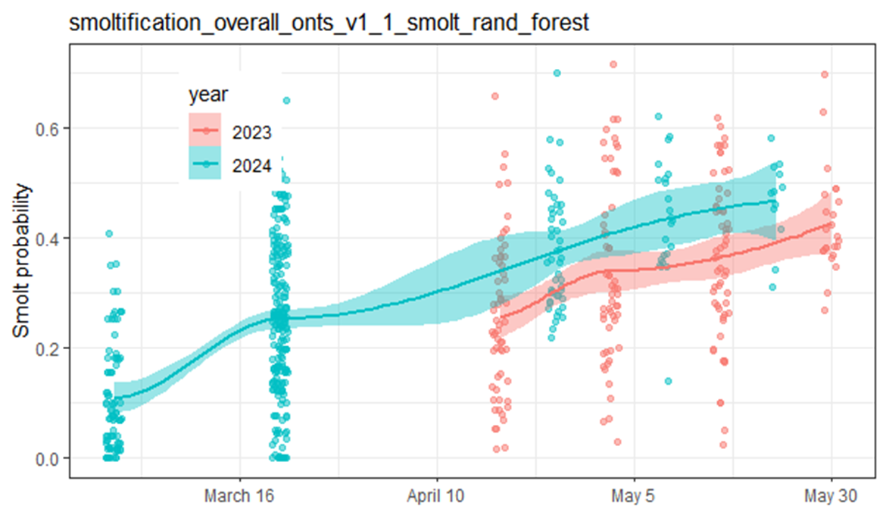Figure 4. Fit-Chips can monitor smoltification status in fish tissues during hatchery rearing and provide smolt readiness information to managers. Smoltification status at Robertson Creek showed significant variation between years.
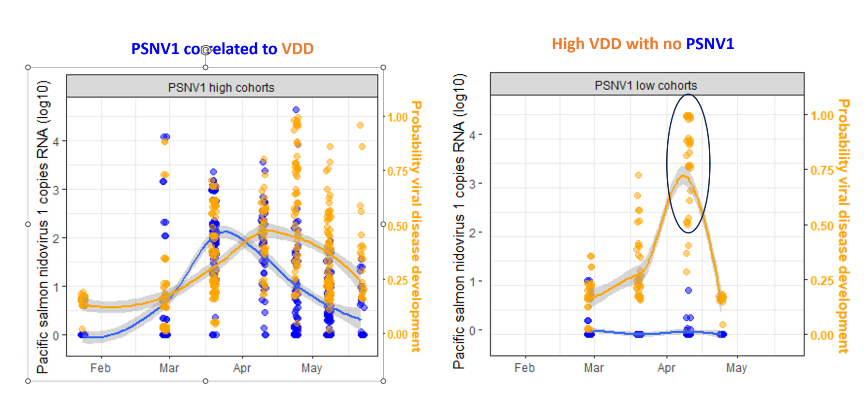
Figure 5. FitChips provide proactive health monitoring through the early detection of viral disease and novel viral agents. High loads of PsNV (Pacific salmon nidovirus) were associated with high probability of a viral disease development gene expression signature (left). A novel Influenza B like (IfnB) virus was discovered in collaboration with Dr. Gideon Mordecai in a VDD high cohort with low PsNV detections (right) and no other known viruses present. Targeted IfnB assays demonstrated a correlation between IfnB and the probability of viral disease development.
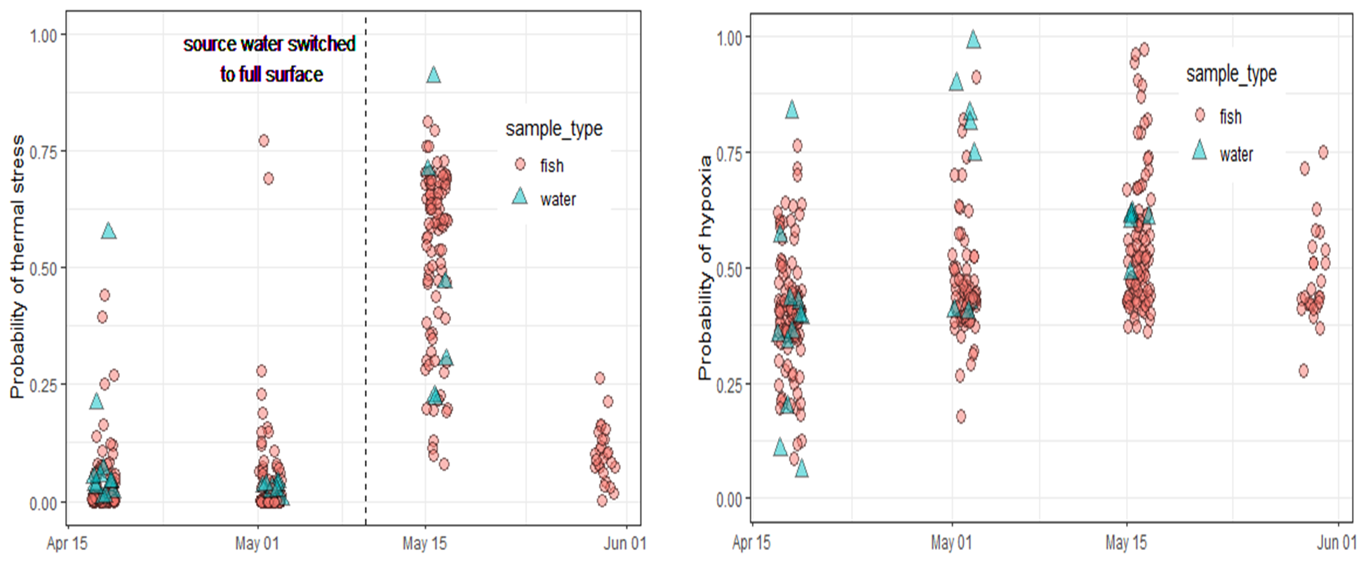
Figure 6. Fit-Chips provide promising results by resolving selected stressor states from eRNA water samples. The thermal stress signature (left) and hypoxia signature (right) were resolved in both the fish gill tissue (red circles) and eRNA samples (blue triangles). The correlation between fish and water for thermal stress was stronger than that between fish and water for hypoxia.

📈 References
Akbarzadeh A, Ming TJ, Schulze AD, Kaukinen KH, Li S, Gunther OP, Houde ALS, Miller KM (2024) “Developing molecular classifiers to detect environmental stressors, smolt stages and morbidity in coho salmon Oncorhynchus kisutch.” Science of the Total Environment, 951(15). https://doi.org/10.1016/j.scitotenv.2024.175626

Harstad DL, Larsen DA, Miller J, Adams I, Spangenberg DK, Nance S, Rhobach L, Murauskas JG, Beckman BR. 2018. Winter-rearing temperature affects growth profiles, age of maturation, and smolt-to-adult returns for yearling summer Chinook salmon in the Upper Columbia River Basin. North American Journal of Fisheries Management, 38:867-885.

