COSC 4370 Homework #1

# Overview:

This first assignment is intended to ensure that everyone has a working Python development environment and can run the basic code. In addition, we would like to learn some of the basic commands in OpenGL and practice programming using Python.

# Specifications:

The provided starter code should run and show a wireframe-cube rotating about the vector [1,1,1]. In addition, a set of coordinate axes in red, blue and green (x, y, and z-axis respectively) rotate with the cube. There is also a circle with a radius of 1 displayed in purple. The first goal of the assignment is to get the code running and see the window shown below in Figure 1.

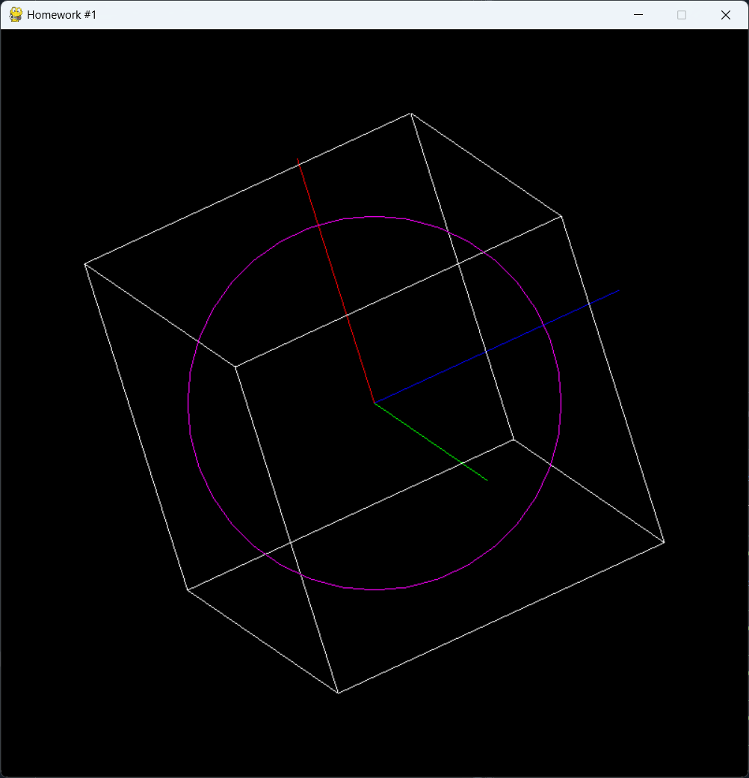

Figure 1 - Default Cube

The next step is to modify the vertices of the cube so that it fits inside a sphere of radius 1.0. To do so, you will need to modify the values of the vertices so that no point is more than 1.0 away from the center. The new cube will appear completely inside the purple circle as it rotates, just touching the circle in some orientations. In other orientations, you will notice a gap, like the one shown in Figure 2.

Figure 2 Cude inside sphere of radius 1

The next step is to add in the remaining Platonic solids: a **Tetrahedron**, **Octahedron**, **Dodecahedron** and **Icosahedron** (see figures below). These shapes should all be drawn in wireframe and be sized to fit inside a sphere of radius 1.0. For ease of grading, we would like to be able to change the shape currently displayed by pressing a number key. The number 1 should display the tetrahedron, 2 the cube, 3 the octahedron, 4 the dodecahedron, and 5 the icosahedron.

# Deliverables:

* Submit a single python file to Canvas based on the provided starter code. This should include the unit circle and colored axes.
* The program should display each of the 5 Platonic solids
* Provide a mechanism to change the shape displayed with a numerical keypress.

# Notes:

* I recommend installing the Anaconda package and using Spyder as a light IDE for python.

You can download if for free at <https://www.anaconda.com/download/success>

* You will need to ensure that the required packages are installed on your system. You will need to open a console and run a command like:  
  pip install pyopengl pyopengl-accelerate pyopengltk pygame
* In pygame, the command to retrieve the state of keypresses is:  
  keys = pygame.key.get_pressed()
* The starter code should run on your system, but if not, you may need to contact myself or a TA for help

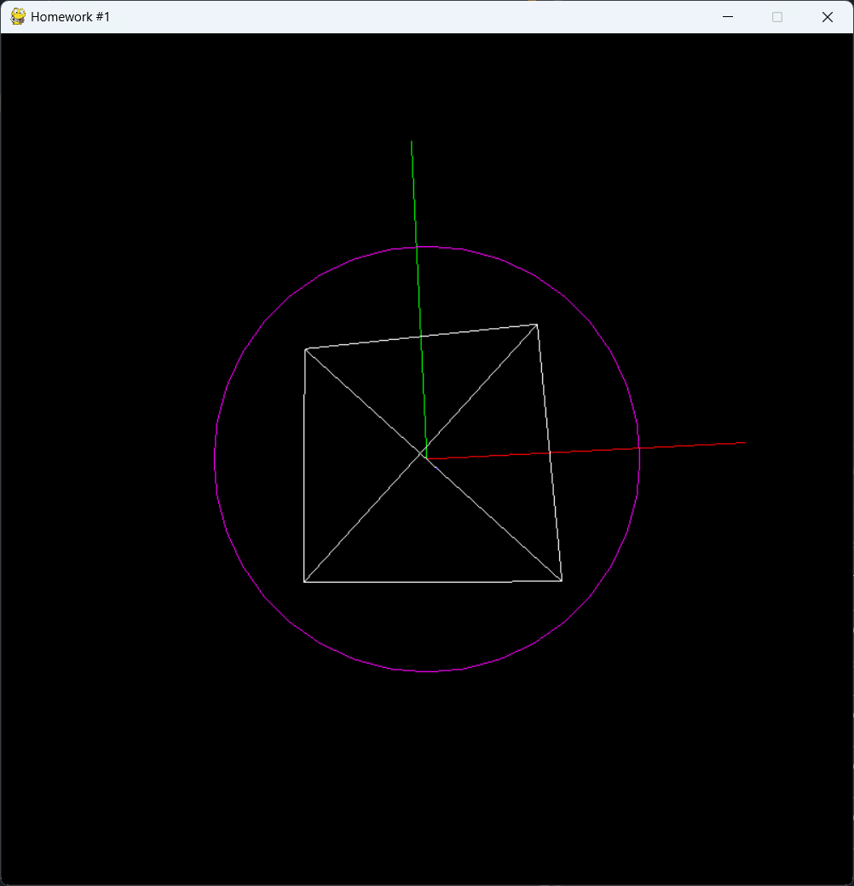

Figure 3 – Tetrahedron

Figure 4 – Octahedron

Figure 5 – Dodecahedron

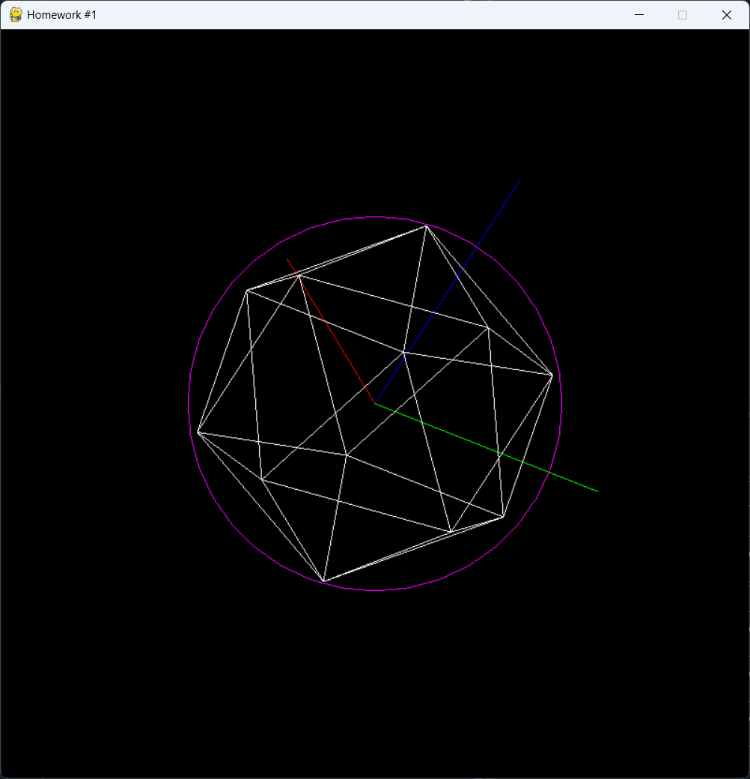

Figure 6 - Icosahedron