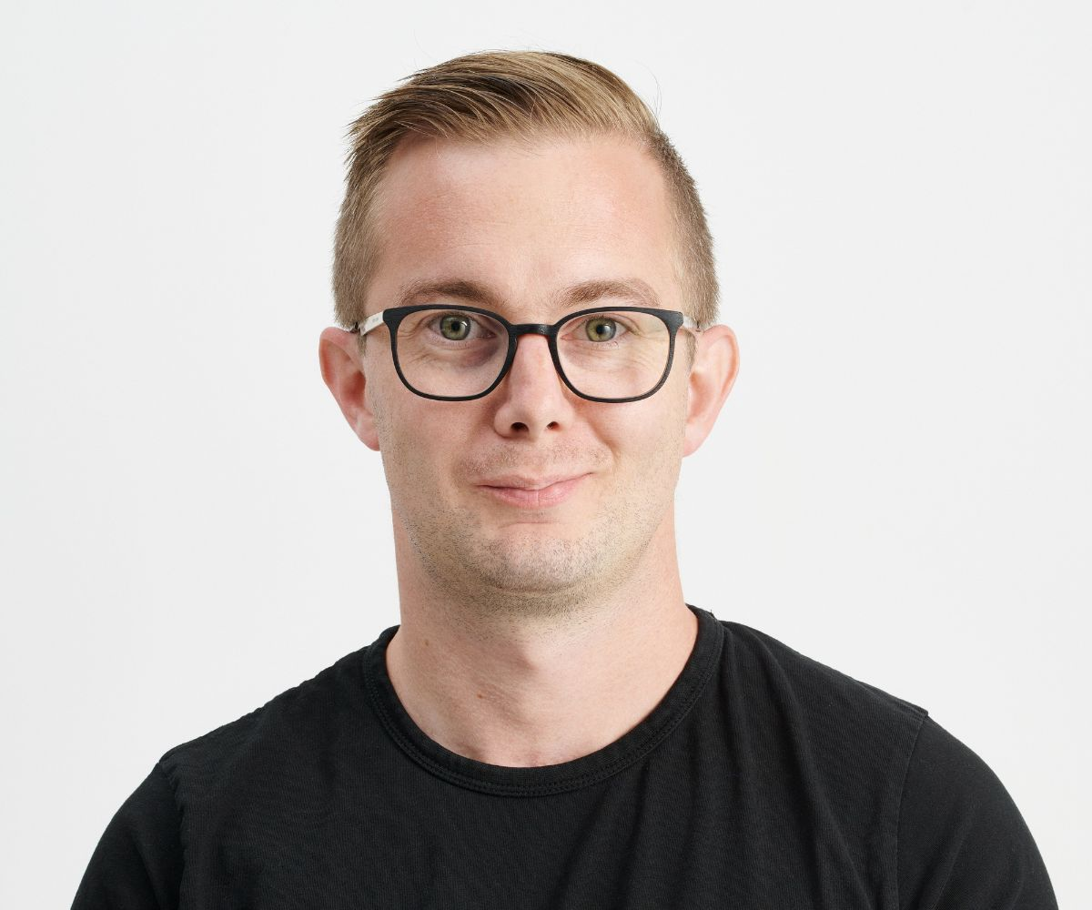
Daniel Hansson
Email: mailto@danielhansson.nu
Telephone: +46 734 04 55 55
LinkedIn: linkedin.com/in/daniel-hansson-7564a490
GitHub: github.com/enoch85
Website: rekrytera.danielhansson.nu
Location: Genarp, Skåne, Sweden

Data Center Manager • Open Source Expert • Entrepreneur • System Administrator
Results-oriented and driven personality with a passion for automation, stability and continuous improvement. Love building and running IT environments where things just work - from small companies to enterprise (700+ servers). Ideally, most things should happen automatically. Combines technical expertise in Linux and virtualization with the ability to lead teams and drive development and modernization projects. Entrepreneurial background allows me to understand the whole: both technology and business.

KEY COMPETENCIES
• Datacenter Operations & Management
• Server & Infrastructure Administration
• Virtualization & Hypervisors (VMware, Nutanix, Proxmox, Hyper-V)
• Open Source & Automation
• Entrepreneurship & Business Development

WORK EXPERIENCE
 Datacenter Manager
InfraCom Smart Digital Solutions | Malmö | Nov 2023 – Present
Responsible for a team in southern Sweden working with operations and development of datacenters nationally. Ensures high availability for critical infrastructure through proactive monitoring, incident management, and continuous improvements. Drives modernization projects including migration between hypervisors, and automation of routine tasks. Working under ISO 27001 according to ITIL framework.
Keywords: Datacenter Operations, VMware vSphere, Nutanix, Proxmox, Team Leadership, Incident Management

 Application Specialist
Redpill Linpro | Linköping (Remote) | Feb 2023 – Nov 2023
Implemented and supported enterprise open source solutions for Swedish government agencies. Focus on secure, scalable platforms based on open standards with requirements for high availability and compliance.
Keywords: Nextcloud Enterprise, Jitsi, Linux, Customer Support
 Founder & CTO
T&M Hansson IT AB | Genarp | Sep 2018 – Nov 2023
Founded and ran an IT consulting company specialized in open source infrastructure and automation. Maintainer for Nextcloud's official VM (100+ downloads/day globally). Developed automated deployment solutions for several virtualization platforms. Supported customers worldwide. Sold the company to Kafit AB 2021.
Keywords: Entrepreneurship, IaC, Bash Automation, Open Source Maintenance
 Operations / DevOps Engineer
SenseNode | Lund | Feb 2022 – Feb 2023
Manufactured and installed IoT devices with Ansible for energy metering at large industries. Responsible for organizing framework agreements with telephony operators and ensuring devices were always connected. Provided support and managed infrastructure for secure data transfer.
Keywords: IoT, Operations, Customer Support, Vendor Management
 IT Technician → System Administrator
Vessinge IT | Malmö | Jul 2017 – Jan 2022
Started as IT technician and advanced to system administrator with main responsibility for all servers and software. Later became responsible for Second-Line support. Managed Windows/Linux hybrid environment with VMware, Hyper-V, Windows Server 2008-2019, Ubuntu, Docker, and Portainer. Daily contact with vendors and resolved issues at a higher technical level.
Keywords: System Admin, VMware/Hyper-V, Windows/Linux Hybrid, SQL Server

 Account Manager
Örestad Linux AB | Malmö | Nov 2016 – May 2017
Technical sales role focusing on Linux-based hosting solutions. Made Örestad Linux a Nextcloud partner and implemented VPS platform for Nextcloud hosting.
Keywords: Technical Pre-Sales, Linux Solutions, Nextcloud
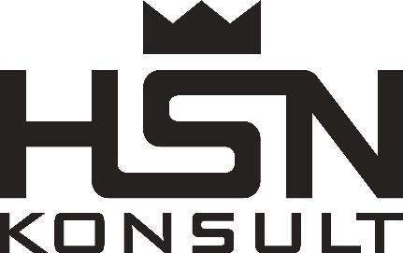 Previous Sales Career
Västerås, Malmö | 2008 – 2016
HSN Konsult (2008-2011): Founder, B2B sales. Sold company in 2011.
Powersales Sweden AB (2011-2014): CTO. Responsible for IT.
Trygg-Hansa (2014-2016): Insurance Advisor.
Keywords: Business Development, CTO, B2B Sales

EDUCATION
IT & Sales (300 YH-points), EC Utbildning, Malmö (2013 – 2014)
High School Diploma, Västerås

Certificates:
• Nutanix ECA (2024)
• Certified Insurance Intermediary (2014)
• Microsoft Technical Advisor (2016)

IT SKILLS
Virtualization & Hypervisors: VMware vSphere/ESX, Nutanix AHV, Hyper-V, Proxmox VE, Hyperconverged Infrastructure
Operating Systems & Servers: Linux-administration, Linux Server, Windows Server, Active Directory, Microsoft Exchange, Microsoft Azure, Docker, PostgreSQL, MySQL
Backup & Storage: Veeam, Ahsay, Proxmox PBS, Disaster Recovery, Backuplösningar, High Availability
Network & Security: VPN, DNS/BIND, Fortigate, opnSense, pfSense, Unifi, Nätverkssäkerhet
Operation & Management: Datacenterdrift, IT-ledarskap, Incidenthantering, ITIL/SLA, Kapacitetsplanering, Övervakning
Automation & Scripting: Ansible, Bash, PowerShell, VS Code, Infrastructure as Code, Packer, Git, Konfigurationshantering

LANGUAGES
• Swedish (Native)
• English (Fluent)
• Portuguese (Beginner)

PROJECTS & OPEN SOURCE
Nextcloud VM: Official Nextcloud appliance with interactive scripts for secure hosting. Used globally.
OVMS Home Assistant: MQTT integration for Open Vehicle Monitoring System.
Global Energy Spotprices: Global electricity price forecast integration.
EffektGuard: Intelligent heat pump optimization using ML.

