

**IE HRMS TEST REPORT**

August 4, 2021

Contents

**INTRODUCTION** 3

Purpose 3

Functionality testing 3

A. Login page 3

B. Home Dashboard 5

C. Employee 5

D. Attendance 8

E. Warning 10

F. Deductions 12

G. Payroll 13

Database Testing 15

Structural database testing 15

Functional Database Testing 17

**Conclusion** 19

# **INTRODUCTION**

IE HRMS is a system that controls the activities of employees of IE Network Solution related to payroll, attendance, human resource, deductions and merits, warnings, loans, and so on. It manages activities regarding human resource and finance teams.

The system is expected to generate daily, weekly and monthly reports according to its request.

## Purpose

This document is intended on end to end testing of the IE HRMS (Human Resource Management System) website. For the testing purpose, we carried out both cloud testing and local testing.

This document gives a brief procedure for testing this system. The testing includes **Functional testing** and **Database testing**

## Functionality testing

### Login page

Case 1. Password reset

This is the feature where the users get a password reset link through email.

* Steps

Click forgot password button on the login page.

Enter your email address in the text filed

Click the sent password reset link

* Expected Result

Password reset link should be sent to account provided email

* Actual Result

The system does not send a password reset link

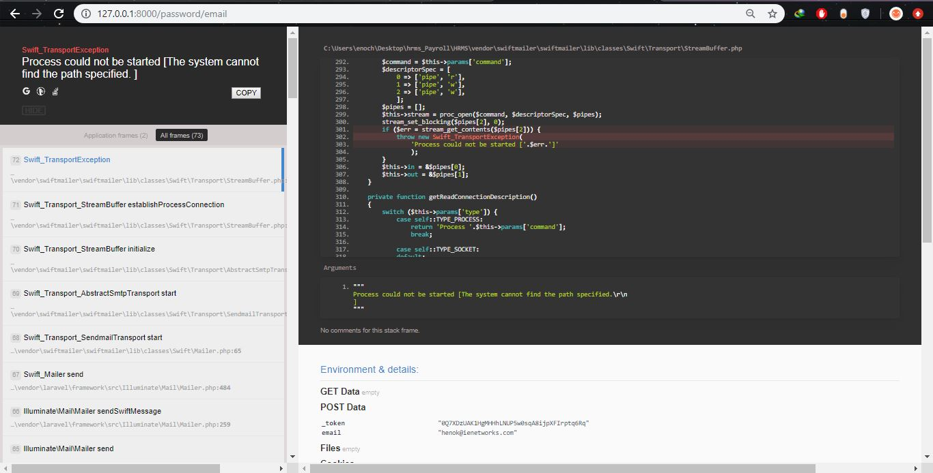

### Home Dashboard

Case 2. Setting button

On the user profile (Avatar) on the top right side, pressing the profile button sends us to the profile page and we can update our password and username. But when we press the setting button it doesn’t direct us to any page. So setting button is not functional. 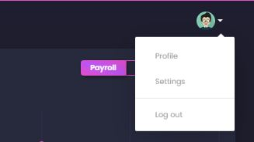

Its reference is set as



It should be directed to the appropriate page.

On the home page, the chart is only showing for a given time (from August 2020 to May 2020) which is dynamic and shows real data in a chart form but, it should be a dropdown button where it can let us select a required date and month.

In home dashboard, records of employee’s data can be shown but the users' name is not displaying. First name and Last name are not specified in the database. It shows only blank for the Name category.

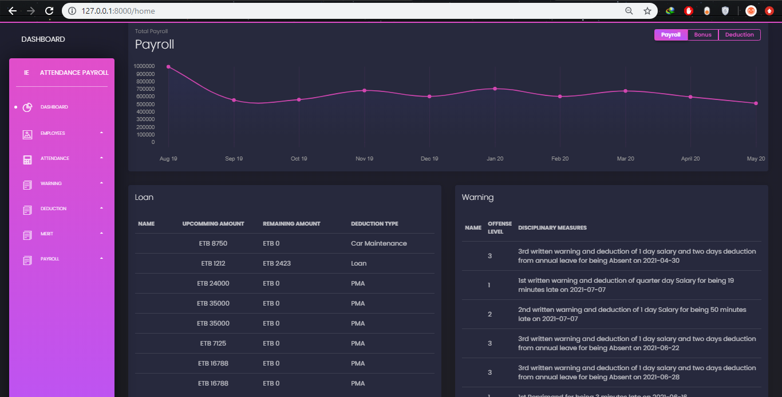

### Employee

On the left side of the dashboard (home) page, we can find a button called Employees which is a dropdown for

* + - User profile
    - Employee Management
    - User Management and
    - Shift Management

Case 3. Duplicated page

**User Profile –** isanidentical page with a profile page which we can get on the right-hand side of by pressing our avatar. Since it is an identical page user profile in the Employees dropdown must be omitted.

Case 4. Content not displaying

**Employee Management –** Pressing employee management redirects us to view every employee registered in the system. It doesn’t show Employee Name because it is assigned to only show name but not a first name and last name. It should show both the first and last names of employees.

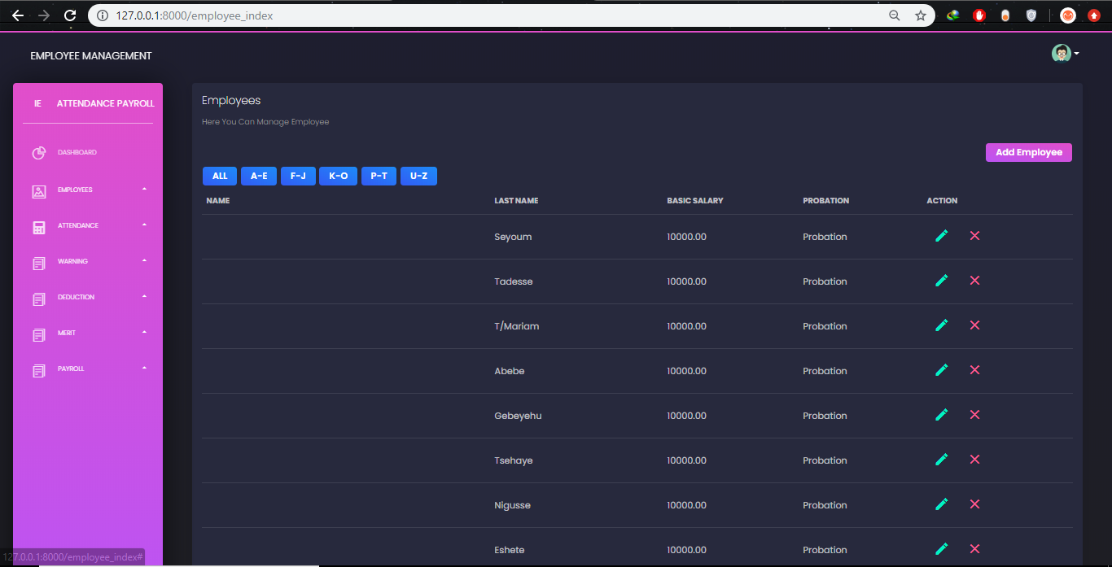

**Shift Management –** When pressingShift management, nothing displays. There is an active and de-active button but no employee's name is displayed.

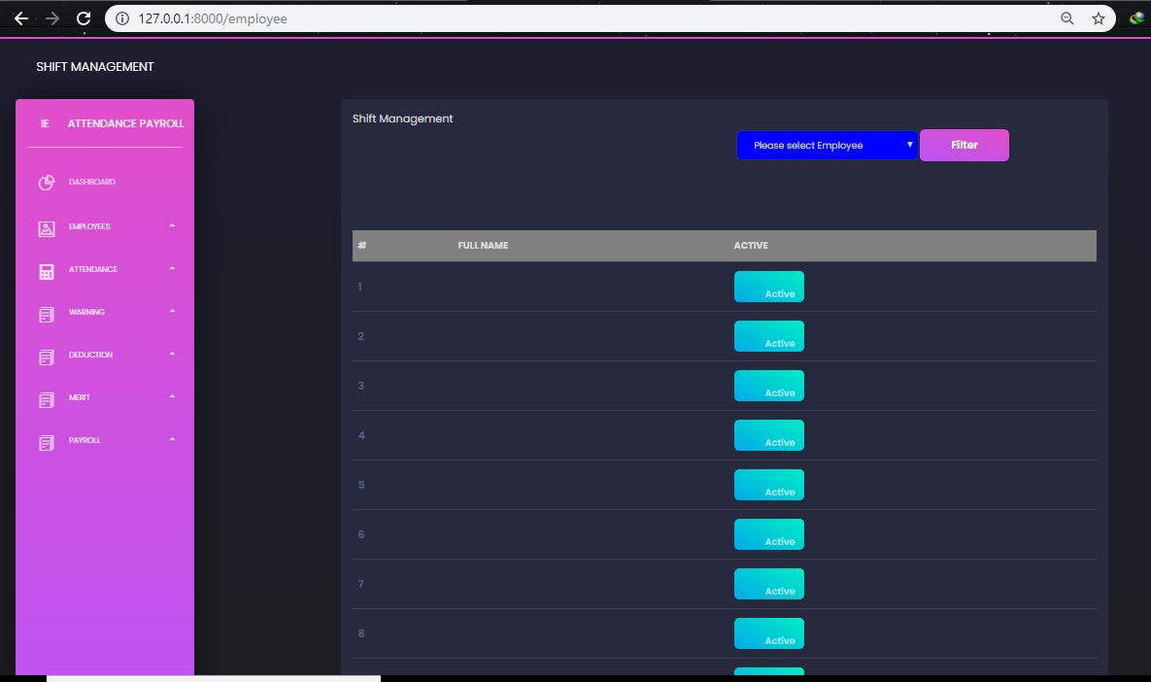

### Attendance

In the Attendance dropdown button, we can find

Raw data

WEBHR data

Export

**Raw data –** In “Incentive Report” tab when we import a specific document into the system and press submit, it takes us to another unrelated (Merit index) page in the system. We cannot import Incentive Report data to the system. Therefore it is not a functional button.

**WEBHR data –** By pressing the “Absent” tab on the right corner we can import absent data from WebHR, but when we press the ‘Submit’ button it just reloads the page and nothing we be imported to the system. So this button is not functional. And also employees name when filtering is not all visible.

“New/Resigned” tab shows a list of employees who are either new or resigned from the organization. When we press the ‘Trash’ button it deletes that user from the database. This button is functional but it should rather be an Active or Inactive button rather than deleting the whole employee’s information from the database.

Again in this tab employee name lists are not all visible.

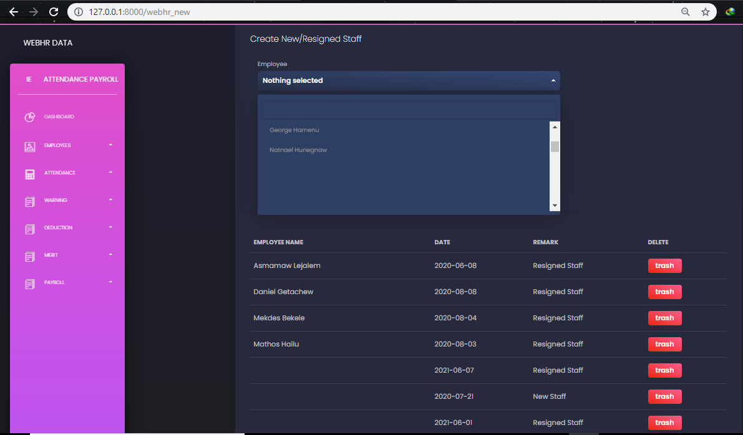

The last tab is “Latecommers” which shows lists of employees who are late. This data is imported from WebHR by defining a specific date. On this page, the employee name is not displayed correctly. Some names are displayed randomly but not correctly.

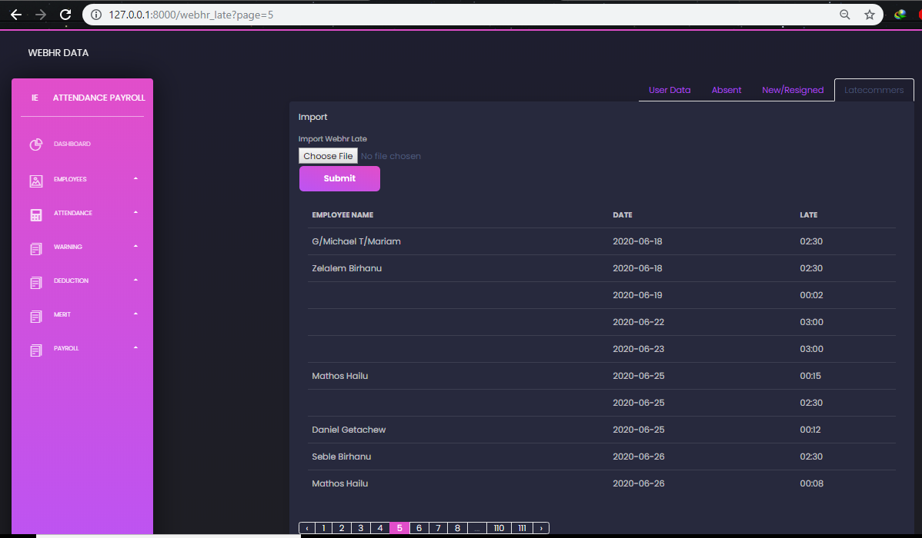

### Warning

In the warning button, we can find a dropdown for

Warning record

Warning type

**Warning record –** This page shows lists of employee who has been given a warning. It displays the type of warning they get, a number of warnings they got previously, disciplinary measures taken. We can also add new warning to employees by pressing the “Add Warning” button.

We can find “Generate Warning” button which is not functional. It doesn’t take you to any page available.

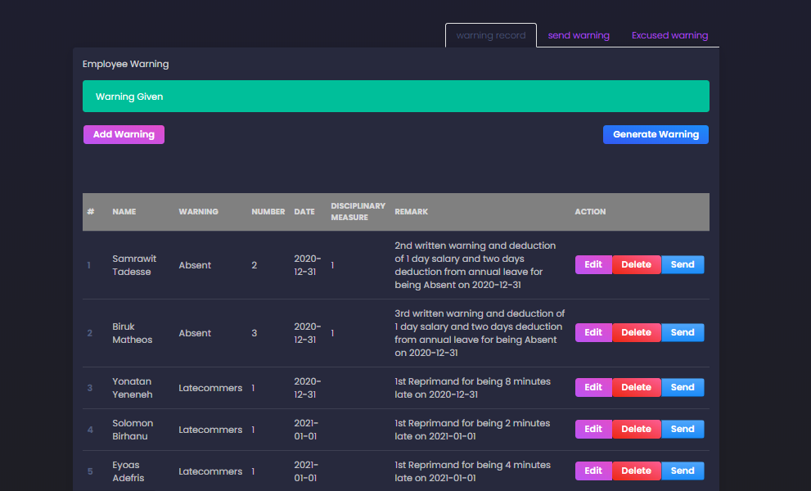

We can find another tab “Send warning” which is intended to send a warning for a mentioned employee. When we press send button the system loads and gives an error of Timeout execution.

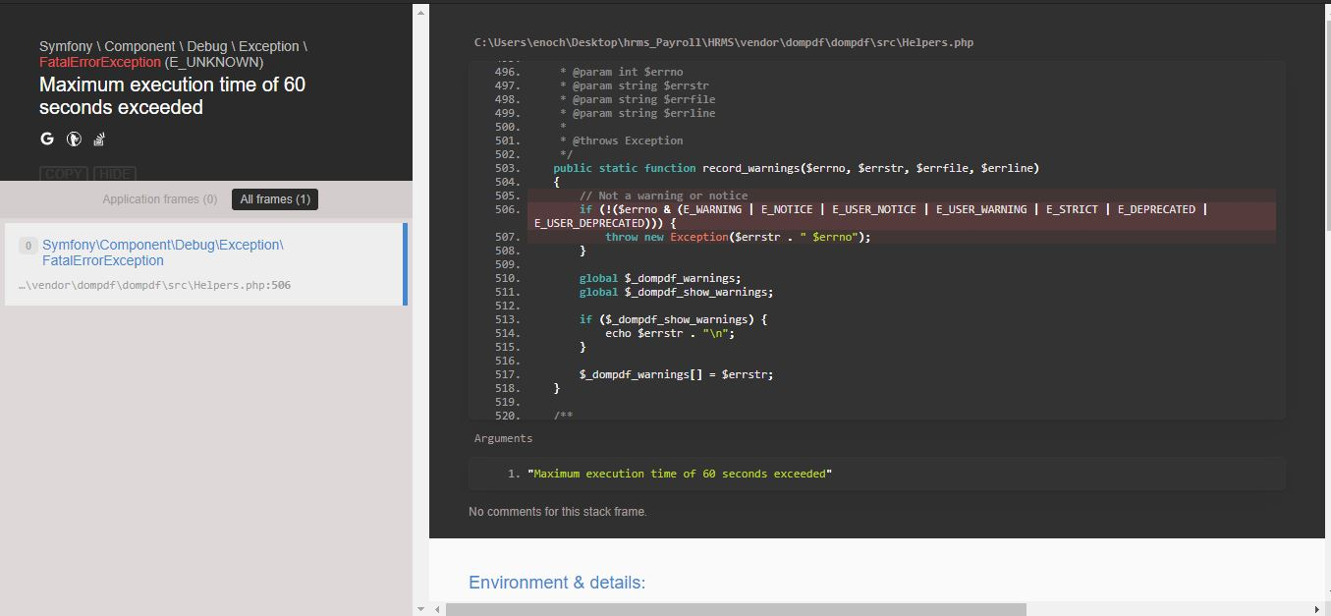

Our last tab is “Excused warning” where employee are given excuse for their late warning given. It displays green for excused employees and red for condemn employees. In this list employee name is not displayed.

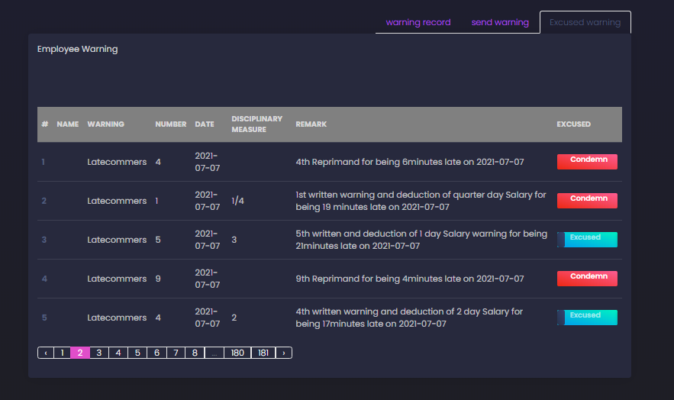

### Deductions

In deductions we can find a dropdown of

Deduction record

Deduction type

**Deduction record –** This shows lists of employees who have been deducted in the system. We can add new list by pressing “Add Loan” button.

In the employee list, full name of employees are not visible. For searching and filtering purpose, employees name is also not visible.

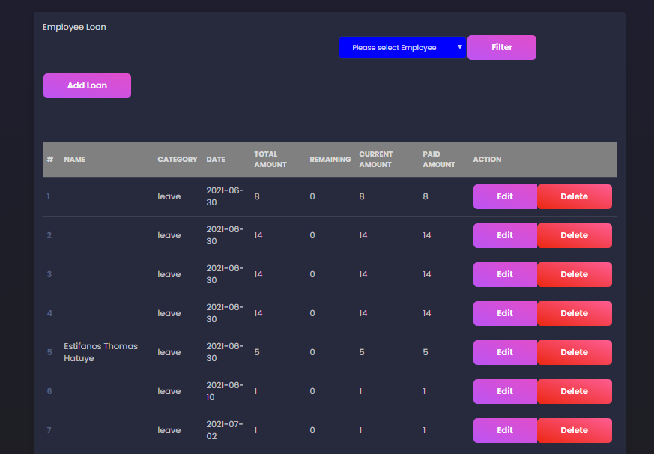

### Payroll

In payroll button we can find a dropdown for

Award

Deduct

Bank

Payroll

**Award –** We can view lists of employees who have been awarded. We can also create new data with specified award categories. “New bonus” button takes us to a create award page where we fill out every information. But we don’t have a back button if we decided to not add a new award to the system. **A back button is required.**

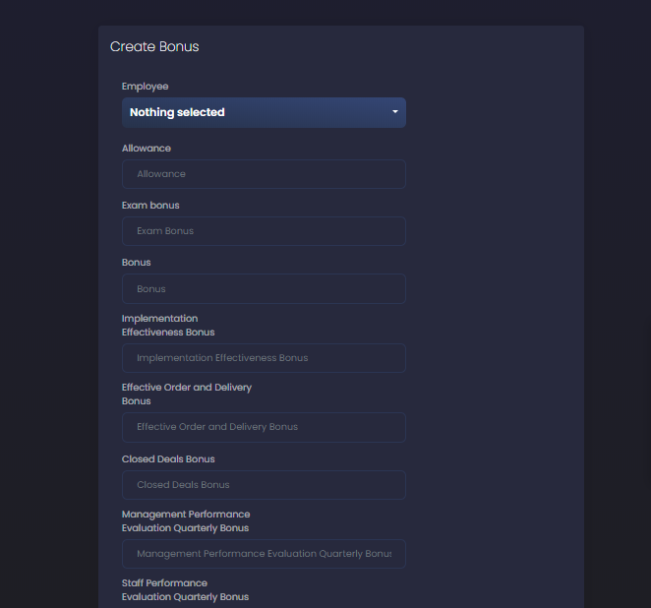

All employees name are not displayed.

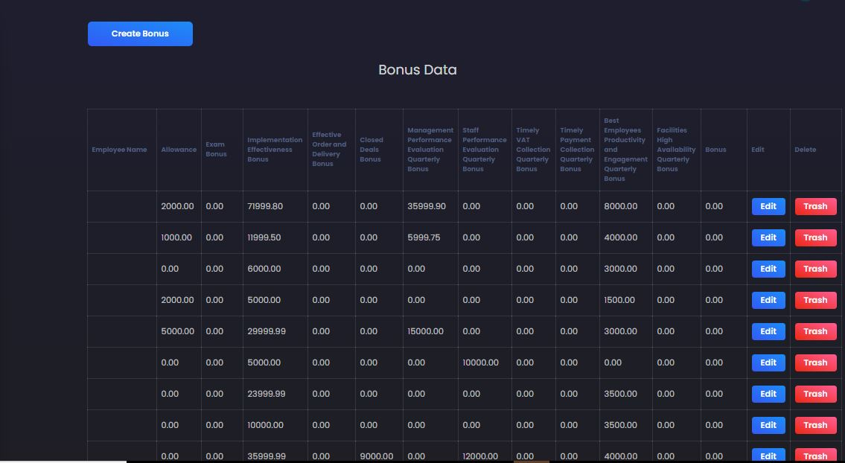

**Deduct –** We can view lists of employees who have been deducted. We can add deduction by pressing the “Create Deduction” button and fill out specific information. Again if we want to discard creating a new deduction we cannot go back, **a back button is required.**

**Payroll –** This page is to export payroll and bank information’s from the system and sends an email to employees.

We have 4 tabs

Payroll export: it exports an excel format document of payroll of employees. The document is not displaying the employee’s full name.

Export bank: it exports an excel format document of bank information of employees

Send Email: rather than sending an email this button sends us to the homepage (Dashboard) of the system. This button is not functional.

Bank letter: this is also a not functional button in our system it shows an error as shown in the figure below.

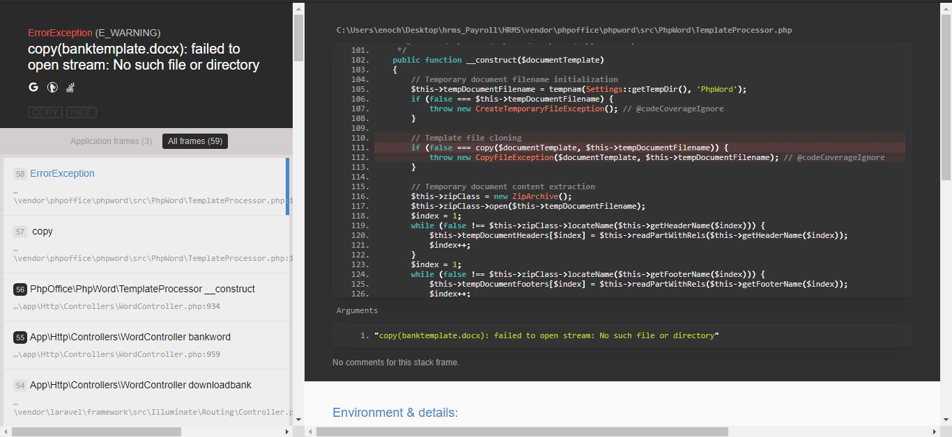

## Database Testing

**IE HRMS** testing of the database is conducted using 2 database testing methods.

Structural database testing

Functional database testing

### Structural database testing

A database testing technique that validates all the elements inside the data repository that are mainly used for data storage and which are not allowed to be directly manipulated by end-users.

This method allows us to inspect the database management of the system.

Are tables, columns, and rows compatible with the User Interface? Our data are stored in the right database table?

By locally configuring IE HRMS, we can test the system’s database.

**Storing data** – in the employee data table in the database the columns are

FullName | FirstName | LastName | gLastName

This is a database repetition, it should be only

**FirstName | LastName | gLastName**

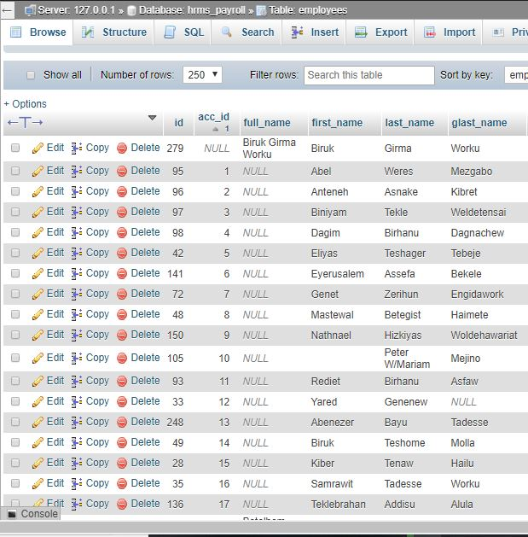

The interface on the creating of a new employee is completely different from the “Employee” database.

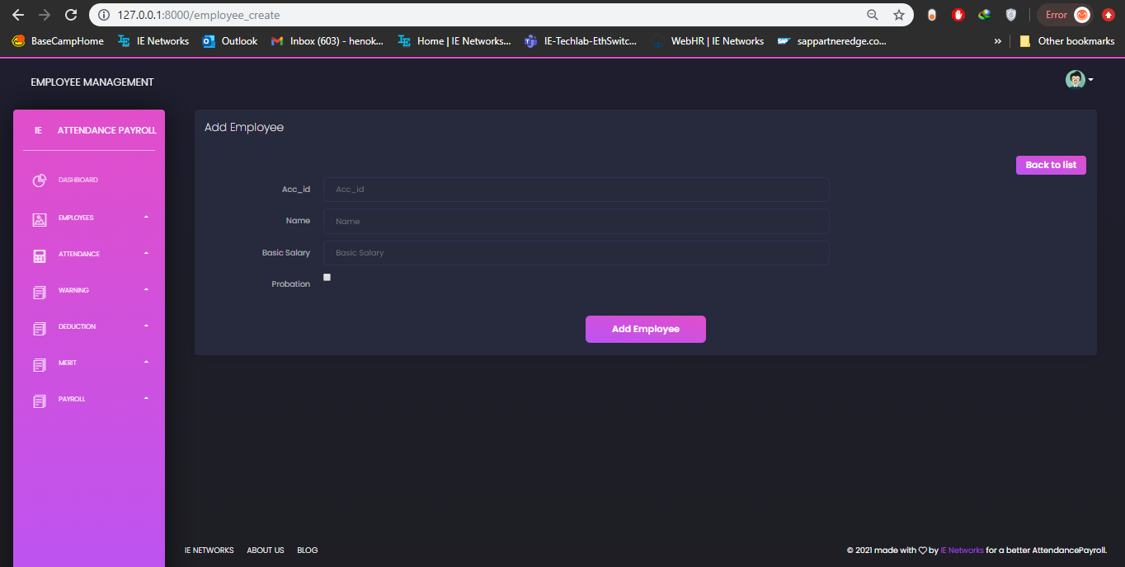

This misuse of the user interface is impacting the displaying and fetching of employee names into the system.

### **Functional Database Testing**

It is a type of database testing that is used to validate the functional requirements of a database from the end-user’s perspective. The main goal of functional database testing is to test whether the transactions and operations performed by the end-users which are related to the database work as expected or not.

Mandatory fields are or must be fillable.

The system requires all fillable data and does not proceed unleased filled with the required information.

**Login and User Security**

The system authenticates the user’s credentials from the database. It successfully logs in user who is registered into the system.

All data informations are secured from unauthorized access.

* Multiple trials and brute login attempts are not handled in the system.
* Timeout must be set if a user is not active for a specific time.

Passwords and sensitive data are stored encrypted in the system

# **Conclusion**

The system is not consistent in displaying contents. Full information is not displayed consistently. Names are not displayed on most pages.

All links are incorrectly set on buttons. On <http://127.0.0.1:8000/payroll> URL Send Email button is not linked rather than sending an email this button sends us to the homepage (Dashboard) of the system.