**ITP 325 – Lab 08 – Metasploit**

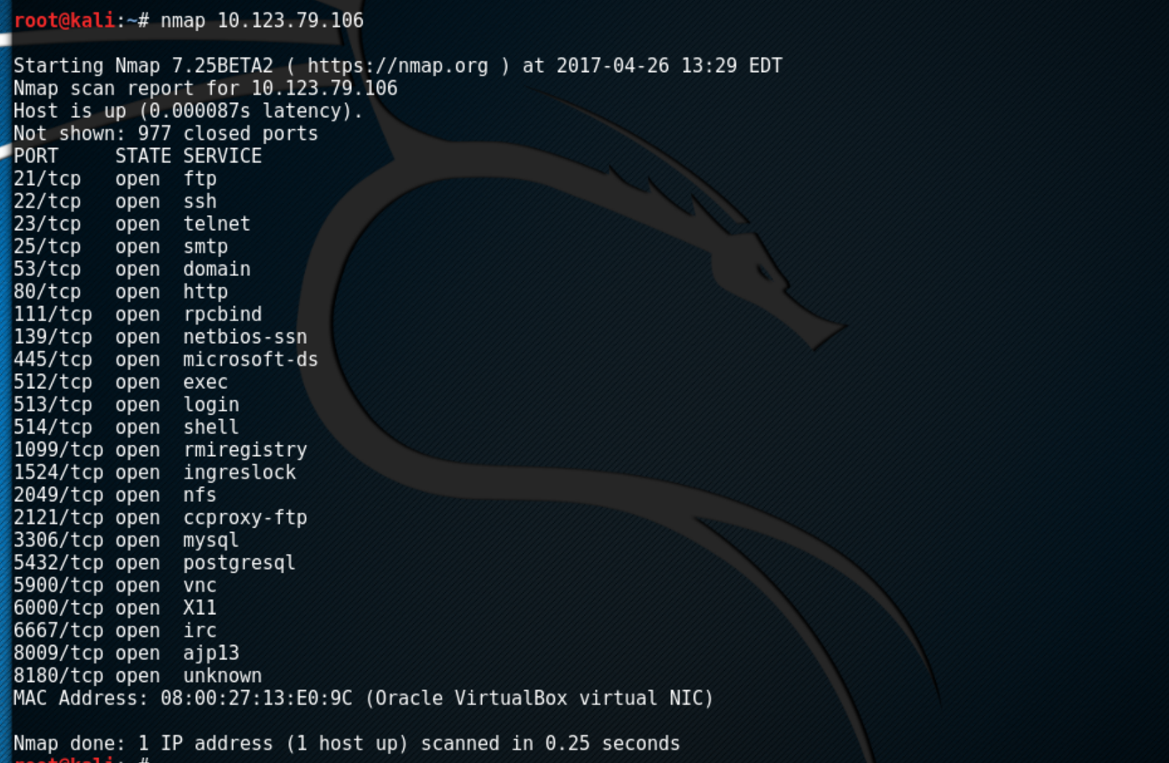



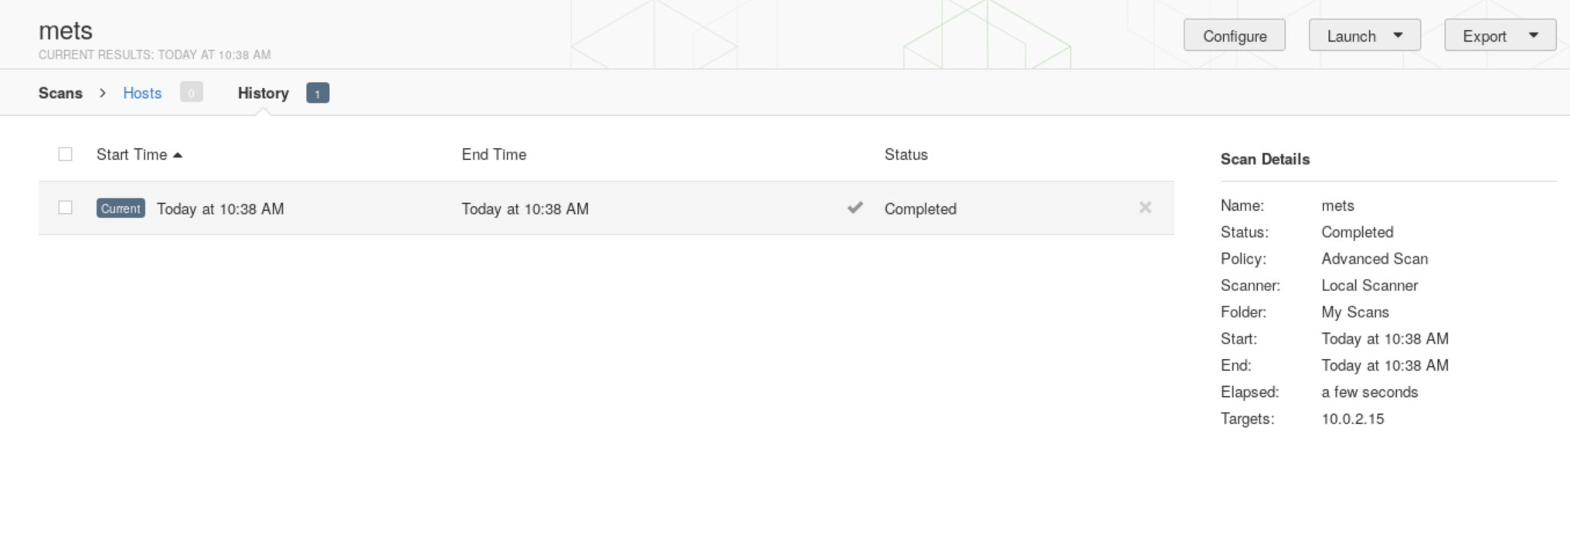

1. There are 5 different admin passwords and users. 5 ways to get in include, using ssh, port 22, then port 512, 513, and 514 .Lastly using 25 to thoroughly get the admin access. Also using sudo su command can also get you admin access.
2. I ssh’d into the metasploitable. Then I admin myself up, then I used the wget command to install a picture of a cat from the web.
3. Possibly through the history of commands run and how that might even have access to the computer and the key strokes. Can check through the ports what is connected to what and there be able to discover what is accessing them.