**BANK LOAN REPORT SQL QUERY DOCUMENT**

1. **BANK LOAN REPORT | SUMMARY**

**KPI’s:**

1. Total Loan Applications

**Total Loan Applications**

SELECT COUNT(id) AS Total_Loan_Applications

FROM bank_loan_data

**

**MTD Loan Applications**

SELECT COUNT(id) AS MTD_Total_Loan_Applications

FROM bank_loan_data

WHERE MONTH(issue_date) = 12 *-- This query count all records where the issue_date falls within December 2021 --*

AND YEAR(issue_date) = 2021

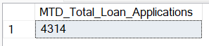

**PMTD Loan Applications**

SELECT COUNT(id) AS PMTD_Total_Loan_Applications

FROM bank_loan_data

WHERE MONTH(issue_date) =11 *-- This query count all records where the issue_date falls within November 2021 --*

AND YEAR(issue_date) = 2021

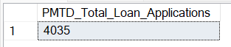

1. Total Funded Amount

**Total Funded Amount**

SELECT SUM(loan_amount) AS Total_Funded_Amount

FROM bank_loan_data



**MTD Total Funded Amount**

SELECT SUM(loan_amount) AS MTD_Total_Funded_Amount

FROM bank_loan_data

WHERE MONTH(issue_date) = 12

AND YEAR(issue_date) = 2021

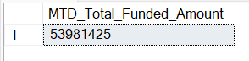

**PMTD Total Funded Amount**

SELECT SUM(loan_amount) AS PMTD_Total_Funded_Amount

FROM bank_loan_data

WHERE MONTH(issue_date) = 11

AND YEAR(issue_date) = 2021

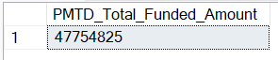

1. Total Amount Received

**Total Amount Received**

SELECT SUM(total_payment) AS Total_Amount_Received

FROM bank_loan_data

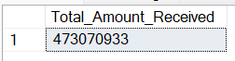

**MTD Total Amount Received**

SELECT SUM(total_payment) AS MTD_Total_Amount_Received

FROM bank_loan_data

WHERE MONTH(issue_date) = 12

AND YEAR(issue_date) = 2021

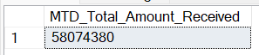

**PMTD Total Amount Received**

SELECT SUM(total_payment) AS PMTD_Total_Amount_Received

FROM bank_loan_data

WHERE MONTH(issue_date) = 11

AND YEAR(issue_date) = 2021



1. **Average Interest Rate**

**Average Interest Rate**

SELECT ROUND(AVG(int_rate), 4)*100 AS Average_Interest_Rate

FROM bank_loan_data



**MTD Average Interest**

SELECT ROUND(AVG(int_rate), 4)*100 AS MTD_Average_Interest_Rate

FROM bank_loan_data

WHERE MONTH(issue_date) = 12

AND YEAR(issue_date) = 2021



**PMTD Average Interest**

SELECT ROUND(AVG(int_rate), 4)*100 AS PMTD_Average_Interest_Rate

FROM bank_loan_data

WHERE MONTH(issue_date) = 11

AND YEAR(issue_date) = 2021



1. Average Debt to Income Ratio (DTI)

**Average DTI**

SELECT ROUND(AVG(dti), 4)*100 AS Average_DTI

FROM bank_loan_data



**MTD Average DTI**

SELECT ROUND(AVG(dti), 4)*100 AS MTD_Average_DTI

FROM bank_loan_data

WHERE MONTH(issue_date) = 12

AND YEAR(issue_date) = 2021



**PMTD Average DTI**

SELECT ROUND(AVG(dti), 4)*100 AS PMTD_Average_DTI

FROM bank_loan_data

WHERE MONTH(issue_date) = 11

AND YEAR(issue_date) = 2021



**GOOD LOAN ISSUED**

**Good Loan Percentage**

SELECT

(COUNT(

CASE

WHEN loan_status = 'Fully Paid' OR loan_status = 'Current'

THEN id

END) * 100.0) / (COUNT(id))

)AS Good_Loan_Percentage

FROM bank_loan_data



**Good Loan Applications**

SELECT

COUNT(id) AS Good_Loan_Applications

FROM bank_loan_data

WHERE loan_status = 'Fully Paid' OR loan_status = 'Current'



**Good Loan Funded Amount**

SELECT

SUM(loan_amount) AS Good_Loan_Funded_Amount

FROM bank_loan_data

WHERE loan_status = 'Fully Paid' OR loan_status = 'Current'



**Good Loan Amount Received**

SELECT

SUM(total_payment) AS Good_Loan_Amount_Received

FROM bank_loan_data

WHERE loan_status = 'Fully Paid' OR loan_status = 'Current'



**BAD LOAN ISSUED**

**Bad Loan Percentage**

SELECT

(COUNT(

CASE

WHEN loan_status = 'Charged Off'

THEN id

END) * 100.0) / (COUNT(id))

)AS Bad_Loan_Percentage

FROM bank_loan_data



**Bad Loan Applications**

SELECT

COUNT(id) AS Bad_Loan_Applications

FROM bank_loan_data

WHERE loan_status = 'Charged Off'



**Bad Loan Funded Amount**

SELECT

SUM(loan_amount) AS Bad_Loan_Funded_Amount

FROM bank_loan_data

WHERE loan_status = 'Charged Off'



**Bad Loan Amount Received**

SELECT

SUM(total_payment) AS Bad_Loan_Amount_Received

FROM bank_loan_data

WHERE loan_status = 'Charged Off'



**LOAN STATUS**

SELECT

loan_status,

COUNT(id) AS LoanCount,

SUM(total_payment) AS Total_Amount_Received,

SUM(loan_amount) AS Total_Funded_Amount,

ROUND(AVG(int_rate * 100), 2) AS Interest_Rate,

ROUND(AVG(dti * 100), 2) AS DTI

FROM

bank_loan_data

GROUP BY

loan_status

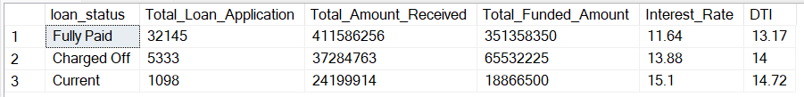

SELECT

loan_status,

SUM(total_payment) AS MTD_Total_Amount_Received,

SUM(loan_amount) AS MTD_Total_Funded_Amount

FROM bank_loan_data

WHERE MONTH(issue_date) = 12 AND YEAR(issue_date) = 2021

GROUP BY loan_status

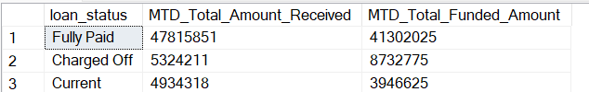

1. **BANK LOAN REPORT | OVERVIEW**
2. **Monthly Trends by Issue Date**

SELECT

MONTH(issue_date) AS Month_Munber,

DATENAME(MONTH, issue_date) AS Month_name,

COUNT(id) AS Total_Loan_Applications,

SUM(loan_amount) AS Total_Funded_Amount,

SUM(total_payment) AS Total_Amount_Received

FROM bank_loan_data

GROUP BY MONTH(issue_date), DATENAME(MONTH, issue_date)

ORDER BY MONTH(issue_date)

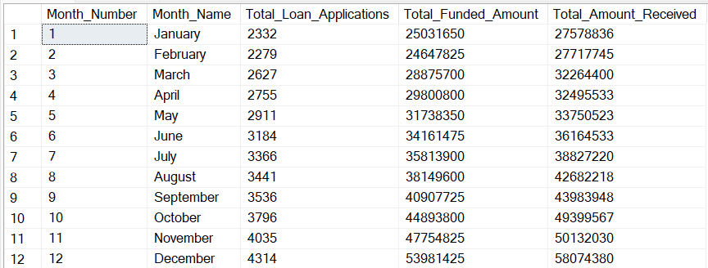

1. **Regional Analysis by State**

SELECT

address_state AS State,

COUNT(id) AS Total_Loan_Applications,

SUM(loan_amount) AS Total_Funded_Amount,

SUM(total_payment) AS Total_Amount_Received

FROM bank_loan_data

GROUP BY address_state

ORDER BY address_state

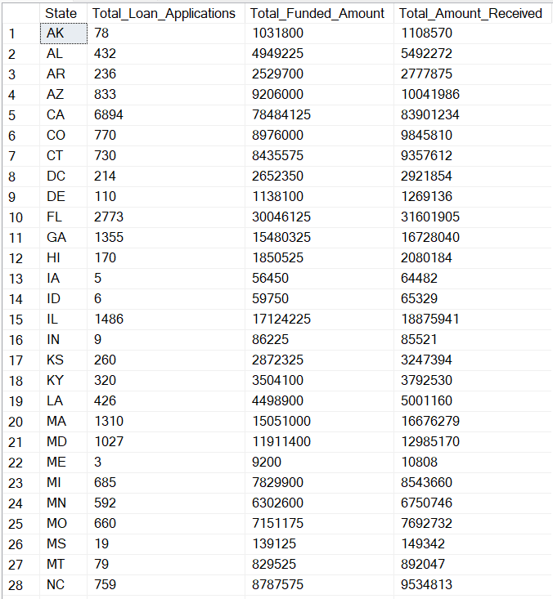

1. **Loan Term Analysis**

SELECT

term AS Loan_Term,

COUNT(id) AS Total_Loan_Applications,

SUM(loan_amount) AS Total_Funded_Amount,

SUM(total_payment) AS Total_Amount_Received

FROM bank_loan_data

GROUP BY term

ORDER BY term

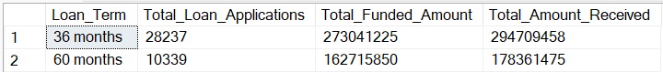

1. **Employee Length Analysis**

SELECT

emp_length AS Employee_Length,

COUNT(id) AS Total_Loan_Applications,

SUM(loan_amount) AS Total_Funded_Amount,

SUM(total_payment) AS Total_Amount_Received

FROM bank_loan_data

GROUP BY emp_length

ORDER BY emp_length

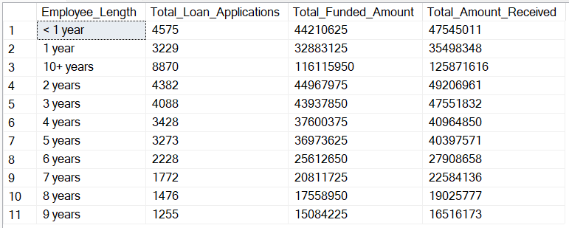

1. **Loan Purpose Breakdown**

SELECT

purpose AS Loan_Purpose,

COUNT(id) AS Total_Loan_Applications,

SUM(loan_amount) AS Total_Funded_Amount,

SUM(total_payment) AS Total_Amount_Received

FROM bank_loan_data

GROUP BY purpose

ORDER BY purpose

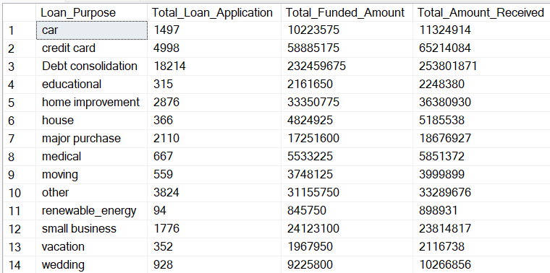

1. **Home Ownership Analysis**

SELECT

home_ownership AS Home_Ownership,

COUNT(id) AS Total_Loan_Applications,

SUM(loan_amount) AS Total_Funded_Amount,

SUM(total_payment) AS Total_Amount_Received

FROM bank_loan_data

GROUP BY home_ownership

ORDER BY home_ownership

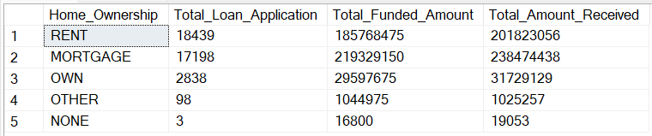

**BANK LOAN REPORT DOCUMENT (DAX QUERY)**

**BANK LOAN REPORT | SUMMARY**

**Creating a Date Table (DAX Query):**

**Date Table**

Date Table = CALENDAR(

    MIN(

        bank_loan_data[issue_date]

    ),

    MAX(

        bank_loan_data[issue_date]

    )

)

**Month Column**

Month =

    FORMAT(

        'Date Table'[Date], "mmm"

    )

**Month Number**

Month Number =

    MONTH(

        'Date Table'[Date]

    )

**KPI’s:**

1. Total Loan Applications

**Total Loan Applications**

Total Loan Applications =

COUNT(

bank_loan_data[id]

)

**MTD Loan Applications**

MTD Loan Applications =

    CALCULATE(

        TOTALMTD(

            [Total Loan Applications],

            'Date Table'[Date]

        )

    )

**PMTD Loan Applications**

PMTD Loan Applications =

    CALCULATE(

        [Total Loan Applications],

        DATESMTD(

            DATEADD(

                'Date Table'[Date], -1, MONTH

            )

        )

    )

**MoM Loan Applications**

MoM Loan Applications = ([MTD Loan Applications] - [PMTD Loan Applications]) / [PMTD Loan Applications]

1. Total Funded Amount

**Total Funded Amount**

Total Funded Amount =

    SUM(

        bank_loan_data[loan_amount]

    )

**MTD Total Funded Amount**

MTD Total Funded Amount =

    CALCULATE(

        TOTALMTD(

            [Total Funded Amount],

            'Date Table'[Date]

        )

    )

**PMTD Total Funded Amount**

PMTD Funded Amount =

    CALCULATE(

        [Total Funded Amount],

        DATESMTD(

            DATEADD(

                'Date Table'[Date], -1, MONTH

            )

        )

    )

**MoM Funded Amount**

MoM Funded Amount = ([MTD Funded Amount] - [PMTD Funded Amount]) / [PMTD Funded Amount]

1. Total Amount Received

**Total Amount Received**

Total Amount Received =

    SUM(

        bank_loan_data[total_payment]

    )

**MTD Total Amount Received**

MTD Total Amount Received =

    CALCULATE(

        TOTALMTD(

            [Total Amount Received],

            'Date Table'[Date]

        )

    )

**PMTD Total Amount Received**

PMTD Total Amount Received =

    CALCULATE(

        [Total Amount Received],

        DATESMTD(

            DATEADD(

                'Date Table'[Date], -1, MONTH

            )

        )

    )

**MoM Amount Received**

MoM Total Amount Received = ([MTD Total Amount Received] - [PMTD Total Amount Received]) / [PMTD Total Amount Received]

1. **Average Interest Rate**

**Average Interest Rate**

Average Interest Rate =

    AVERAGE(

        bank_loan_data[int_rate]

    )

**MTD Average Interest**

MTD Average Interest Rate =

    CALCULATE(

        TOTALMTD(

            [Average Interest Rate],

            'Date Table'[Date]

        )

    )

**PMTD Average Interest**

PMTD Average Interest =

    CALCULATE(

        [Average Interest Rate],

        DATESMTD(

            DATEADD(

                'Date Table'[Date], -1, MONTH

            )

        )

    )

**MoM Average Interest Rate**

MoM Average Interest Rate = ([MTD Average Interest Rate] - [PMTD Average Interest Rate]) / [PMTD Average Interest Rate]

1. Average Debt to Income Ratio (DTI)

**Average DTI**

Average DTI =

    AVERAGE(

        bank_loan_data[dti]

    )

**MTD Average DTI**

MTD Average DTI =

    CALCULATE(

        TOTALMTD(

            [Average DTI],

            'Date Table'[Date]

        )

    )

**PMTD Average DTI**

PMTD Average DTI =

    CALCULATE(

        [Average DTI],

        DATESMTD(

            DATEADD(

                'Date Table'[Date], -1, MONTH

            )

        )

    )

**MoM Average DTI**

MoM Average DTI = ([MTD Average DTI] - [PMTD Average DTI]) / [PMTD Average DTI]

**GOOD LOAN ISSUED**

**Good Loan Percentage**

Good Loan % =

    (

        CALCULATE(

            [Total Loan Applications],

            bank_loan_data[Good Loan Vs Bad Loan] = "Good Loan"

        )

    )/[Total Loan Applications]

**Good Loan Applications**

Good Loan Applications =

    (

        CALCULATE(

            [Total Loan Applications],

            bank_loan_data[Good Loan Vs Bad Loan] = "Good Loan"

        )

    )

**Good Loan Funded Amount**

Good Loan Funded Amount =

    (

        CALCULATE(

            [Total Funded Amount],

            bank_loan_data[Good Loan Vs Bad Loan] = "Good Loan"

        )

    )

**Good Loan Amount Received**

Good Loan Amount Received =

    (

        CALCULATE(

            [Total Amount Received],

            bank_loan_data[Good Loan Vs Bad Loan] = "Good Loan"

        )

    )

**BAD LOAN ISSUED**

**Bad Loan Percentage**

Bad Loan % =

    (

        CALCULATE(

            [Total Loan Applications],

            bank_loan_data[Good Loan Vs Bad Loan] = "Bad Loan"

        )

    )/[Total Loan Applications]

**Bad Loan Applications**

Bad Loan Applications =

    (

        CALCULATE(

            [Total Loan Applications],

            bank_loan_data[Good Loan Vs Bad Loan] = "Bad Loan"

        )

    )

**Bad Loan Funded Amount**

Bad Loan Funded Amount =

    (

        CALCULATE(

            [Total Funded Amount],

            bank_loan_data[Good Loan Vs Bad Loan] = "Bad Loan"

        )

    )

**Bad Loan Amount Received**

Bad Loan Amount Received =

    (

        CALCULATE(

            [Total Amount Received],

            bank_loan_data[Good Loan Vs Bad Loan] = "Bad Loan"

        )

    )