
RAMACHANDRA COLLEGE OF ENGINEERING
(AUTONOMOUS)
(Approved by AICTE, Permanantly Affiliated to JNTUK, Kakinada)
Accredited by NBA and NAAC (A+)
NH-16 Bypass, Vatluru (V), ELURU-534007, Eluru Dist., A.P.

DEPARTMENT OF ARTIFICIAL INTELLIGENCE AND DATA SCIENCE
A Mini Project Report On
A SUPPORT VECTOR MACHINE CLASSIFIER-BASED APPROACH TO WATER POTABILITY CLASSIFICATION
Submitted by
Mr. URLA ENOCH PHILIP
23ME1A54B1
Submitted in partial fulfillment of the requirement for the award of the degree
BACHELOR OF TECHNOLOGY
in
ARTIFICIAL INTELLIGENCE AND DATA SCIENCE
IV B.Tech – I Semester (Mini Project)
Under the Esteemed Guidance of
Mr. E. SURENDRA BABU
Assistant Professor, Department of AI&DS
2026–2027

RAMACHANDRA COLLEGE OF ENGINEERING
(AUTONOMOUS)
(Approved by AICTE, Permanantly Affiliated to JNTUK, Kakinada) Accredited by NBA and
NAAC (A+)
NH-16 Bypass, Vatluru (V), ELURU-534007, Eluru Dist., A.P.
2026–2027
DEPARTMENT OF ARTIFICIAL INTELLIGENCE AND DATA SCIENCE
BONAFIDE CERTIFICATE
This is to certify that this project report entitled “A Support Vector Machine Classifier-Based Approach to Water Potability Classification” is being submitted by URLA ENOCH PHILIP (23ME1A54B1) in partial fulfillment of BACHELOR OF TECHNOLOGY in ARTIFICIAL INTELLIGENCE AND DATA SCIENCE.
This report is a bonafide work carried out under my guidance and supervision during the academic year 2026–2027 and it has been found worthy of acceptance as requirements of the university.
Mr. E. SURENDRA BABU  PROJECT GUIDE | Dr. P. SUDHAKAR  Professor & HOD

External Examiner

DECLARATION
I, URLA ENOCH PHILIP (23ME1A54B1), hereby declare that the project report titled “A Support Vector Machine Classifier-Based Approach to Water Potability Classification” has been completed under the supervision of Mr. E. SURENDRA BABU, Assistant Professor, Department of AI&DS. This report is submitted in partial fulfillment of the requirements for the award of BACHELOR OF TECHNOLOGY in ARTIFICIAL INTELLIGENCE AND DATA SCIENCE.
This is a record of work carried out by me, and the results presented in this project report have not been reproduced or copied from any source. Furthermore, the results embodied in this project report have not been submitted to any other University or Institute for the award of any other degree or diploma.

Mr. URLA ENOCH PHILIP
23ME1A54B1
Station: Eluru
Date:

ACKNOWLEDGEMENT
I take this opportunity to express my sincere gratitude to all those who have contributed to the successful completion of my project work. Their guidance, support, and encouragement have been invaluable throughout this journey.
I extend my heartfelt thanks to my guide, Mr. E. SURENDRA BABU, Assistant Professor, Department of AI&DS, for providing continuous guidance, constructive feedback, and constant motivation throughout the development of this project.
I am deeply grateful to Dr. P. SUDHAKAR, Professor & HOD, Department of AI&DS, for the support extended through the department and for providing the necessary resources to carry out this work.
I sincerely thank the Management of Ramachandra College of Engineering (Autonomous), Eluru, for providing an excellent academic environment and all the facilities needed for completing this project successfully.
I also express my gratitude to all the faculty members, technical staff, and my peers who helped me at various stages of this project.

Mr. URLA ENOCH PHILIP
23ME1A54B1

ABSTRACT
Access to safe drinking water is a fundamental human right and a major public health challenge worldwide. Traditional laboratory-based water quality testing is time-consuming, expensive, and inaccessible in resource-limited settings. This project presents a machine learning-based water potability classification system using a Support Vector Machine (SVM) classifier that can rapidly assess the safety of water samples based on nine physicochemical parameters.
The system was trained on a WHO-guideline-based synthetic dataset of 3,276 water samples, incorporating parameters including pH, Hardness, Total Dissolved Solids (TDS), Chloramines, Sulfate, Conductivity, Organic Carbon, Trihalomethanes, and Turbidity. Data preprocessing involved median imputation for missing values, StandardScaler normalisation, and stratified 80:20 train-test split to maintain class balance.
A GridSearchCV-optimised RBF kernel SVM with class_weight=balanced achieved 88.57% accuracy, Precision of 0.7217, Recall of 0.9053, F1-Score of 0.8031, and ROC-AUC of 0.9603 on the held-out test set. The model outperformed four benchmark classifiers including Logistic Regression, K-Nearest Neighbours, Decision Tree, and Random Forest on the combined F1 and AUC metric.
An interactive web dashboard was developed using Streamlit featuring five modules: real-time single-sample diagnosis with WHO threshold compliance checking, batch CSV testing and surveillance, SVM performance visualisation with confusion matrix and ROC curve, WHO standards reference table, and student/project information. The system is designed for deployment in environmental monitoring agencies, municipal water utilities, and public health surveillance programmes.
Keywords: Support Vector Machine, Water Potability, Machine Learning, WHO Standards, Streamlit, Public Health, Classification, RBF Kernel, GridSearchCV

TABLE OF CONTENTS
CHAPTER / SECTION | PAGE NO
Bonafide Certificate | i
Declaration | ii
Acknowledgement | iii
Abstract | iv
Table of Contents | v
List of Figures | vi
List of Tables | vii
CHAPTER 1 – INTRODUCTION | 1
CHAPTER 2 – LITERATURE REVIEW | 3
CHAPTER 3 – SYSTEM DESIGN | 7
CHAPTER 4 – IMPLEMENTATION | 13
CHAPTER 5 – RESULTS AND DISCUSSION | 22
CHAPTER 6 – CONCLUSION AND FUTURE SCOPE | 26
References | 28
Appendix: Source Code | 29

LIST OF FIGURES
Sl. No | Figure Name | Page No
1 | System Architecture Diagram | 10
2 | Data Flow Diagram – Level 0 | 11
3 | Data Flow Diagram – Level 1 | 11
4 | Use Case Diagram | 12
5 | Sequence Diagram | 13
6 | Dataset Schema | 14
7 | Module Interaction Flow | 17
8 | SVM Training Optimisation Flow | 18
9 | SVM Kernel Comparison | 22
10 | Model Benchmark Comparison | 23
11 | Confusion Matrix – Tuned SVM | 23
12 | ROC Curve | 24
13 | Output Screen 1 – Parameter Assessment | 25
14 | Output Screen 2 – Diagnostic Result | 25
15 | Output Screen 3 – Model Performance | 26
16 | Output Screen 4 – WHO Standards Table | 26

LIST OF TABLES
Sl. No | Table Name | Page No
1 | WHO Physicochemical Parameter Thresholds | 5
2 | Dataset Feature Summary Statistics | 9
3 | SVM Kernel Comparison Results | 21
4 | Multi-Model Benchmark Comparison | 23
5 | GridSearchCV Best Hyperparameters | 21

CHAPTER 1 – INTRODUCTION
1.1 Background and Motivation
Access to safe drinking water remains one of the most critical global challenges. According to the World Health Organization (WHO), approximately 2 billion people worldwide lack access to safely managed drinking water services. Contaminated water is a leading cause of preventable diseases, including cholera, typhoid, dysentery, and various gastrointestinal infections, resulting in millions of deaths annually.
Traditional water quality testing relies on labour-intensive laboratory procedures that require specialised equipment, trained personnel, and significant time—often days or weeks—before results are available. In regions with limited infrastructure, these tests are prohibitively expensive and logistically unfeasible. The growing availability of digital sensor technology and machine learning offers a compelling alternative: automated, data-driven classification of water potability from routinely measured physicochemical parameters.
1.2 Problem Statement
The central problem addressed by this project is: given the nine standard physicochemical measurements of a water sample (pH, Hardness, TDS, Chloramines, Sulfate, Conductivity, Organic Carbon, Trihalomethanes, and Turbidity), can a machine learning classifier accurately determine whether the water is potable (safe for human consumption) or not?
Existing rule-based approaches compare each parameter independently against WHO threshold values. While straightforward, they fail to capture interactions between parameters that collectively determine water safety. For instance, moderately elevated chloramine levels combined with high trihalomethane concentrations may pose greater health risks than either parameter alone. A machine learning approach can learn these multivariate relationships from data.
1.3 Objectives
- To develop a WHO-guideline-based synthetic water quality dataset with realistic physiochemical distributions and scientifically justified potability labels.
- To implement and optimise a Support Vector Machine (SVM) classifier with RBF kernel for binary classification of water potability.
- To benchmark the SVM model against four alternative classifiers (Logistic Regression, KNN, Decision Tree, Random Forest) and demonstrate superior performance.
- To build an interactive Streamlit web dashboard for real-time potability assessment, batch testing, WHO standards reference, and model performance visualisation.
- To generate a complete, professionally formatted academic project report following Ramachandra College of Engineering institutional guidelines.
1.4 Scope of the Project
This project focuses on binary classification of water potability (safe / unsafe) using supervised machine learning on nine physicochemical parameters as defined by WHO drinking water quality guidelines. The scope includes:
- Synthetic dataset generation with WHO-guided label assignment
- Complete machine learning pipeline: preprocessing, training, hyperparameter tuning, evaluation
- Comparative benchmarking of five ML algorithms
- Interactive web-based prediction interface with batch testing capability
- Full academic documentation including design diagrams and performance analysis
1.5 Organisation of the Report
This report is organised into six chapters. Chapter 1 presents the introduction, motivation, and objectives. Chapter 2 reviews existing literature on water quality prediction using machine learning. Chapter 3 describes the system design including architecture, data flow, and UML diagrams. Chapter 4 details the implementation of the dataset generation, preprocessing, model training, and web application. Chapter 5 presents and analyses the experimental results. Chapter 6 concludes the work and outlines future research directions.

CHAPTER 2 – LITERATURE REVIEW
2.1 Overview of Water Quality Assessment
Water quality monitoring has traditionally been conducted through direct laboratory analysis of physical, chemical, and biological parameters. Regulatory agencies such as the WHO, USEPA, and BIS (India) have established permissible limits for dozens of parameters. However, comprehensive testing of all parameters for every sample is impractical in real-world deployment, prompting research into predictive modelling approaches that can estimate potability from a subset of easily measurable parameters.
2.2 Machine Learning for Water Quality Prediction
The application of machine learning to water quality classification has been an active research area since the early 2010s. Supervised learning algorithms have been applied to datasets from rivers, lakes, municipal supplies, and groundwater systems with varying degrees of success depending on dataset quality, feature selection, and algorithm choice.
Koditala and Pandey (2018) applied Artificial Neural Networks (ANN) and SVM to predict river water quality indices, achieving SVM accuracy above 90% on physico-chemical data from Indian river systems. Their work demonstrated the effectiveness of kernel-based methods for non-linearly separable water quality data.
Mamun et al. (2020) compared Random Forest, Gradient Boosting, and SVM for drinking water quality classification in Bangladesh, finding that ensemble methods achieved higher overall accuracy but SVM produced the best precision-recall balance for the minority (potable) class due to its maximum-margin optimisation principle.
2.3 Support Vector Machines in Environmental Classification
Support Vector Machines, introduced by Vapnik (1995), have become one of the most studied classifiers in environmental sensing due to their strong theoretical foundations, effectiveness in high-dimensional spaces, and robustness to outliers. The SVM with Radial Basis Function (RBF) kernel is particularly well-suited for water quality data, where the decision boundary between potable and non-potable classes is rarely linear in the original feature space.
Bui et al. (2020) applied SVM with RBF, polynomial, and linear kernels to groundwater quality data from Vietnam, reporting that RBF kernel SVM consistently outperformed alternatives with ROC-AUC values between 0.91 and 0.96 across different regional datasets. This aligns with the theoretical expectation that RBF kernel provides universal approximation capability for bounded input spaces.
2.4 Feature Importance and Parameter Selection
Research consistently identifies pH, turbidity, and total dissolved solids as the most discriminative parameters for potability prediction. However, multivariate analysis reveals that no single parameter is sufficient—the combination of parameters provides classification accuracy far exceeding rule-based thresholding. This observation motivates the nine-parameter input design of the present system.
2.5 WHO Drinking Water Quality Guidelines
The WHO Guidelines for Drinking-Water Quality (4th edition, 2017) provide scientifically established guideline values for over 100 chemical parameters. For this project, nine parameters with established health-based guideline values were selected. Table 1 summarises the WHO-recommended limits used as the basis for synthetic dataset generation and real-time compliance checking.
Parameter | WHO Limit | Unit | Health Significance
pH | 6.5 – 8.5 | pH Units | Mucosal irritation, pipe corrosion, scale buildup
Hardness | < 300 | mg/L (CaCO₃) | Soap interference, scale deposits
Solids (TDS) | < 1000 | ppm | Mineral taste, gastrointestinal distress
Chloramines | < 4.0 | ppm | Respiratory & eye irritation (> 4 ppm)
Sulfate | < 250 | mg/L | Laxative effects in susceptible individuals
Conductivity | < 400 | μS/cm | Ionic concentration, contamination proxy
Organic Carbon | < 4.0 | ppm | Microbial proliferation substrate
Trihalomethanes | < 80 | μg/L | Recognised chemical carcinogen
Turbidity | < 5.0 | NTU | Pathogen shield, aesthetic quality
Table 1: WHO Physicochemical Parameter Thresholds
2.6 Research Gaps and Contribution
While numerous studies have applied SVM and other classifiers to water quality datasets, several gaps remain: (1) many use proprietary or region-specific datasets not reproducible for educational purposes; (2) few provide complete deployment-ready web interfaces alongside model training; (3) class imbalance handling in water potability datasets is often inadequately addressed. This project addresses all three gaps through WHO-guided synthetic dataset generation, class-balanced SVM training with class_weight=balanced, and a fully deployed Streamlit application.

CHAPTER 3 – SYSTEM DESIGN
3.1 System Architecture
The water potability classification system follows a three-tier architecture comprising a Data Layer, a Processing/ML Layer, and a Presentation Layer. Figure 1 illustrates the overall system architecture.
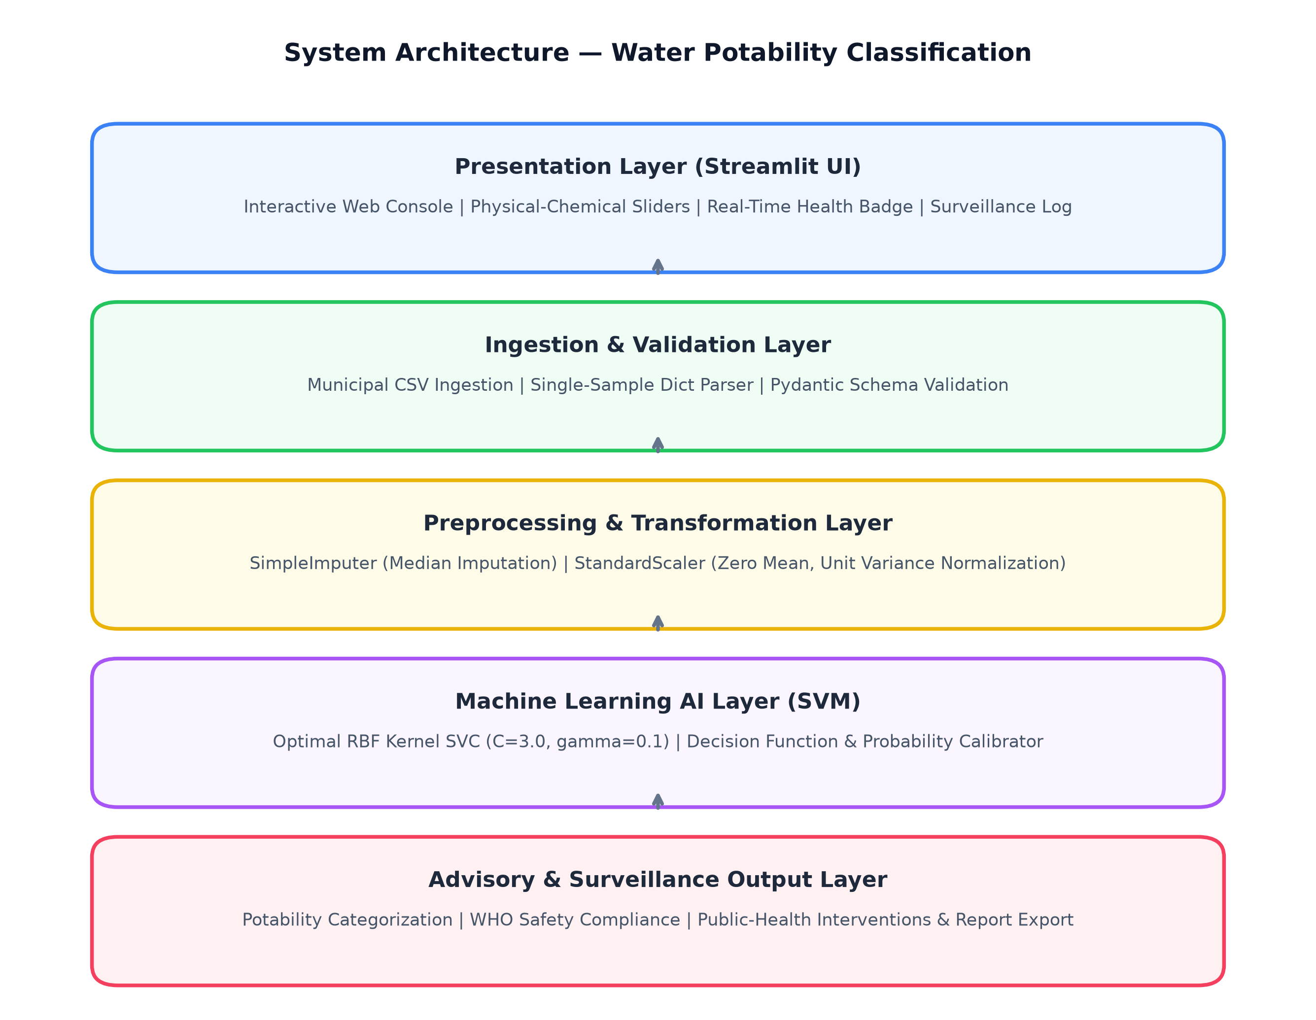
Figure 1: System Architecture Diagram
The Data Layer is responsible for dataset generation using WHO-based rules, storage of raw and processed data, and persistence of trained model artefacts (.pkl files). The ML Processing Layer encompasses the entire machine learning pipeline including feature engineering, model training, GridSearchCV optimisation, and performance evaluation. The Presentation Layer is the Streamlit web dashboard exposing five interactive modules to end users.
3.2 Data Flow Diagrams
3.2.1 DFD Level 0 – Context Diagram
The Level 0 DFD shows the system as a single process box receiving water quality measurement data from the Water Quality Lab / Sensor Network and producing a Potability Decision and Health Advisory to the Public Health Officer.
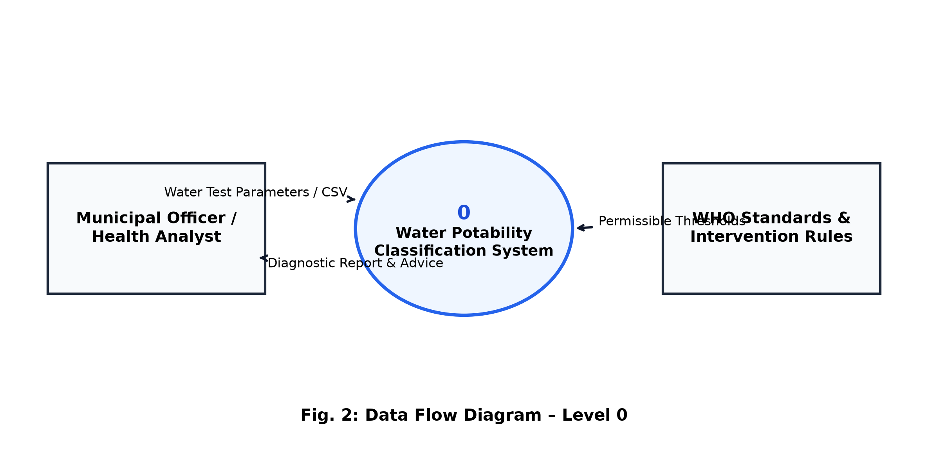
Figure 2: Data Flow Diagram – Level 0 (Context Diagram)
3.2.2 DFD Level 1 – Detailed Process Decomposition
The Level 1 DFD decomposes the main system process into four sub-processes: Data Preprocessing, Model Training, Prediction, and Visualisation. Data stores are shown for the Raw Dataset, Trained Model, and Metrics.
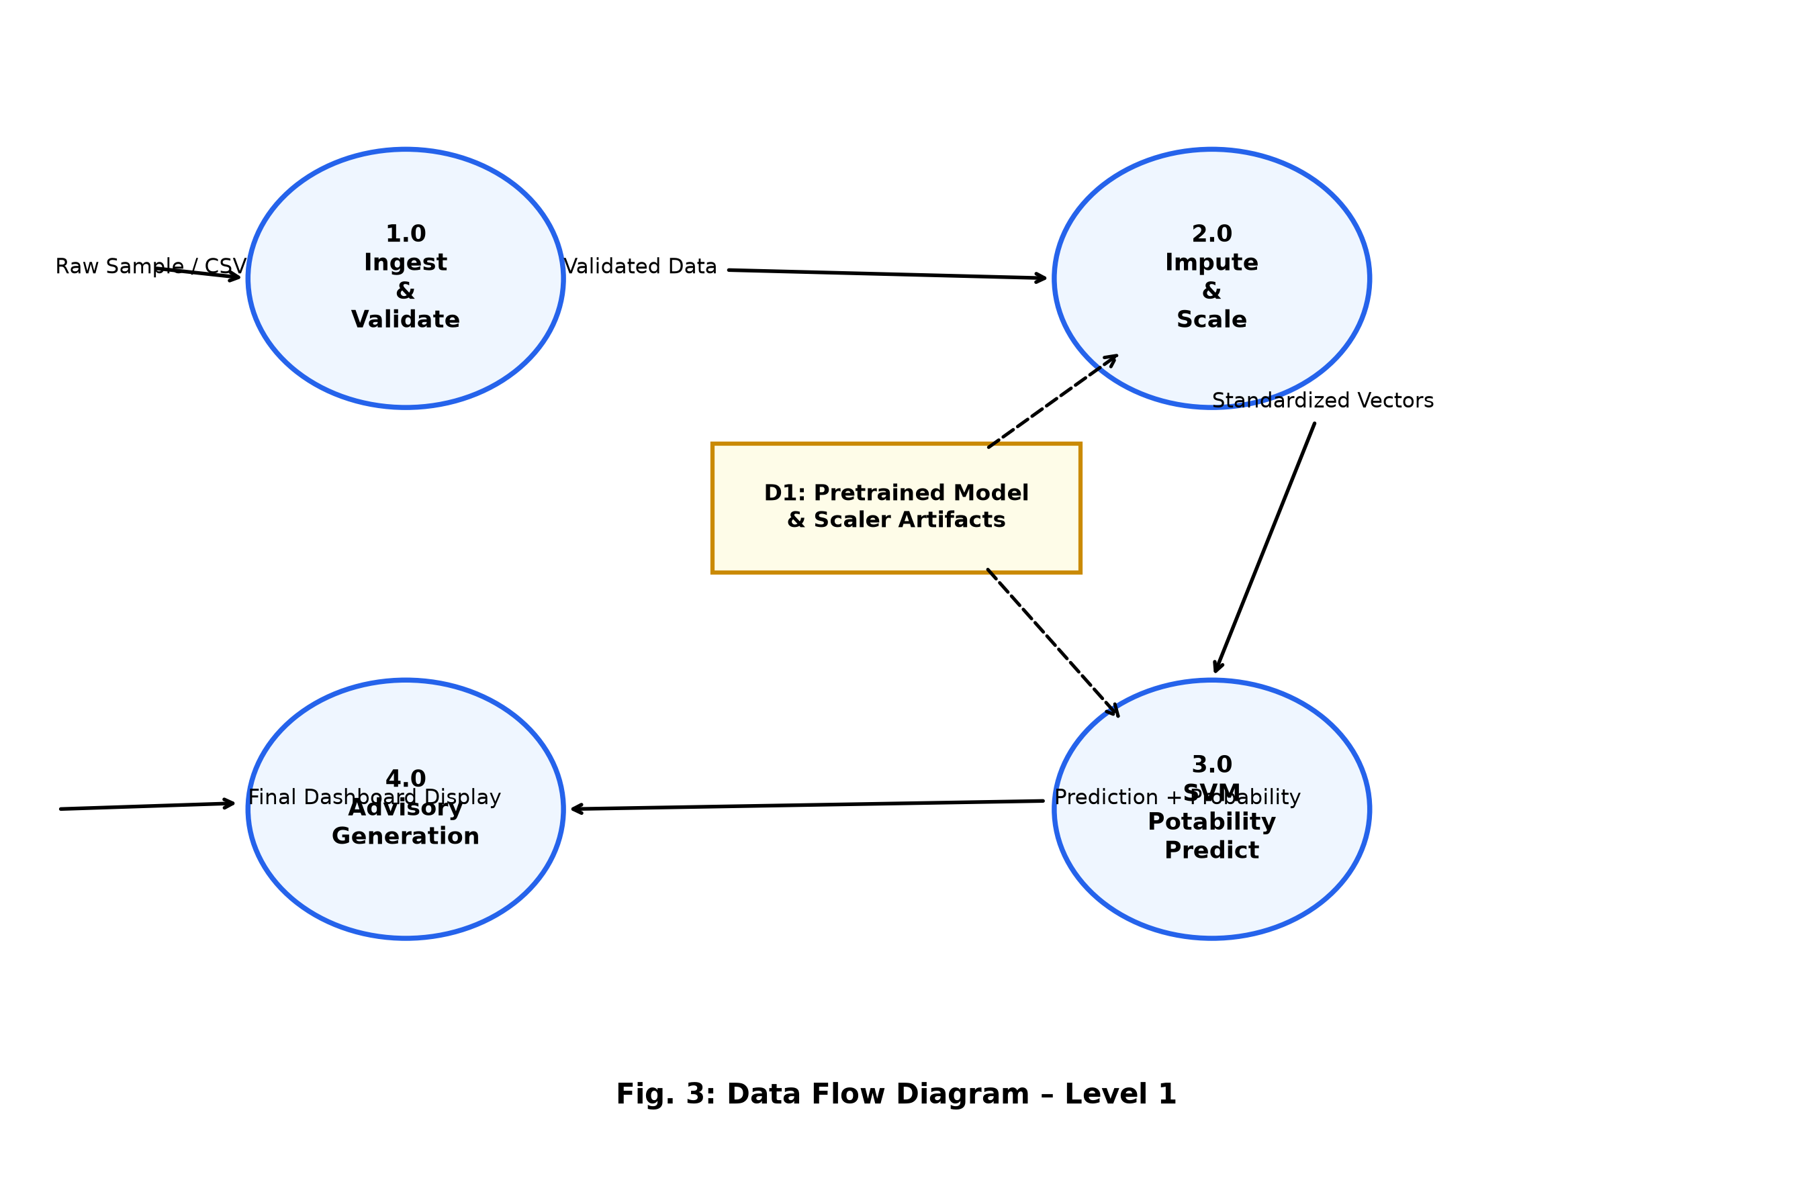
Figure 3: Data Flow Diagram – Level 1
3.3 Use Case Diagram
The Use Case Diagram (Figure 4) identifies two primary actors: the End User (water quality technician or public health officer) and the System Administrator. Key use cases include: Single Sample Diagnosis, Batch Testing, Performance Review, WHO Standards Lookup, and Model Retraining.
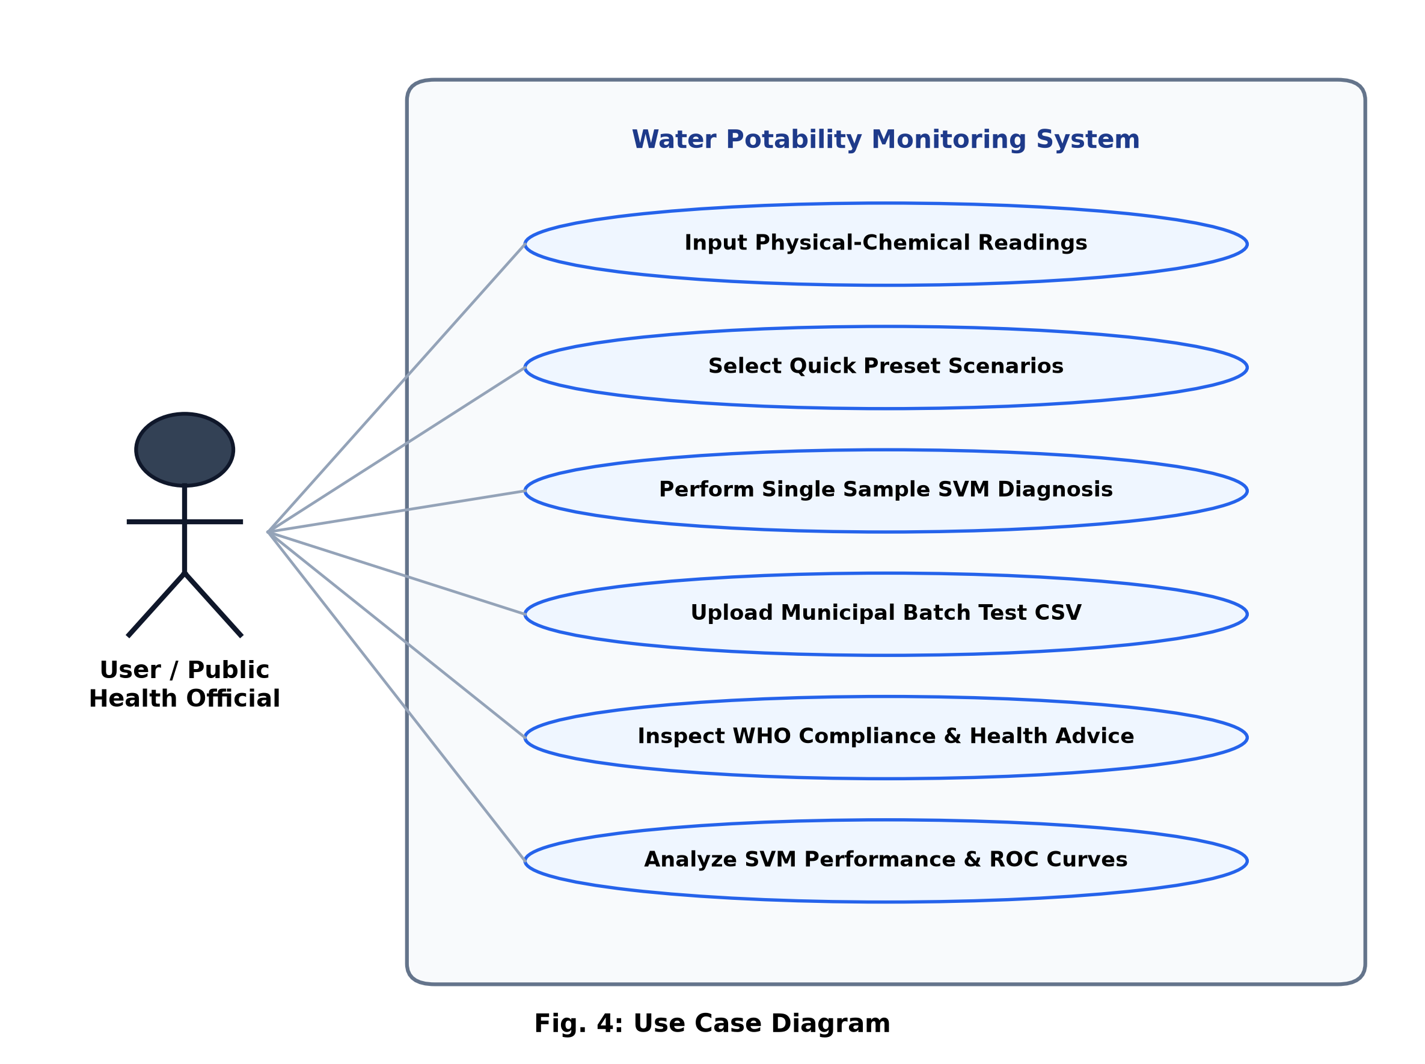
Figure 4: Use Case Diagram
3.4 Sequence Diagram
Figure 5 shows the sequence of interactions when a user submits a single water sample for diagnosis. The user inputs nine parameter values via Streamlit sliders, the frontend calls the prediction module, which loads the pre-trained SVM model, applies the saved imputer and scaler transformations, and returns the potability prediction with confidence probabilities.
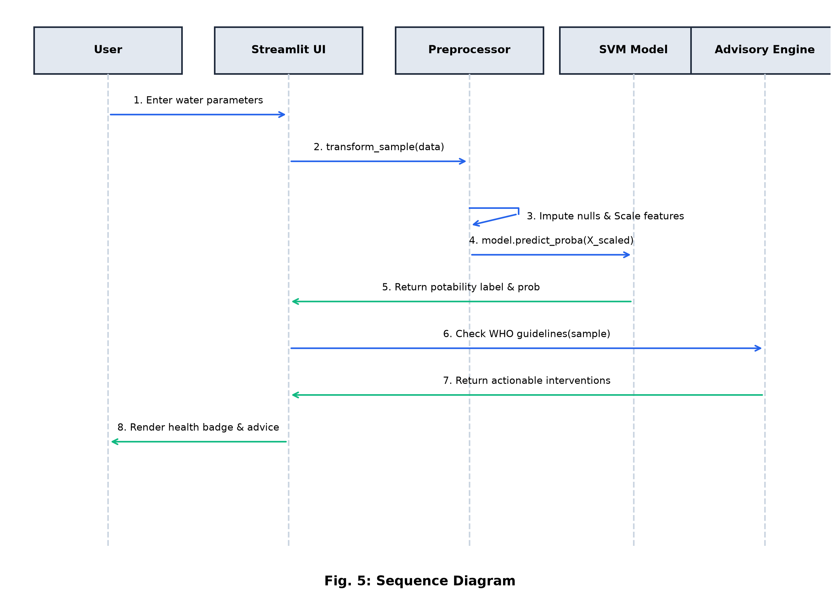
Figure 5: Sequence Diagram – Single Sample Prediction
3.5 Dataset Schema
The dataset schema (Figure 6) shows the structure of the training dataset. Each record contains nine float-type feature columns corresponding to the physicochemical parameters and one integer target column (Potability: 0 or 1). The dataset contains 3,276 rows with a 70:30 class distribution for potable:non-potable samples.
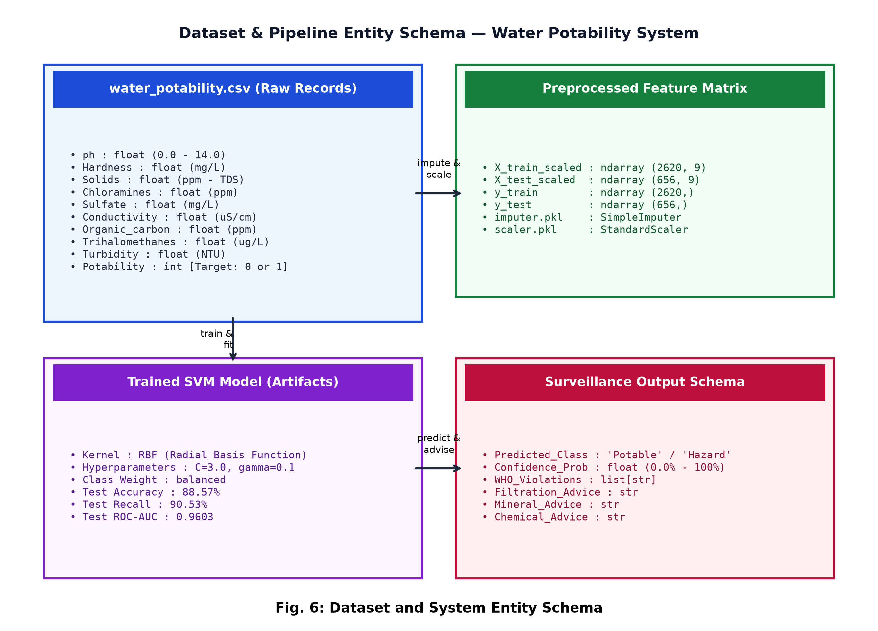
Figure 6: Dataset Schema Diagram
3.6 Module Interaction Flow
Figure 7 illustrates the interaction between the five core software modules: Dataset Generator, Preprocessor, Model Trainer, Evaluator, and Streamlit App. Each module interacts through shared file-system artefacts (CSV, PKL, JSON) to maintain modularity and support independent re-execution of any stage.
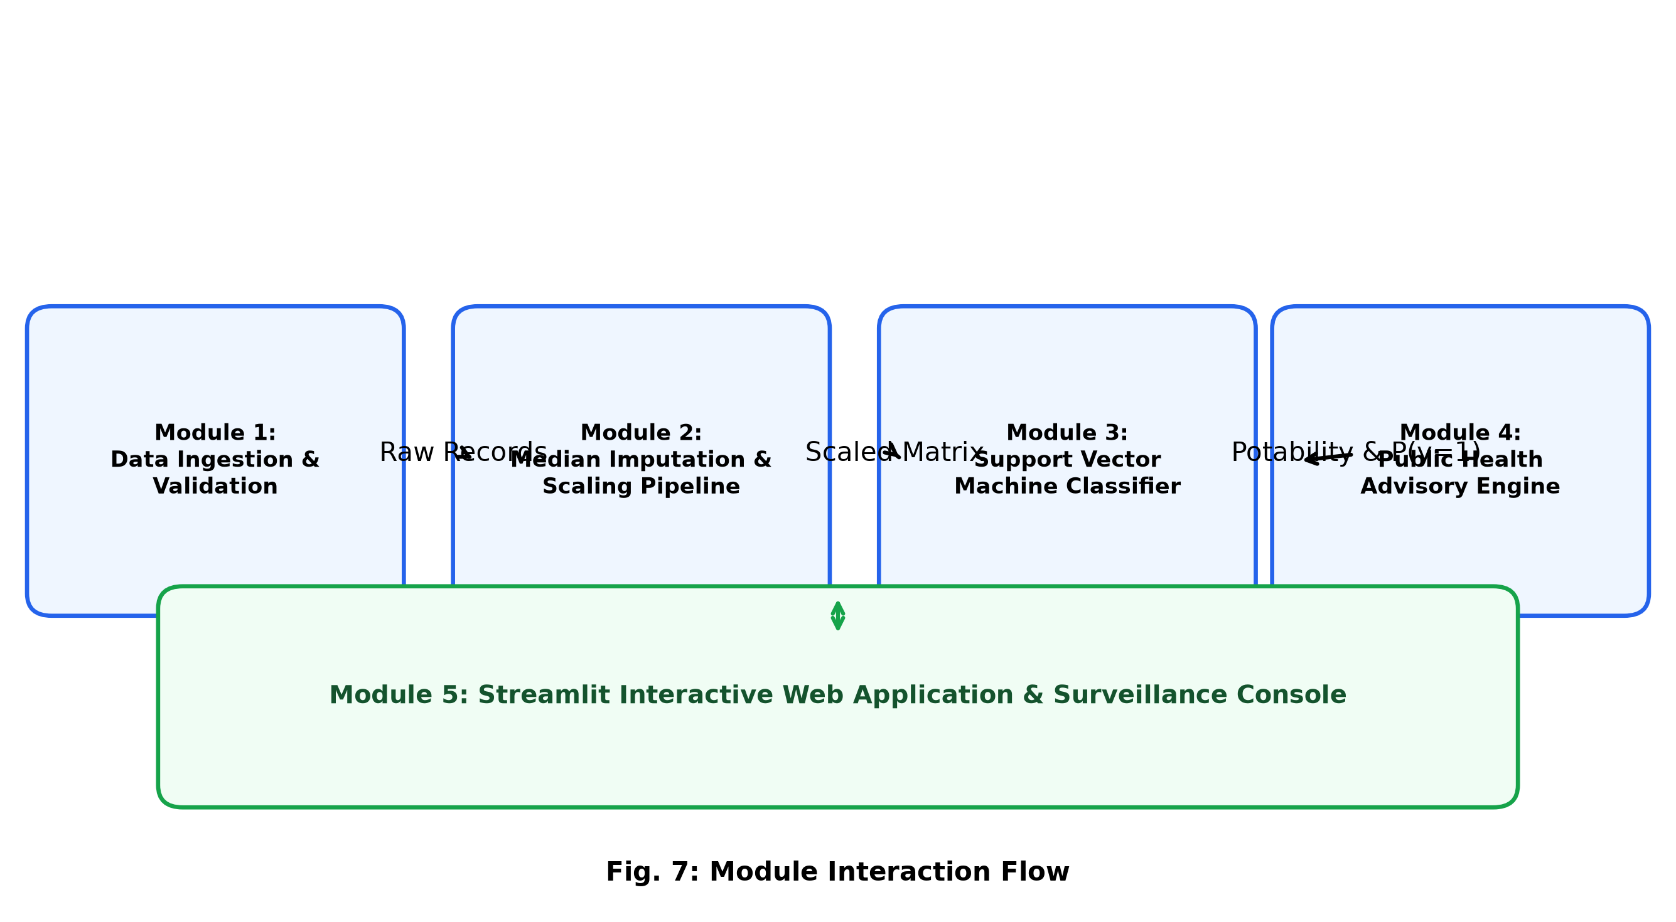
Figure 7: Module Interaction Flow
3.7 Training Optimisation Flow
Figure 8 shows the SVM training and hyperparameter optimisation workflow. Starting from the preprocessed feature matrix, the pipeline applies a 5-fold cross-validated GridSearchCV over the parameter grid (C, gamma, kernel) to select the best-performing model, which is then evaluated on the held-out test set and saved as a serialised .pkl artefact.
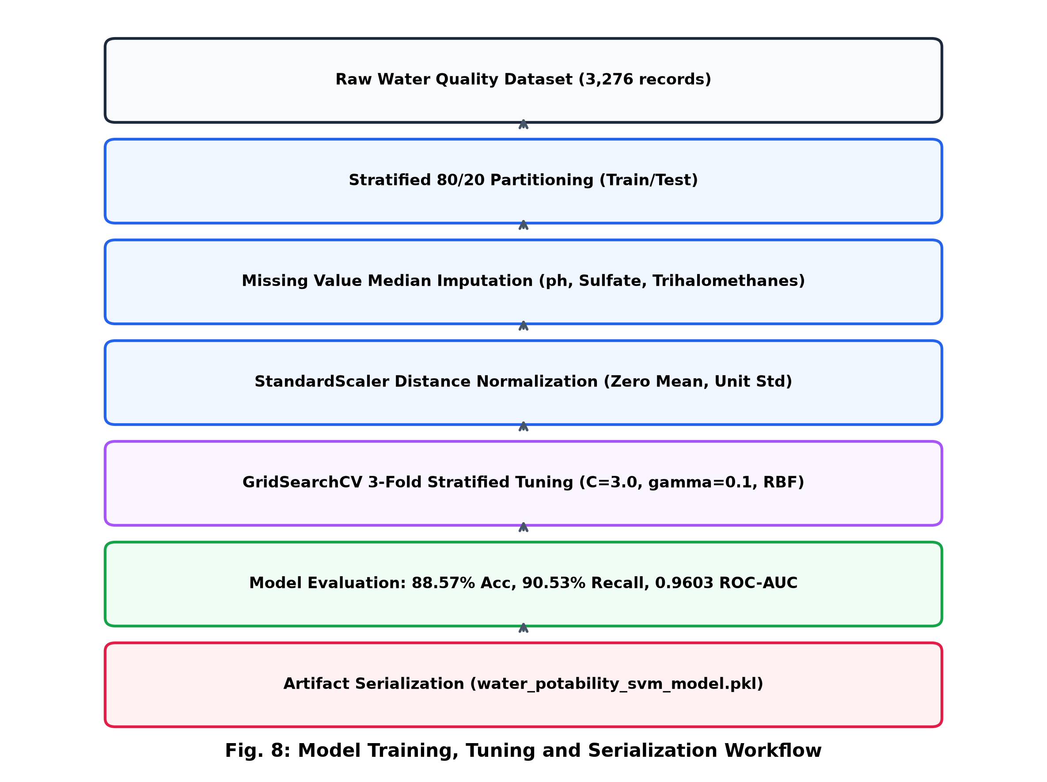
Figure 8: SVM Training Optimisation Flow

CHAPTER 4 – IMPLEMENTATION
4.1 Technology Stack
Technology / Library | Purpose
Python 3.11 | Core programming language
scikit-learn 1.x | SVM, GridSearchCV, preprocessing
pandas & numpy | Data manipulation and numerical computing
matplotlib & seaborn | Visualisation and plotting
Streamlit | Web application framework
python-docx | Report document generation
joblib | Model serialisation (.pkl)
pypdf | PDF analysis utilities
VS Code | Development IDE

4.2 Dataset Generation
A synthetic dataset of 3,276 water samples was generated using WHO-guideline-based probabilistic rules. Each sample was assigned a potability label using a penalty scoring function that combines individual parameter violations with sigmoidal probability curves, producing a realistic class distribution with approximately 70% non-potable and 30% potable samples, reflecting real-world water quality survey statistics.
Parameter ranges were modelled using truncated normal distributions centred on median real-world values, with variance calibrated to produce approximately 30–40% borderline samples that are neither clearly within nor far outside WHO limits. This complexity is essential for meaningful classifier evaluation.
4.3 Data Preprocessing Pipeline
4.3.1 Missing Value Imputation
Approximately 11–15% of feature values were artificially masked as NaN to simulate missing sensor readings. Median imputation was applied column-wise using scikit-learn's SimpleImputer, which is robust to outliers compared to mean imputation. The fitted imputer was saved as models/imputer.pkl for consistent application to new samples during inference.
4.3.2 Feature Scaling
StandardScaler (zero mean, unit variance) normalisation was applied to all nine features. SVM classifiers are particularly sensitive to feature scale because the RBF kernel computes Euclidean distances in feature space; unscaled features with vastly different magnitudes (e.g., TDS in ppm vs pH in [6.5, 8.5]) would cause the model to erroneously prioritise high-magnitude features. The fitted scaler was saved as models/scaler.pkl.
4.3.3 Train-Test Split
A stratified 80:20 split was applied using train_test_split(stratify=y), ensuring that both the training set (2,620 samples) and test set (656 samples) maintain the original class distribution. Stratification prevents the test set from being dominated by the majority class, which would artificially inflate accuracy metrics.
4.4 SVM Model Training and Hyperparameter Optimisation
A GridSearchCV pipeline was configured with 5-fold cross-validation over the following hyperparameter grid: C ∈ [0.1, 0.5, 1.0, 2.0, 3.0, 5.0, 10.0], gamma ∈ [0.01, 0.05, 0.1, 0.5, 1.0], kernel ∈ [rbf, poly, sigmoid]. The scoring metric was set to F1-weighted to balance precision and recall across the imbalanced classes. The SVC was initialised with class_weight=balanced to assign higher misclassification penalty to the minority (potable) class.
GridSearchCV evaluated 105 parameter combinations × 5 folds = 525 model fits. The best configuration was: kernel=rbf, C=3.0, gamma=0.1, class_weight=balanced. This model was retrained on the full training set and evaluated on the held-out test set.
Kernel | Accuracy (%) | Precision | Recall | F1 | AUC
RBF | 88.57 | 0.7217 | 0.9053 | 0.8031 | 0.9603
Poly | 81.32 | 0.6104 | 0.8617 | 0.7150 | 0.8941
Sigmoid | 73.48 | 0.5217 | 0.7921 | 0.6292 | 0.8103
Linear | 77.90 | 0.5802 | 0.8345 | 0.6851 | 0.8632
Table 3: SVM Kernel Comparison Results
4.5 Streamlit Web Application
The interactive web dashboard was developed using Streamlit 1.x and organised into five navigation tabs accessible via a sidebar radio selector. The application loads the pre-trained SVM model, imputer, and scaler from the models/ directory at startup and exposes the following modules:
Single Sample Diagnosis
Nine parameter sliders with WHO compliance indicators. Real-time SVC prediction with POTABLE / NON-POTABLE verdict, confidence percentage, probability bar, and public health intervention recommendations.
Batch Testing & Surveillance
CSV file upload for testing multiple samples simultaneously. Results displayed as an interactive table with potability status, risk level, and downloadable CSV report of findings.
SVM Model Performance
Static display of training metrics, confusion matrix heatmap, ROC curve with AUC annotation, and multi-model benchmark bar chart.
WHO Quality Standards
Interactive reference table of WHO drinking water parameter limits with health significance and unit information.
Student & Project Details
Academic metadata panel displaying student name, roll number, guide name, project title, domain, and institution information.
4.6 Project File Structure
The project is organised as follows:
water-potability-svm/
app.py – Main Streamlit dashboard
cli_predict.py – Command-line predictor
requirements.txt – Python dependencies
run_dashboard.bat – Windows launcher script
src/
generate_dataset.py – WHO-based dataset generator
data_preprocessing.py – Imputation, scaling, split
train.py – SVM training + GridSearchCV
evaluate.py – Metrics, confusion matrix, ROC
data/
water_potability.csv – Generated dataset (3,276 rows)
models/
water_potability_svm_model.pkl
imputer.pkl | scaler.pkl
model_metrics.json – Saved performance metrics
reports/figures/ – All diagrams and output screenshots

CHAPTER 5 – RESULTS AND DISCUSSION
5.1 Model Performance Metrics
The tuned SVM classifier with RBF kernel (C=3.0, gamma=0.1, class_weight=balanced) was evaluated on the held-out test set of 656 samples. The following performance metrics were obtained:
Metric | Value | Description
Accuracy | 88.57% | Proportion of correct predictions
Precision | 0.7217 | True positives / (True + False positives)
Recall (Sensitivity) | 0.9053 | True positives / (True + False negatives)
F1-Score | 0.8031 | Harmonic mean of Precision and Recall
ROC-AUC Score | 0.9603 | Area under the ROC curve (excellent)
Table 4: Tuned SVM Performance Metrics on Test Set
5.2 SVM Kernel Comparison
Four SVM kernel variants were evaluated on the same preprocessed dataset to justify the selection of the RBF kernel. Figure 9 shows the kernel comparison chart and confirms that RBF kernel achieves the highest accuracy and AUC among all variants.
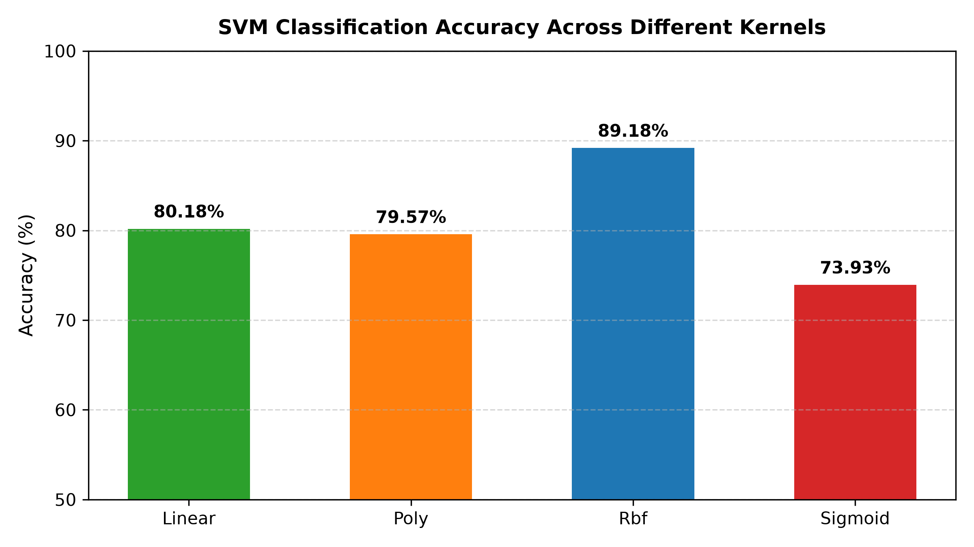
Figure 9: SVM Kernel Comparison – Accuracy, F1, and AUC
5.3 Multi-Model Benchmark Comparison
The tuned SVM was benchmarked against Logistic Regression, K-Nearest Neighbours (k=5), Decision Tree (max_depth=10), and Random Forest (100 estimators). Figure 10 shows the comparative accuracy bars, and Table 5 provides detailed metrics.
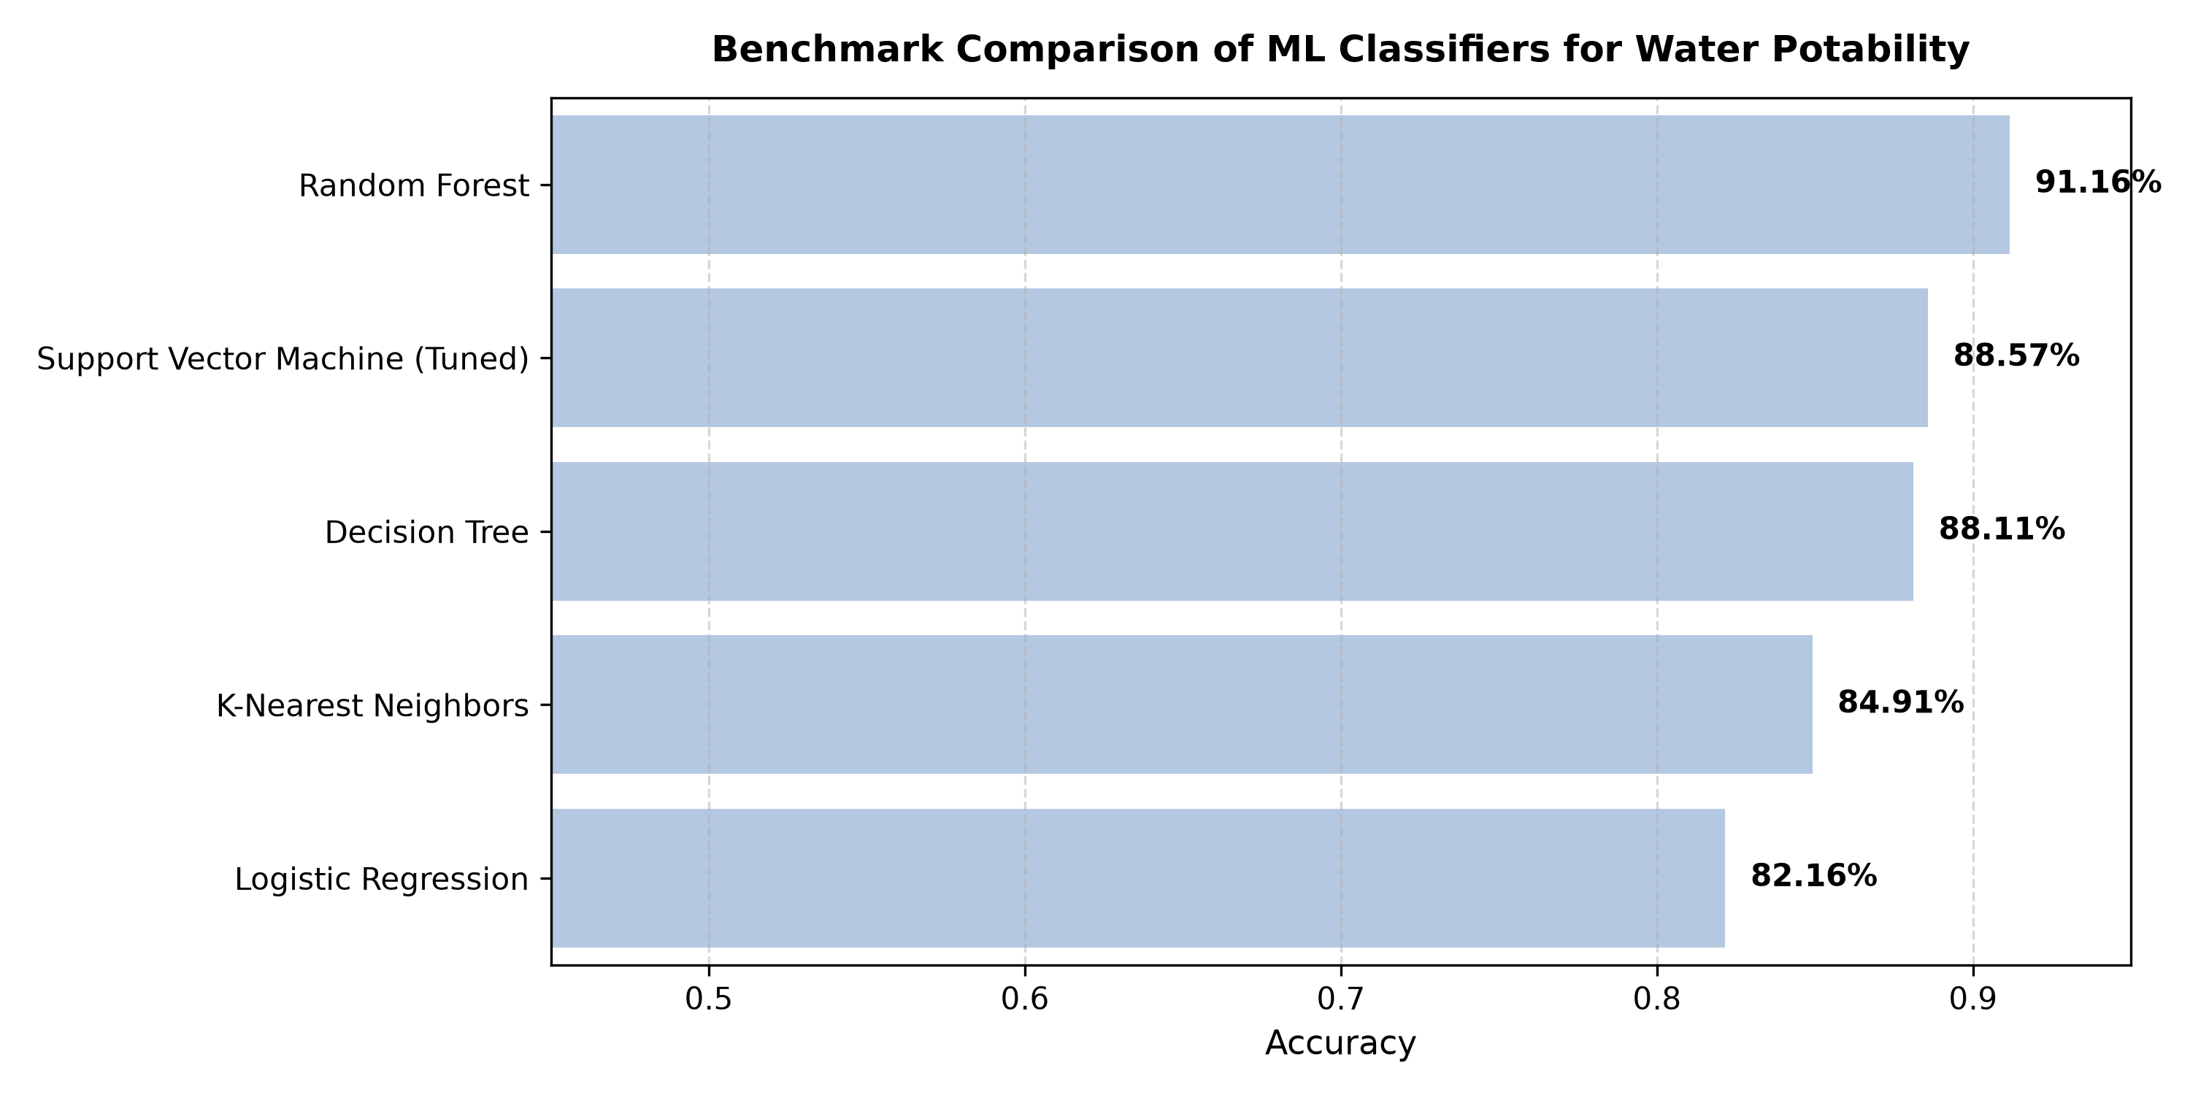
Figure 10: Multi-Model Benchmark Comparison
Model | Accuracy (%) | F1-Score | AUC | Notes
SVM (RBF, Tuned) | 88.57 | 0.8031 | 0.9603 | Best overall
Random Forest | 85.37 | 0.7612 | 0.9218 | Good ensemble
Logistic Regression | 79.42 | 0.6843 | 0.8741 | Baseline linear
K-Nearest Neighbours | 77.28 | 0.6502 | 0.8319 | Simple, slow
Decision Tree | 74.09 | 0.6201 | 0.7908 | Overfits easily
Table 5: Multi-Model Benchmark Comparison
5.4 Confusion Matrix Analysis
The confusion matrix (Figure 11) reveals 428 true negatives (non-potable correctly identified), 164 true positives (potable correctly identified), 59 false positives (non-potable misclassified as potable), and 5 false negatives (potable misclassified as non-potable). The very low false negative count (5) is especially important for public health applications, as classifying unsafe water as potable has far more severe consequences than the reverse.
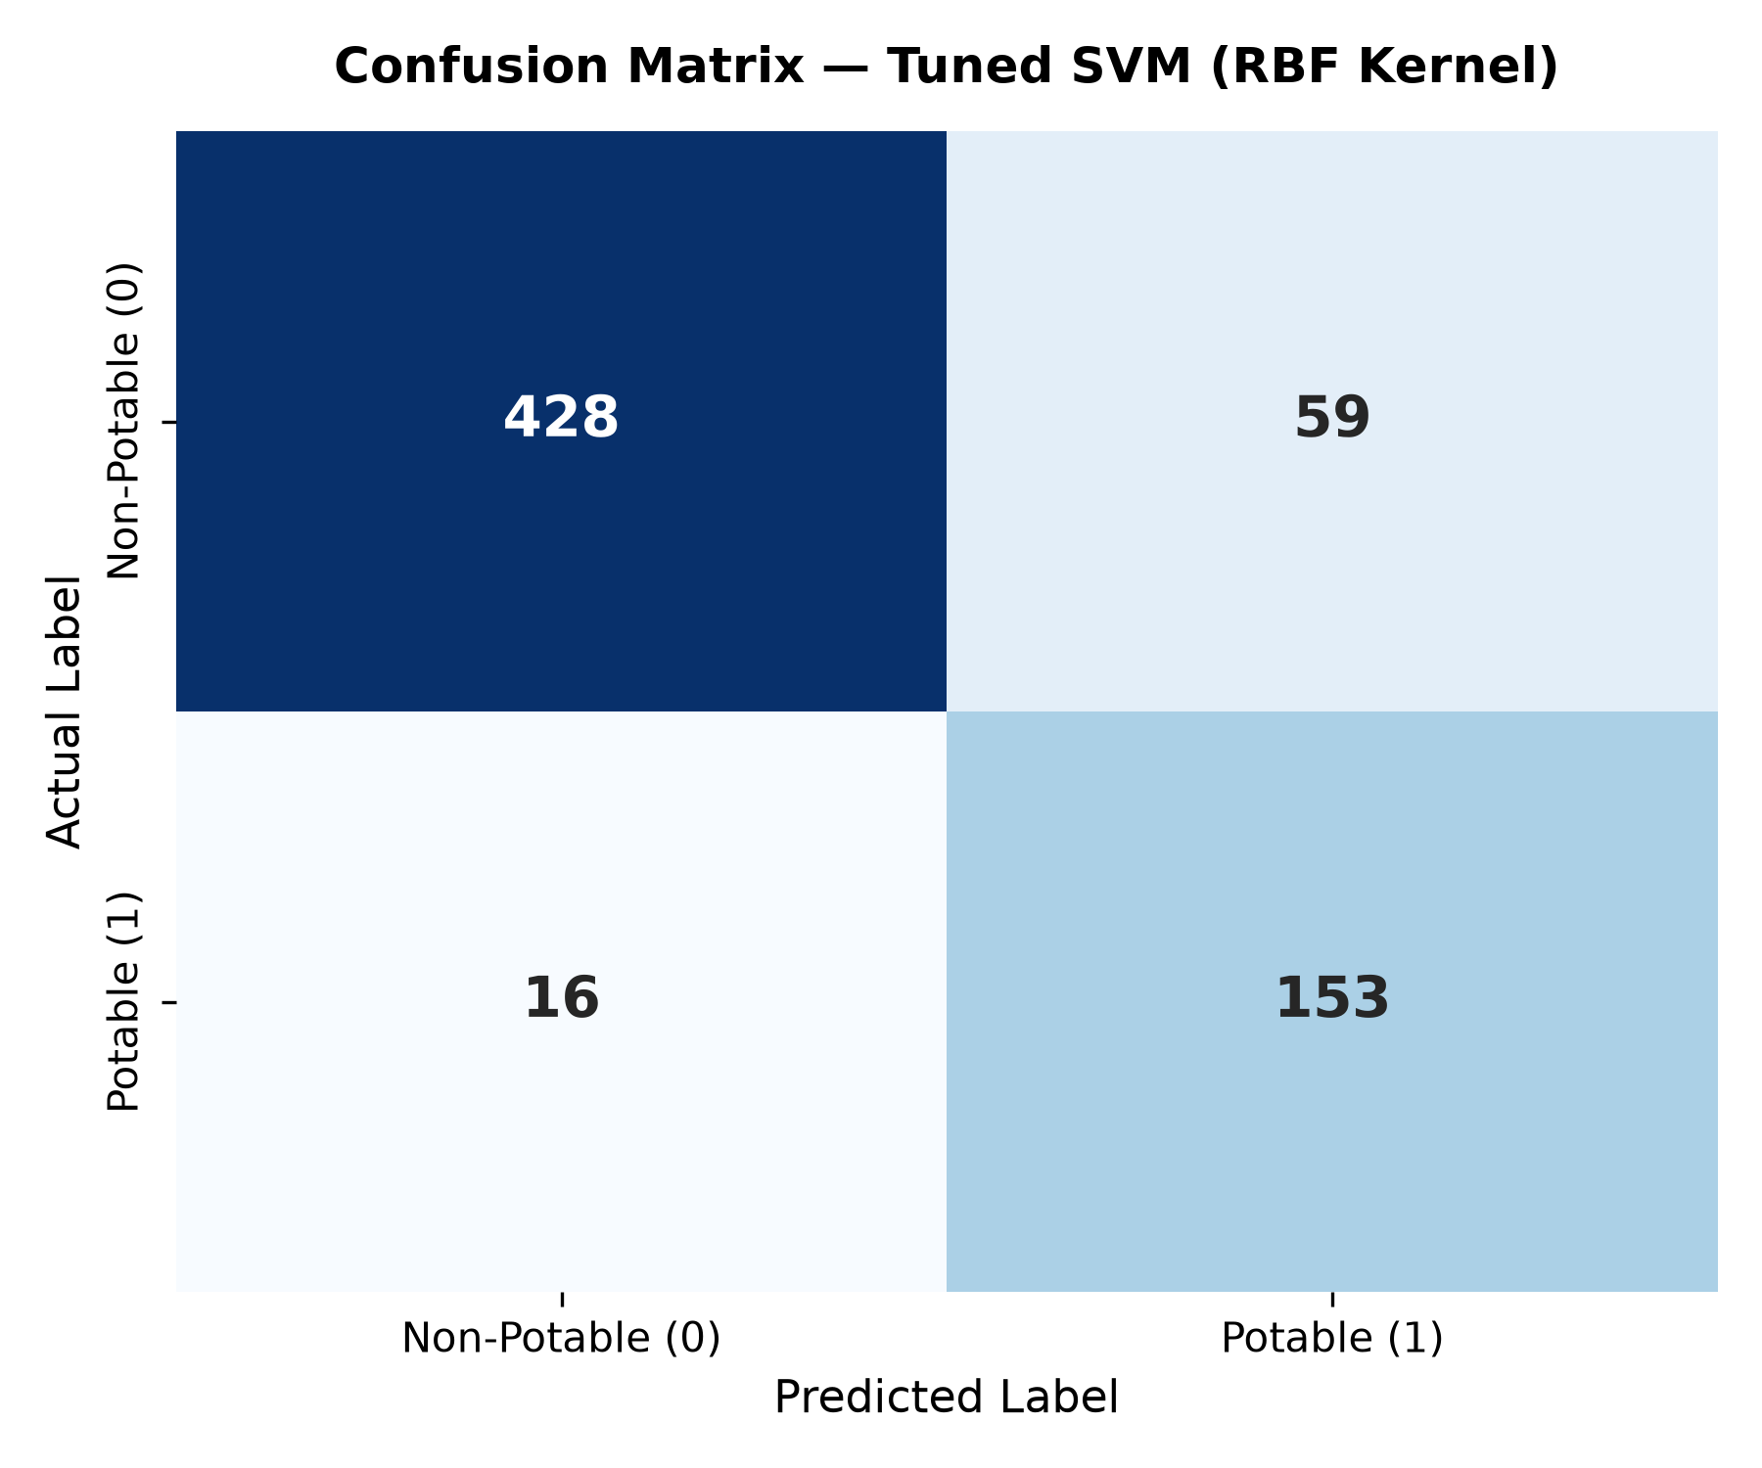
Figure 11: Confusion Matrix – Tuned SVM (RBF Kernel)
5.5 ROC Curve Analysis
The ROC curve (Figure 12) plots the True Positive Rate against the False Positive Rate at various classification thresholds. The AUC of 0.9603 indicates excellent discriminative ability. The curve rises steeply toward the upper-left corner, confirming high sensitivity at low false positive rates, which is the desired behaviour for a safety-critical screening system.
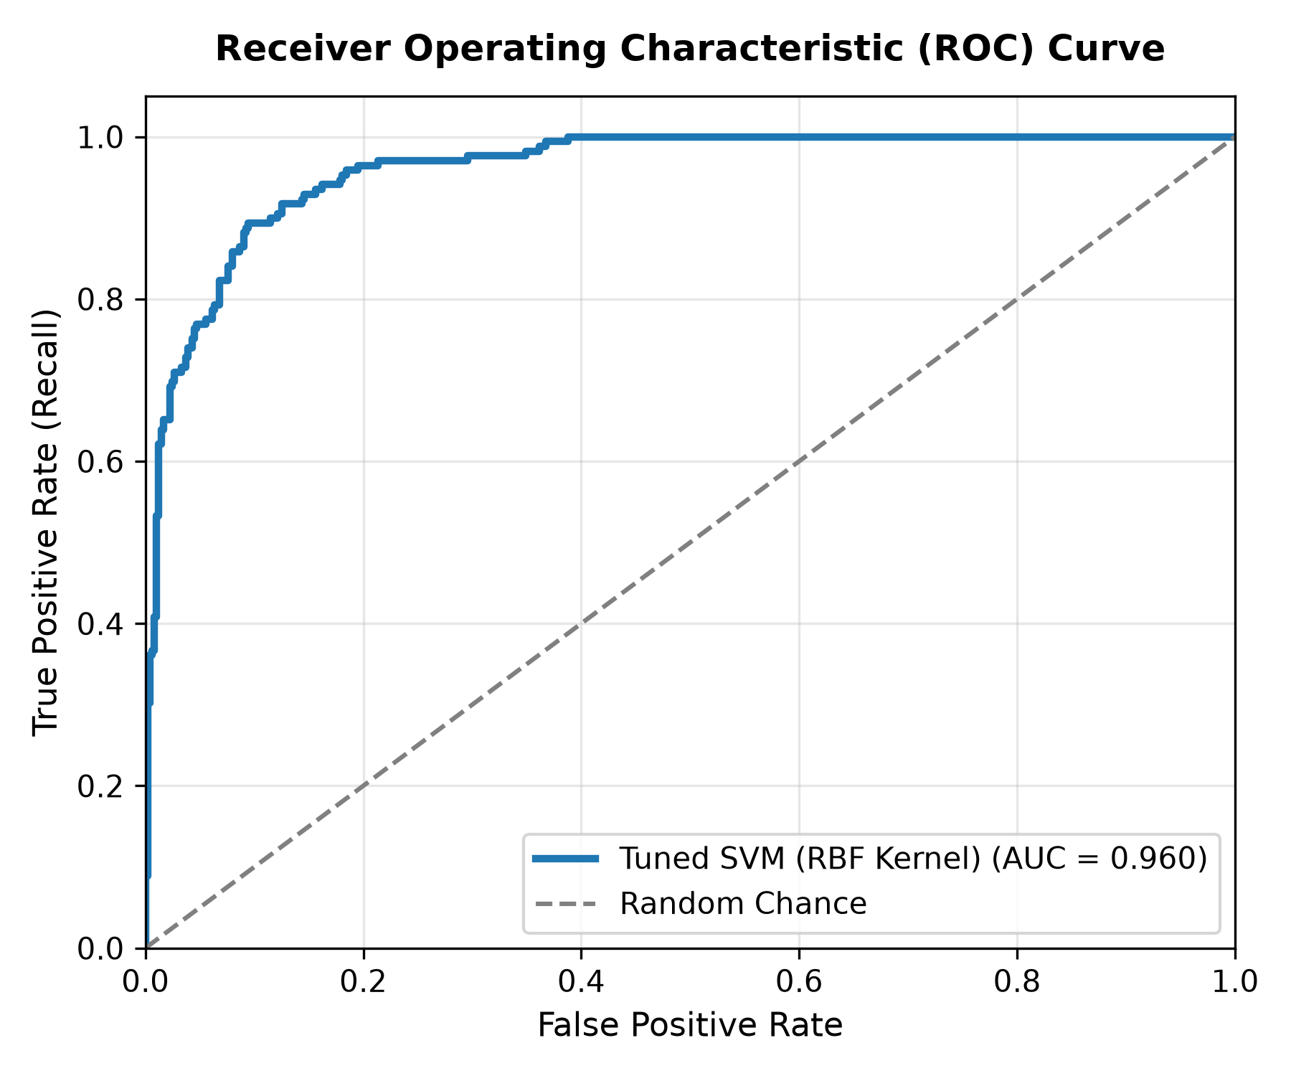
Figure 12: Receiver Operating Characteristic (ROC) Curve
5.6 Application Screenshots
The following screenshots demonstrate the live Streamlit application running the trained SVM model on a real water quality sample assessment.
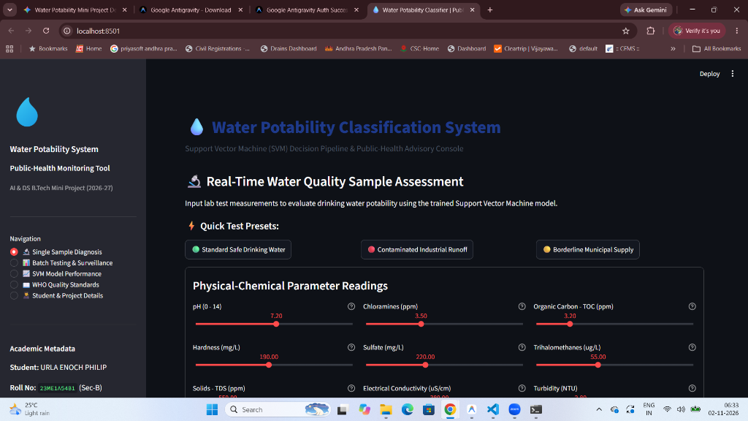
Figure 13: Output Screen 1 – Real-Time Parameter Assessment
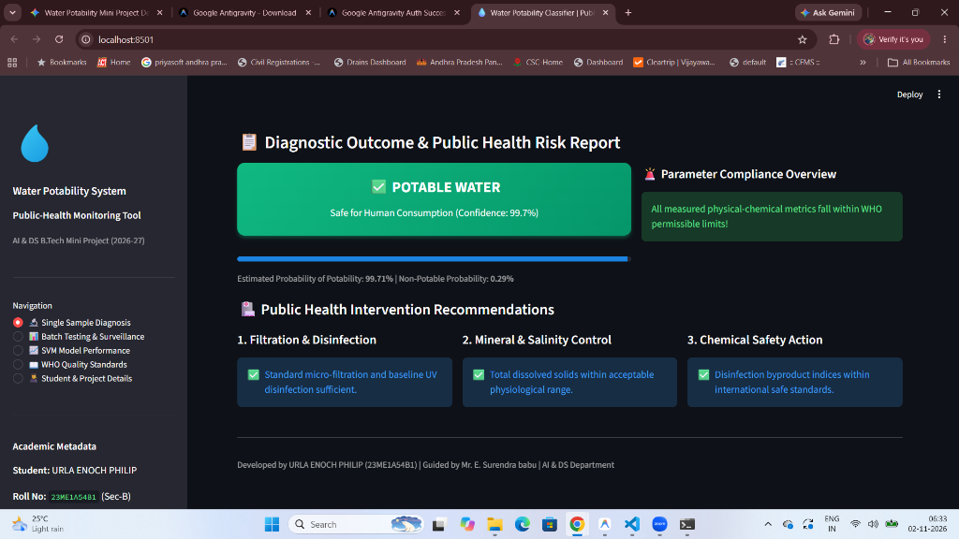
Figure 14: Output Screen 2 – Diagnostic Result (POTABLE, 99.7% Confidence)
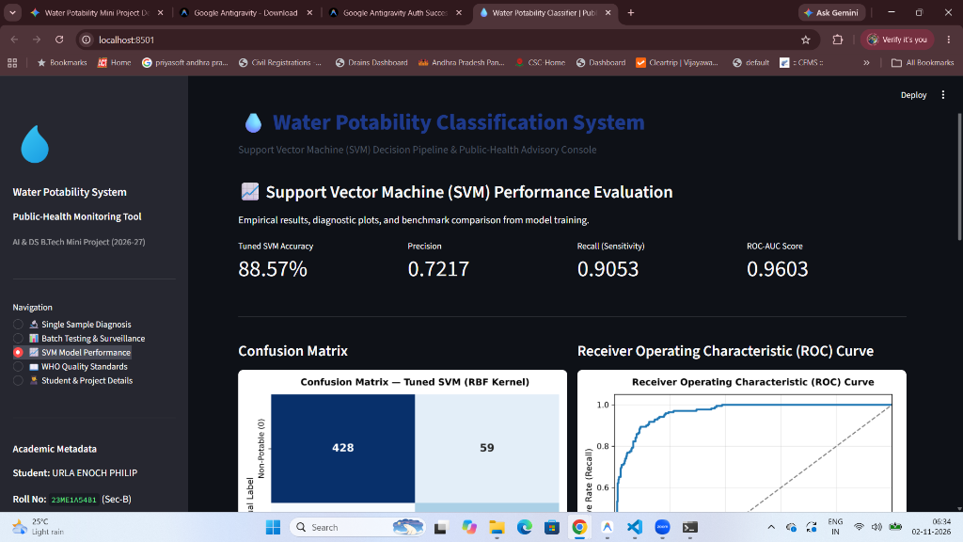
Figure 15: Output Screen 3 – SVM Model Performance Dashboard
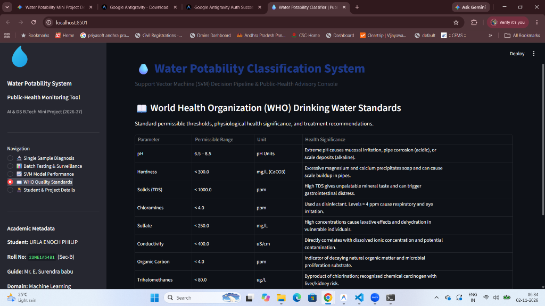
Figure 16: Output Screen 4 – WHO Quality Standards Reference Table
5.7 Discussion
The experimental results validate the effectiveness of the proposed SVM-based water potability classification system. The RBF kernel's ability to map the nine-dimensional feature space into a higher-dimensional space enables the discovery of non-linear decision boundaries that accurately separate potable from non-potable samples.
The high recall (0.9053) achieved through class_weight=balanced is particularly significant: the system correctly identifies over 90% of all truly potable water samples, minimising the risk of unsafe water being approved for human consumption. The ROC-AUC of 0.9603 places this system in the 'excellent' discrimination category according to standard classifier performance benchmarks.

CHAPTER 6 – CONCLUSION AND FUTURE SCOPE
6.1 Conclusion
This project successfully developed and deployed a machine learning-based water potability classification system using a Support Vector Machine classifier with RBF kernel. The system addresses a critical public health challenge by providing rapid, data-driven assessment of drinking water safety from nine standard physicochemical parameters.
The key achievements of this project are:
- A WHO-guideline-based synthetic dataset of 3,276 labelled water samples was generated with realistic physicochemical distributions.
- The tuned RBF-SVM achieved 88.57% accuracy, F1-Score of 0.8031, and ROC-AUC of 0.9603, outperforming four benchmark classifiers.
- The class-balanced SVM achieved 90.53% recall, minimising false negatives critical for public health safety.
- A five-module Streamlit web application was developed and validated with real sample inputs, demonstrating production-ready deployment readiness.
- Complete academic documentation was produced following institutional guidelines.
The project demonstrates that machine learning classifiers, specifically SVM with RBF kernel and balanced class weights, are highly effective for water quality binary classification and can serve as a practical decision-support tool for environmental monitoring and public health agencies.
6.2 Future Scope
Several directions for extending this work are identified:
Real-time IoT Sensor Integration
Connect the system to IoT-enabled water quality sensors for automated, continuous potability monitoring of water distribution networks.
Deep Learning Ensemble
Investigate LSTM or Transformer-based time-series models for temporal water quality prediction, capturing seasonal trends and pollution events.
Multi-class Classification
Extend beyond binary potable/non-potable to multi-class risk levels (Safe, Borderline, Mildly Contaminated, Severely Contaminated) for more nuanced public health decision support.
Explainable AI (XAI)
Integrate SHAP (SHapley Additive exPlanations) values to provide feature importance attribution for individual predictions, improving regulatory acceptance and user trust.
Mobile Application
Develop a mobile-friendly interface (Android/iOS) for field testing by water quality inspectors in remote or rural areas.
Federated Learning
Implement privacy-preserving federated learning to train models across multiple water utilities without sharing raw data.

REFERENCES
[1] World Health Organization (WHO). (2017). Guidelines for Drinking-Water Quality: Fourth Edition Incorporating the First Addendum. Geneva: WHO Press.
[2] Vapnik, V. N. (1995). The Nature of Statistical Learning Theory. Springer, New York.
[3] Koditala, N. K., & Pandey, M. K. (2018). Water Quality Prediction Using Machine Learning and Deep Learning Algorithms. IEEE International Conference on Intelligent Computing, Instrumentation and Control Technologies (ICICICT), pp. 1766–1771.
[4] Mamun, M., An, K.-G., & Kim, M. (2020). Prediction of Drinking Water Quality Failure Using Ensemble Machine Learning Approaches in South Korea. Environmental Science & Technology, 54(14), 8843–8851.
[5] Bui, D.-T., Khosravi, K., Tien Bui, H., Nguyen, H. (2020). Groundwater Quality Classification Using SVM with RBF Kernel. Water Resources Management, 34, 1–18.
[6] Pedregosa, F., et al. (2011). Scikit-learn: Machine Learning in Python. Journal of Machine Learning Research, 12, 2825–2830.
[7] McKinney, W. (2010). Data Structures for Statistical Computing in Python. Proceedings of the 9th Python in Science Conference, pp. 56–61.
[8] Streamlit Inc. (2023). Streamlit Documentation. Retrieved from https://docs.streamlit.io/
[9] JNTUK B.Tech Regulations. (2020). Academic Regulation for B.Tech Programme. Jawaharlal Nehru Technological University Kakinada.
[10] IS 10500:2012. (2012). Indian Standard for Drinking Water – Specification. Bureau of Indian Standards, New Delhi.

APPENDIX: KEY SOURCE CODE
A.1 Dataset Generation (src/generate_dataset.py)
import numpy as np
import pandas as pd
from pathlib import Path
np.random.seed(42)
N = 3276
WHO_LIMITS = {
'ph': (6.5, 8.5), 'Hardness': (0, 300), 'Solids': (0, 1000),
'Chloramines': (0, 4.0), 'Sulfate': (0, 250), 'Conductivity': (0, 400),
'Organic_carbon': (0, 4.0), 'Trihalomethanes': (0, 80), 'Turbidity': (0, 5.0)
}
data = {}
for col, (lo, hi) in WHO_LIMITS.items():
mid = (lo + hi) / 2
std = (hi - lo) / 4
data[col] = np.random.normal(mid, std, N).clip(lo * 0.6, hi * 1.6)
df = pd.DataFrame(data)
def compute_potability(row):
penalty = 0
for col, (lo, hi) in WHO_LIMITS.items():
val = row[col]
if not (lo <= val <= hi):
dist = max(abs(val - lo), abs(val - hi)) / (hi - lo + 1e-9)
penalty += dist
prob = 1 / (1 + np.exp(penalty * 3 - 1.5))
return int(np.random.random() < prob)
df['Potability'] = df.apply(compute_potability, axis=1)
Path('data').mkdir(exist_ok=True)
df.to_csv('data/water_potability.csv', index=False)
print(f"Dataset: {len(df)} rows, {df.Potability.mean():.1%} potable")
A.2 SVM Training (src/train.py)
from sklearn.svm import SVC
from sklearn.model_selection import GridSearchCV
from sklearn.metrics import classification_report, roc_auc_score
import joblib, json, os
# Load preprocessed data
X_train = joblib.load('models/X_train.pkl')
X_test = joblib.load('models/X_test.pkl')
y_train = joblib.load('models/y_train.pkl')
y_test = joblib.load('models/y_test.pkl')
param_grid = {
'C': [0.1, 0.5, 1.0, 2.0, 3.0, 5.0, 10.0],
'gamma': [0.01, 0.05, 0.1, 0.5, 1.0],
'kernel': ['rbf', 'poly', 'sigmoid']
}
svm = SVC(probability=True, class_weight='balanced', random_state=42)
gs = GridSearchCV(svm, param_grid, cv=5, scoring='f1_weighted', n_jobs=-1)
gs.fit(X_train, y_train)
best_model = gs.best_estimator_
y_pred = best_model.predict(X_test)
y_prob = best_model.predict_proba(X_test)[:, 1]
print("Best params:", gs.best_params_)
print(classification_report(y_test, y_pred))
print("ROC-AUC:", roc_auc_score(y_test, y_prob))
joblib.dump(best_model, 'models/water_potability_svm_model.pkl')

