|  |
| --- |
| The Institute of Applied Poultry Technology |
| Flock Information Database |

|  |
| --- |
| Enoch Tsang, Jackie Luc, James Inglis, Moath Althawad |

**Abstract:**

The Institute of Applied Poultry Technology (IAPT) is a non-profit entity that was established to innovate cost saving poultry health technologies that provides a full range of laboratory services. They aim to maximize the health, welfare and productivity of their livestock and as well as further improve food quality and safety. Some responsibilities of the IAPT employees is to conduct research to study and create new vaccines to combat new or existing diseases. Enterprises, who hire poultry producers, must submit forms known as flock sheets (please refer below), which contain valuable data that allows IAPT employees to retrieve the data from the database for their research. These physical forms results in an inconvenience and also inefficiency in organizing or sorting data required for research. A solution to this issue is to remove the requirement of manually acquiring the data by implementing an interface that interacts with a database that stores the submitted data. This solution will reduce physical overhead such as submission of forms in person or through fax and also improve the efficiency of research of the IAPT employees. 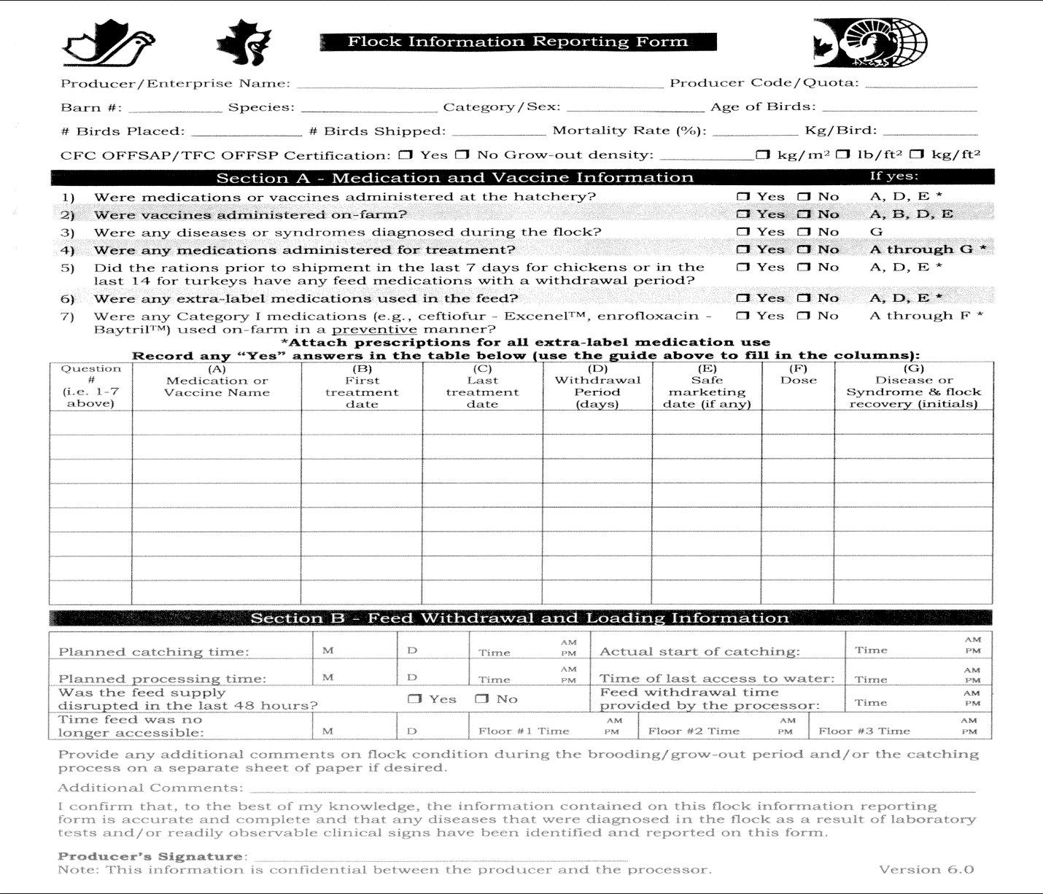

**Introduction:**

The current format of accessing the data of submission forms is very inefficient, as a result of the required manual labour of searching, organizing, or retrieving data. A solution to this inefficiency is to develop a digital system of filling and submitting the form, and as well as allow employees to access the submitted data more efficiently. This solution would be offered to the poultry producer without a cost, and ultimately allows the employees to retrieve any data that was submitted for more efficient research. A database will be implemented to store the data from the submitted forms.A website application will be an interface to allow producers to submit the forms. A producer is expected to be able to access a website and fill in the form and also be able to submit it to be stored in the database. An IAPT employee, would be expected to be able to access the database and retrieve results that can be manipulated for their research. A government employee would be expected to view the data that was submitted and will also store a copy of required information in their own preferences.

**Project Design:**

There are three users that will use this system. The user’s interaction with this system will be discussed in more detail below.

**Enterprises/Producers:** An enterprise is a company that hires one or more producers of agriculture and these producers can also be enterprises. In this system, a producer will be able to submit information related to their flock of poultry. The submitted information includes but is not limited to the barn number, category of poultry, and any medications that have been administered to the flock that is being reported. A producer is required to provide this information by accessing the website interface to submit a form. Currently, the producer is only limited to have access to a submission page where they can report the information and not any other page other than the login page. Realistically, a producer should be given an account or be required to register and to be verified by the government to ensure that the data that is being submitted is authorized and valid. However, for the purpose of demonstration of our system, a simple registry system of the producer is implemented. Some sample transactions for a producer includes registering and logging into the website, and as well as submitting a form. These transactions include inserting information into the database, as a result of registering the user and the submission of their form. Another transaction may include retrieving the producer’s credentials to verify a valid user upon login.

**IAPT Employees:** An IAPT employee can range from veterinarians to scientists, but suppose that these employees are strictly researchers and disregard any other position. These employees will have full access to the database and can retrieve specific information that has been submitted by the producers. It would be reasonable for the researchers to only have access to retrieving data from the database and let another group of employees that has acquired technical database management knowledge (and possibly not be a researcher), to have full access to maintain and authorize changes to the information that is stored or the database itself. However, this design aspect is out of the scope of the current design of the system. Currently, an employee is limited to retrieving specific information from the database and should not be able to create, insert, alter, or remove any data. These employees can also access the same website interface to retrieve the data from the database. Again, employees should internally be given an account by the employers to ensure valid and authorized access to information. For the purpose of demonstration of our system, a simple registry system of the IAPT employee is also implemented. Some sample transactions for an employee includes registering and logging into the website, and as well as retrieving information from a database. These transactions include retrieving and viewing the data of specific information, such as viewing what type of medicine that has been administered to the flock, which enterprise or producer submitted the form, and also when the flock may have been processed. These transactions include inserting information into the database as a result of registering the user. Another transaction may include retrieving the employee’s credentials from the database to verify a valid user upon login and also retrieving respective data that the employee would like to retrieve.

**Government Employees:** A government employee can also range from many different fields, but also suppose here that these employees strictly handle agricultural related material. The employees will be restricted from creating, inserting, altering, or removing any data or the database itself. In the current system, these employees will only have access to retrieve and view general information that was submitted by an enterprise or a producer within a range of dates and will not be able to have other access to the database for specific information that the IAPT employees are more freely able to do. Again, these employees should not be able to freely register on the website and should internally be authorized an account. These employees access the website interface to retrieve and view the data. Some sample transactions for an employee includes registering and logging into the website, and as well as retrieving information from a database. These transactions include but are not limited to retrieving and viewing the data of general information within a range of dates, such as which enterprise or producer submitted the form and when they submitted it. These transactions include inserting information into the database as a result of registering the user. Another transaction may include retrieving the employee’s credentials from the database to verify a valid user upon login and also retrieving the respective data that the employee would like to retrieve.

**Entity-Relationship Diagram:**

**Project Implementation:**

**User Interface:**