Modeling Human Activity States Using Hidden Markov Models
Formative 2 — Hidden Markov Models
Enock Mugisha • Individual submission
African Leadership University • 30 October 2026
Code & data (GitHub): github.com/enockmugisha1/hmm-activity-recognition

1. Background and Motivation
Continuous motion signals from the smartphones and wearables people already carry are a cheap, scalable window into human activity, but the activity itself is never measured directly: it is a hidden state buried under noisy accelerometer and gyroscope streams. My use case is community-based physical-activity and mobility monitoring for elderly and post-rehabilitation patients in Rwanda, where clinicians cannot observe patients continuously and dedicated medical sensors are costly. A phone in the pocket that can reliably tell standing from walking, jumping from lying still lets a health worker track whether a recovering patient is meeting daily mobility targets, flag long sedentary periods, and detect sudden high-impact events — all from one everyday device. Because the true activity is latent and transitions between activities are sequential and correlated in time, a Hidden Markov Model (HMM), which explicitly models hidden states, their transitions, and noisy emissions, is a natural fit for turning raw sensor data into clinically meaningful activity labels.

2. Data Collection and Pre-processing
Devices and app. All data was recorded with the Sensor Logger app in Kigali, logging the accelerometer, gyroscope, and gravity/total-acceleration channels. Training clips were collected mostly on a Samsung SM-G973F at a true 100 Hz; the two unseen test recordings were collected on a Google Pixel 6, whose accelerometer delivered ~55 Hz despite a 100 Hz request (a hardware limit the app warns about). This two-device, two-rate setup is handled explicitly in pre-processing.
Dataset. 65 labelled recordings in total: 63 single-activity training clips (18 standing, 15 walking, 15 jumping, 15 still) of 5–13 s each, plus 2 continuous ~45 s test recordings in which the phone moves through all four activities in sequence. Each activity exceeds the 90 s minimum.
Activity | Train (s) | Test (s) | Total (s) | Train clips
standing | 100.6 | 11.0 | 111.6 | 18
walking | 73.7 | 23.0 | 96.7 | 15
jumping | 75.4 | 15.0 | 90.4 | 15
still | 72.5 | 19.5 | 92.0 | 15

Harmonising sampling rates. Every recording is brought to a common 50 Hz. Faster streams (the 100 Hz Samsung data) are first passed through a zero-phase windowed-sinc low-pass filter at 0.4×50 Hz to prevent aliasing, then linearly interpolated onto a uniform 50 Hz grid; the ~55 Hz Pixel data is interpolated onto the same grid. After this step, training and test data share identical timing, so window sample counts and feature scales are identical across phones.
Window size and its link to the sampling rate. At 50 Hz a 2 s window holds exactly 100 samples. This is long enough to contain one to several full gait or jump cycles (walking ≈1.5–2.5 Hz, jumping ≈1.5–3 Hz) and gives an FFT frequency resolution of 0.5 Hz across the 0.3–12 Hz band of human motion, so the dominant frequency is resolvable. A 1 s hop (50 % overlap) produces one HMM observation per second — the timescale over which a person realistically stays in one activity — keeping the hidden-state sequence smooth without blurring transitions.
Cleaning pipeline. For each file we drop non-finite rows, sort and de-duplicate timestamps, trim 0.5 s from both ends (where tapping start/stop shakes the phone), align accelerometer and gyroscope on a shared clock, and keep gravity in the acceleration signal so phone tilt stays measurable. The maximum sampling gap across all 65 files is 0.14 s, and gravity handling is identical everywhere.
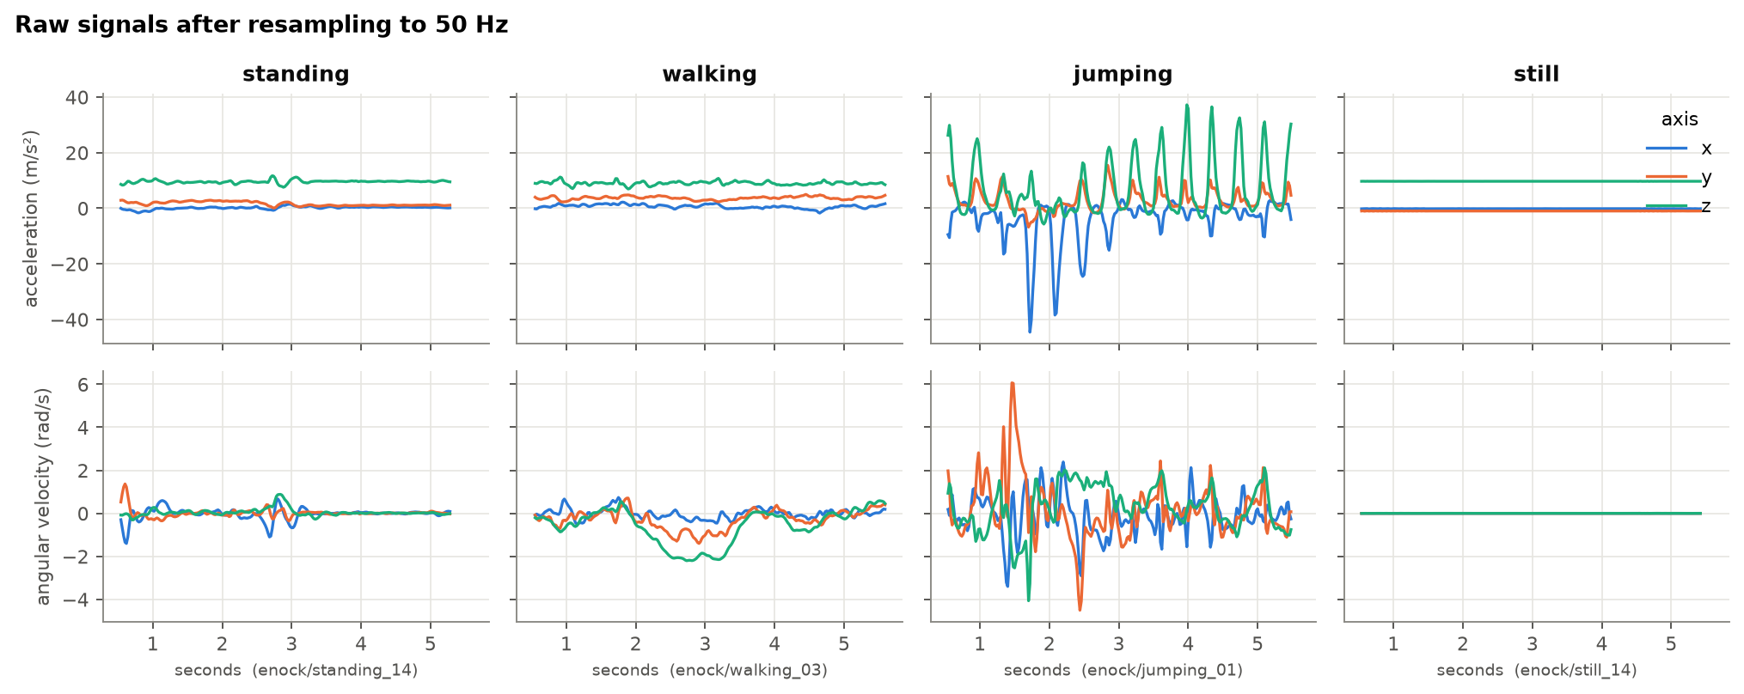
Figure 1. Representative accelerometer and gyroscope signals for each activity. The amplitude and regularity differ sharply: still is flat, standing is low, walking is moderate and periodic, jumping is high-amplitude.
Data-collection videos. Four videos (one per activity, each ≥5 s, whole body and face visible in good light, holding the phone) are linked below:
- Standing: https://youtube.com/shorts/MuexVpJiZWw
- Walking: https://youtube.com/shorts/fzsP2rYffkM
- Jumping: https://youtube.com/shorts/NbohnmOFKUk
- Still: https://youtube.com/shorts/TWcEYuwgiLQ

3. Feature Extraction
From every 2 s window we extract seven features — four time-domain and three frequency-domain (all FFT-derived) — chosen so that each activity occupies a distinct region of feature space:
Feature | Domain | Why it separates the activities
log acc. std. | Time | Overall movement intensity: still≈0, standing low, walking moderate, jumping high.
log acc. range | Time | Peak-to-peak impact; isolates the hard landings of jumping.
log gyro. mean | Time | Rotational motion; walking and jumping swing the phone, still/standing do not.
tilt (deg) | Time | Orientation from the gravity vector; separates in-hand postures from flat-on-table.
dominant freq. | Freq (FFT) | Cadence of the motion; walking and jumping have clear periodic peaks.
spectral centroid | Freq (FFT) | Where the signal's energy sits in frequency; low for still, higher for dynamic motion.
spectral entropy | Freq (FFT) | Flatness of the spectrum; a steady rhythm (walking) is peaky, noise/stillness is flat.

Normalisation. Each feature is standardised with Z-score normalisation (zero mean, unit variance). Crucially, the mean and standard deviation are computed on the training windows only and then applied to the test windows, so no information from the unseen test set leaks into training. Z-score is well suited here because the features live on very different scales (degrees of tilt vs. log m/s² vs. Hz) and Gaussian HMM emissions assume comparably scaled inputs.
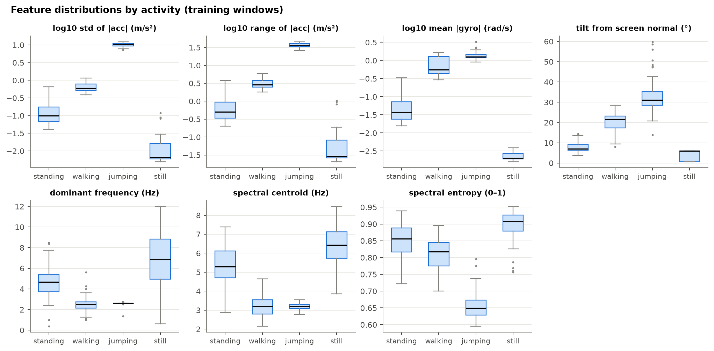
Figure 2. Distribution of each feature by activity (training windows). The boxes separate cleanly, confirming the features are informative; jumping and walking overlap most on the frequency features.

4. HMM Setup and Implementation Details
Element | In this model
Hidden states Z | The 4 activities: standing, walking, jumping, still.
Observations X | The 7-dimensional normalised feature vector of each 1 s time step.
Transitions A | 4×4 matrix; probability of moving from one activity to another between steps.
Emissions B | Per-state multivariate Gaussian with a diagonal covariance over the 7 features.
Initial π | Probability of the first window being each activity.

Algorithms and why they fit the metrics. We implement the HMM from scratch in NumPy in log-space. Baum–Welch (the EM algorithm) estimates A, B and π; the forward–backward algorithm supplies the likelihoods and posteriors it needs; and Viterbi performs the decoding. Viterbi is the right decoder for this task because the evaluation scores one predicted label per window and Viterbi returns the single most-likely hidden-state sequence — directly the quantity sensitivity, specificity and accuracy are computed on. We initialise A, B, π from the labels (a supervised estimate) and then refine with Baum–Welch, which lets the model also learn transition structure the single-activity clips cannot show.
Convergence. Baum–Welch stops when the mean log-likelihood per window improves by less than 1×10⁻⁵ (a proper convergence check rather than a fixed iteration count). It converged in 5 iterations, with the training log-likelihood rising monotonically from −75.8 to −66.8.
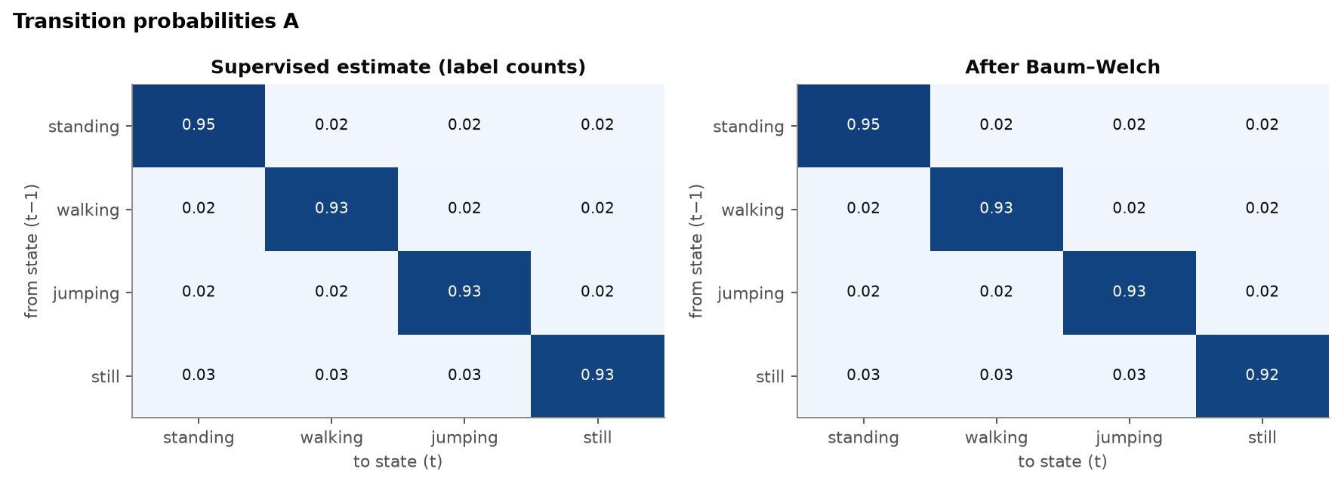
Figure 3. Learned transition matrix (left: supervised init; right: after Baum–Welch). The strong diagonal means each activity tends to persist from one second to the next.
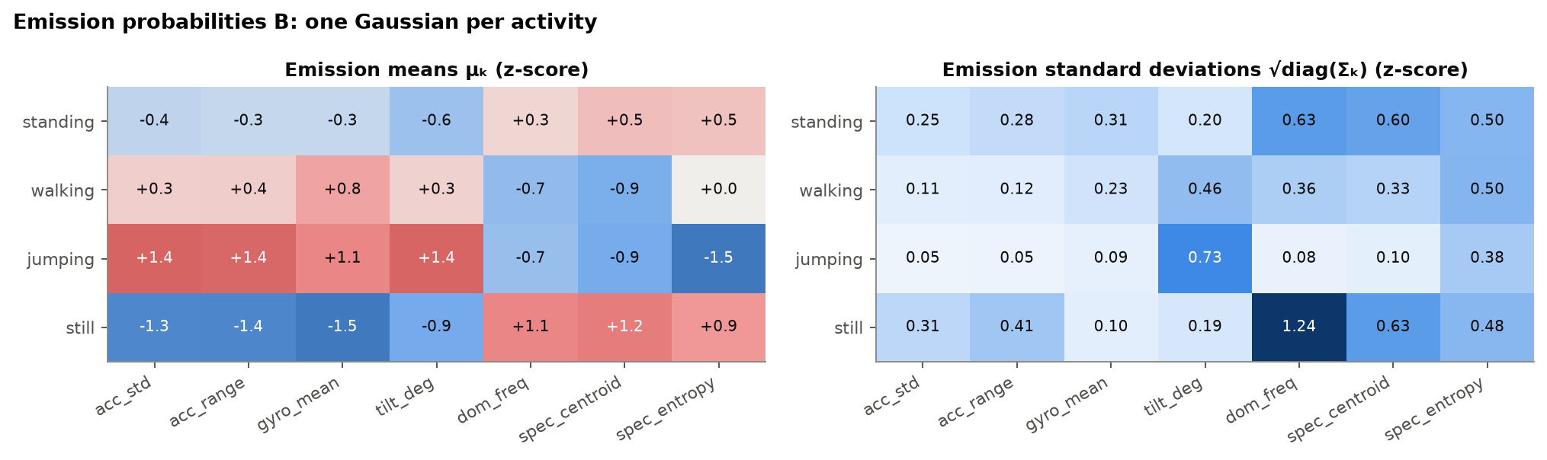
Figure 4. Emission parameters: per-activity mean of each standardised feature. The distinct rows show each state emits a characteristic feature signature.

5. Results and Interpretation
The model is evaluated on the two Pixel 6 test recordings, which were never used for training, Baum–Welch, or the normalisation statistics. Each is decoded as one sequence with Viterbi; only labelled windows are scored. For activity k (one-vs-rest): sensitivity = TP/(TP+FN), specificity = TN/(TN+FP).
State (Activity) | Samples | Sensitivity | Specificity | Overall Accuracy
standing | 11 | 0.727 | 0.847 | 0.829
walking | 22 | 1.000 | 0.917 | 0.943
jumping | 16 | 0.438 | 1.000 | 0.871
still | 21 | 0.952 | 1.000 | 0.986
All activities | 70 | 0.779 | 0.941 | 0.814

The HMM earns its keep. Classifying each window independently with the Gaussian emissions alone gives 75.7 % test accuracy, and simply adding Viterbi decoding on top of the supervised-initialised transitions leaves it unchanged at 75.7 %. It is the Baum–Welch-refined transition matrix that lifts accuracy to 81.4 %, smoothing out isolated misreads by exploiting the fact that activities persist. Per file, test 1 scores 91.7 % and test 2 scores 70.6 %.
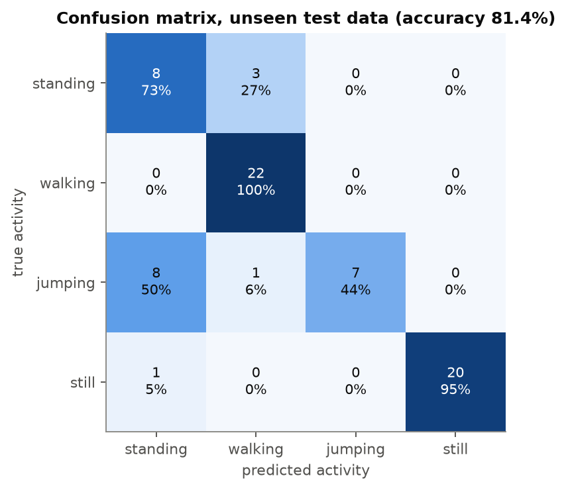
Figure 5. Confusion matrix on the unseen test windows. Still, walking and standing are recovered well; jumping is the main source of error.
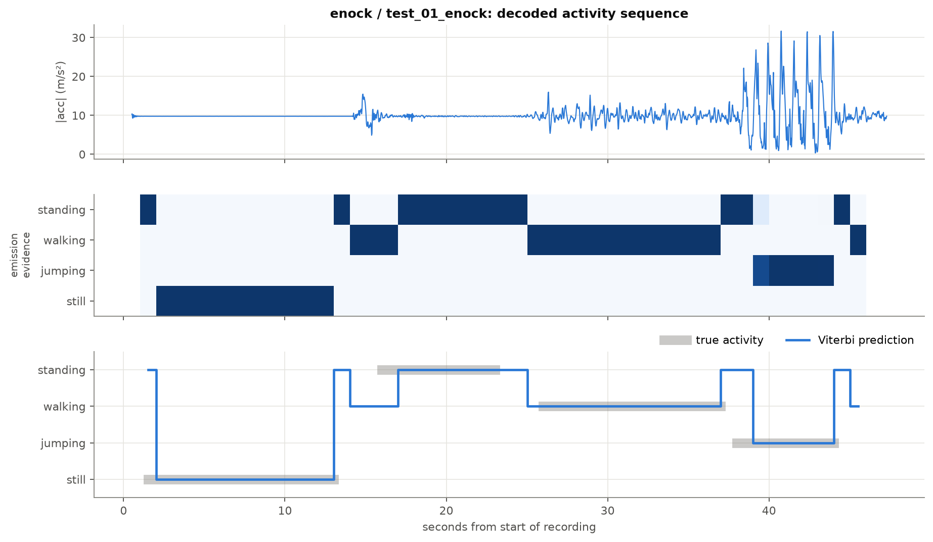
Figure 6. Decoded sequence for test recording 1 (accuracy 91.7 %): sensor signal, per-window evidence, and true vs. Viterbi-predicted activity path.
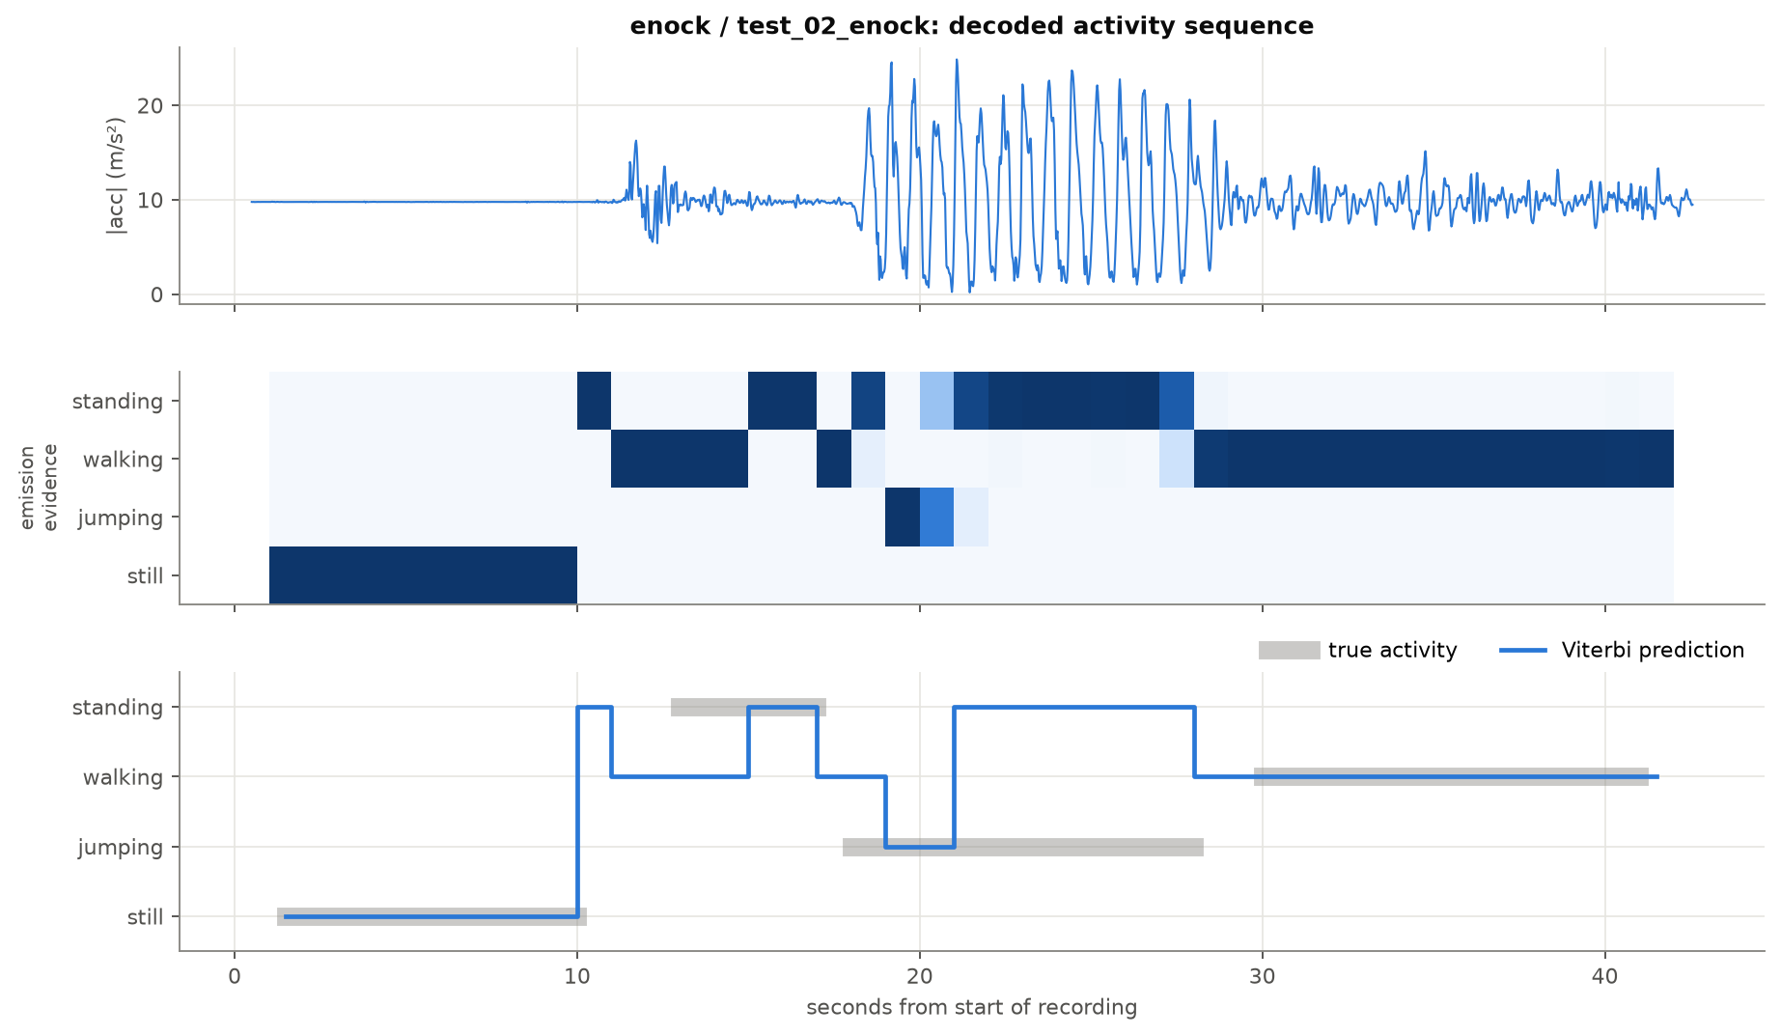
Figure 7. Decoded sequence for test recording 2 (accuracy 70.6 %): most errors occur in the jumping segment.

6. Discussion and Conclusion
Easiest vs. hardest. Still (98.6 % accuracy) and walking (100 % sensitivity) are easiest: still is almost flat and walking has a clear, steady cadence, so both sit far from the other classes in feature space. Jumping is hardest (43.8 % sensitivity): although jumping is very energetic, on the Pixel 6 its windows are most often confused with standing at the start and end of the jump bursts, where the phone is briefly steady before and after the impacts, and the ~55 Hz sampling slightly blunts the high-frequency content the model learned from 100 Hz training jumps.
Transitions reflect real behaviour. The learned transition matrix is strongly diagonal (self-transition ≈0.93–0.95), implying an expected dwell time of roughly 13–18 s per activity before switching. This matches how people actually move — we hold a posture for many seconds rather than flipping activities every second — and is exactly the prior that lets Viterbi correct noisy single-window predictions.
Effect of sensor noise and sampling rate. Training at 100 Hz and testing at ~55 Hz is a genuine domain shift; resampling everything to 50 Hz removes most of it, but residual differences in how each phone's sensors render the sharp impacts of jumping explain much of the train–test gap (train 98.7 % vs. test 81.4 %). Gyroscope and accelerometer noise mainly affect the low-energy classes, which is why standing occasionally leaks into still.
Improvements. (i) More data from more participants and phones would teach the model device-invariant jumping patterns; (ii) continuous multi-activity training recordings would let Baum–Welch learn richer, asymmetric transitions instead of near-symmetric ones; (iii) extra features (jerk, axis-correlation, higher-frequency bands) and a full-covariance emission could sharpen the jumping/standing boundary; (iv) adding the magnetometer or a second body location would disambiguate similar-energy postures.
Conclusion. A from-scratch Gaussian-emission HMM, trained with Baum–Welch and decoded with Viterbi, recognises four human activities from phone accelerometer and gyroscope data at 81.4 % accuracy on genuinely unseen, different-device data. The temporal model measurably outperforms per-window classification, and its learned transitions and dwell times are behaviourally realistic — a promising, low-cost basis for the mobility-monitoring use case that motivated the work.

