
CropManager
Digital crop production management for Africa’s farmers
Product Overview, Features and Impact
How CropManager works, who it serves, and how it can help transform agriculture across Africa
Version 2.0 · September 2026
Web application · Android & iOS mobile app

Contents
1. Executive summary 2
2. The challenge: farming without data 2
2.1 The state of the sector 3
2.2 Why the data gap matters 3
3. Introducing CropManager 4
3.1 Who it is for 4
3.2 Available everywhere the farmer is 4
3.3 Design principles 5
4. Features 5
4.1 Dashboard 5
4.2 Farm management 6
4.3 Production 6
4.4 Resources 7
4.5 Finance 7
4.6 Agronomic calculators 7
4.7 Reports and analytics 8
4.8 Calendar and alerts 9
4.9 Mobile app 9
4.10 Accounts, roles and administration 9
5. A season with CropManager 10
6. Who benefits 11
7. Transforming Africa’s agriculture 11
7.1 From guesswork to data-driven farming 11
7.2 Unlocking finance and insurance 11
7.3 Cutting waste and costs 11
7.4 Raising incomes and market power 12
7.5 Scaling extension and advice 12
7.6 Building climate resilience 12
7.7 Attracting young people to agriculture 12
7.8 Better data for food security and policy 12
8. Technology and security 12
8.1 Security and privacy 13
9. Roadmap 13
10. Getting started 14
11. Conclusion 14

1. Executive summary
Agriculture is the backbone of Africa’s economies. It employs more people than any other sector, feeds a fast-growing population and holds the key to rural prosperity. Yet most African farms are still managed from memory, paper notebooks and guesswork. Without records, farmers struggle to know which fields, crops and practices actually make money, lenders cannot assess them, and the extension services and governments that support them work with little reliable data.
CropManager is a complete crop production management system that closes this gap. It gives farmers, farm managers, agronomists and cooperatives one place to plan, record and analyse everything that happens on a farm — from land and seasons, through planting, irrigation, fertiliser and crop protection, to harvest, inventory, expenses and sales. It works in any web browser and as a native mobile app for Android and iOS, with the same account and the same data on every device.
Every record a farmer enters turns into insight: a live dashboard of farm performance, yield and financial reports, harvest forecasts, stock alerts and nine agronomic calculators that remove guesswork from input planning. Over a season, CropManager builds a trustworthy production and financial history — exactly what a farmer needs to improve yields, cut waste, negotiate better prices and qualify for credit and insurance.
CropManager at a glance
18 integrated farm modules covering land, production, resources and finance
9 agronomic calculators, including fertilizer, NPK, seed rate, irrigation and yield
Live dashboard, production / yield / financial / crop-cycle reports, calendar and alerts
Web app plus Android and iOS app, with Google sign-in and light / dark themes
Secure, private accounts, and a platform administration area for organisations

This document explains what CropManager is, how it is used, the features it offers, and how — deployed at scale through farmers, cooperatives, agribusinesses, financial institutions and governments — it can help transform the productivity, profitability and resilience of Africa’s agriculture sector.

2. The challenge: farming without data
Africa has extraordinary agricultural potential. It is widely reported to hold around 60 percent of the world’s remaining uncultivated arable land, a young and growing workforce, and diverse climates suited to a wide range of crops. Yet that potential is far from realised.

2.1 The state of the sector
- Agriculture is the largest employer. In sub-Saharan Africa, farming provides work for roughly half of the labour force and contributes around a fifth of economic output.
- Smallholders produce most of the food. An estimated 33 million small farms supply the majority of the food consumed in the region — often cited as up to 80 percent.
- Yields lag far behind. Average cereal yields in sub-Saharan Africa remain well below half of the global average, despite improved seed and practices being available.
- Losses are high. A significant share of harvests is lost between the field and the market; in some value chains the estimate is a third or more.
- The continent imports what it could grow. Africa spends tens of billions of US dollars every year importing food.
Figures are rounded, widely cited estimates from the FAO, IFAD, the World Bank and the African Development Bank; exact values vary by source, country and year.

2.2 Why the data gap matters
Behind these numbers is a common, practical problem: most farms have no reliable records. That single gap causes a chain of others.
Problem | What happens on the farm | Wider consequence
No production records | Farmers cannot compare fields, varieties or practices, so they repeat what they did last year. | Yields stagnate; good practices spread slowly.
No cost tracking | Input spend, labour and transport are not added up, so true profit per crop is unknown. | Farmers under-price produce and over-spend on inputs.
No financial history | There is nothing to show a bank, insurer or buyer. | Farmers stay locked out of credit, insurance and formal markets.
Guesswork on inputs | Fertiliser, seed and water are applied by habit, not by calculation. | Money and inputs are wasted; soils degrade.
Scattered information | Notes live in notebooks, phones and people’s heads. | Cooperatives, extension officers and policymakers cannot see what is happening.

Digital tools can break this cycle — but only if they are complete enough to run a real farm, simple enough for everyday use, and available on the devices farmers already carry. CropManager was built to meet all three conditions.

3. Introducing CropManager
CropManager is a digital farm management platform focused on crop production. It follows a farm through its entire production cycle and connects every activity to its cost, its output and its outcome.

3.1 Who it is for
User | How they use CropManager
Smallholder and commercial farmers | Record fields, crops, activities, harvests and money; see what is working and what is not.
Farm managers | Coordinate several farms and fields, track work and inputs, and monitor equipment and stock.
Agronomists and extension officers | Use scouting records, crop-health alerts and calculators to give precise, data-backed advice.
Cooperatives and outgrower schemes | Standardise record-keeping across members and aggregate production for planning and marketing.
Platform administrators | Manage users and roles, oversee platform activity and maintain system settings.

3.2 Available everywhere the farmer is
CropManager runs as a responsive web application in any modern browser — on a laptop in the farm office or a tablet in the field — and as a native mobile app for Android and iOS. Both use the same secure account and the same data, so a harvest recorded on a phone in the field appears instantly on the dashboard in the office.
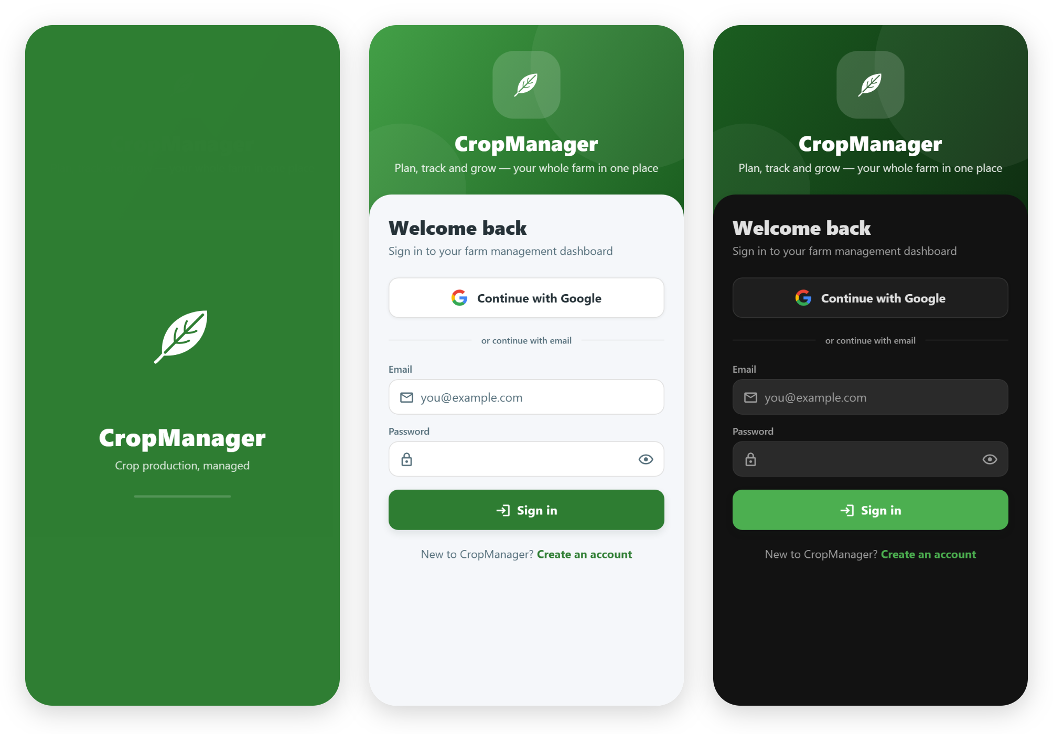
Figure 1 — The CropManager mobile app: animated splash screen, sign-in, and dark mode

3.3 Design principles
- Complete: one system for the whole farm, instead of separate tools for records, stock and money.
- Simple: clear screens, guided forms, sensible defaults and plain language.
- Insightful: every record feeds dashboards, reports and alerts automatically — no spreadsheets required.
- Responsive: layouts adapt to any screen, from a small phone to a wide monitor, and every tap gives immediate visual and tactile feedback.
- Secure and private: each user’s farm data belongs to that user and is only visible to them and to authorised administrators.

4. Features
CropManager’s features are organised the way a farm is run: farm management, production, resources and finance, supported by tools, analytics and administration.

4.1 Dashboard
The dashboard is the farmer’s daily control panel. It greets the user and summarises the entire operation at a glance, filterable by farm, season and date range.
- Key indicators: farms, fields, active crop cycles, planted area, expected harvest, harvest records, expenses, sales, inventory items and low-stock items — each linking straight to the relevant module.
- Land utilisation: the share of land under crops versus fallow.
- Charts: crop distribution, cycle status, harvest by crop, production trend, revenue against expenses, expense breakdown and crop performance.
- Health and stock panels: inventory health (healthy, low, out of stock, expiring soon) and crop health from scouting (healthy, observed, at risk).
- Activity and alerts: recent field activities, upcoming harvests and automatic alerts for issues that need attention.

4.2 Farm management
Module | What it records
Farms | Each farm’s location, district, type and total area.
Fields | Production areas within each farm, with size, soil information and status (active, fallow, preparing, maintenance).
Crops | The farm’s crop database — category, description and typical growing period.
Varieties | Varieties within each crop, including seed source and maturity period.
Seasons | Growing periods (for example rainy and dry seasons) with start and end dates and status.

4.3 Production
The production modules follow a crop from planting to harvest. At their centre is the crop cycle — one crop, on one field, in one season — to which planting, activities, inputs and harvests are linked.
Module | What it records
Crop Cycles | Crop and variety, farm, field and season, planting and expected harvest dates, area planted, expected and actual production, and status from Planned to Completed.
Planting Records | Planting date, seed quantity, seed source and cost, and plant health at establishment.
Field Activities | All work done — land preparation, planting, weeding, spraying, harvesting, transport and machinery — with descriptions and dates.
Irrigation | Water applications by method, date, amount and duration.
Fertilizer | Fertiliser type and name, application date, rate and cost.
Crop Protection | Pest, disease and weed problems, their severity, and the treatments applied.
Crop Scouting | Field observations of plant health, pests, diseases, weeds and moisture, with photos taken on the phone camera and recommendations.
Harvest | Harvest date, area, quantity, grade and quality, storage location, and labour, transport and other costs.

4.4 Resources
Module | What it records
Inventory | Seeds, fertilisers, chemicals and other stock, with quantities, minimum levels, unit costs, suppliers, storage and expiry dates. Stock-in and stock-out movements update balances and trigger low-stock and expiry alerts.
Equipment | Tractors, pumps, sprayers and tools, with their condition and status (available, in use, damaged, retired).
Maintenance | Service and repair history for each piece of equipment, including costs and next due dates.

4.5 Finance
Module | What it records
Expenses | Every cost by category (seed, fertiliser, labour, fuel, transport and more), linked to farm and crop cycle, with payment method and supplier.
Sales | Buyer, market, quantity, unit price, total and payment status (paid, pending, partially paid).

Because expenses and sales can be linked to specific crop cycles, CropManager can show profit by crop, by field and by season — the information farmers most often lack.

4.6 Agronomic calculators
Nine built-in calculators turn agronomic best practice into quick answers. Results can be saved to a history and reopened later.
Calculator | What it answers
Fertilizer | How much fertiliser product is needed for a field at a recommended nutrient rate.
NPK | How to meet nitrogen, phosphorus and potassium targets from the products available.
Seed Rate | How much seed to buy for a given area, spacing and germination rate.
Plant Population | How many plants a field will carry at a given spacing.
Irrigation | How much water a crop needs and how long to irrigate.
Rainfall | Rainfall volumes and their contribution to crop water needs.
Field Area | The area of a field from its measurements, in the units the farmer uses.
Yield | Expected or actual yield per hectare from harvest data.
Crop Spacing | Row and plant spacing needed to reach a target population.

4.7 Reports and analytics
The Reports area turns records into decision-ready analysis, filtered by farm, season and date range.
- Production report: cycles, planted area, expected versus harvested quantity, yield per hectare and achievement rate, by crop.
- Yield report: harvested quantity, harvested area and average yield per crop, with a monthly harvest trend.
- Financial report: revenue, expenses, net profit and margin by month, plus a breakdown of spending by category.
- Crop cycle report: every cycle with its status, dates, area and production.
Each report combines summary figures, charts and a detailed table, and can be exported to CSV for spreadsheets or printed — ready to share with a cooperative, lender or buyer.
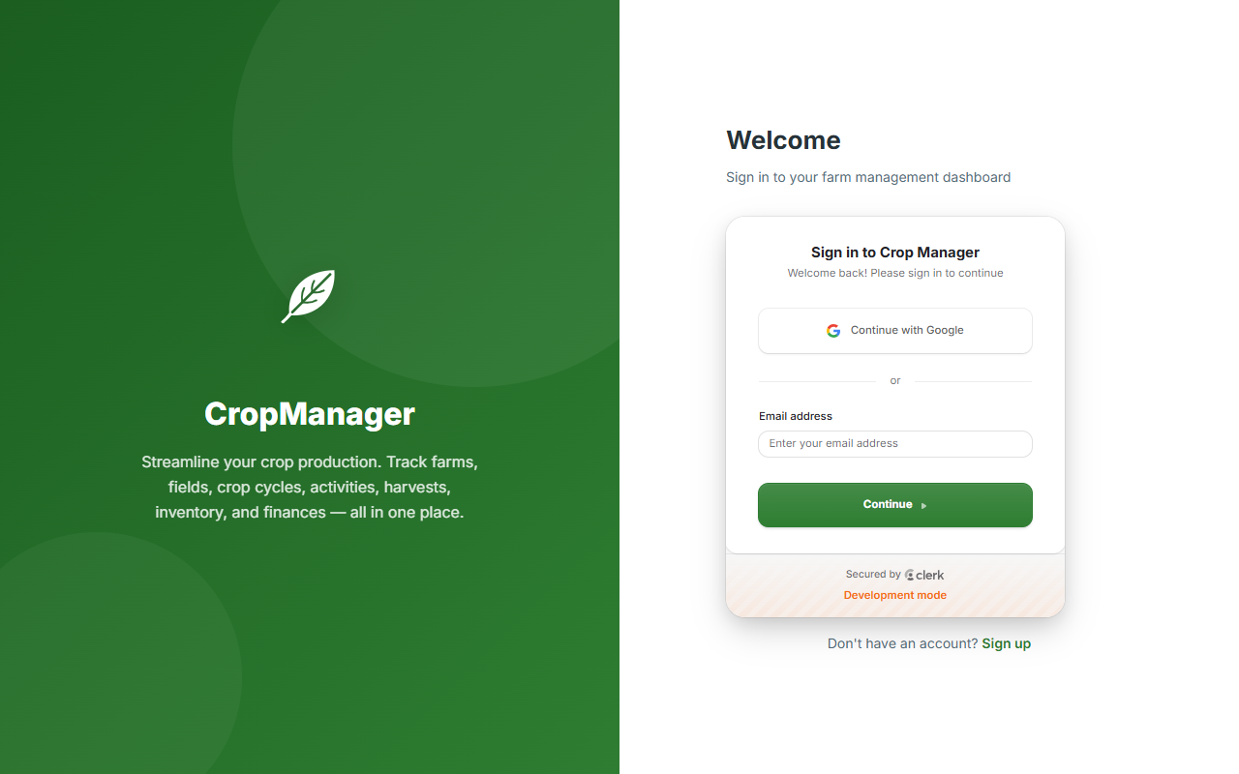
Figure 2 — The CropManager web application sign-in, with “Continue with Google”

4.8 Calendar and alerts
The calendar lists upcoming expected harvests so that labour, transport, storage and buyers can be arranged in time. Automatic alerts highlight crops at risk from scouting reports, stock that is low, out or about to expire, and other items that need action.

4.9 Mobile app
The Android and iOS app gives the same capabilities in the field, where the work actually happens.
- All modules on the phone: the dashboard, all 18 modules, calculators, reports, calendar and settings.
- Camera integration: scouting photos are captured directly and attached to records.
- Fast, familiar sign-in: Google sign-in or email and password, with the session kept securely on the device.
- Designed for touch: large tap targets, press animations, haptic feedback, pull-to-refresh, search and filters.
- Comfortable in any light: light, dark or automatic themes, with numbers that resize to fit on small screens.
- Clear feedback: friendly loading placeholders, success and error messages, and a clear retry screen if the server cannot be reached.

4.10 Accounts, roles and administration
- Simple onboarding: sign up with Google or email, confirm your name, and start. New users join as Farmers.
- Role management: administrators assign roles (for example Farm Manager, Agronomist or Cooperative Manager); users cannot change their own role.
- Admin console: platform overview, user management (activate, deactivate, promote), a data browser across modules, and system settings including the administrator allow-list.
- Personal settings: profile details, profile photo and theme preferences.

5. A season with CropManager
The following example is illustrative. It shows how a typical farmer might use CropManager over one rainy season.
Meet Grace — a maize and soybean farmer
Grace farms 12 hectares across three fields with two seasonal workers. Before CropManager she kept notes in an exercise book and could never say for sure which crop earned more.

- Set up the farm (day 1). Grace signs in with her Google account, adds her farm and three fields, and chooses maize and soybean varieties from her crop list. She creates the “2026/27 Rainy” season.
- Plan inputs (before planting). Using the Seed Rate and Fertilizer calculators, she works out exactly how much seed and fertiliser to buy for each field, and records the purchases as inventory and expenses.
- Plant and track (weeks 1–10). She opens a crop cycle for each field, logs planting, weeding and fertiliser applications from her phone, and records every labour and fuel cost as it happens.
- Protect the crop (mid-season). While scouting, Grace photographs fall armyworm damage. The record shows the field as “at risk” on her dashboard and her extension officer recommends a targeted spray, which she logs under Crop Protection.
- Harvest and sell (end of season). She records each harvest by field and quality, then each sale by buyer and price. The calendar had already reminded her to book transport and storage.
- Learn and grow (after the season). Grace’s reports show yield and profit per field and per crop. Soybean earned more per hectare, and one maize field under-performed. She takes a printed financial report to her bank to apply for an input loan for next season.

Every step took a few minutes on her phone. At the end of the season Grace has what most farmers never have: an accurate, shareable record of what she produced, what it cost and what she earned.

6. Who benefits
Stakeholder | Benefit
Farmers | Know true costs and profits per crop and field; plan inputs precisely; reduce losses; build a credit-worthy history.
Cooperatives and outgrower schemes | Standardised member records, aggregated production data for bulk input buying, collective marketing and traceability.
Extension services and agronomists | Field-level scouting and production data to target advice, follow up on problems and measure the impact of recommendations.
Banks, microfinance and insurers | Verifiable production and financial histories to assess risk, lend with confidence and design insurance products.
Agribusinesses and buyers | Better supply forecasting from expected-harvest data, and quality and grade information for sourcing.
Governments and development partners | Timely, farm-level data to guide food-security planning, subsidy targeting and investment decisions.

7. Transforming Africa’s agriculture
Technology alone does not transform agriculture — people and institutions do. But reliable information is the foundation that almost every other improvement depends on. Adopted at scale, CropManager can contribute to change in eight connected ways.

7.1 From guesswork to data-driven farming
When farmers can compare fields, varieties and practices using their own numbers, they keep what works and drop what does not. Season after season, that learning loop is one of the most direct routes to closing Africa’s yield gap.

7.2 Unlocking finance and insurance
Lack of records is one of the main reasons smallholders are refused credit. A season of CropManager data — planted area, inputs, yields, sales and profit — gives lenders and insurers the evidence they need. Access to finance lets farmers buy better seed, fertiliser and equipment, multiplying the benefit.

7.3 Cutting waste and costs
Calculators match inputs to real field sizes and needs; inventory tracking prevents over-buying and expired stock; harvest and storage records highlight where losses occur. Every kilogramme and kwacha saved goes straight to the farmer’s income.

7.4 Raising incomes and market power
Farmers who know their cost of production know their minimum selling price. Sales records show which buyers and markets pay best and pay on time. Cooperatives can aggregate reliable volumes and negotiate as one.

7.5 Scaling extension and advice
Extension officers serve many farmers each. Scouting reports with photos, crop-health alerts and production data let advisers focus on the fields that need them most, and follow up remotely.

7.6 Building climate resilience
Irrigation, rainfall and scouting records create a history of how crops respond to dry spells, heavy rains, pests and disease. That evidence helps farmers adapt planting dates, varieties and water use as the climate changes.

7.7 Attracting young people to agriculture
A modern, mobile-first tool presents farming as the business it is. Digital skills, data and professional reports make agriculture more attractive to Africa’s young population and create new roles in farm management and agri-services.

7.8 Better data for food security and policy
Aggregated, anonymised production data — shared with consent — can give governments and partners early insight into planted areas, expected harvests and emerging pest threats, supporting better food-security planning, input programmes and investment.
The long-term vision
Every African farmer running their farm as a business: knowing what they produce, what it costs and what it earns — and using that knowledge to grow more, waste less, access finance and feed the continent.

8. Technology and security
CropManager is built on proven, widely used technology chosen for reliability, security and the ability to scale.
Layer | Technology | Why it matters
Web application | React (Vite) | A fast, responsive interface that adapts to any screen size.
Mobile application | React Native with Expo (Android and iOS) | One codebase for both platforms, delivered as installable apps.
Server and API | Node.js and Express | A secure REST API shared by the web and mobile apps.
Database | MongoDB Atlas (cloud) | Managed, replicated storage that grows with the user base.
Authentication | Clerk, with Google sign-in | Industry-standard sign-in, sessions and account security.

8.1 Security and privacy
- Private by design: every record is owned by the account that created it; users only see their own farm data.
- Verified sign-in: every request to the API is authenticated with a signed session token.
- Controlled roles: only administrators can change roles; the administrator allow-list is managed centrally.
- Protected server: security headers, rate limiting and input validation protect the API from misuse.
- Encrypted connections: production deployments serve all traffic over HTTPS.

9. Roadmap
CropManager is fully functional today. The following developments are planned to broaden its reach across Africa.
Priority | Development | Impact
Near term | Public cloud deployment of the API | The app works anywhere with a data connection, not just on a local network.
Near term | Offline-first mobile app | Record work in fields without signal; sync automatically when back online.
Near term | Google Play and App Store release | Simple installation and automatic updates for all users.
Medium term | Local languages (e.g. Swahili, French, Hausa, Kinyarwanda) | Reach farmers in the language they use every day.
Medium term | Multi-currency and regional settings | Local currencies and units for every country served.
Medium term | Mobile-money integration | Record and receive payments directly, strengthening financial histories.
Longer term | Weather, satellite and soil data | Field-specific forecasts, crop monitoring and input recommendations.
Longer term | SMS / USSD companion | Include farmers who use basic phones.
Longer term | Marketplace and lender connections | Link farmers directly to buyers, input suppliers and financial institutions.

10. Getting started
- Create an account. Open the web app or install the mobile app and choose “Continue with Google”, or sign up with an email address.
- Confirm your name. Onboarding takes one step; you join as a Farmer and an administrator can adjust your role later.
- Add your farm and fields. Enter each farm, its fields and their sizes.
- Set up crops and seasons. Add the crops and varieties you grow and the current season.
- Record as you go. Open a crop cycle for each field and log planting, activities, inputs, harvests, expenses and sales as they happen.
- Review and improve. Use the dashboard daily and the reports at the end of each season to decide what to change next time.

11. Conclusion
Africa’s farmers do not lack effort, knowledge or ambition — they lack information that is easy to capture and easy to use. CropManager puts a complete, modern farm management system in their hands, on the phone they already own, and turns everyday records into better decisions, stronger finances and more resilient farms.
Deployed through cooperatives, agribusinesses, financial institutions, extension services and governments, CropManager can help move millions of farms from subsistence toward profitable, data-driven enterprises — raising yields, cutting waste, unlocking finance and strengthening food security across the continent.
CropManager — Plan, track and grow: your whole farm in one place.

