Lab 2

Riley Sansone

2023-01-18

## Poultry Prices

library(astsa)  
data(chicken)

## Poultry Price Plots

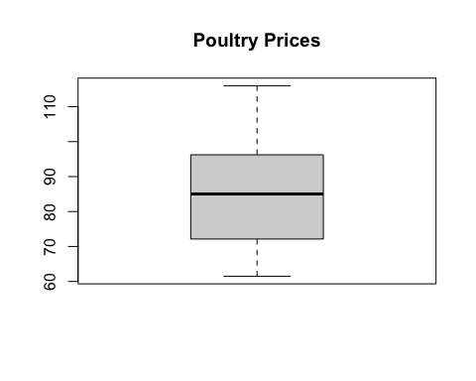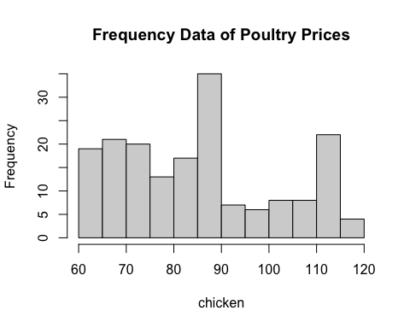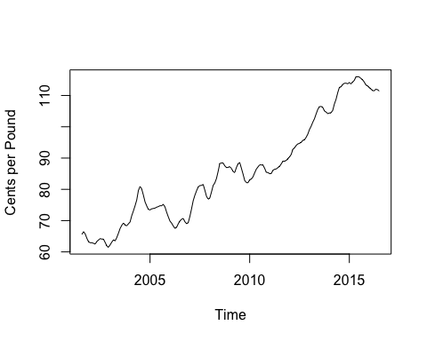

##### The histogram is slightly right skewed with notable bimodality at around 85 and 115.

##### There is a general rising trend of poultry price over the past 15 years.

## Executive Summary

Over the past 15 years, poultry prices have experienced a general rise with rapid growth in price per pound over the last five years of observation. In the time plot we can see this increase as the slope slowly rises until it rises dramatically around 2012-2013. In the boxplot created we can see that the modal price of poultry tends to be around 85 center per pound with a range spanning from around 60 to 115. This information is consistent with the timeplot as the highest and lowest range represents the time periods at the end and beginning of observation respectively and the mode represents a relatively stable period in the middle of the chart. In the histogram, we can see that prices are relatively right skewed with notable bimodality at 85 and 115. The bimodality of the data is also represented in the time plot with poultry price being relatively stable at 85 cents per pound during a period from around 2008-2012, which is why there is a large distribution of chickens priced at around 85 cents, and the recent surge in price in the final years of observation provide context for the outlier at 115. Before this time period, from 2001-2005, the price was much lower at around 60-70 cents and gives us the right skew.