**Lifestyle App for Diabetic**

**User’s Manual**

By

Jay L. Enot

Ronnie S. Uy

**ABSTRACT**

Diabetes is a chronic health problem with devastating, yet preventable consequences. It is characterized by high blood glucose levels resulting from defects in insulin production, insulin action, or both. Along with the increase in incidence of diabetes, both individual and societal expectations concerning the management of diabetes have also increased, with many reports from The Centers for Disease Control (CDC), urging patients to “Take Charge of Your Diabetes” and “Conquer Diabetes”. It is with this thrust that the researchers developed Lifestyle App for Diabetic. One of the main goals of Lifestyle App, is to improve the quality of life for persons with diabetes. This study used descriptive research designed to describe the data and characteristics of the subject being studied. The results revealed that the respondents have found out the system as an alternative tool for conventional method of health monitoring which implied that the respondents strongly agreed that Lifestyle App helped the patients by: reminding the patient when it is time to eat, reminding the patient for medicine intakes, provides a diet plan for patients to follow. In addition, the system provided a new method of sending SOS messages to family or relatives when the patient needs urgent medical attention.

|  |  |
| --- | --- |
| **Table of Contents** |  |
|  | **Page** |
| Title page | 1 |
| Abstract | 2 |
| Table of Contents | 3 |
| Getting started with Lifestyle | 4 |
| Results | 8 |

**Getting started with Lifestyle App!**

**STEP 1:**

Patient interface is completely browser based. The interface works with any browser and any operating system.

* Open your browser.
* In the address bar type the URL for the administrator interface.
* To access the website you need to create an account.

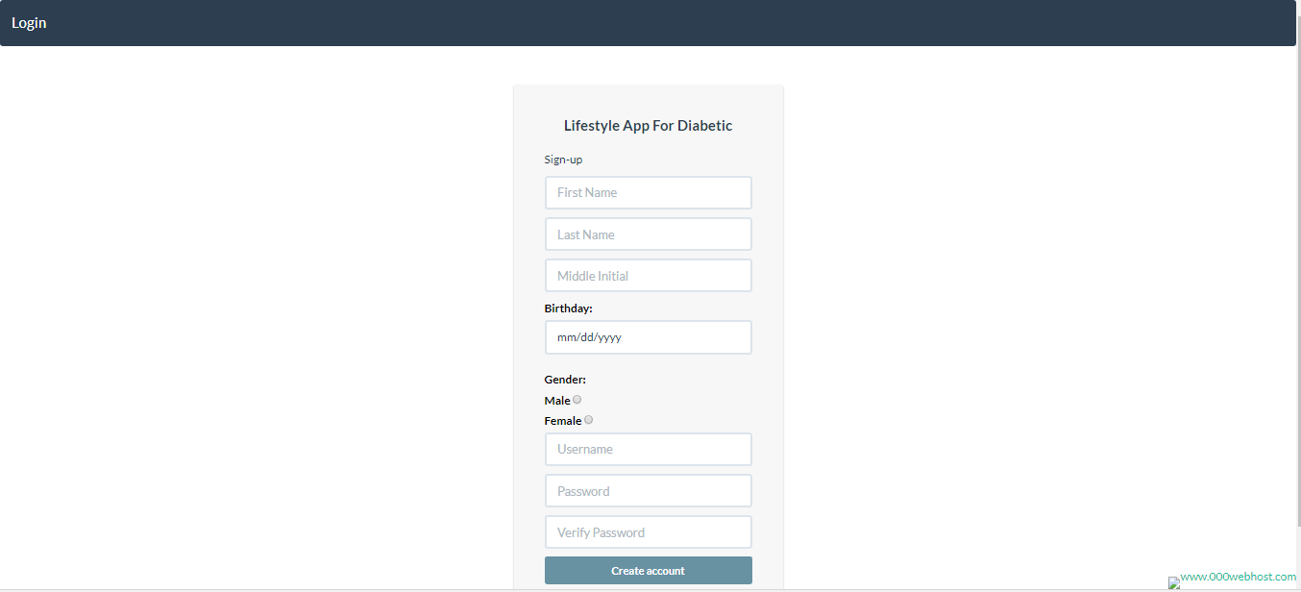

* Type in required information to register.

**STEP 2:**

* Click the login button on the upper left corner of the website.



**STEP 3:**

* Input required information.

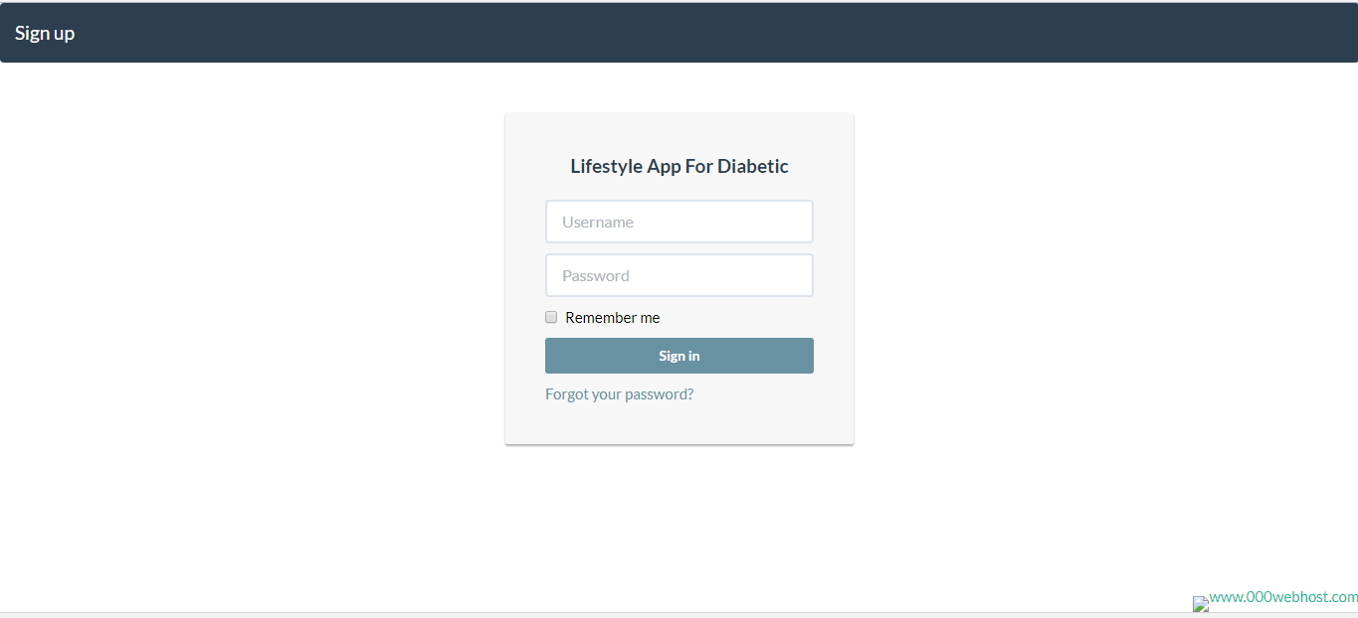

* Click sign in button.

**STEP 4:**

Home page.

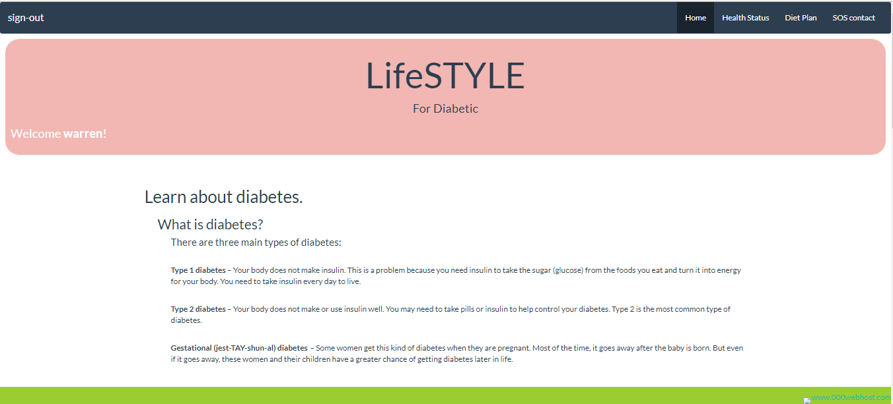

* Navigate through the website using the nav panel located at the top left corner of the screen.



**STEP 5:**

Health Status

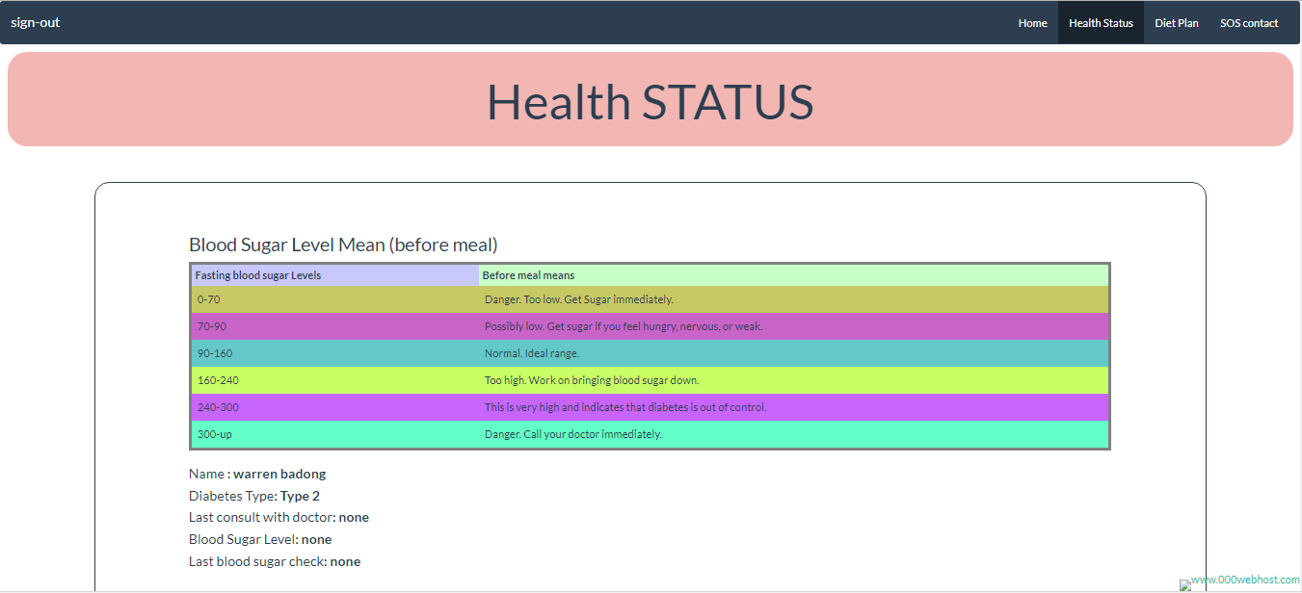

* Input information required.

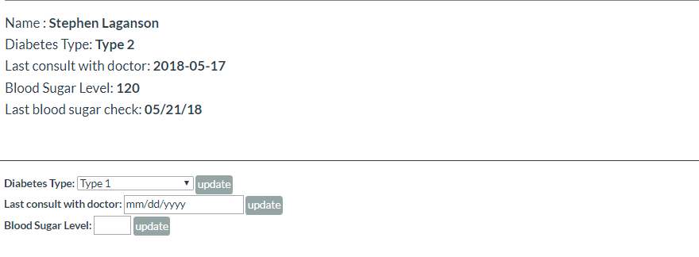

**STEP 6:**

Diet Plan

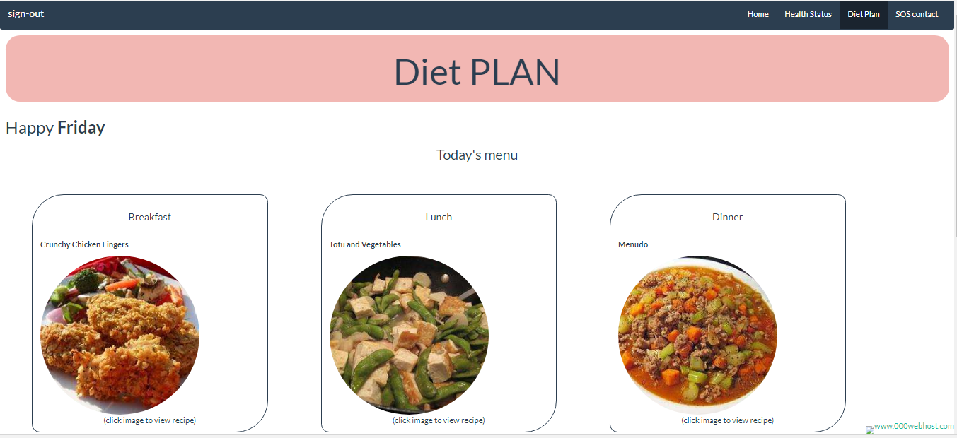

* Click Image to view recipe

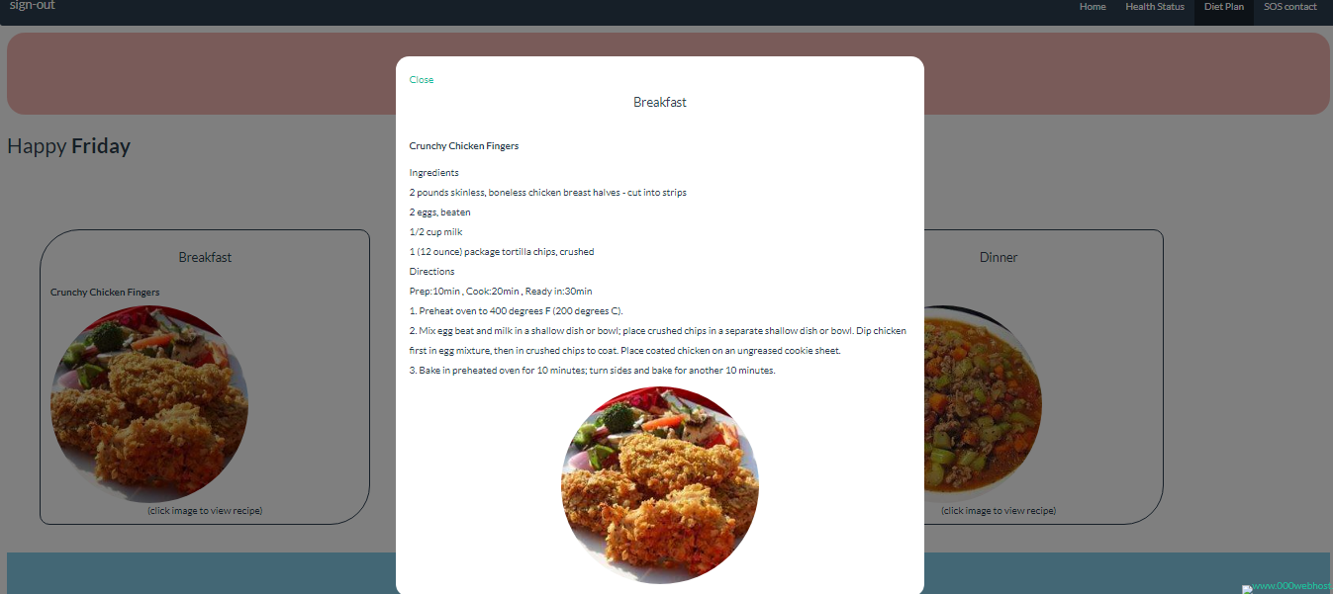

**STEP 7:**

Add medicine

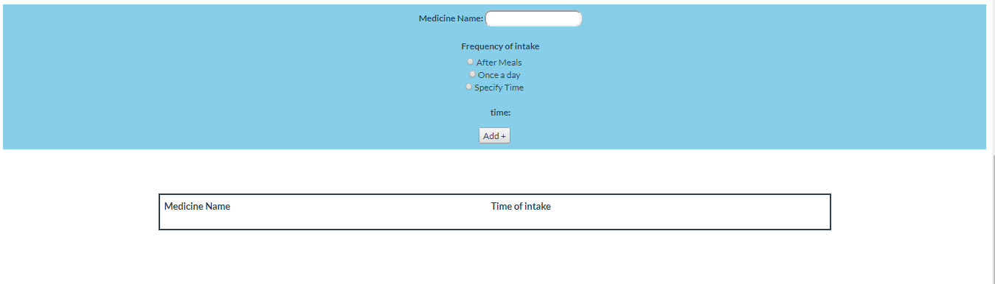

* Input medicine name, frequency of intake and time of intake. Then click add button to add a medicine to the list.

**STEP 8:**

Sos contact list.

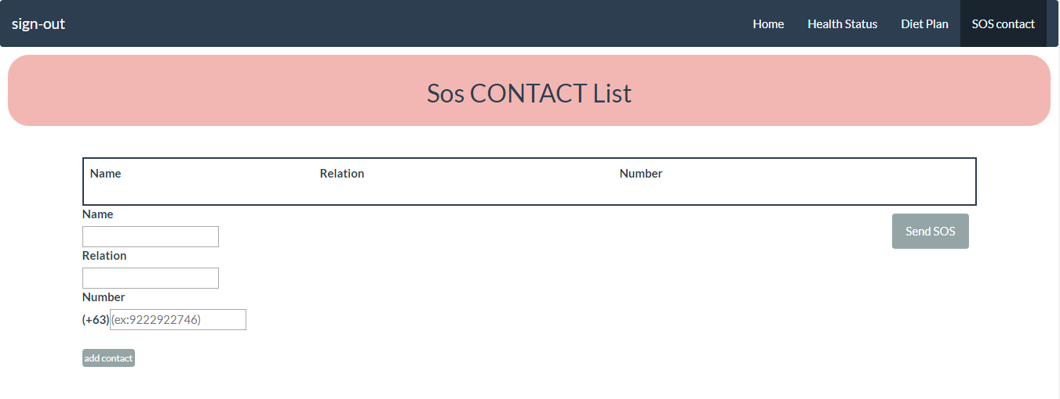

* Input required information on the textboxes.
* Click add contact button.



**STEP 8:**

Sending SOS.

* Click send SOS button to send an SOS message to all contacts.



**STEP 9:**

* Click sign-out button to finish session.

