Econ 398 Model

Ethan Nourbash

February 2022

# Set Up

My model is inspired by Diamond 2016 with several key changes to provide insight on the impact of remote work on worker location choice. (1) The place of residence is determined separately from place of work; (2) the local good price is endogenous; (3) amenity utility function has two factors, commute time and density of entertainment venues, that are both endogenous; (4) proportion of work done from home is integrated as an endogenous variable.  
Assume that worker $i$ has a job in the city center where he is paid a wage $W_{i,t}$. He chooses to live in region $p$ that offers him the most desirable bundle of local good prices and amenities. Let this be represented by a Cobb-Douglas utility function of local goods $M$ with price $R_{p,t}$, national goods $O$ with a price $P_{t}$, and local amenities $A_{i,p,t}$. Let $s_{i}$ be the worker i’s amenity utility function.

$$U\left(M,O,p\right):=M^{α}O^{1−α}e^{s_{i}\left(A_{i,p,t}\right)}$$

$$\text{s.t }R_{p,t}M+P_{t}O≤W_{i,t}$$

Let $R_{p,t}$ be a function of distance from city center $d_{p}$ such that $R_{p,t}′\left(d_{p}\right)<0$ and $R_{p,t}″\left(d_{p}\right)>0$. In particular, we will assume that the price of local goods takes this particular functional form.

$$R_{p,t}:=R_{t}+β_{δ_{1}}d_{p}+β_{δ_{2}}d_{p}^{δ}$$

Where $R_{t}$ is the rent in the city center and $0<δ$.  
  
Let $A_{i,p,t}$ contain two variables: effective commute time, $c_{i,p,t}$, and density of entertainment venues, $e_{p,t}$. Let $s_{i}$ have the following properties: $\frac{∂}{∂c}s_{i}<0$, $\frac{∂}{∂e}s_{i}>0$, $\frac{∂^{2}}{∂e^{2}}s_{i,t}<0$. Since effective commute time is partially determined by amount of work done at home, $A_{i,p,t}$ will respond endogenously to the amount of WFH individual i experiences. This allows $c_{i,p,t}$ and $e_{p,t}$ to have depreciating impact on the function. To achieve this goal, let $s_{i}$ have the following form.

$$s_{i}\left(A_{i,p,t}\right):=β_{c}c_{i,p,t}+β_{e}e_{p,t}$$

Where $β_{c}$ and $β_{e}$ are preference coefficients such that $β_{c}<0$, $β_{e}>0$.  
  
Let $c_{i,p,t}$ be a function of distance from city center, with the following functional form

$$c_{i,p,t}:=\left(1−r_{i}\right)β_{r}d_{p}$$

Where $d_{p}$ is the distance to city center from place of residence, $d_{p}>0$; $β_{r}d_{p}$ be the time it takes to commute distance $d_{p}$, $β_{r}>0$; and $r_{i}$ is the exogenous share of work done remotely, $0<r_{i}<1$.  
The assumption behind this specified commute time function is that workers care about the mean commute time they experience, effective commute time, rather that the commute time of traveling distance $d_{p}$. For example, let worker j live 10 miles from her office, she works from home $20\%$ of the time, and it takes 40 minutes to commute 10 miles to her office. Her effective commute time would be 32 minutes. When deciding whether or not to relocate, she considers her current commute to be 32 minutes rather than 40.  
  
For further simplification, assume that $e_{p,t}$ is a function of distance from city center.

$$e_{p,t}:=e_{t}+β_{ψ_{1}}d_{p}+β_{ψ_{2}}d_{p}^{ψ}$$

Where $e_{t}$ is entertainment density at city center, $β_{ψ_{2}}<0$, and $0<ψ<1$.

# Evaluation

## Marginal Utility Equivalence

The first order conditions of the household problem yield the following.

$$\frac{U_{M}}{R_{p,t}}=\frac{U_{O}}{P_{t}}$$

$$\frac{αM^{α−1}O^{1−α}e^{s_{g}\left(A_{i,p,t}\right)}}{R_{p,t}}=\frac{\left(1−α\right)M^{α}O^{−α}e^{s_{g}\left(A_{i,p,t}\right)}}{P_{t}}$$

$$\frac{αO}{R_{p,t}}=\frac{\left(1−α\right)M}{P_{t}}$$

$$O=\frac{\left(1−α\right)}{α}\frac{R_{p,t}}{P_{t}}M$$

## Budget Constraint

Substitute first order condition results for $O$ in the budget constraint.

$$R_{p,t}M+P_{t}\frac{\left(1−α\right)}{α}\frac{R_{p,t}}{P_{t}}M≤W_{i,t}$$

$$\left(1+\frac{\left(1−α\right)}{α}\right)R_{p,t}M≤W_{i,t}$$

Assume worker is using his entire wage to solve for $M$.

$$M=\frac{W_{i,t}}{\left(1+\frac{\left(1−α\right)}{α}\right)R_{p,t}}$$

## Utility Maximization

After combining the equations, log-transforming, and simplifying (See Appendix 9.5), we get the following results.

$$\begin{matrix}\max_{p}ln\left(U\right) & =\left(1−α\right)ln\left(\frac{\left(1−α\right)}{α}\right)−ln\left(1+\frac{\left(1−α\right)}{α}\right)+\left(−α\right)ln\left(R_{t}+β_{δ_{1}}d_{p}+β_{δ_{2}}d_{p}^{δ}\right) \\ & −\left(1−α\right)ln\left(P_{t}\right)+ln\left(W_{i,t}\right)+β_{c}\left(\left(1−r_{i}\right)β_{r}d_{p}\right)+β_{e}\left(e_{t}+β_{ψ_{1}}d_{p}+β_{ψ_{2}}d_{p}^{ψ}\right)\end{matrix}$$

# Example

Assume the rent function has the following values (See 5: Rent Function Form):

$$R_{t}=4102,β_{δ1}=93.91,β_{δ2}=−886.93,δ=.5$$

Assume an average commute speed of 40 mph (1.5 minutes per mile):

$$β_{r}=1.5$$

Assume the entertainment density function has the following values (assume a proportional to rent decline):

$$e_{t}=4,β_{ψ_{1}}=.094,β_{ψ_{2}}=−.887,ψ=.5$$

Assume the following values reasonable amenity utility function coefficients:

$$β_{c}=−0.0346,β_{e}=.02$$

Assume average income and $400 national good spending (average monthly car payment):

$$W_{i,t}=5500,P_{t}=400$$

Assume the following reasonable estimate for elasticity of consumption:

$$α=.75$$

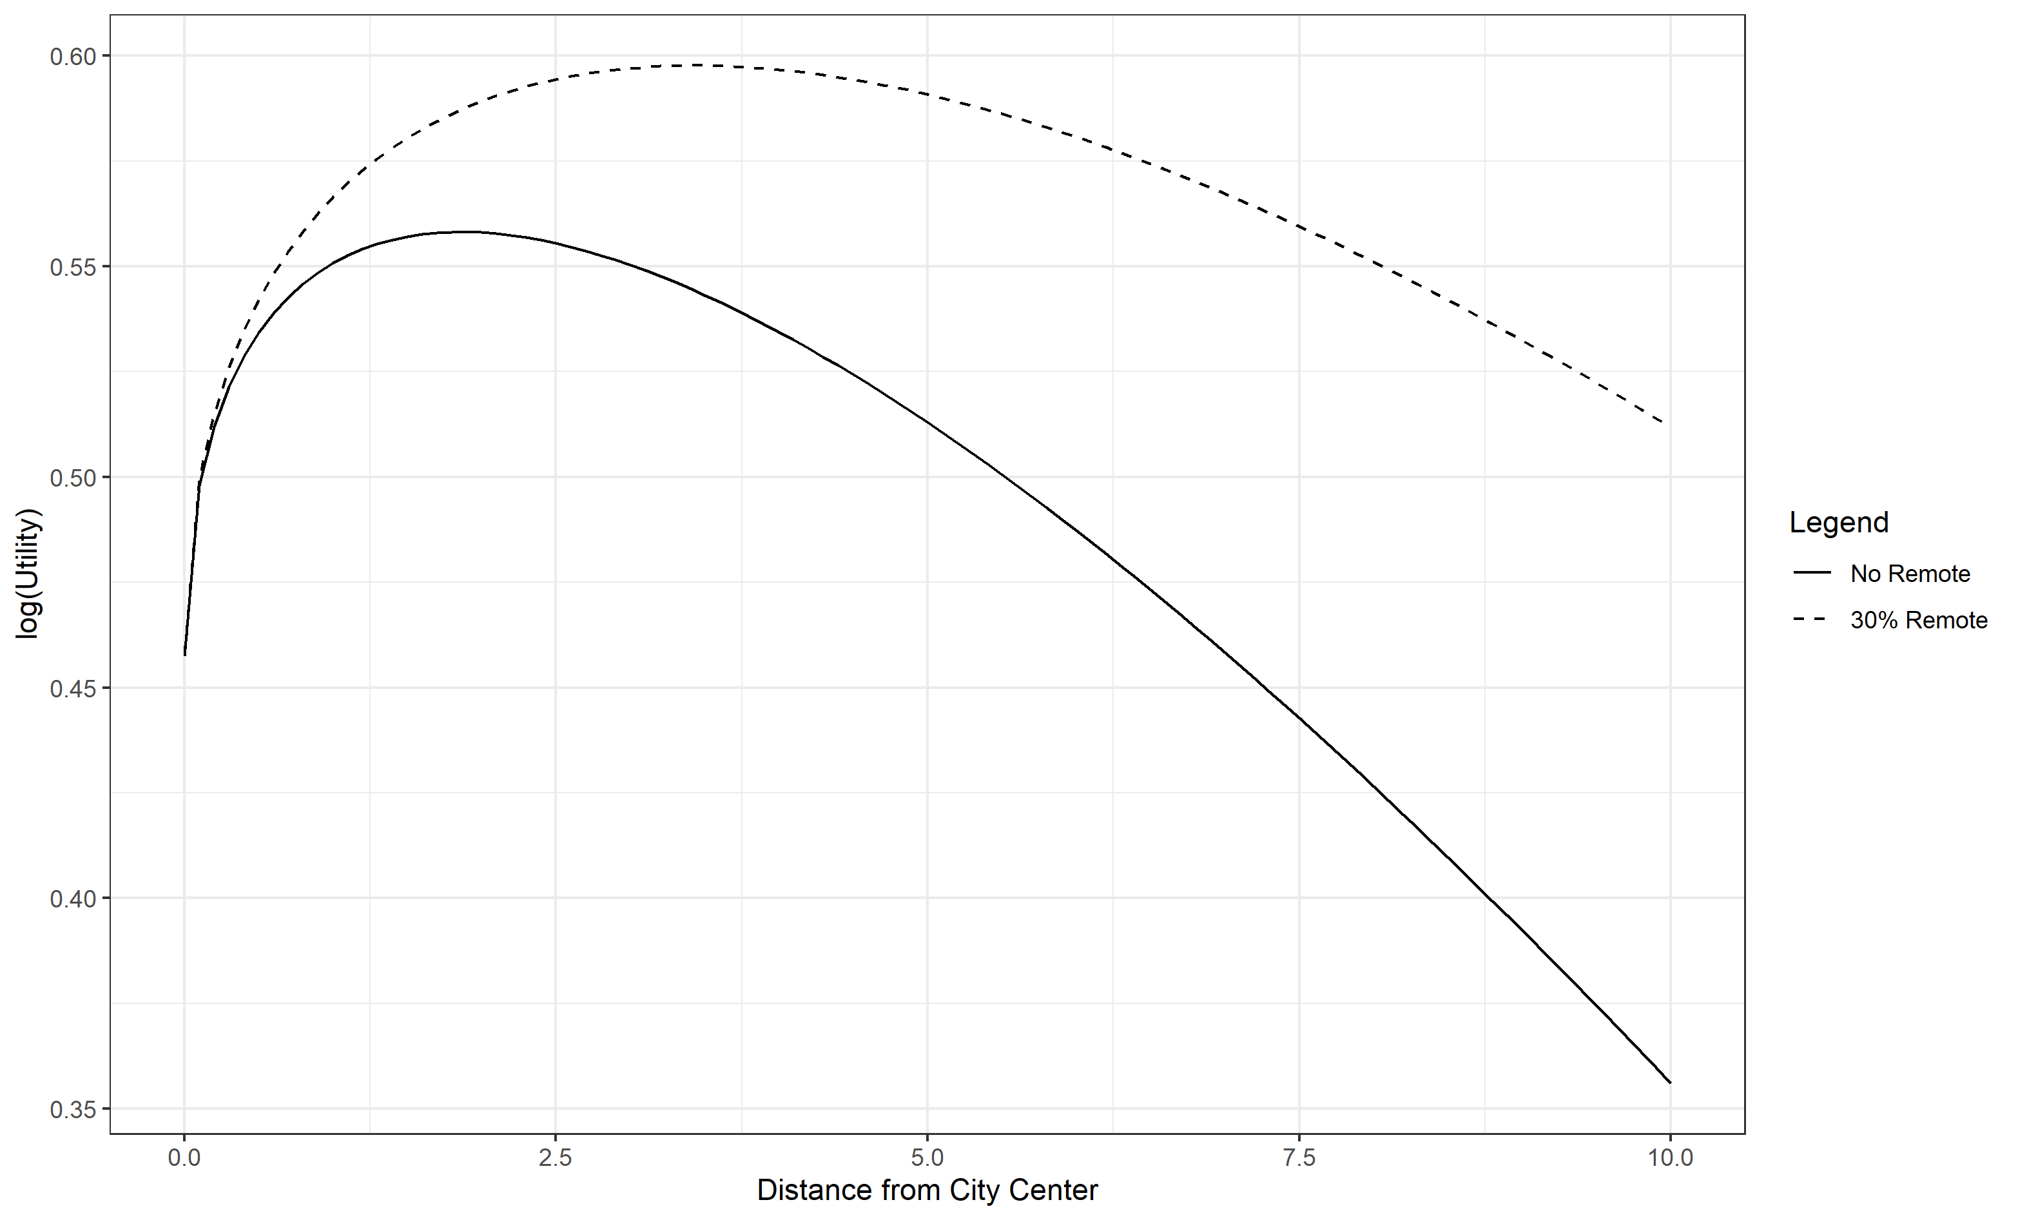 Assume the worker could effectively complete 30% of her work from home. She experienced no WFH previously but a company policy changed experienced WFH to its fullest potential (30%). When the amount of remote work increases, her optimal location choice gets further from the city. This reflects commute time being traded off for more local good consumption when effective commute time decreased.

# Comparison Example

Let the above variable values represent that of a young urban worker. Let an old urban worker have the same values except for the amenity preference function coefficients. Let the old worker not care about entertainment ($β_{e}=0$) and care about commute time slightly less ($β_{c}=.02768$).  
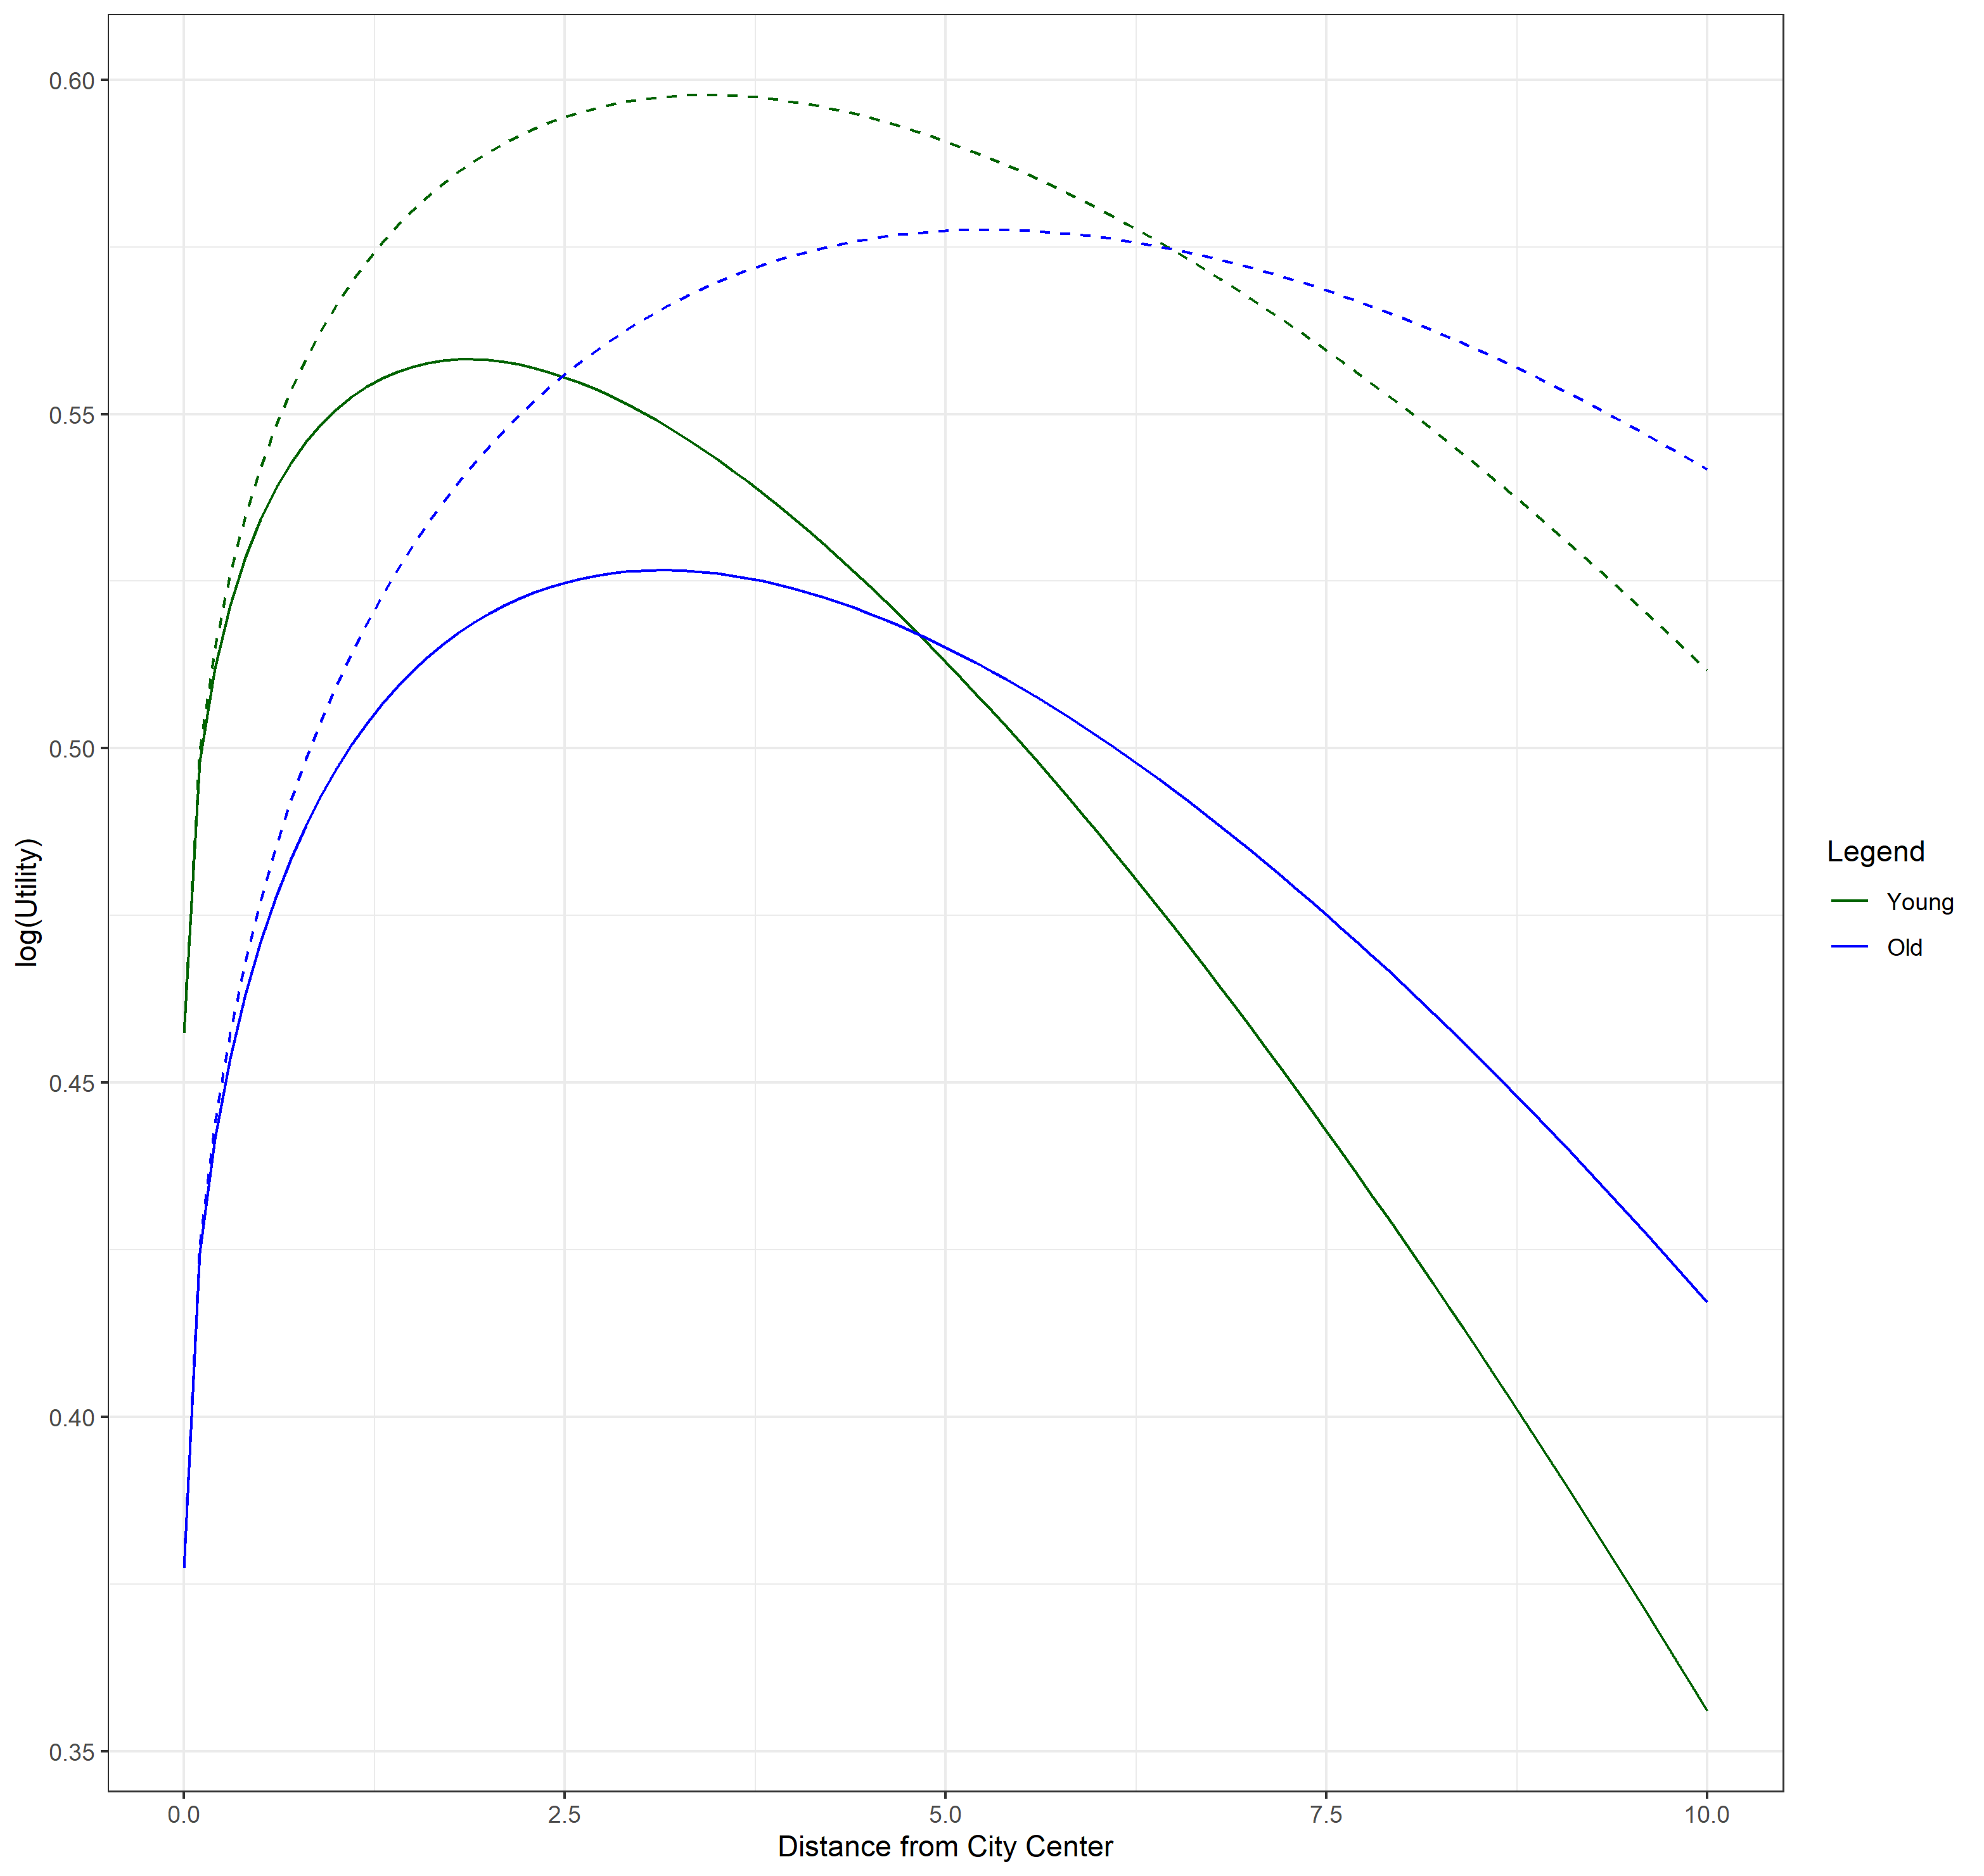 As can be seen in the above figure, the young and old worker have different initial and final optimal locations. Furthermore, the old worker experiences a larger change in optimal log(Utility) and change in optimal distance from city center. If there were to be any constant moving cost associated with changing locations, the old worker would be more likely to still find the move profitable. This model suggests that amenity preferences can influence the willingness to move away from a city when amount of time working remotely increases. If this theory holds true along with the assumption that there is some homogeneous amenity preferences within education/age/family-status groups, then the demographics of a region should influence the percent change in housing price.