Experiments with a Berlese Funnel

Paul J. Palmer

Trying to figure out what to call a Berlese (or Tullgren) Funnel takes more time than describing what it does. It is an apparatus for collecting microfauna from soil or leaf litter samples. The history is hard to pin down, but the earliest mention seems to be from Berlese (1905) and Tullgren (1917) so it appears that Berlese was the first to describe the apparatus, using a water bath as a heater, and then Tullgren simplified the overall arrangement by using an electric lamp as a source of heat. I’m going to stick with “Berlese Funnel” for now.

The general principle involves providing a funnel with a fine-mesh lid, an inner coarse mesh upon which the sample material is laid, and a slippery funnel leading to a receptacle with a liquid preserving agent. The use of a lamp to warm and dry the sample is an optional extra in these days of high energy costs, especially if you keep the apparatus in a warm, dry place. Mine was set up in the greenhouse with a small lamp to dry the material (See Figure 1) and a tube filled with 100% Mono Propylene Glycol (MPG) to catch the microfauna. I’m a fan of MPG as it is a good preservative, slow to evaporate, non toxic, preserves colours, and keeps specimens fairly supple. I found that most of the catch appeared after three days and little ever appeared after a week.

For my experimental trial, all the material came from locations on the nature reserve at Rutland Water: So what did I find?

My favourite and a personal first was the Pseudoscorpion *Chthonius ischnocheles* (Common Chthonid) Figure 2. It turned out that the keys to woodlice are quite easy to use so Figures 3 and 4 show the common woodlice Ag. and . All the by-catch was separated and logged and thanks to Graham Finch I have a list of the beetles too. Of note were *Ochthebius pusillus* with just one previous record in 1936, and *Dacrila fallax* with just three previous records, with the last Rutland Water record in 2021. The current list of species recorder is in Table 1.

After this encouraging start I shall be expanding use of the Berlese Funnel in 2024.

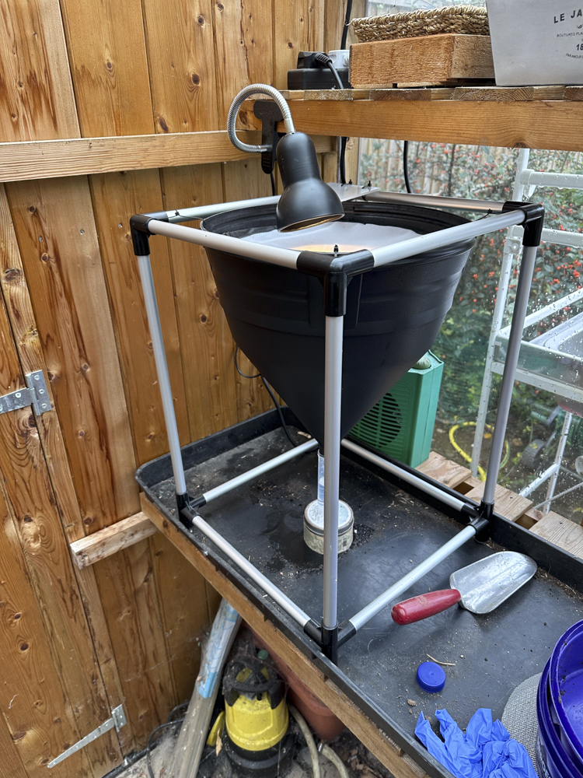

Figure 1: Berlese Funnel set up in the greenhouse.

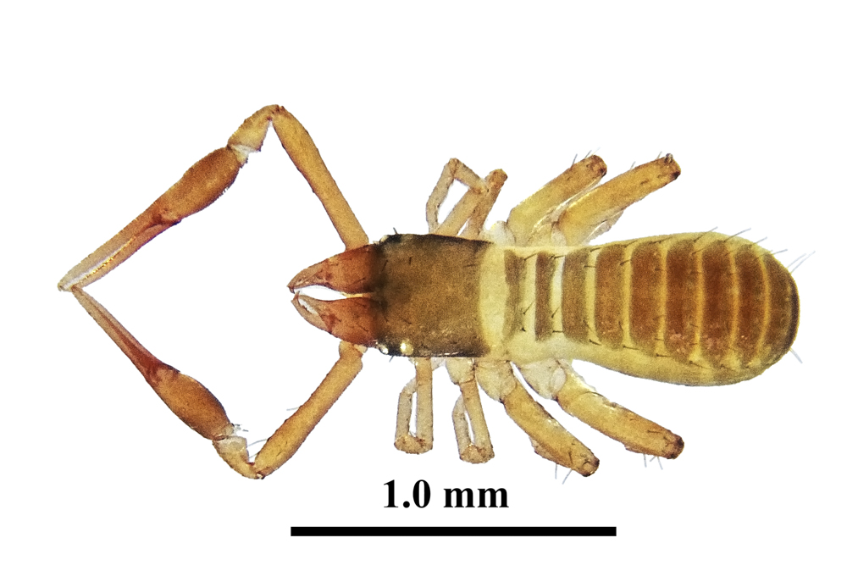

Figure 2: Common Chthonid

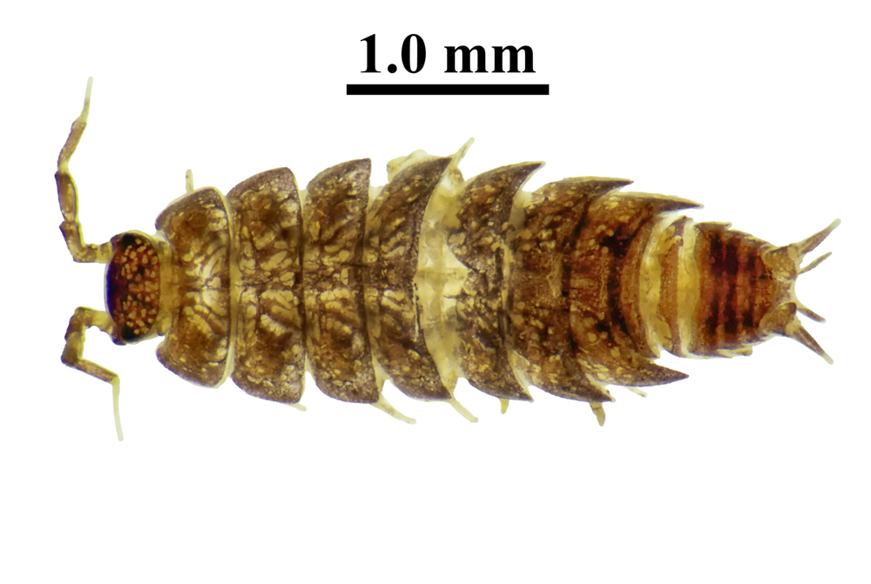

Figure 3: Ag. Common Pygmy Woodlouse

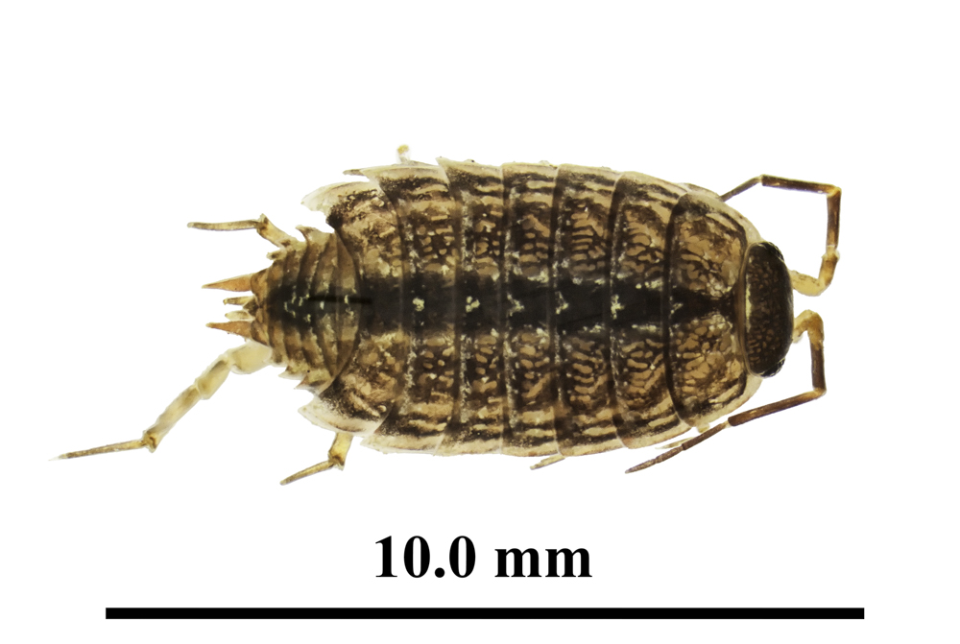

Figure 4: Common Striped Woodlouse

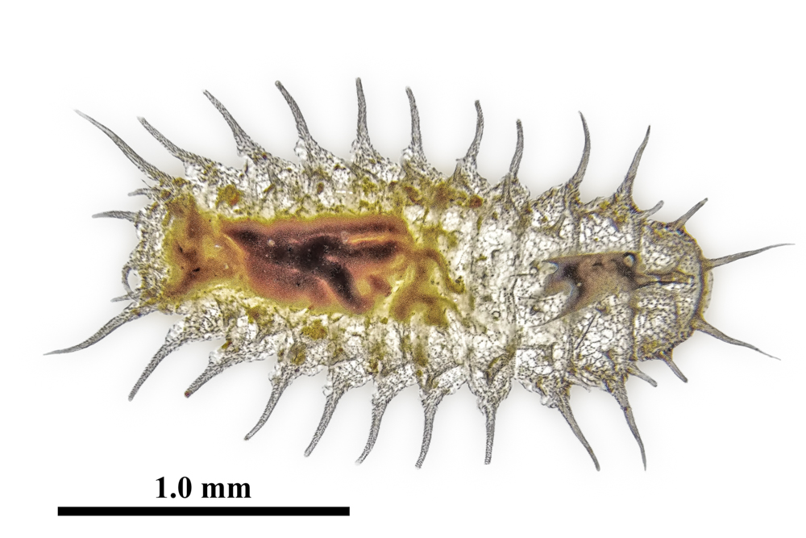

Figure 5: Unknown Scale Insect, mobile stage.

# Bibliography

This short bibliography covers sources that helped to inspire this article.

Berlese, Antonio. 1905. “Apparecchio Per Raccogliere Presto e in Gran Numero Piccoli Arthropodi.” *REDIA – Journal of Zoology*, 85–89.

Tullgren, A. 1917. “En Enkel Apprat För Automatiskt Vittjande Av Sällgods.” *Entomologisk Tidskrift* 38: 97–100. <https://www.biodiversitylibrary.org/item/42375#page/124/mode/1up>.