Angular

Client framwork for SPA Include only

--One html (index.html)

-- One javascript bundled

<input type=”text” [(ngModel)]=”name”/> 🡪 Call directive and he listen to input text and store it into name

<p>{{name}}</p>

Index html has html directive called <app-root> </app-root>, This component tied all application together.

Main.ts the first code to be executed

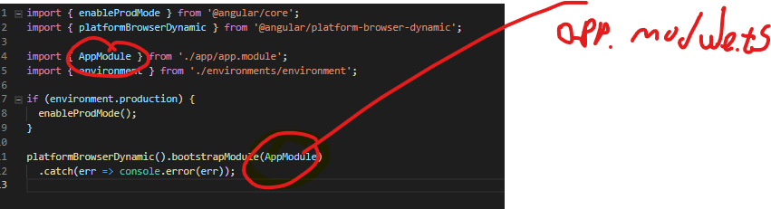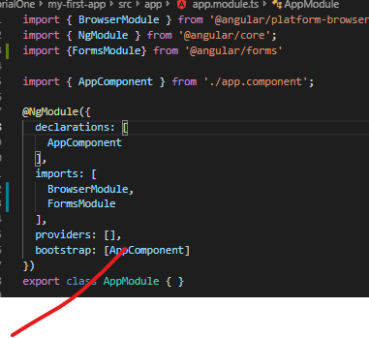

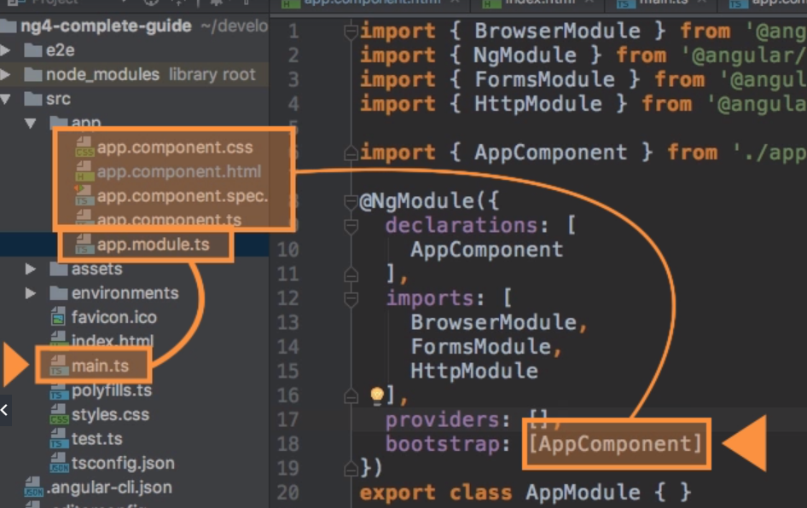

Property binding {{serverId}} 🡪 string interpolation ,

[disabled]=”property” will bind data directly to attribute 🡪 property binding

<button> (click)=”foo()” </button> 🡪 event binding 🡪 Event binding

[(ngModel)]="user.email"> 🡪 Two way binding

**Directives**

Directive are instructions in the DOM <https://www.dev6.com/angular-2-the-three-types-of-directives>

Component Comunication

@Input() – From parent to child

@Output() – From Child Emit to parent event

The chin of input output can grow to complex communication (See diagram) in order to child a communicate with child b , we should performe a lot of iput output chain, in order to solve it we use services

Child b

Parent

Child a

Services

We should create a typical class

Inject it to component constructer

Provide Type for the component leve

Service is a simple class the can be injected from all kind of component level such (child, parent, module).

We should understand something very important regarding for services. If service inject from top hierarchy, all sub hierarchy will share the same instance of the same service service .

Unless one of the child provide hi on service

Ng Lifecycle main

* ngOnChange 🡪called when input change
* ngOnInit 🡪called when after object initialized
* ngDoCheck everyChnge detection
* ngOndestroy called when object about to destroy

Commands

Node -v (Version n ode js)

npm install -g (Update node version )

npm install g -n latest

npm install --save bootstrap@3 (--save add pakcge to json file no needed anymore)

<https://www.udemy.com/the-complete-guide-to-angular-2/learn/lecture/6655678#overview>

code -n . (open current folder)

-g for general

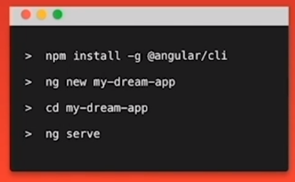

ng serve --open (copile and run app by default to port 4200)

ng serve --port 4203 --open

ng g c some-component-name “component name” g for generate c for component

vs code

shift + alt+f (identation)