Traffic Sign Recognition via Transfer Learning on GTSRB
Anurag Chaudhary
ECE 5831-02 Pattern Recognition and Neural Networks — Final Project Report (Dec 2025)

Abstract
Traffic sign recognition is a practical multi-class classification problem with safety implications for driver-assistance systems. In this project, I built an end-to-end PyTorch pipeline for the German Traffic Sign Recognition Benchmark (GTSRB, 43 classes) using transfer learning from ImageNet-pretrained CNN backbones. The system supports a two-stage training recipe (classifier head warm-up followed by partial fine-tuning), data augmentation, optional class-balanced sampling, and regularization via label smoothing and MixUp/CutMix. Beyond accuracy, the pipeline reports macro-F1, calibration via expected calibration error (ECE) with reliability diagrams, and interpretability via Grad-CAM overlays. Initial work-in-progress runs validate the full workflow and produce quantitative metrics and visual diagnostics; longer training and additional ablations are identified as the primary next steps to reach the expected >97% accuracy typically reported for CNNs on GTSRB.

Introduction
Traffic sign recognition is a classic vision task: given a cropped sign image, predict one of 43 categories such as speed limits, right-of-way, or warning signs. It is interesting because it combines (1) real-world variability (lighting, motion blur, viewpoint, occlusion), (2) class imbalance and visually similar categories (e.g., speed-limit signs), and (3) practical constraints (latency and model size) that motivate efficient architectures.
This project focuses on building a reproducible training and evaluation pipeline that can be used to explore modern transfer learning practices for GTSRB. Instead of training a CNN from scratch, I fine-tune ImageNet-pretrained networks (MobileNetV3-Small by default, with an option for ResNet50) and evaluate not only predictive performance but also model reliability (calibration) and interpretability (Grad-CAM).

Related Work / Literature Review
GTSRB benchmark. The German Traffic Sign Recognition Benchmark (GTSRB) is a widely used dataset for traffic sign classification, providing a curated set of real-world sign images with significant variations in scale and illumination. CNN-based approaches have achieved strong performance on this benchmark, making it a useful testbed for transfer learning and robustness analyses.
Transfer learning and efficient CNN backbones. Transfer learning from ImageNet is a standard approach for problems with limited labeled data or when fast convergence is desired. ResNet architectures introduced deep residual connections that enable training very deep networks effectively, while the MobileNet family focuses on mobile-friendly computation using depthwise separable convolutions and later architectural improvements (e.g., MobileNetV3).
Regularization and data augmentation. Augmentation is particularly important for traffic sign recognition because real deployment conditions include blur, brightness changes, and geometric transforms. MixUp and CutMix are popular augmentation-based regularizers that often improve generalization and reduce overconfidence.
Calibration and interpretability. Modern neural networks can be miscalibrated, producing confidence scores that do not match empirical correctness. Temperature scaling and related calibration methods are commonly evaluated using expected calibration error (ECE) and reliability diagrams. For interpretability, Grad-CAM provides class-specific saliency maps that help verify whether a model relies on sign-relevant regions rather than background cues.

Method

Data and preprocessing
The pipeline uses torchvision.datasets.GTSRB and creates an internal train/validation split from the training partition (default: 90% train, 10% validation with a fixed seed). Images are resized to a configurable square resolution (default 96×96). Training-time transforms include random resized cropping, rotation, color jitter, blur, and horizontal flips; evaluation uses deterministic resizing and ImageNet normalization.
To handle torchvision’s dataset interface (single transform per dataset instance), the implementation uses separate dataset instances for train vs. validation transforms while sharing the same underlying samples, then applies split indices consistently.

Model and training recipe
Two pretrained backbones are supported:
- MobileNetV3-Small (default): designed for efficient inference
- ResNet50: larger model for higher capacity at increased compute cost
The classifier head is replaced with a 43-class linear layer. Training follows a two-stage recipe:
- Head warm-up: freeze the backbone and train only the classifier head for a small number of epochs.
- Fine-tuning: unfreeze the last N backbone blocks and continue training end-to-end.
Optimization uses AdamW with optional OneCycle or cosine learning-rate schedules. Regularization options include label smoothing and MixUp/CutMix.

Evaluation, reporting, and interpretability
Evaluation reports accuracy and macro-F1 (to reduce sensitivity to class imbalance). Calibration is quantified using expected calibration error (ECE) and visualized with a reliability diagram. For interpretability, Grad-CAM overlays are exported for a few validation examples.

Results (Work in Progress)
Because full training to convergence is compute-intensive, the results below are from short runs intended to validate the end-to-end pipeline and generate artifacts (metrics, plots, Grad-CAM). Longer runs are planned as the primary improvement path.

Quantitative metrics
Run | Backbone | Image size | Head epochs | Fine-tune epochs | Val Acc | Val Macro-F1 | Val ECE | Test Acc | Test Macro-F1 | Test ECE
outputs/smoke | MobileNetV3-Small | 96 | 0 | 0 | 0.033 | 0.023 | 0.019 | – | – | –
outputs/demo_fast | MobileNetV3-Small | 64 | 0 | 1 | 0.474 | 0.342 | 0.100 | – | – | –
outputs/final_project | MobileNetV3-Small | 96 | 1 | 1 | 0.714 | 0.653 | 0.171 | 0.580 | 0.437 | 0.079

Visual diagnostics
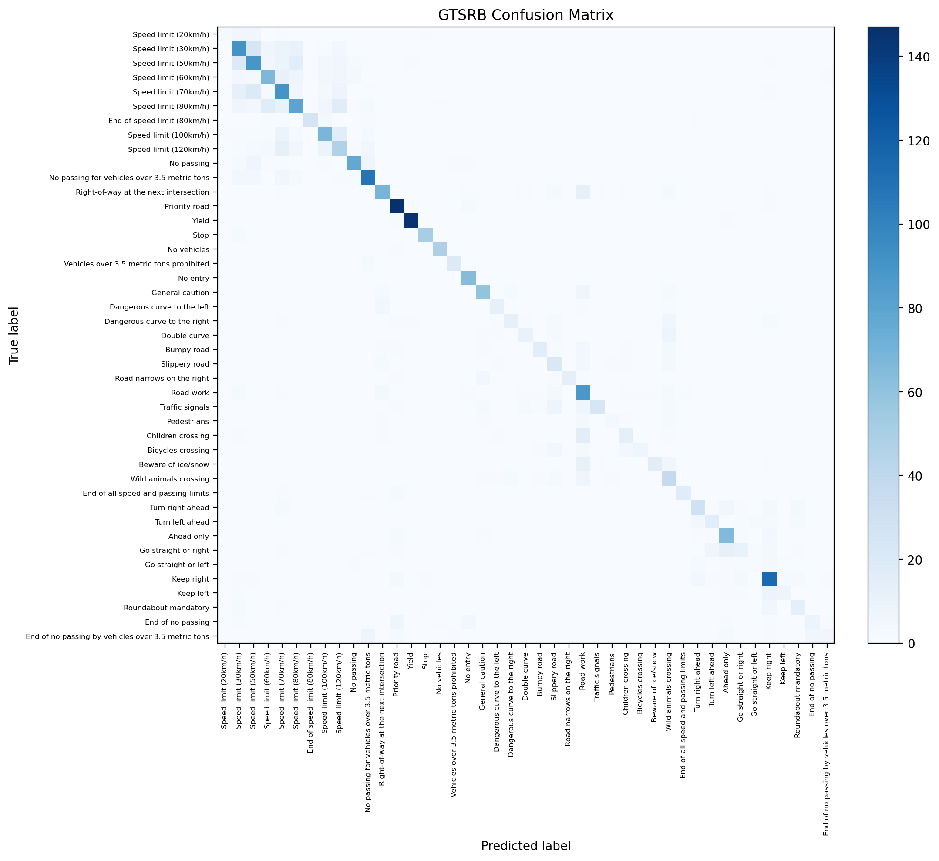
Confusion matrix (work-in-progress run).
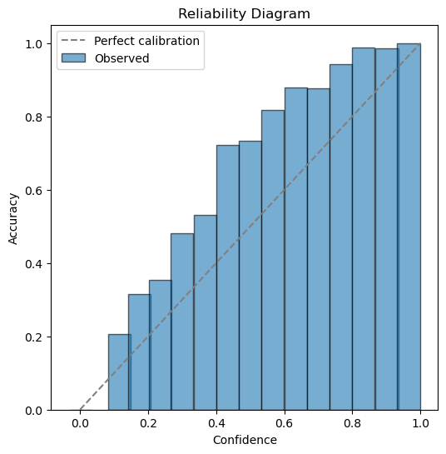
Reliability diagram (work-in-progress run).

Grad-CAM demo overlay for a sample image.

Discussion and Next Steps
The work-in-progress metrics show that the pipeline functions end-to-end and produces the intended quantitative and qualitative artifacts. However, the current accuracy is well below the typical 97–98% reported for well-trained CNNs on GTSRB. The primary reason is that the logged run uses a very short schedule (1 epoch head warm-up + 1 epoch fine-tuning), which is appropriate for debugging but not for final performance. In addition, some settings (image resolution, unfreeze depth, use of a balanced sampler, and augmentation strength) likely require tuning.
Concrete next steps:
- Train to convergence and run ablations. Increase epochs (e.g., 3–5 head warm-up and 10–20 fine-tuning), compare MobileNetV3-Small vs. ResNet50, and vary input resolution (64/96/128) to quantify the compute–accuracy tradeoff.
- Address class imbalance. Enable the weighted sampler and report per-class precision/recall to see whether minority classes improve without harming overall accuracy.
- Improve calibration. Evaluate temperature scaling on the validation set and compare ECE/reliability diagrams with and without MixUp/label smoothing.
- Robustness checks. Report accuracy under synthetic corruptions such as blur and brightness shifts to simulate real driving conditions.
- Interpretability-driven error analysis. Use Grad-CAM on failure cases to categorize common errors (e.g., confusing similar speed-limit signs) and identify whether background bias or cropping issues contribute.

References
- J. Stallkamp, M. Schlipsing, J. Salmen, and C. Igel, “The German Traffic Sign Recognition Benchmark: A multi-class classification competition,” IJCNN, 2011.
- K. He, X. Zhang, S. Ren, and J. Sun, “Deep Residual Learning for Image Recognition,” CVPR, 2016.
- A. Howard et al., “Searching for MobileNetV3,” ICCV, 2019.
- R. R. Selvaraju et al., “Grad-CAM: Visual Explanations from Deep Networks via Gradient-Based Localization,” ICCV, 2017.
- H. Zhang et al., “mixup: Beyond Empirical Risk Minimization,” ICLR, 2018.
- S. Yun et al., “CutMix: Regularization Strategy to Train Strong Classifiers with Localizable Features,” ICCV, 2019.
- C. Guo, G. Pleiss, Y. Sun, and K. Q. Weinberger, “On Calibration of Modern Neural Networks,” ICML, 2017.

