LAB 5: MUSIC CLASSIFICATION
Author
Enric Verdaguer Morales
SMC Master
Universitat Pompeu Fabra

All code, documentation, feature tables and Audio Samples used in this lab can be found in the following link:
https://github.com/enric592/MIR_Lab5
- INTRODUCTION
In this lab we are going to build a music classifier, concretely we are going to work in mood. The general aim of our work is to learn about the whole process of building a classifier by working with a reduced dataset and taxonomy in order to keep it as simple as possible.
- TAXONOMY DEFINITION
We decided to build a 'mood' classifier, by considering the most easy and well-known moods.
The given database for this lab had three different classes: Happy, Sad and Aggressive, but we took the decision to work only with the first two ones because we were looking for the most easy and clear case.
Additionally, while Happy and Sad are known as complete opposites, being easy for people to distinguish between them, aggressiveness distinction looks a little more vague to me:
For me 'Aggressive' it is not a completely independent entity: I can think about some cases of Happy and Aggressive songs, but I can not imagine any excerpt being Happy and Sad simultaneously.
- DATASEt DEFINITION
For training purposes we use the given Happy/Sad database composed by 60 samples: 34 of them are tagged 'Happy' and the other 26 are sad:

Song | Artist | Mood
Black Is The Color of My True Loves Hair | Nina Simone | Sad
Honey | Erykah Badu | Happy
Truth | Chiddy Bang | Happy
Good Life (Ft. T-Pain) | Kanye West | Happy
Todo el mundo lo sabe | Solo los Solo | Happy
Por que te fuiste? | MDE Click | Sad
Runaway (Ft. Pusha T) | Kanye West | Sad
Down In A Hole | Alice in Chains | Sad
Sweet Home Alabama | Lynyrd Skynyrd | Happy
Brothers In Arms | Dire Straits | Sad
Mouthful Of Cavities (24-Bit Digitally Remastered 01) | Blind Melon | Sad
Murir | MDE Click | Sad
Rainy Day Women # 12 & 35 | Bob Dylan | Happy
Here Comes Your Man | Pixies | Happy
Troy (2009 Digital Remaster) | Sinéad O'Connor | Sad
Adagio in G minor | Albinoni | Sad
Adagio for Strings | Samuel Barber | Sad
Always | Bon Jovi | Sad
Fingerbib | Aphex Twin | Happy
Dance Little Liar | Arctic Monkeys | sad
Bang Bang | Nancy Sinatra | Sad
Bessarabian horadi sapozhkelekh | Kroke | Sad
Stir it up | Bob Marley | Happy
Brother Bru | Billy Martin & Wil Blades | Happy
Cloud Atlas End Title | Unknown | Sad
Collapse The Light Into The Earth | Porcupine Tree | Sad
Country House | Blur | Happy
Dance, dance | Fall out boy | Happy
Power Ballad | Datasette | Happy
New Beginning | Deaf Center | Happy
Nantes | Barbara | Sad
Don´t Cry | Guns´n Rose | Sad
Don't stop me now | Queen | Happy
Waternight | Eric Whitacre | Sad
Excuse me | Peter Gabriel | Happy
Jungle Drum | Emiliana Torríni | Happy
I'm into Something Good | Herman's Hermits | Happy
Surfin' USA | The Beach Boys | Happy
The Air-Conditioned Nightmare | Mr Bungle | Happy
Nude | Radiohead | Sad
I've Been Loving You Too Long | Otis Redding | Sad
Theme from Schindler's List | John Williams | Sad
The Air-Conditioned Nightmare | Mr Bungle | Sad
Gloomy Sunday | Rezso Seress | Sad
Goodbye My Lover | James Blunt | Sad
Goodbye to Romance | Ozzy Osbourne | Sad
Since I Left You | The Avalanches | Happy
Sexual Healing | Hot 8 Brass Band | Happy
We're from Barcelona | I'm from Barcelona | Happy
Anyone Else But You | The Moldy Peaches | Happy
Unknown | Unknown | Happy
High Hopes | Pink Floyd | Sad
How Long | Eagles | Happy
Hurt | Johnny Cash | Sad
Ice Cream Man | Van Halen | Happy
Ha en rozsa volnek | Janos Brody | Sad
Soda's Theme | Ilkae | Happy
Is this love | Bob Marley | Happy
Je Veux | Zaz | Happy
Restless | Kakkmaddafakka | happy
La Caravane | Caravane Place | Happy
Lacrimosa | Mozart | Sad
Lola's Mambo | Juan Luis Guerra | Happy
Long Live Rock 'n' Roll | Rainbow | Happy
La primavera Trompetera | Los delinqüentes | Happy
Love Today | Mika | Happy
Mamma Mia | ABBA | Happy
Red Paint | Matt and Kim | happy
Moonlight Sonata | Ludwig van Beethoven | Sad
Sunburn | Muse | sad
Neues Liebeslied | Kleinggeldprinzessin | Sad
Familiar | Nils Fraum | Sad
Nothing else matters | Metallica | Sad
A1 | Olafur Arnalds | Sad
Once more once | Michel Camilo | Happy
Pirata Capitán | La Kinky Beat | Happy
Spring | Vivaldi | Happy
Karma Police | Radiohead | sad
Roads | Portishead | Sad
Pyramid Song | Radiohead | Sad
Untitled #1 (Vaka) | Sigur Rós | Sad
Pictures Of You | The Cure | Sad
Sacrificed Sons | Dream Theater | Sad
Legalizacion | Ska P | Happy
Still Got the Blues | Gary Moore | Sad
John Wayne Gacy Jr | Sufjan Stevens | Sad
Sunrise to sunset | Edna's Goldfish | Happy
Horny | Mousse T | Happy
Tears in Heaven | Eric Clapton | Sad
Zombie | The Cranberries | sad
Same Jeans | The View | happy
Tus Ojos | Guerola | Sad
Vacant | Dream theater | Sad
A-punk | Vampire Weekend | happy
Walking on Sunshine | Katrine and the Waves | Happy
When You Are Gone | Avril Lavingne | Sad
You Shook Me All Night Long | AC/DC | Happy
Young for You | Gala | Happy
I'm Waiting For The Man | The Velvet Underground / Nico | Happy
Table 1. Training dataset.
Apart from this given set we made our own contribution by adding 10 more excerpts. The idea is to use them as a test set to evaluate the built classifier with samples of known songs. This small evaluation set is composed by five samples of each instance with a duration of around 30 seconds (same as training).

Song | Artist | Mood
Soc feliç | Hora de Joglar | Happy
Waterloo | Abba | Happy
Warmness on the Soul | Avenged Sevenfold | Sad
Everybody Talk | Neon Trees | Happy
My Immortal | Evanescence | Sad
Abril 74 | Lluís Llach | Sad
Happy | Pharell Williams | Happy
Love of my life | Queen | Sad
Stay with me | Sam Smith | Sad
Wake me up before you go go | Wham! | Happy
Table 2. Test dataset.
- FEATURE EXTRACTION
We developed a feature extractor using Matlab and MIR toolbox, and exported our results into a .csv file.

As mood is something a little vague to define, and is not directly represented by any descriptor, we are going to use many of them that can be indirectly related in order to extract enough information to build a good classifier.

Considering that we are working in a quite small dataset of 60 instances for training, we have to use a reduced set of features to avoid over-fitting, so we are picking only those that make real sense to us and we can understand directly.
In this table we have a relation of all the features available in MIR toolbox together with a description. We well mark in color the features picked for our classifier:

Descriptor name | Description
ENERGY
mirrms | Root Mean Square, effective power of audio.
mirlowenergy | Number of frames with lower than average energy.
mirenvelope | Amplitude envelope (global shape of the waveform)
mironsets | Note onset positions and characteristics
mirattacktime | Duration of note attacks
mirattackslope | Average slope of note attacks
mirdecreaseslope | Note release phase description
mirattackleap | Change of amplitude in note attacks
mirduration | Note duration from attack to release
mireventdensity | Average frequency of events
RHYTHM
mirtempo | Tempo (in beats per minute)
mirmetre | Metrical analysis
mirmetroid | Dynamic metrical centroid and strength
mirfluctuation | Fluctuation strength (periodicities in each channel)
mirbeatspectrum | Beat spectrum, characterizing the rhythmic content
mirpulseclarity | Rhythmic clarity, i.e., beat strength
TIMBRE
mircentroid
mirspread
mirbrightness | Spectral brightness (high-frequency rate)
mirrolloff | Spectral rolloff (frequency above which is located a certain amount of energy)
mirmfcc | Mel-frequency cepstrum coefficients
mirinharmonicity | Inharmonicity (partials non-multiple of fundamental)
mirroughness | Roughness (sensory dissonance)
mirregularity | Spectrum irregularity (amplitude variability of successive peaks)
PITCH
mirpitch | Pitch frequencies
mircepstrum | Cepstrum representation (showing periodicities)
mirmidi | Attempts a conversion of audio into MIDI
TONALITY
mirchromagram | Chromagram (distribution of energy along pitches)
mirkeystrength | Key strengths (probability of key candidates)
mirkey | Best keys and modes (in the 12 tone system)
mirkeysom | Visualizes key strengths with self-organizing map
mirmode | General estimation of mode (major/minor)
mirtonalcentroid | Tonal centroid (using circles of fifths and thirds)
mirhcdf | Harmonic Change Detection Function
Table 3. MIR toolbox available descriptors and picked ones.
We said before that mood is spread and present along many features, we will now try to justify our feature selection for each category:

- Energy: Happy songs usually feel more en energetic, and will probably have a higher amount of instruments (more energy), but nowadays with the growing presence of Compression in music it's difficult to say if any differences in this facet could be found.
Anyway, we are going to make use of some of them: RMS, LowEnergy, AttackTime, NoteDuration and EventDensity

- Timbre: Features based on Spectrum seem to be more representative of the “color” of the signal, and somehow model the shape of every sample so we are going to make use of all of them.

- Rhythm: Again, this kind of descriptors could be representative in our classification as we think that most of th Sad songs tend to be slower than happy ones, so we are going to use some related features as: Tempo,Metroid, and PulseClarity.

- Tonality: We don't know if key has a direct incidence on mood, but the mode is for sure something relevant in that case, as minor mode usually sounds more sad than major. We are going to consider: Key, Mode and TonalCentroid

As we commented in the beginning of this section, all the selected features are extracted with MATLAB (code attached in the .zip file), for all samples of each class. This process resulted in two .csv files (one for each class) containing all feature values (43 attributes) for each sample in the class (60 instances) [Happy.csv | Sad.csv].

We then joined both .csv files and filtered some conflictive characters with LibreOffice Calc in order to get a file ready to be loaded in Weka [Features.csv].

The same procedure is done using the test dataset samples to get a Test .csv [Test.csv].
- Automatic classification
At this step, we have to model the extracted features of our training dataset together with their annotated class to build a classifier. To do it we used Weka.
After loading our training dataset, we applied a Normalize filter as suggested and performed Classification using different classifiers. We tried to used those which sound more common to us: J48 (decision tree), SMO (support vector machine), Ibk (k-Nearest Neighbours), AdaBoost and ZeroR as our Baseline.
The final classifier is evaluated both using Cross-validation (Xval) technique (10 folds) and with our Test Dataset, because an arbitrary and small test set was in our opinion not enough to evaluate the quality of a classifier.

Classifier | Xval accuracy | Test D accuracy
ZeroR (baseline) | 56,67 % | 50 %
J48 | 66,67 % | 70 %
SMO | 65 % | 80 %
LBk | 51,67% | 40 %
AdaBoostM1 | 70 % | 70 %
Table 4. Classifier accuracies in both evaluation methods.

Classifier | Xval Confusion M | Test D Confusion M
ZeroR (baseline) | 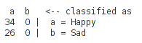 | 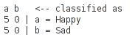
J48 | 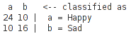 | 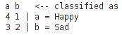
SMO | 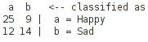 | 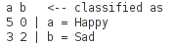
LBk | 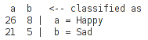 | 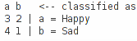
AdaBoostM1 | 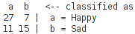 | 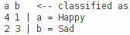
Table 5. Confusion matrices in both evaluation methods.

ZeroR classifier just looks for the most popular class and guesses that all the time. It used a baseline to compare and evaluate the results for other classifiers. It can be easily understood by looking at the confusion matrix: all our instances get assigned to the most common class: Happy.

From the results we can say that both evaluation methods seem to be slightly correlated, as they tend to behave similarly along all classifiers.
The best classifier for Xval evaluation is AdaBoostM1which gets a 70% accuracy while SMO reaches 80% for our training dataset.

We are going to focus our analysis into the results of the Test dataset, as is a reduced, fixed and know bunch of samples that we can listen and analyze with more precision.
If we take a look to the accuracy by class of SMO and into it's confusion matrix, we can see that our mean results are around 80% both in Precision and Recall, having classified well all 'Happy' instances (recall = 1).
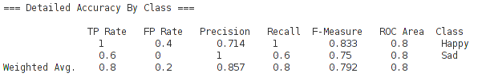
Figure 1. Caption of Weka Output: Datailed accuracy by class of SMO.

We could consider this results quite good, as our classifier will give 2 out of 10 erroneous results, but looking at cross validation or other classifier results, we can say that our features are not good enough to model this two classes, as overall results are not too high (around 60-70%).

As we used a small test dataset, we can now take a look to the specific result of each classified instance (using best-result methods):

Song | Annotated | Predicted
Soc feliç | Happy | Happy
Waterloo | Happy | Happy
Warmness on the Soul | Sad | Happy
Everybody Talk | Happy | Happy
My Immortal | Sad | Sad
Abril 74 | Sad | Sad
Happy | Happy | Happy
Love of my life | Sad | Happy
Stay with me | Sad | Sad
Wake me up before you go go | Happy | Happy
Table 6. Annotated vs Predicted class with SMO classifier for each instance of the Test Dataset.

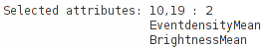
If we then go to Select Attributes, we will get a selection of those which perform better in our classification. In our case we get:
Figure 2. Caption of the Weka output: BestFirst attribute selection.
If we visualize them together in Weka:
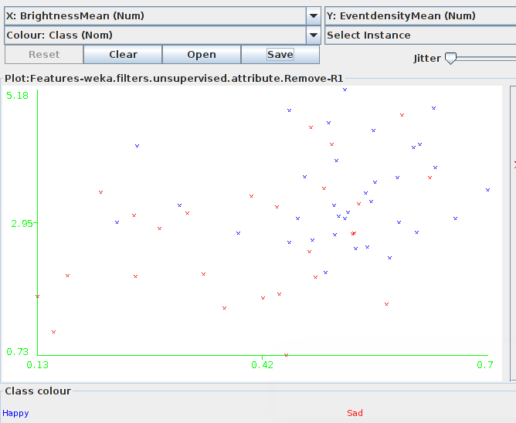
Figure 3. Weka plot caption: EventDensityMean vs BrightnessMean

We can see that it is a good starting point as there seems to be a slight tendency for Happy Songs to be Brighter (more high-frequency content) and with a higher Event Density Rate.

We can go a step further and perform a fast classification using only this two features [Features_reduced.arff | Test_reduced.arff]:

Classifier | Xval accuracy | Test D accuracy
ZeroR (baseline) | 56,67 % | 50 %
J48 | 73,33 % | 60 %
SMO | 71.67 % | 70 %
LBk | 58,33 % | 50 %
AdaBoostM1 | 66,67 % | 90 %
Table 7. Classifier accuracies in both evaluation methods for a reduced feature set.
If we compare with the previous result, we can easily see that despite we are using a drastically fewer number of features the results are not worse. This means that from all the selected features, this are actually the best pair. Additionally, we see that in some cases the new result is even better than the previous one, this can be due to the effect of over-fitting in the first classification where we had 43 attributes for 60 instances.

In this new scenario J48 is the best for Xval evaluation and AdaBoost for Test Dataset, where only one instance falls into error:

Song | Annotated | Predicted | Percentage
Soc feliç | Happy | Happy | 0.667
Waterloo | Happy | Happy | 0.853
Warmness on the Soul | Sad | Sad | 0.598
Everybody Talk | Happy | Happy | 0.853
My Immortal | Sad | Happy | 0.667
Abril 74 | Sad | Sad | 0.598
Happy | Happy | Happy | 0.667
Love of my life | Sad | Sad | 0.988
Stay with me | Sad | Sad | 0.598
Wake me up before you go go | Happy | Happy | 0.667
Table 8. Annotated vs Predicted class with SMO classifier for each instance of the Test Dataset for a reduced feature set.

- Conclusions
We started the whole process with the idea of getting an insight on automatic classification. We worked on mood, a very subjective taxonomy which apart from the content, have a lot of information in Context (both user and music).
We picked a huge amount of features that could be somehow related to the selected classes Happy and Sad, but working with a small Training Dataset of 60 instances, our picked 43 features seem to over-fit some of the classifiers.
After testing different classifiers and analyzing results EventDensityMean and BrightnessMean appeared the most relevant features from our selection, leading a 2-feature classifier to surprisingly good results compared to the complete feature selection.

