Contents
Introduction 2
Comparison baselines 4
Affectation of tissue 4
Metastasis prediction on pt1 CRC 5
Working with WSI: a large problem 6
Detection of affected tissue on WSI 6
Splitting procedure 6
UNI2: the vision encoder model 7
Determining an optimal patch size 7
Analysis of the complete dataset 8
Evaluation 10
Discussion 10
Further work 11
Biomarker analysis for the prediction of metastasis 12
Dataset 12
Evaluation metrics 12
Univariate analysis 12
Multivariate analysis 13
Discussion 15
Further work 15
WSI analysis for metastasis prediction 16
Dataset 16
Whole image feature extraction and analysis 16
Evaluation 17
Discussion 17
Further work 18
References 19

Introduction
Colorectal cancer is one of the most common cancers in the whole world and in Spain, the second leading cause of cancer death. Early-stage CRC adenocarcinoma (pt1 CRC) is the first stage in colorectal cancer. The adenocarcinoma infiltrates the submucosa and reaches the lymph nodes, where it can spread to farther areas and increase the risk of metastasis. If detected in time, survival rate over 5 years increases in 90%, but there are no specific morphological features that predict affectation of lymph nodes.
The deeP lEarning AlgoRithm in the diagnoSis of early cOlorectal cancer (PEARSON) project, a coorperation between Computer Vision Center and the Josep Carreras Institute. The aim of this project is two-fold: 1) to develop a prediction pipeline to discriminate between affected (presenting dysplasia or infiltration) and healthy tissue and 2) to develop a different prediction pipelines that, from whole tissue images, can determine the cancer stage of a patient: N0 (no cancer cells in the lymph nodes) or N1+ (there are cancer cells in as many as lymph nodes).
To achieve this, a dataset of 600+ patients with pt1 CRC cancer was collected from over 26 hospitals from all over Spain. All of these patients had had a resection operation en bloc to remove part of the colon. Each patient had accompanying associated clinical data, 5-year follow-up and whole slide images of the resected tissue.
Whole slide images
Each patient had 1 to 4 digitalized histological images of the slices of the resected polyp or extracted tissue. The staining was the standard hematoxylin and eosin (H&E) stain with Ventana and Roche technology, but with the addition of D2-40 immunostaining to detect lymphatic vessels. The stained slices were scanned with an Ultra-Fast 180 slide scanner to obtain these large, high resolution images (WSI).
Quality, color and brightness vary a lot between health centers, probably due to different machines, technicians, operating procedures and light level, as demonstrated in Figure 1.
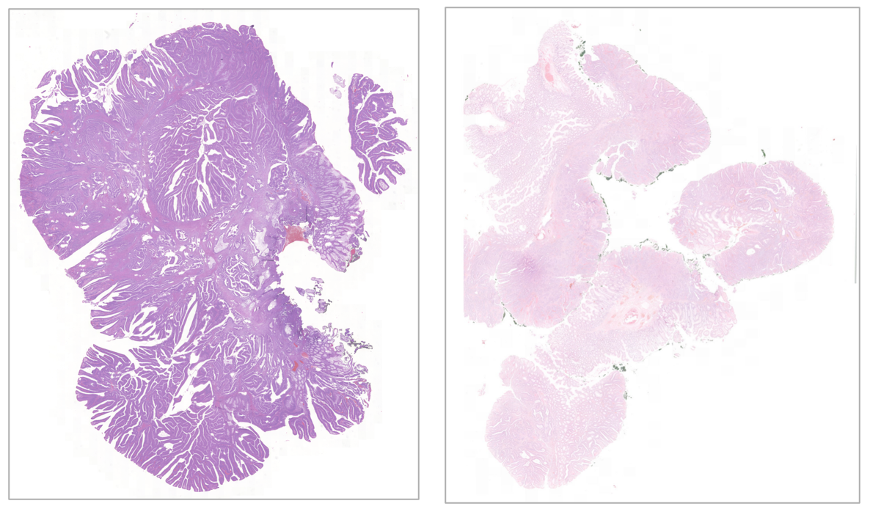
Figure 1. Comparison between a slide from H. Clínic de Barcelona (left) and one from H. Althaia Manresa (right)
Clinical data
The images were visually inspected by two or more expert pathologists to identify the following morphological parameters:
- Tumor differentiation grade (TDG). This variable indicates the degree of cell anaplasia and has 4 grades: G1, G2, G3, G4.
- Angiolymphatic invasion (ALI). Binary variable indicating whether lymph node are affected.
- Perineural invasion (PI). Binary variable indicating the presence of tumoral cells around nerve sheaths.
- Tumor budding (TB). Categorical variable indicating the degree of budding: Bd0 for 0 buds, Bd1 for 1-4 buds, Bd2 for 5-9 buds and Bd3 for more than 10 buds.
- Poorly differentiated clusters (PDC). This variable measures tumor budding considered in groups of 5 or more tumor cells in the infiltrated margin. Its values are G1 for 0-4 clusters, G2 for 5-9 clusters and G3 for more than 10 clusters.
- Submucosal invasion (SMI) measured in mm.
- Vertical resection margin (VRM) measured in mm.
- Horizontal resection margin (HRM) measured in mm.
The above variables were grouped into low and high risk categories as follows:
- TDG was grouped into low (G1 and G2) and high (G3 and G4) grade;
- ALI and PI were grouped into positive and negative;
- TB into negative (Bd0) and positive (Bd1-3);
- PDC into negative (G1) and positive (G2,G3);
- SMI into low (< 1mm) and high (≥ 1mm) invasion;
- VRM and HRM in large (> 1mm) and small (≤ 1mm) margins.
5-year follow-up
Each patient had follow-up information over five years, indicating whether there was tumoral recurrence, whether the patient had died and the cause of death.
Table 1. Number of patients and classes of the 26 hospitals
Hospital | nº of patients
nº hospitals=26 | Total | N0 | N1+
H. Clínic Barcelona | 39 | 28 | 11
Vasque Country Collection | 51 | 37 | 14
H. 12Octubre | 48 | 43 | 5
H. Alicante | 3 | 2 | 1
H. Althaia Manresa | 10 | 8 | 2
H. Aranda Duero / H. Santos Rey | 3 | 3 | 0
H. Broggi | 7 | 7 | 0
H. Clínico Valencia | 11 | 8 | 3
H. Granollers | 12 | 7 | 5
H. Inca | 3 | 1 | 2
H. Marqués de Valdecilla | 6 | 5 | 1
H. Móstoles | 4 | 0 | 4
H. Ourense | 3 | 3 | 0
H. Palamós | 20 | 12 | 8
H. Parc Tauli | 7 | 3 | 4
H. Puerta de hierro | 28 | 23 | 5
H. Ramón y Cajal | 5 | 0 | 5
H. Río Hortega | 11 | 8 | 3
H. Tenerife | 5 | 5 | 0
H. Terrassa | 7 | 5 | 2
H. V. Rocío Sevilla / HVR Sevilla | 8 | 6 | 2
H. Vall d’Hebron | 16 | 10 | 6
HCU Arrixaca Murcia | 6 | 6 | 0
HCU Zaragoza | 17 | 12 | 5
ICO Bellvitge | 9 | 3 | 6

Comparison baselines

Affectation of tissue
Detection of cancerous tissue based on histopathological images has been studied for many types of cancer (Dad et al. 2025; Valieris et al. 2024; C. Nguyen et al. 2025; Zheng et al. 2025), including pt1 CRC, if on a smaller scope (Höhn et al. 2023; Ke et al. 2025; Di Giammarco et al. 2024). On some cancer types, very high prediction values (Kumar and Misra 2025) (accuracy=99.95%) have been achieved. Most studies use public databases to conduct their experiments. While very useful for benchmark comparisons, these databases are usually curated and standardized, and fail to take into variation in staining, technician ability and hospital procedure. There are much fewer studies conducted on pt1 CRC on real-world data and they have achieved much worse performance (Brockmoeller et al. 2022; Muti et al. 2023)

Metastasis prediction on pt1 CRC
The baseline for metastasis prediction are the current diagnostic guidelines utilized by pathologists. The three most common ones are from the European Society for Medical Oncology (ESMO) (Cervantes et al. 2023), the National Comprehensive Cancer Network (NCCN) (Ajani et al. 2025) and Japanese Society for Cancer of the Colon and Rectum (JSCCR) (Hashiguchi et al. 2020). While these guidelines generally agree on parameters, they differ slightly.
The ESMO guidelines recommend endoscopic resection en bloc if any of the following criteria are met and surveillance if not:
- Lymphovascular invasion
- Tumor budding Bd2 or Bd3
- Affected vertical resection margin
- Mucinous adenocarcinoma
- High degree of differentiation (G3 or G4)
The NCCN guidelines are less stringent and don’t take mucinous level and budding into account:
- Lymphovascular invasion
- Affected vertical resection margin
- High degree of differentiation (G3 or G4)
Finally, the JSCCR guidelines analyze the vertical resection margin. If it’s affected, surgery is recommended. If it is not, the following criteria are evaluated, recommending resection if any one of them is found or surveillance otherwise:
- Lymphovascular invasion
- Tumor budding Bd2 or Bd3
- Affected vertical resection margin
- Mucinous adenocarcinoma
- High degree of differentiation (G3 or G4)

At the moment of writing, only two other publication addresses lymph node involvement (Brockmoeller et al. 2022; Muti et al. 2023), predicting the presence of more than one nodal metastasis (AUROC=0.733, 0.71) and any nodal metastasis (AUROC=0.567).

Working with WSI: a large problem
Whole slide imaging is a validated and highly used technology, particularly in the field of pathology. The technological advances of scanners, visualization methods and digital storages have allowed the obtention of images with high quality and resolution. The size of these images has, unfortunately, also become a downsize: machine learning algorithms struggle to open them in memory in their entirety, much less several them at once. Several alternative strategies are available: reducing the resolution, at a cost in detail; splitting the images into smaller patches that are latter processed and combined; extraction of simpler characteristics that are utilized instead of the WSIs (Sharma et al. 2025) or some combination of these strategies.

Detection of affected tissue on WSI
Whole slide images were analyzed by E. Musulen to identify three types of tissue: dysplasia; infiltration; and dysplasia and infiltration, when it was impossible to separate the two. If the tissue was not identified, it was considered healthy tissue.
For this experiment, infiltration and dysplasia were combined into a single category: affected tissue. Therefore there are two possible classes: affected (A) and healthy tissue (H).

Splitting procedure
Each WSI was split into 256x256 non-overlapping patches using a slidding window. Only patches that were not entirely white (background), entirely black (ink blotch) and showed enough color variance (a lack of variance would mean dirt, a smudge or another artifact). For each patch created, the following information was stored:
- Hospital of origin
- Patient
- Slide of the patch
- whether it had been labeled as dysplasia/infiltration/infiltration and dysplasia
- percentage of the patch that is labeled area
- percentage of the patch that is white
- blurriness of the patch (based on the fast Fourier transform)

UNI2: the vision encoder model
To obtain as much useful information as possible from the patches, we considered several extraction models, but decided on UNI2 (R. J. Chen et al. 2024) (https://github.com/mahmoodlab). UNI is a large pretrained vision enconder, trained on 100M images and 100K WSIs, all from neoplastic, inflammatatory, infectious and healthy tissue. It has already been proven in several different tasks (Jabbar et al. 2024; Hou et al. 2024; Yang et al. 2024; M. Chen et al. 2024), in real world datasets and with many different types of tissues (M. D. Nguyen et al. 2025; Zheng et al. 2025; Valieris et al. 2024). Therefore, compared to other encoder model such as Resnet or VGG that trained on all types of data, this model is much more prepared for histopathological experiments.

Determining an optimal patch size
A patch size too small could fail to provide contextual information for UNI2 to extract, so different patch sizes were studied using a smaller subset of 5 hospitals (H. Clínic Barcelona, H. Bellvitge, H. Basurto, H. Alicante, Consorci Sanitari de Terrassa).
Patches were combined into higher-area megapatches of 512x512 (4 patches), 2048x2048 (64 patches) and 4096x4096 px (256 patches). A higher area megapatch was only kept if all individual patches existed and if the higher-area patch was considered not blurry based on a threshold on the Fourier transform. The megapatch construction procedure is shown below.
Megapatch construction (size: n² patches, in a square with a side of n patches):
- Starting from the topmost, leftmost patch coordinate, a megapatch of size n x n is attempted. If all patches are available, the megapatch is constructed. Any patches that had already been used to build a megapatch are not considered available.

- If the average blurriness across all patches was below threshold=37, the megapatch was discarded.

- If the average infiltration and dysplasia across all patches was >0.75, the megapatch was labelled as “affected”. If it was <0.25, it was labelled as “healthy”. If the average was outside these two ranges, the megapatch was discarded.

Features from each patch were extracted using UNI2, obtaining a 1536-vectors (CLS), each one codifying all the relevant information from a megapatch. Then, for each patch size, a classification model was trained in a 5-fold cross-validation experiment, separating by patient to avoid leakage and stratifying both training and validation test to ensure representation of both labels. The models were weighted to account for the class imbalance.
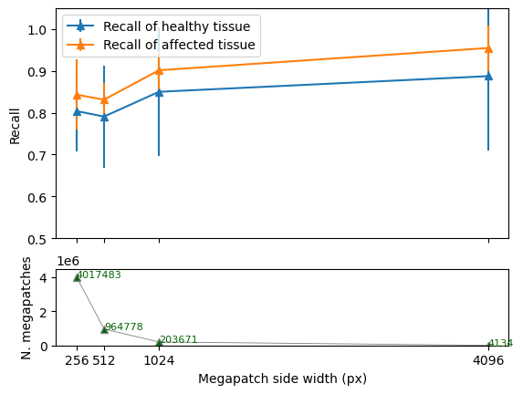
Figure 2. Evolution of recall and available megapatches at different megapatch size.
Here we see that as size increases, performance increases as well. This is probably due to an increasing resolution being able to capture more relevant features. Increasing the size decreases the number of final megapatches. As such, 4096x was considered the best size as a good tradeoff between performance and number of samples.

Analysis of the complete dataset
As 4096x4096 was decided as the optimum megapatch size, the entire dataset was split and collated using this size, therefore capturing each slide as a collection of smaller squares, but containing enough detail and resolution as to inform the model (see Figure 3).
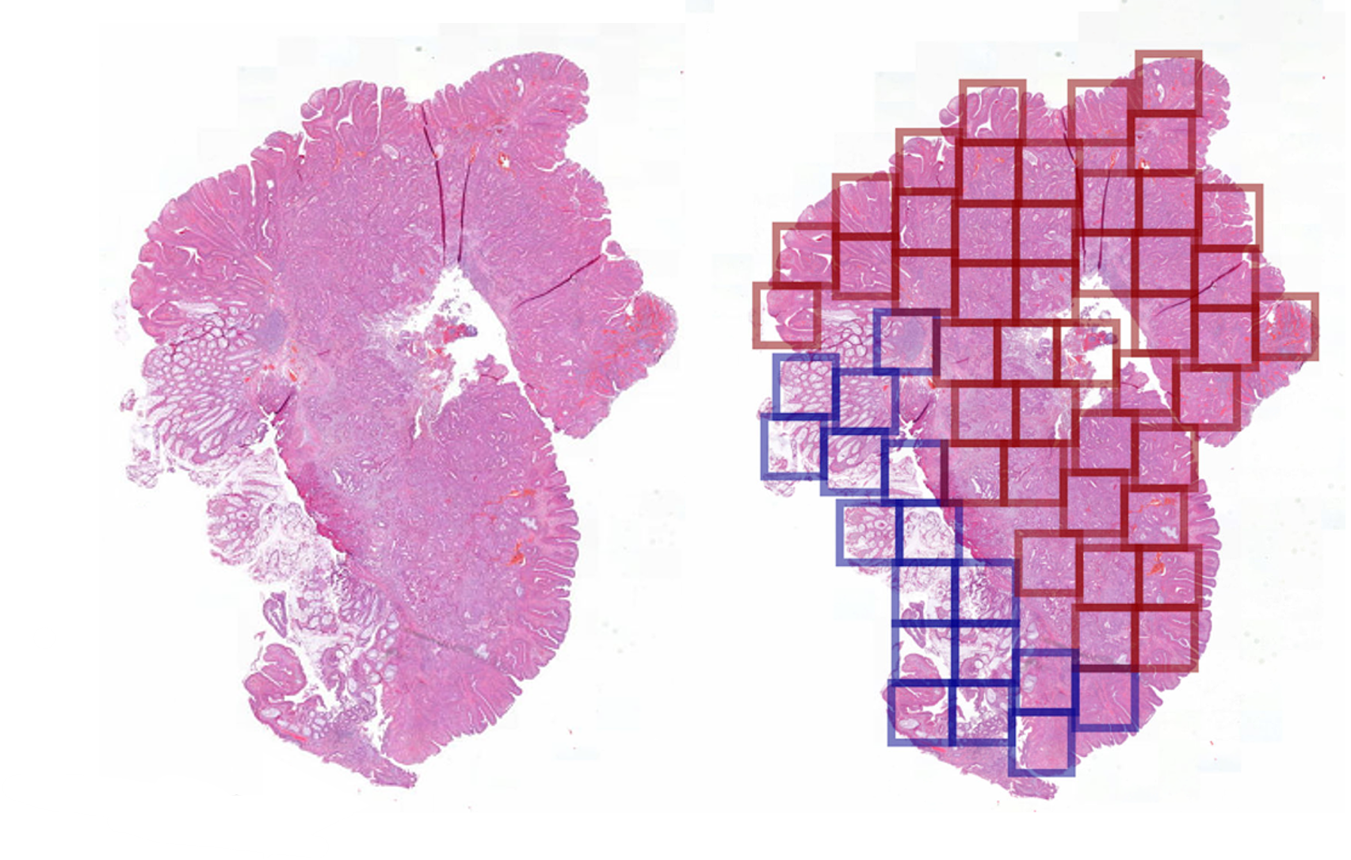
Figure 3. Left, a slide from the Vasque Country Collection. Right, the same tissue with 4096x megapatches, indicating healthy tissue (blue) and affected tissue (red)
Using the UNI2 encoder, from each megapatch a vector of 1536 components (CLS) was obtained with a corresponding label of 0 (healthy) or 1 (affected). A holdout set was separated for evaluation afterwards and the rest of the data was used for a cross-validation analysis. In both cases, all the data from a single patient was always in the training or testing set, to ensure there was no leaking of information.
The cross-validation had 20 folds, with 19/20 of the data used for training the classification head and the other 1/20 for evaluating performance. The data was stratified in both train and evaluation folds to ensure representation of both labels. The complete methodology is summarized in Figure 4.
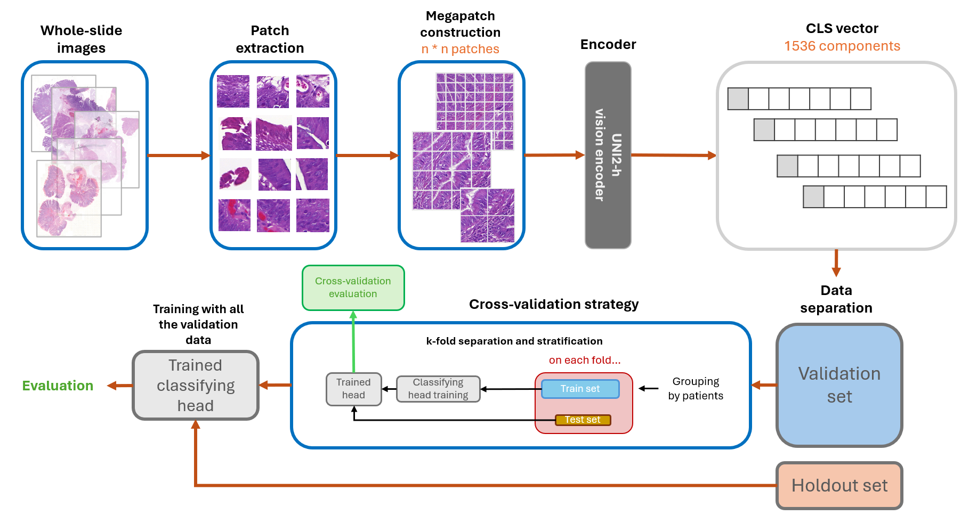
Figure 4. Pipeline for the analysis and evaluation of the entire dataset for tissue type prediction.

17145 megapatches were used on the cross-validation methodology and 3535 on the holdout set.

Evaluation
Performance metrics of the cross-validation are reported on Table 2. Affected tissue is more easily classified than healthy tissue, but both classes exhibit high performance metrics. The difference in performance could be related to the class imbalance, where A is overrepresented compared to H and the model tends to classify healthy tissue as affected.
Performance on the holdout set is also reported on Table 2 and Figure 5 (AUROC curve). The performance is similar, indicating there was no overfitting on the training data and is actually higher, indicating that the randomly selected holdout set had easier data to evaluate.
Table 2. Performance metrics of the cross-validation and holdout set. (A) refers to the affected class and (H) to the healthy class.
 | Recall H | Recall A | Precision H | Precision A | F1 H | F1 A | AUC
Training set (20-fold) | 0.6685 ± 0.1470 | 0.8894 ± 0.0517 | 0.6674 ± 0.1457 | 0.8821 ± 0.0757 | 0.6530 ± 0.1144 | 0.8827 ± 0.0433 | 0.8543 ± 0.0727
Holdout set | 0.7697 | 0.9450 | 0.8304 | 0.9214 | 0.7989 | 0.9331 | 0.9508

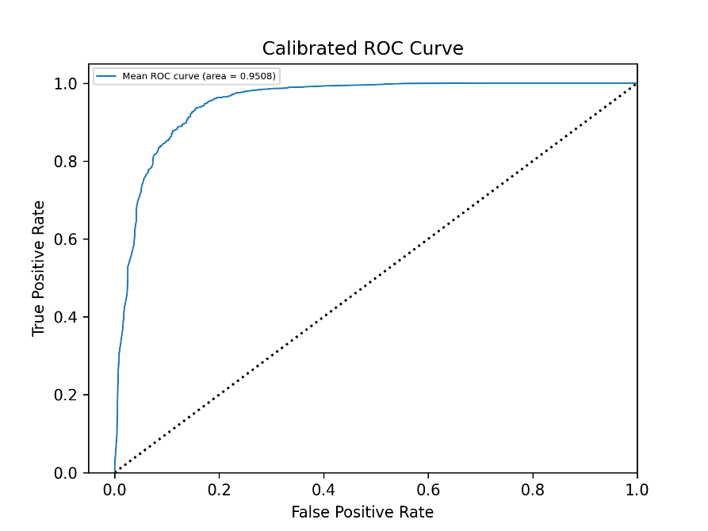
Figure 5 AUROC Curve of the affected class.

Discussion
Our pipeline was able to effectively separate between affected and healthy tissue, even among different hospitals and highly different images. Standard deviation is also high, indicating that there are many differences between folds. As different hospitals have different machines and technicians and operating procedures, we observe a lot of color and brightness variability between hospitals. While UNI2 incorporates a standardization transformation for the images, it might be unable to correct it completely.
This variability could also explain the difference in performance between the two classes. If affected tissue tends to be denser and more homogeneous, it could be darker in color, but then naturally darker tissue might be getting incorrectly classified. Further studies on the shared visual characteristics of affected tissue compared to healthy tissue, such as studying the vectorial space, could lead to better separation.

Further work
Computer vision models often work as black boxes: while the model may obtain accurate prediction, it’s difficult to correlate those predictions with the actual visual markers the model is focusing on. Further work could go towards designing features that can be related to specific visual components of the images, or toward stablishing what exactly the model is focusing on.
Another useful avenue would be to reduce the variation between hospital slides, ensuring that either the model is able to recognize relevant features and elements in very different images or by developing a normalization and standardization that captures the relevant features with as much clarity as possible.
If this pipeline is refined and performance is increased, it could be used to rank slides by the amount of affected tissue and facilitate the work of pathologists, by ensuring those slides with a lot of tumorous tissue are checked first.

Biomarker analysis for the prediction of metastasis
The first experiment for the prediction of metastasis was utilizing the parameters that the pathologists had identified on the WSIs, instead of the images themselves. These parameters supposedly capture relevant information about the state of the affected tissue and are the golden standard that pathologist use to evaluate the state of the tumor and decide whether to resect the colon or not.

Dataset
Some of the patients of the dataset had a regional lymph node metastasis descriptor of NX: this indicates that the operating technician was unable to extract the minimum number of lymph nodes necessary (at least 12 healthy or 1 affected) for a diagnosis. As such, these patients were not considered, so the total remaining was 223 patients (94 women and 129 men) aged between 52 and 98, of which 89 had regional lymph node metastases (N1+) and 134 did not (N0).

Evaluation metrics
In order to define a pathomic signature, we have explored the correlation of the variables to lymph node metastasis using multivariate statistical analysis using as target metrics the positive and negative predictive values (PPV and NPV respectively). These metrics have more clinical relevance than accuracy.
The PPV (or precision) is a measure of how often someone who tests positive for a disease actually has the disease and it is relevant to prevent unnecessary treatments. The NPV is the likelihood that a person who has a negative test result does not have the disease, that is, it is a way of measuring how accurate a specific test is. PPV and NPV are given by:
$$PPV = \frac{TP}{TP+FP} NPV = \frac{TN}{TN+FN}$$
for TP the number of true positives, FP the number of false positives, TN the number of true negatives and FN the number of false negatives.

Univariate analysis
First, histopathological parameters were explored individually, to assess whether any one of them had a high correlation with metastasis.
For the univariate analysis, the differences in PPV were assessed by χ2 or Barnard test (when the sample size was too small). In this analysis, PPV is equal to the proportion of cases with lymph node metastasis.
Table 2 shows the result of the univariate analysis. For each variable there is a contingency table with the proportion of positive cases for each variable value and the corresponding p-value of the statistical test between the two proportions.
The variables that had a significant difference in proportions were DGT (p=0.043), ALI (p=0.0026), TB (p=0.0016), PDC (p=0.013), and SMI (p=0.0035). In spite of this significance, the PPV and NPV of all variables are low for a reliable clinical application. PPV was less than 0.6 (0.58 for TDG, 0.56 for ALI, 0.59 for TB, 0.59 for PDC and 0.44 for SMI), while PNV (given by 1-proportion of the low risk value) was less than 0.7 in almost all cases. The only significant variable that had a high NPV was SMI with 1-0.167=0.833, at the cost of the lowest PPV (=0.44).
Table 3. Univariate analysis of the morphological parameters
Degree of differentiation (TDG) |  |  |  |  | Angiolymphatic invasion (ALI)
 | No metastasis | Metastasis | Prop |  |  | No metastasis | Metastasis | Prop
Low grade | 121 | 71 | 0.37 |  | No | 106 | 53 | 0.333
High grade | 13 | 18 | 0.581 |  | Yes | 28 | 36 | 0.562
p-value = 0.0427 |  |  |  |  | p-value = 0.0026
Perineural Invasion (PI) |  |  |  |  | Tumor Budding (TB)
 | No metastasis | Metastasis | Prop |  |  | No metastasis | Metastasis | Prop
No | 129 | 84 | 0.394 |  | Bd0/Bd1 | 113 | 58 | 0.339
Yes | 5 | 5 | 0.5 |  | Bd2/Bd3 | 21 | 31 | 0.596
p-value = 0.0427 |  |  |  |  | p-value = 0.0016
Poorly differentiated clusters (PDC) |  |  |  |  | Submucosal invasion (SMI)
 | No metastasis | Metastasis | Prop |  |  | No metastasis | Metastasis | Prop
Neg. | 118 | 66 | 0.359 |  | <1 mm | 30 | 6 | 0.167
Pos. | 16 | 23 | 0.59 |  | ≥1 mm | 104 | 83 | 0.444
p-value = 0.0125 |  |  |  |  | p-value = 0.0035
Vertical resection margin (VRM) |  |  |  |  | Horizontal resection margin (HRM)
 | No metastasis | Metastasis | Prop |  |  | No metastasis | Metastasis | Prop
Neg. | 79 | 56 | 0.415 |  | Neg. | 114 | 80 | 0.412
Pos. | 55 | 33 | 0.375 |  | Pos. | 20 | 9 | 0.31
p-value = 0.6502 |  |  |  |  | p-value = 0.3991

Multivariate analysis
The variables that showed statistical significance were selected for a subsequent multivariate analysis. Because TB and PDC describe the same characteristic, only the latter was included. VRM was included as well, despite its nonsignificance, due to its important role in literature.
For the multivariate analysis, we have considered all the combinations of variables and, for each of them:
- the proportion of patients with metastasis was used as an indicator of risk prediction that scores each combination.
- Unsupervised clustering analysis was conducted to group combinations in four categories: very high risk (VHR), moderate high risk (MHR), moderate low risk (MLR) and very low risk (VLR).
- The difference in the proportion of patients with metastasis observed within each category was compared with the other complementary samples to assess significant stratification of risk, using a two-proportion Z-test (two-sided).
Table 3 contains all the possible combinations of the selected variables: the total number of samples, number of positive cases, the proportion and the complementary population not having that specific combination. The rule of thumb is that for those combinations that have a significant association with low or high risk of metastasis, the proportion of positive cases having the combination should be significantly different than the proportion observed in the remaining cases. The table also shows the combinations grouped according to the k-means clustering used for the stratification of risk into VHR, MHR, MLR and VLR. We observe that for the extreme groups, VHR and VLR, the proportion of metastasis achieves also extreme high (above 0.8) and low (around 0.1) values.
Table 4. Risk categories as determined by the k-means cluster, based on the metastatic proportion.
 | ALI | TDG | SMI | PDC | VRM | Met. | Total | Prop. | Met. Rest | Total Rest | Prop. Rest
VHR | 0 | 1 | 1 | 1 | 0 | 1 | 1 | 1 | 88 | 222 | 0.396
 | 0 | 0 | 0 | 1 | 0 | 1 | 1 | 1 | 88 | 222 | 0.396
 | 0 | 1 | 1 | 0 | 0 | 2 | 2 | 1 | 87 | 221 | 0.394
 | 1 | 1 | 1 | 0 | 0 | 3 | 3 | 1 | 86 | 220 | 0.391
 | 1 | 1 | 1 | 0 | 1 | 5 | 6 | 0.833 | 84 | 217 | 0.387
 | 1 | 0 | 1 | 1 | 0 | 8 | 10 | 0.8 | 81 | 213 | 0.38
MHR | 1 | 1 | 1 | 1 | 0 | 4 | 6 | 0.667 | 85 | 217 | 0.392
 | 0 | 0 | 1 | 1 | 0 | 3 | 5 | 0.6 | 86 | 218 | 0.394
 | 1 | 0 | 1 | 0 | 0 | 6 | 11 | 0.545 | 83 | 212 | 0.392
 | 1 | 0 | 1 | 1 | 1 | 2 | 4 | 0.5 | 87 | 219 | 0.397
 | 1 | 0 | 0 | 1 | 0 | 1 | 2 | 0.5 | 88 | 221 | 0.398
 | 1 | 1 | 0 | 0 | 0 | 1 | 2 | 0.5 | 88 | 221 | 0.398
 | 0 | 0 | 1 | 1 | 1 | 2 | 4 | 0.5 | 87 | 219 | 0.397
 | 1 | 0 | 1 | 0 | 1 | 5 | 11 | 0.455 | 84 | 212 | 0.396
MLR | 0 | 0 | 1 | 0 | 0 | 23 | 63 | 0.365 | 66 | 160 | 0.412
 | 0 | 0 | 1 | 0 | 1 | 17 | 51 | 0.333 | 72 | 172 | 0.419
 | 1 | 1 | 1 | 1 | 1 | 4 | 6 | 0.667 | 85 | 217 | 0.392
 | 0 | 1 | 1 | 0 | 1 | 3 | 5 | 0.6 | 86 | 218 | 0.394
MHR | 0 | 0 | 0 | 0 | 0 | 6 | 11 | 0.545 | 83 | 212 | 0.392
 | 1 | 1 | 0 | 1 | 0 | 2 | 4 | 0.5 | 87 | 219 | 0.397
 | 0 | 0 | 0 | 0 | 1 | 1 | 2 | 0.5 | 88 | 221 | 0.398
 | 0 | 1 | 1 | 1 | 1 | 1 | 2 | 0.5 | 88 | 221 | 0.398
 | 1 | 0 | 0 | 0 | 0 | 2 | 4 | 0.5 | 87 | 219 | 0.397

Table 4 demonstrates that the categories are separated with statistical significance of at least p=0.05.
Table 5. Statistical analysis of the risk groups by 2-proportion Z-test
 | Metastasis | Total | Proportion | Metastasis Rest | Total Rest | Proportion Rest | p-value
VHR | 20 | 23 | 0.87 | 69 | 200 | 0.34 | <0.001
MHR | 24 | 45 | 0.53 | 65 | 178 | 0.36 | <0.01
MLR | 42 | 123 | 0.34 | 47 | 100 | 0.47 | 0.05
VLR | 3 | 24 | 0.125 | 86 | 199 | 0.43 | <0.01

Discussion
Here, we demonstrate that VRM is not significantly related to lymph node metastasis (p-value = 0.6502), despite its traditionally important role in the decision-making process of pt1 CRC treatment. The horizontal resection margin (HRM) is also not significant (p-value = 0.3991). Moreover, no single one of the considered variables, by itself, reliably predicts metastasis (with the proportion of metastatic patients always <60%), and therefore none should be taken as solely indicative of the necessity for surgery.
Furthermore, aggregating several of these factors provides a better predictive strategy and allows a first stratification of risk. For example, patients presenting any of the configurations classified under the VHR group have 87% chance of lymph node metastasis—far higher than the <60% probability associated with any one of the individual parameters. Also the VLR signatures have a high NPV with only 12% of FN. This VLR group includes, as expected, the combination of all negative conditions, which matches the clinical protocol currently followed.

Further work
The predictive power of these parameters is still limited for being considered in clinical practice and highlights the urgent need to identify novel biomarkers that can either complement or replace the current prognostic criteria (Echle et al. 2021). New studies are trying to identify genetic parameters (Radhakrishnan et al. 2025; Sinicrope et al. 2024) density of immune cells (Mlecnik et al. 2020), signaling pathways (Rebersek 2020) and many others (Bonilla et al. 2023; Chen et al. 2021; Hacking et al. 2021).

WSI analysis for metastasis prediction
After analysis of the identified parameters, the objective was to evaluate the histopathological images with deep learning models, to see if visual biomarkers could be found to develop a better prediction strategy.

Dataset
The same 223 patient dataset was utilized as the previous experiment. As some patients have more than one slide, the final image set was of 450 images, 349 N0 and 101 N1+.

Whole image feature extraction and analysis
The analysis of the WSIs for N0 and N1+ was an exploratory analysis utilizing the UNI2 foundation model, due to time constraints.
From each image features were extracted and because the label of N0/N1+ is per-patient, all the slides of a patient were aggregated together. A cross-validation setup similar to one in previous experiments was utilized, but with k=10 due to the fewer number of samples. Because the data is heavily skewed towards N0, the classifying head also incorporated weights. The methodology is summarized in Figure 6. As the dataset was much smaller and this was a preliminary analysis, it was opted to not separate a holdout set and evaluate with the entire dataset.
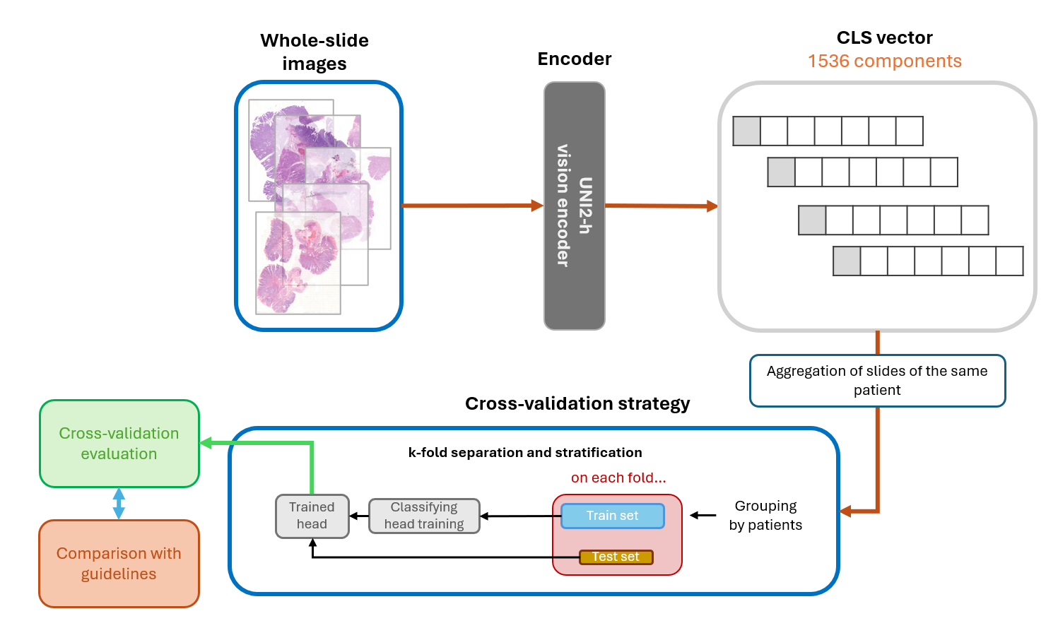
Figure 6. Pipeline of the WSI analysis for lymph node affectation prediction.
The performance in this first experiment is reported in Table 2. To act as a baseline, the same data was also analyzed by the ResNet50 and VGG16 models from pytorch.
Table 6. Performance results of the 10-fold cross-validation of the WSI experiment
 | Recall  N0 | Recall  N1+ | Precision  N0 | Precision N1+ | F1  N0 | F1  N1+ | AUC
Resnet50  ^{ImageNet)} | 0.4299 ± 0.1726 | 0.6461 ± 0.1311 | 0.8092 ± 0.0680 | 0.2477 ± 0.0836 | 0.5416 ± 0.1432 | 0.3420 ± 0.0780 | 0.5716 ± 0.0881
VGG16  ^{(ImageNet)} | 0.4299 ± 0.1726 | 0.6461 ± 0.1311 | 0.8590 ± 0.0466 | 0.5509 ± 0.0900 | 0.8813 ± 0.0364 | 0.4647 ± 0.1595 | 0.7647 ± 0.0839
UNI2-CLS features | 0.8771 ± 0.0879 | 0.5433 ± 0.2846 | 0.8738 ± 0.0704 | 0.5579 ± 0.2669 | 0.8718 ± 0.0594 | 0.5274 ± 0.2519 | 0.7817 ± 0.1698

The Resnet50 and VGG16 models were trained on ImageNet, a large database of images of many different categories, but they are not prepared for histopathological images.

Evaluation
The UNI2 experiment shows the best performance among all three models, with a higher AUC (0.7817>0.7647>0.5716). The only metric in which it scores worse is the recall of N1+ and F1 N0, where VGG slightly outperforms it.
We can also analyze the same datasets, using the same folds with the different health organizations guidelines (Table 3). Both the ESMO and NSCCR guidelines obtain the same results and while they consider many more criteria, they rank worse in all metrics compared to the NCCN metrics,
The ESMO and JSCCR guidelines consider many more criteria than the NCCN for discussing resection, with JSCCR putting vertical resection margin as a key indicator. NCCN score higher in all metrics but also presents similar or higher standard deviation.
Table 7. Evaluation results of the colorectal cancer guidelines.
 | Recall  N0 | Recall  N1+ | Precision  N0 | Precision N1+ | F1  N0 | F1  N1+ | AUC
ESMO | 0.6932 ± 0.1077 | 0.6640 ± 0.1391 | 0.6990 ± 0.1090 | 0.6573 ± 0.1525 | 0.6960 ± 0.1080 | 0.6604 ± 0.1462 | 0.6540 ± 0.1403
NCCN | 0.7439 ± 0.0990 | 0.6870 ± 0.1899 | 0.7384 ± 0.0990 | 0.6920 ± 0.1773 | 0.7411 ± 0.0986 | 0.6892 ± 0.1843 | 0.6424 ± 0.1264
JSCCR | 0.6932 ± 0.1077 | 0.6640 ± 0.1391 | 0.6990 ± 0.1090 | 0.6573 ± 0.1525 | 0.6960 ± 0.1080 | 0.6604 ± 0.1462 | 0.6540 ± 0.1403

If we compare the results of the preliminatory analysis to those of the guidelines, the model trained on UNI2 features outscores all three metrics on detecting N0, but scores worse than the three at detecting N1+. This difference in results could be related to the high class imbalance, as the dataset is heavily skewed towards N0. The UNI2 model has the better area under the curve (AUC) of all models and guidelines, with that model and VGG16 outscoring all the guidelines

Discussion
Training the model on the UNI2 features proved successful, as it achieves higher performance compared to the other two encoder models as the features are prepared for histopathology (AUC: UNI2-CLS: 0.7817> VGG16: 0.7647> Resnet50: 0.5716. Some of the low performance on the N1+ could be explained by the overrepresentation of class N0 (101 N1+ < 349 N0), even with adding weights to the model.
The NCCN guidelines where much better at separating the two classes, indicating that mucinous state of the affected area and the tumor budding gave no additional discriminatory power, while its incorporation is actually reducing the predictive power of the other two.
While the model has some promising results and a higher AUC than the guidelines, proving that using a clinically trained foundational model can lead to better results, it is still far from being good enough for clinical application.

Further work
As this was towards the end of the project, no further exploration was done. As the UNI2 feature extraction process downsizes the images massively, a lot of resolution and detail is lost. The obvious step would be to incorporate the features from the megapatches into the process, instead of utilizing the entire images. Other avenues could incorporate attention based methods on the megapatches (G et al. 2025; Aswolinskiy et al. 2025) to focus on important features; the construction of spatial graph models (Ding et al. 2022) or the incorporation of the clinical markers: although both types of data come from the same images, it might be that the model and the pathologists look at different elements, and a combination of both could prove useful.

References
Ajani, Jaffer A., Thomas A. D’Amico, David J. Bentrem, et al. 2025. “Gastric Cancer, Version 2.2025, NCCN Clinical Practice Guidelines In Oncology.” Journal of the National Comprehensive Cancer Network. Journal of the National Comprehensive Cancer Network 23 (5): 169–91. https://doi.org/10.6004/jnccn.2025.0022.
Aswolinskiy, Witali, Rachel S. van der Post, Michela Campora, et al. 2025. “Attention-Based Whole-Slide Image Compression Achieves Pathologist-Level Prescreening of Multiorgan Routine Histopathology Biopsies.” Modern Pathology 38 (11): 100827. https://doi.org/10.1016/j.modpat.2025.100827.
Bonilla, Carlos Eduardo, Paola Montenegro, Juan Manuel O’Connor, et al. 2023. “Ibero-American Consensus Review and Incorporation of New Biomarkers for Clinical Practice in Colorectal Cancer.” Cancers 15 (17): 4373. https://doi.org/10.3390/cancers15174373.
Brockmoeller, Scarlet, Amelie Echle, Narmin Ghaffari Laleh, et al. 2022. “Deep Learning Identifies Inflamed Fat as a Risk Factor for Lymph Node Metastasis in Early Colorectal Cancer.” The Journal of Pathology 256 (3): 269–81. https://doi.org/10.1002/path.5831.
Cervantes, A., R. Adam, S. Roselló, et al. 2023. “Metastatic Colorectal Cancer: ESMO Clinical Practice Guideline for Diagnosis, Treatment and Follow-Up☆.” Annals of Oncology 34 (1): 10–32. https://doi.org/10.1016/j.annonc.2022.10.003.
Chen, Meixu, Kai Wang, Payal Kapur, James Brugarolas, Raquibul Hannan, and Jing Wang. 2024. “A Multimodal Ensemble Approach for Clear Cell Renal Cell Carcinoma Treatment Outcome Prediction.” ArXiv, December 10, arXiv:2412.07136v1.
Chen, Richard J., Tong Ding, Ming Y. Lu, et al. 2024. “Towards a General-Purpose Foundation Model for Computational Pathology.” Nature Medicine 30 (3): 850–62. https://doi.org/10.1038/s41591-024-02857-3.
Chen, Yaping, Xiao Zheng, and Changping Wu. 2021. “The Role of the Tumor Microenvironment and Treatment Strategies in Colorectal Cancer.” Frontiers in Immunology 12 (December). https://doi.org/10.3389/fimmu.2021.792691.
Dad, Imam, JianFeng He, and Zulqarnain Baloch. 2025. “Graph-Based Analysis of Histopathological Images for Lung Cancer Classification Using GLCM Features and Enhanced Graph.” Frontiers in Oncology 15 (May). https://doi.org/10.3389/fonc.2025.1546635.
Di Giammarco, Marcello, Fabio Martinelli, Antonella Santone, Mario Cesarelli, and Francesco Mercaldo. 2024. “Colon Cancer Diagnosis by Means of Explainable Deep Learning.” Scientific Reports 14 (1): 15334. https://doi.org/10.1038/s41598-024-63659-8.
Ding, Kexin, Mu Zhou, He Wang, Shaoting Zhang, and Dimitri N Metaxas. 2022. “Spatially Aware Graph Neural Networks and Cross-Level Molecular Profile Prediction in Colon Cancer Histopathology: A Retrospective Multi-Cohort Study.” The Lancet Digital Health 4 (11): e787–95. https://doi.org/10.1016/S2589-7500(22)00168-6.
Echle, Amelie, Niklas Timon Rindtorff, Titus Josef Brinker, Tom Luedde, Alexander Thomas Pearson, and Jakob Nikolas Kather. 2021. “Deep Learning in Cancer Pathology: A New Generation of Clinical Biomarkers.” British Journal of Cancer 124 (4): 686–96. https://doi.org/10.1038/s41416-020-01122-x.
G, Tarun, Naman Malpani, Gugan Thoppe, and Sridharan Devarajan. 2025. “Sequential Attention-Based Sampling for Histopathological Analysis.” arXiv:2507.05077. Preprint, arXiv, July 10. https://doi.org/10.48550/arXiv.2507.05077.
Hacking, Sean M., Baidarbhi Chakraborty, Rafae Nasim, Taisia Vitkovski, and Rebecca Thomas. 2021. “A Holistic Appraisal of Stromal Differentiation in Colorectal Cancer: Biology, Histopathology, Computation, and Genomics.” Pathology - Research and Practice 220 (April): 153378. https://doi.org/10.1016/j.prp.2021.153378.
Hashiguchi, Yojiro, Kei Muro, Yutaka Saito, et al. 2020. “Japanese Society for Cancer of the Colon and Rectum (JSCCR) Guidelines 2019 for the Treatment of Colorectal Cancer.” International Journal of Clinical Oncology 25 (1): 1–42. https://doi.org/10.1007/s10147-019-01485-z.
Höhn, Julia, Eva Krieghoff-Henning, Christoph Wies, et al. 2023. “Colorectal Cancer Risk Stratification on Histological Slides Based on Survival Curves Predicted by Deep Learning.” Npj Precision Oncology 7 (1): 98. https://doi.org/10.1038/s41698-023-00451-3.
Hou, Xinhai, Cheng Jiang, Akhil Kondepudi, et al. 2024. “A Self-Supervised Framework for Learning Whole Slide Representations.” arXiv:2402.06188. Preprint, arXiv, May 27. https://doi.org/10.48550/arXiv.2402.06188.
Jabbar, Muzammil Arif Din Abdul, Willa WY Yim, Felicia Wee, Li Yen Chong, and Joe Yeong. 2024. “1250 H&E-Based Cell Prediction Multi-Classification Models to Capture Morphologically Distinct Subpopulations of CD8+ T Cells.” Journal for ImmunoTherapy of Cancer 12 (Suppl 2). https://doi.org/10.1136/jitc-2024-SITC2024.1250.
Ke, Qi, Yan Chai Hum, Wun-She Yap, et al. 2025. “Histopathological Classification of Colorectal Cancer Based on Domain-Specific Transfer Learning and Multi-Model Feature Fusion.” Scientific Reports 15 (1): 35155. https://doi.org/10.1038/s41598-025-19134-z.
Kumar, B. Anil, and Neeraj Kumar Misra. 2025. “Colon Cancer Classification and Detection by Novel CMNV2 Model and Methods of Deep Learning.” Neural Computing and Applications 37 (1): 25–41. https://doi.org/10.1007/s00521-024-10563-x.
Mlecnik, Bernhard, Carlo Bifulco, Gabriela Bindea, et al. 2020. “Multicenter International Society for Immunotherapy of Cancer Study of the Consensus Immunoscore for the Prediction of Survival and Response to Chemotherapy in Stage III Colon Cancer.” Journal of Clinical Oncology 38 (31): 3638–51. https://doi.org/10.1200/JCO.19.03205.
Muti, Hannah S., Christoph Röcken, Hans-Michael Behrens, et al. 2023. “Deep Learning Trained on Lymph Node Status Predicts Outcome from Gastric Cancer Histopathology: A Retrospective Multicentric Study.” European Journal of Cancer 194 (November): 113335. https://doi.org/10.1016/j.ejca.2023.113335.
Nguyen, Chantal, George Hulsey, Kristin James, Timothy James, and Jean M. Carlson. 2025. “Deep Learning Classification of Prostate Cancer Using MRI Histopathologic Data.” Radiology: Imaging Cancer 7 (5): e240381. https://doi.org/10.1148/rycan.240381.
Nguyen, Manh Duong, Dac Thai Nguyen, Trung Viet Nguyen, Homi Yamada, Huy Hieu Pham, and Phi Le Nguyen. 2025. “Bridging Classification and Segmentation in Osteosarcoma Assessment via Foundation and Discrete Diffusion Models.” arXiv:2501.01932. Preprint, arXiv, January 6. https://doi.org/10.48550/arXiv.2501.01932.
Radhakrishnan, Swarnima Kollampallath, Dipanwita Nath, Dominic Russ, et al. 2025. “Machine Learning-Based Identification of Proteomic Markers in Colorectal Cancer Using UK Biobank Data.” Frontiers in Oncology 14 (January). https://doi.org/10.3389/fonc.2024.1505675.
Rebersek, Martina. 2020. “Consensus Molecular Subtypes (CMS) in Metastatic Colorectal Cancer - Personalized Medicine Decision.” Radiology and Oncology 54 (3): 272–77. https://doi.org/10.2478/raon-2020-0031.
Sharma, Abhinav, Bojing Liu, and Mattias Rantalainen. 2025. “A Method for Spatial Interpretation of Weakly Supervised Deep Learning Models in Computational Pathology.” Scientific Reports 15 (1): 19804. https://doi.org/10.1038/s41598-025-04043-y.
Sinicrope, Frank A., Garth D. Nelson, Bahar Saberzadeh-Ardestani, et al. 2024. “Use of Deep Learning to Evaluate Tumor Microenvironmental Features for Prediction of Colon Cancer Recurrence.” Cancer Research Communications 4 (5): 1344–50. https://doi.org/10.1158/2767-9764.CRC-24-0031.
Valieris, Renan, Luan Martins, Alexandre Defelicibus, et al. 2024. “Weakly-Supervised Deep Learning Models Enable HER2-Low Prediction from H &E Stained Slides.” Breast Cancer Research 26 (1): 124. https://doi.org/10.1186/s13058-024-01863-0.
Yang, Zijiang, Zhongwei Qiu, Tiancheng Lin, et al. 2024. “From Histopathology Images to Cell Clouds: Learning Slide Representations with Hierarchical Cell Transformer.” arXiv:2412.16715. Preprint, arXiv, December 24. https://doi.org/10.48550/arXiv.2412.16715.
Zheng, Qingyuan, Panpan Jiao, Rui Yang, et al. 2025. “Deep Learning-Based Lymph Node Metastasis Status Predicts Prognosis from Muscle-Invasive Bladder Cancer Histopathology.” World Journal of Urology 43 (1): 65. https://doi.org/10.1007/s00345-025-05440-8.

