CSCE 2110 — Project 1: QParking
Project Design Document
Course: CSCE 2110 — Data Structures | Valet Parking Simulation
Group Members: Nicholas Richburg, Zachary Yandell
Date: 6/26/2026

1. System Overview
QParking is a simulation of a valet parking operation built around a collection of m “stack” garages, each of identical size n. Because every garage behaves as a last-in-first-out (LIFO) stack, the most recently parked car always sits in front of the cars beneath it. Retrieving a car that is not on top therefore requires temporarily moving the cars above it elsewhere, which is only possible if free space exists. To guarantee that any car can always be retrieved, the system keeps at least n spaces free at all times; consequently the maximum number of cars that may be parked simultaneously is n×(m−1). These reserved spaces are marked as restricted (R) in the occupancy data.
At the highest level the program runs as a short pipeline. A single central controller, QParkingSystem, reads an initial configuration file whose name is supplied by the user at run time. That configuration names two further input files — the initial garage occupancy and the customer roster — which the controller loads to build its in-memory state. The system then reads a sequence of interactions (customers dropping off cars and picking them up), executes each one against the shared garage state, and finally writes the resulting garage layout to a text output file.
The design is organized around six major functionality components coordinated by the QParkingSystem controller. All six operate over the same shared data: a vector of Garage objects (each encapsulating one LIFO stack) and a registry of Customer records. Figure 1 shows how data flows from the input files, through the controller and components, into the shared structures, and out to the final occupancy file.
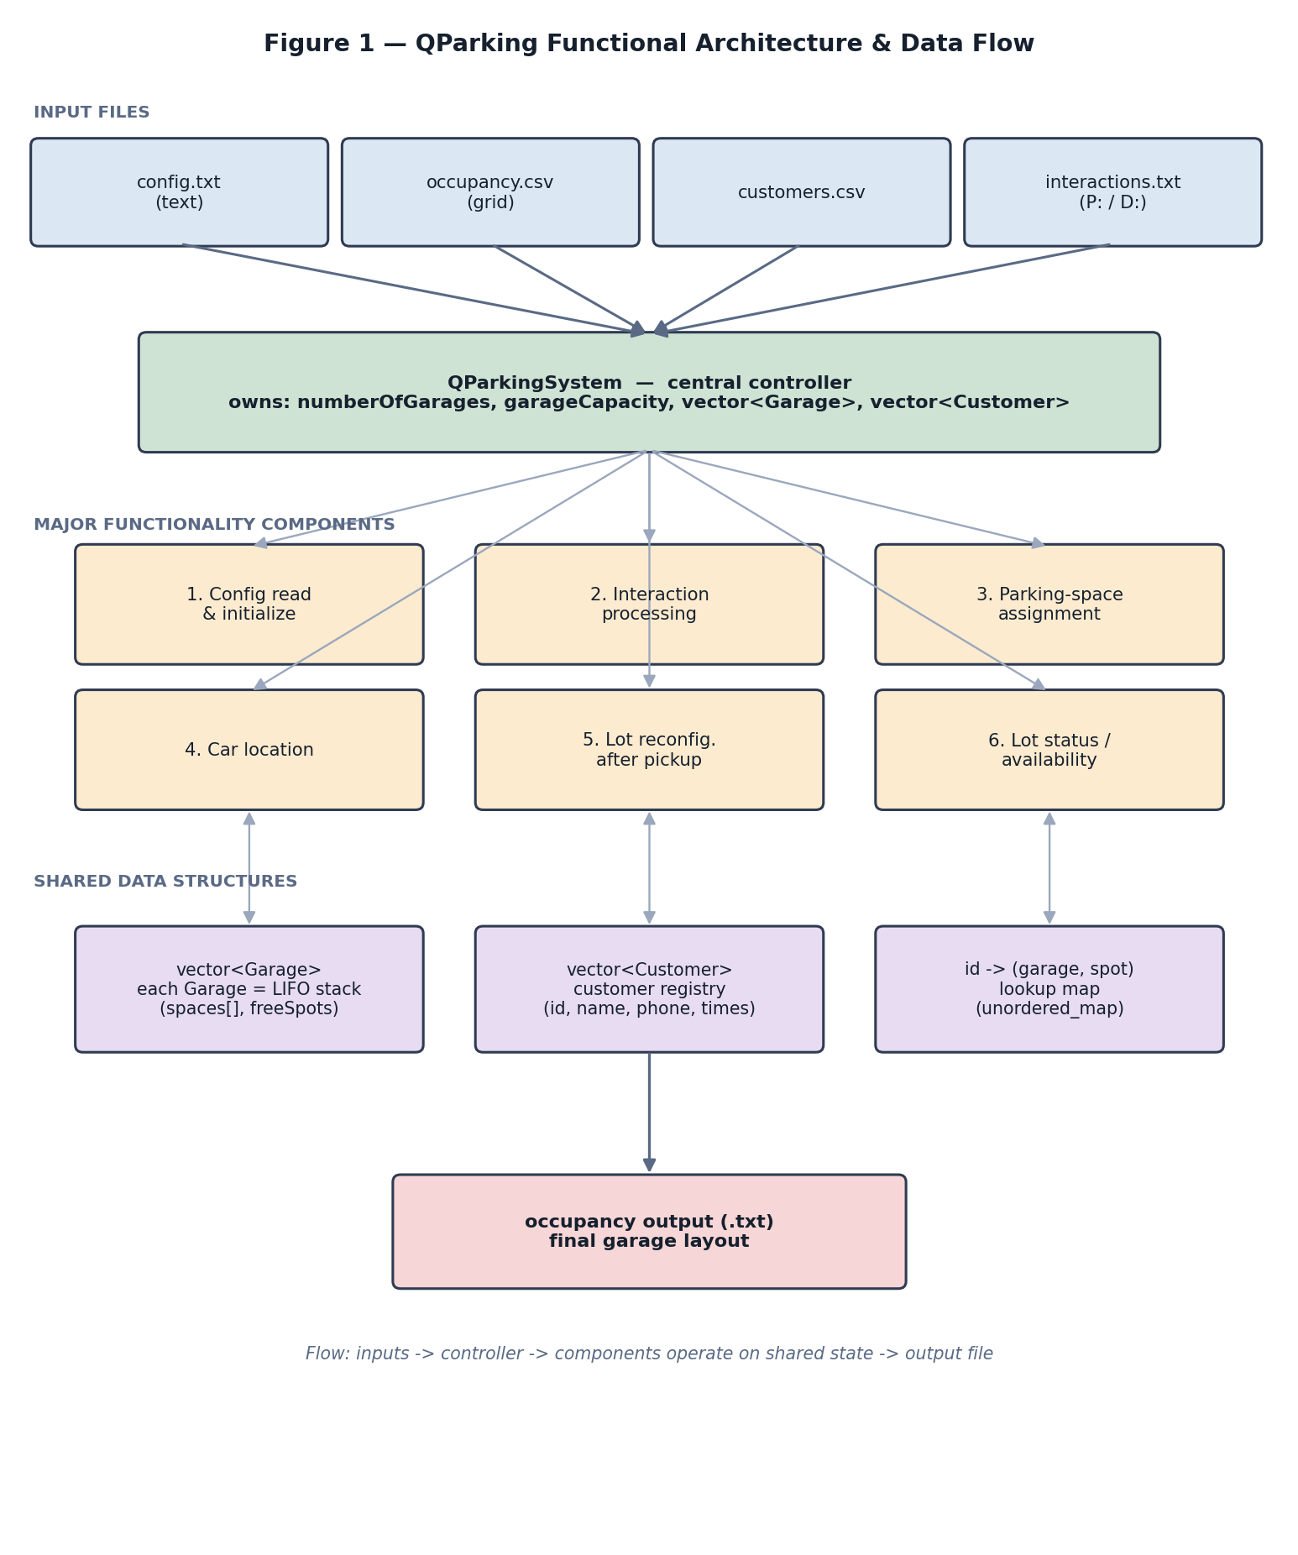
Figure 1. Functional architecture and data flow.

2. Functionality Needs
The work is decomposed into the six major components listed below. They run in roughly the order shown: initialization happens once at startup, after which interaction processing drives the assignment, location, and reconfiguration components repeatedly, with the status component available at any time. Each component is described in terms of its purpose, the sub-functions it needs, the data it requires, and how it relates to the others.

2.1 Configuration and System Initialization (Component 1)
This component bootstraps the entire system and is the deliverable required for the project milestone. Its purpose is to read the user-supplied configuration file and construct the initial in-memory state. It breaks naturally into three sub-functions: LoadConfiguration parses the first line of the config file into the number of garages (m) and the per-garage capacity (n) and captures the two referenced file names; LoadInitialOccupancy reads the occupancy CSV — a grid in which each column is a garage and each cell is either -1 (free), R (restricted), or a customer id (occupied) — and uses it to construct each Garage with its starting contents; and a customer-loading routine reads the customer CSV into the customer registry. It requires only the file names and produces the fully initialized vector<Garage> and vector<Customer>. Every other component depends on this one having run first.

2.2 Sample Interaction Processing (Component 2)
This component reads the interaction file and executes ten sample interactions — five customers picking up their cars and five customers dropping off. Each line is one interaction: “D: name, phone, time” registers a new customer requesting valet service, and “P: customerID” requests retrieval of a parked car. Its sub-functions parse a line, classify it as drop-off or pick-up, and dispatch to the assignment component (Component 3) or the location/reconfiguration components (Components 4 and 5) respectively. It requires the interaction file and read/write access to the shared garage and customer state. It is the runtime driver that sequences the other operational components.

2.3 Parking-Space Assignment (Component 3)
Triggered by a drop-off, this component chooses where a newly arrived car will be parked and records the placement. It must respect the n×(m−1) limit, so it selects a garage that has room without consuming the reserved (R) buffer, pushes the car onto that garage’s LIFO stack, and updates both the customer’s stored location and the id-to-location lookup. It requires the customer being parked and the current garage state, and it produces an updated occupancy. Its results are consumed by the location, reconfiguration, and status components.

2.4 Car Location (Component 4)
This component answers the question “where is this customer’s car?” given a customer id. The straightforward approach stores the garage index and spot index directly on the Customer record; a more efficient approach maintains an unordered_map from customer id to a (garage, spot) pair so that a pick-up request resolves in roughly constant time rather than scanning every garage. It requires the customer id and the lookup structure, and it feeds the reconfiguration component, which needs to know exactly which car to expose.

2.5 Lot Reconfiguration After Pickup (Component 5)
When a customer picks up a car that is not on top of its stack, the cars above it must be moved before it can leave, and the lot must be returned to a valid state afterward. This component pops the cars sitting above the target into the reserved free space, removes the target car, and then restores the displaced cars, updating each moved car’s recorded location and the lookup map as it goes. It is the most algorithmically involved component because it is where the LIFO constraint and the n-free-spaces rule interact. It requires the target car’s location (from Component 4) and full read/write access to the garages.

2.6 Lot Status and Availability (Component 6)
This component reports the state of the lot: whether it is full, how many spaces remain, and the contents of each garage. Its sub-functions total the free spots across all garages (GetAvailableSpaces), test a single garage for room (IsAvailable / GetAvailableCount), and render the occupancy either to the screen (PrintLayout) or to the required output text file (WriteOccupancy). It only reads the shared state and never modifies it, so it can be invoked at any point, and it produces the final deliverable output after all interactions complete.

3. Data Storage
Data is grouped into three classes that mirror the real-world entities of the problem, with the QParkingSystem controller owning the single authoritative copy of the system state that every component shares.

3.1 Customer Record
A Customer stores one car owner’s information: an id, name, phone number, arrival time, and departure time, together with the bookkeeping fields isParked, garageIndex, and spotIndex that record whether and where the car is currently parked. Times are kept as strings in HHMM form, which is sufficient for storage and display and sorts correctly as text; they could be converted to integers later if arithmetic on durations becomes necessary. The class exposes getters for every field plus SetParkingLocation and ClearParkingLocation so the assignment and reconfiguration components can keep each record consistent with the garages.

3.2 Garage (Stack Model)
Each Garage encapsulates one stack garage. It stores its capacity, a vector<string> named spaces holding the contents of each position (-1, R, or a customer id), and a stack<int> of free spot indices. The vector gives direct indexed access for reading and writing the layout, while the stack expresses the LIFO discipline directly: parking pushes and retrieval/reconfiguration pops. Keeping the contents as strings lets a single representation cover all three legal cell values without a separate type. The class provides ParkCustomer, RemoveCustomer, IsAvailable, GetCapacity, GetAvailableCount, GetSpotValue, and PrintLayout.

3.3 QParkingSystem (System State)
The controller stores numberOfGarages and garageCapacity along with a vector<Garage> and a vector<Customer>. This is the central, shared data structure of the project: it is built by Component 1 and then read and modified by every operational component. Because the controller owns it, data flows between components through method calls on the controller rather than through global variables, which keeps scope tight and makes the merge between team members’ components cleaner.

3.4 Shared Data and Data Flow
The table below summarizes the major structures, who owns them, and which components touch them. The dominant pattern is that Component 1 constructs the state, Components 3 and 5 modify it, Component 4 indexes into it, and Component 6 reads it for output.
Structure | Type | Owner | Purpose / Accessed by
garages | vector<Garage> | QParkingSystem | Authoritative lot state; built by C1, modified by C3/C5, read by C4/C6
customers | vector<Customer> | QParkingSystem | Customer registry; built by C1, extended by C2 drop-offs, read by C4
spaces | vector<string> | Garage | Per-position contents (-1 / R / id); read & written by C3/C5/C6
freeSpots | stack<int> | Garage | Free indices in LIFO order; drives parking/retrieval in C3/C5
id → (garage, spot) | unordered_map | QParkingSystem (proposed) | Constant-time car location used by C4 to serve pick-ups

4. File Organization
The project is split so that each class lives in its own header/source pair and int main lives alone, satisfying the requirement that every .cpp except main has an associated header and that no .cpp file is ever #included. Declarations (class definitions and function prototypes) live in the headers; the corresponding definitions live in the matching .cpp files, which are compiled separately and linked together.
The include relationships form a simple chain. customer.h is the base; garage.h includes it because a Garage works with Customer data; qparking.h includes garage.h because the system owns a vector of garages; and main.cpp includes qparking.h (and garage.h) to drive the program. Every header is protected by an include guard so that this chain does not cause double inclusion. Figure 2 illustrates the structure.
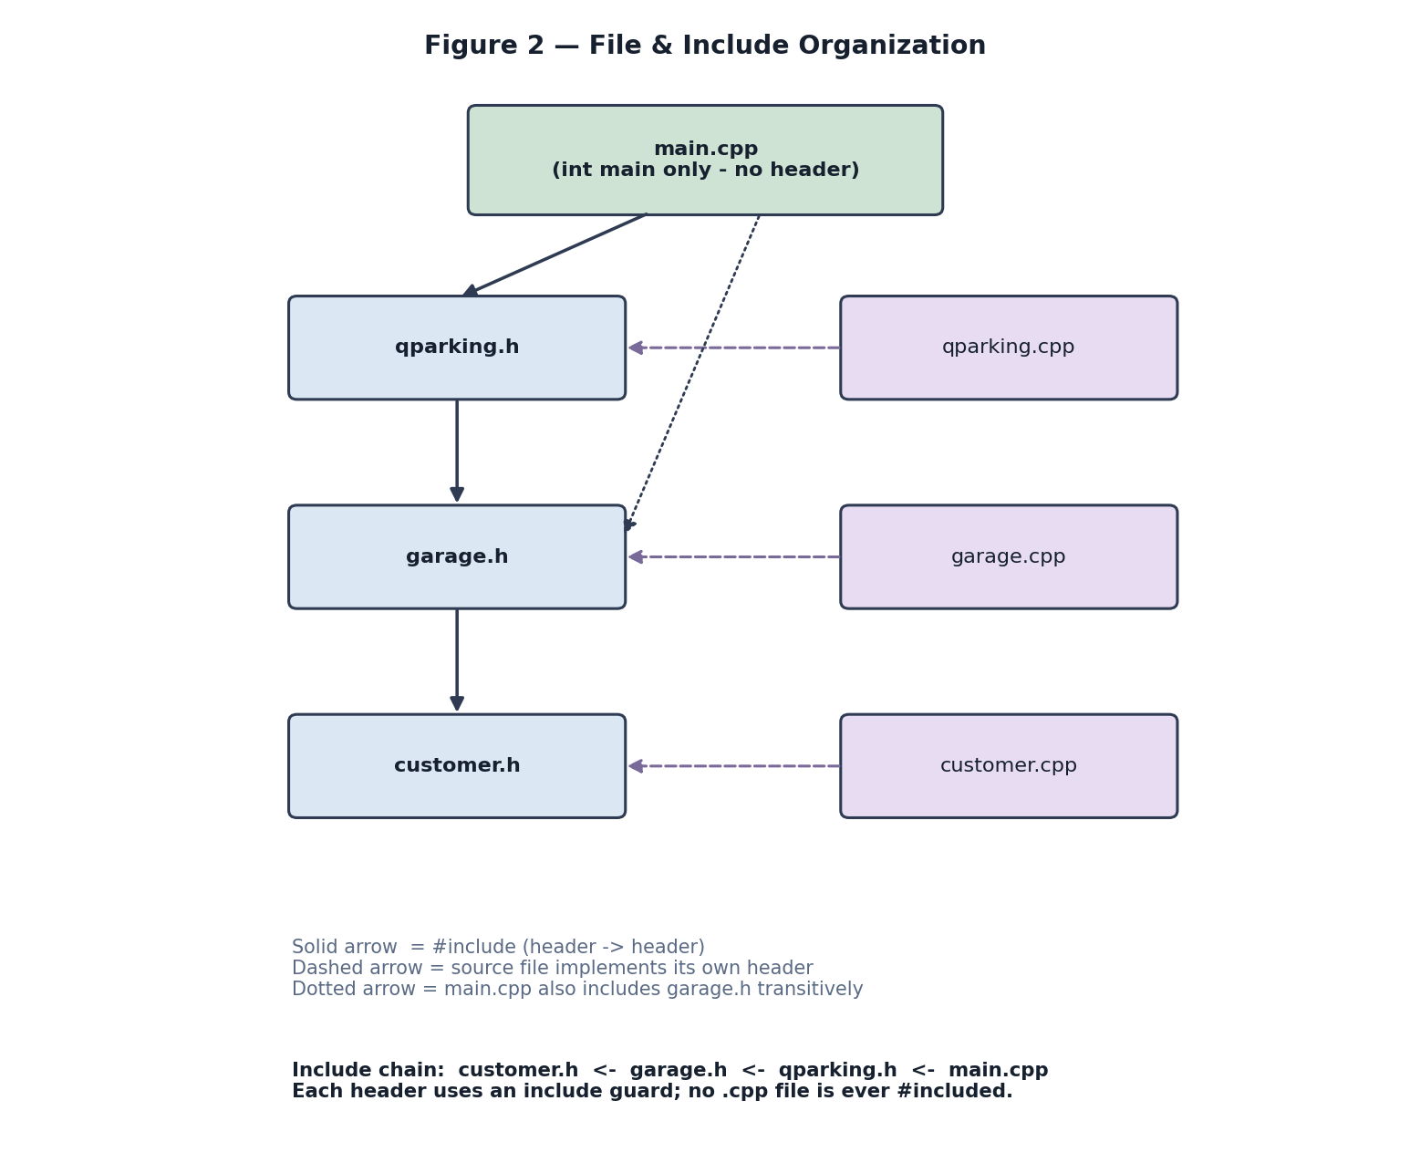
Figure 2. File and include organization.
File | Contains | Includes / Depends on
main.cpp | int main(); reads config filename from the command line; drives the run | qparking.h, garage.h
qparking.h / .cpp | QParkingSystem class: state + Component 1, 2, 3, 5, 6 entry points | garage.h
garage.h / .cpp | Garage class: one LIFO stack garage and its operations | customer.h, <vector>, <stack>, <string>, <unordered_map>
customer.h / .cpp | Customer class: a single car owner record and accessors | <string>
config.txt | User-supplied configuration (garage count + capacity, file names) | —
occupancy.csv | Initial garage grid (columns = garages; -1 / R / id) | —
customers.csv | Customer roster (name, phone, arrival, departure per row) | —

5. Component Ownership and Responsibilities
Ownership reflects the work already recorded in the project's commit history together with the dependency order among components. Zachary Yandell authored the configuration and the input files (config.txt, customers.csv, occupancy.csv) and wired them together, so he owns configuration and initialization (Component 1). Nicholas Richburg authored the class structure and the main driver, so he owns interaction processing (Component 2) along with the closely coupled car-location and reconfiguration components (4 and 5), since retrieval depends directly on locating the car. The remaining components are divided to keep the load balanced at three each. This split is a starting point and may be revised as the design evolves.
Component | Summary | Owner (group member)
1. Config & init | Read config, occupancy, and customers; build system state | Zachary Yandell
2. Interaction processing | Parse and dispatch the P:/D: interaction lines | Nicholas Richburg
3. Parking assignment | Choose a garage and park a dropped-off car | Zachary Yandell
4. Car location | Resolve a customer id to its garage/spot | Nicholas Richburg
5. Reconfiguration | Shuffle cars to retrieve one and restore a valid lot | Nicholas Richburg
6. Status / availability | Report capacity/availability; write output file | Zachary Yandell

6. Design Notes and Possible Refinements
As the instructions note, this design is not binding and may change. A few refinements are already anticipated. First, the action methods currently declared without parameters — for example ParkCustomer and RemoveCustomer — will need arguments (such as a customer id or a spot index) once they are implemented, and GetSpotValue will need an index. Second, the <unordered_map> header is already included in garage.h in anticipation of the id-to-location map that makes Component 4 efficient; the team should decide whether that map lives on the Garage or, more naturally, on the QParkingSystem. Third, the exact layout of the restricted (R) buffer — whether it is one reserved garage or spaces distributed across garages — is a team decision; only the n-free-spaces guarantee is fixed. These items are recorded here so they can be resolved deliberately rather than discovered during the merge.

