Segment Mapper Framework
Solution Architecture — Generic CDP-to-Mainframe Segment Transformation
Audience: Solution Architects · Component: mainframe-segment-transform · Orchestration: data-pipeline-orchestrator · Platform: gcp-pipeline-reference

1. Business purpose
This component is the bridge between the cloud analytics estate and the mainframe batch estate. It takes any table in the Consumable Data Product (CDP) layer, projects it through a declarative field layout, and emits fixed-width files in Google Cloud Storage for the mainframe to pick up. It runs once per extract period per registered segment.
The framing to hold in mind is that this is not a single-segment tool. It is a generic mapping engine: any CDP table can be nominated as the source for a named segment by authoring one YAML template. There is no segment-specific Python code. Adding a new segment is a configuration change, not a release.

2. Capabilities at a glance
Capability | What it means in practice
Generic source binding | Any BigQuery CDP table can be the source of any segment. The binding is declared in YAML — source.dataset, source.table, and a SQL query with period placeholders.
Declarative record layout | Record length, ordered field list, field types (string, integer, amount, rate, date, filler), widths, padding, and truncation rules are all in YAML. The engine enforces that field widths sum to record_length at load time.
Built-in chunking | Output is sharded on write; shard size is per-segment configurable (max_records_per_shard, default 1,000,000). BigQuery reads are partition-pruned. Dataflow autoscales workers.
Platform integration | Reuses the shared gcp-pipeline-core library for run lifecycle: job_control in BigQuery, audit events to Pub/Sub, metrics to Cloud Monitoring, error classification to gcp-pipeline-error-handling.
Lineage and idempotency | Every run writes under gs://.../{period}/{run_id}/{segment}/. Same run_id = overwrite, new run_id = independent extract. A JSON manifest accompanies each run for mainframe-side verification.
Airflow orchestration | Extraction is one task in a wider DAG graph: ingestion → FDP transformation → CDP build → segment extract. The orchestrator owns scheduling, dependency checks, retries, and alerting.

3. Solution context
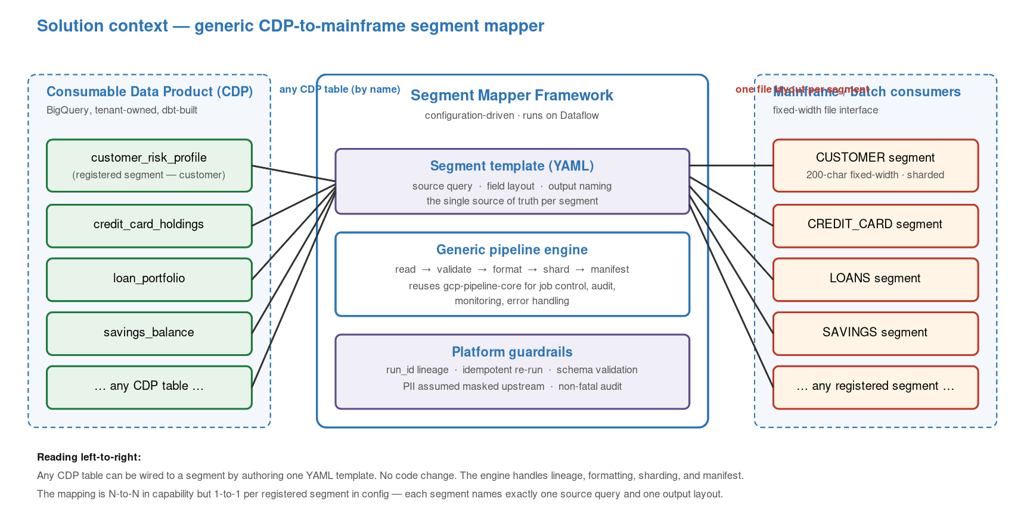
Figure 1 — Solution context: any CDP table can be mapped to any registered segment.
The framework sits between two stable interfaces. Upstream, it reads from the CDP layer in BigQuery — the assumption is that PII masking, enrichment, and business rules have already been applied there by upstream dbt transformations. Downstream, it writes fixed-width files to a GCS bucket that the mainframe batch scheduler watches.
The relationship between source tables and output segments is N-to-N in capability: any table can back any segment. In configuration, each registered segment names exactly one source table and one field layout. This is the intentional constraint that keeps the platform auditable — a segment has exactly one contract, and the contract is the YAML.

4. The mapping pattern
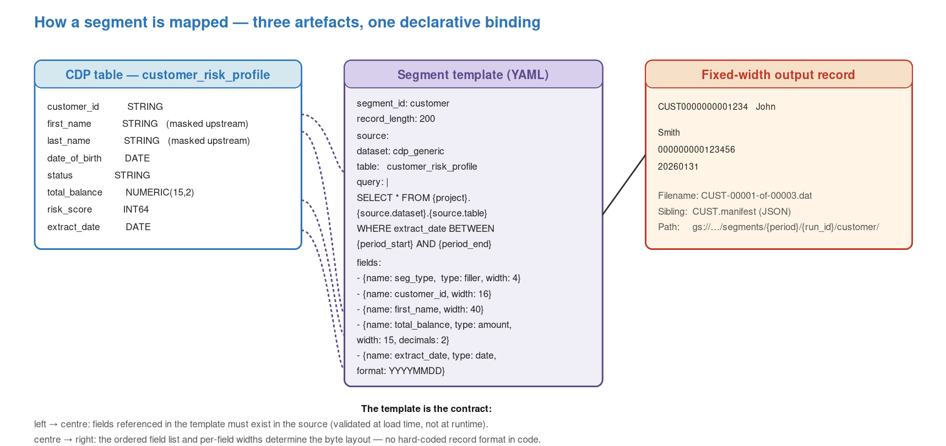
Figure 2 — How a CDP table, a segment template, and an output record are bound.
Three artefacts participate in every segment: the CDP table (schema), the segment template (YAML), and the fixed-width output (byte layout). The template is the contract that binds the first to the third. It references source columns by name, declares the order and width of fields in the output, and embeds the SQL that selects the right rows for the requested period.
Two validation passes enforce the contract. At template load time, the engine checks that field widths sum to record_length and that the segment is registered in system.yaml. At runtime, the Beam formatter validates the produced record length per row and surfaces any mismatch as a format_errors metric — the job continues, but the metric is dashboarded so drift is visible.

4.1 Adding a new segment — the end-to-end change
- Author config/templates/<segment>.yaml with source table, SQL, field layout.
- Register the segment under segments: in config/system.yaml.
- Rebuild the Flex Template image (CI runs the cloudbuild.yaml on merge).
- Author or extend an Airflow DAG task that launches the Flex Template with segment=<new_segment> and the appropriate period.
- No Python code change. No redeploy of other segments.

5. Scale and chunking
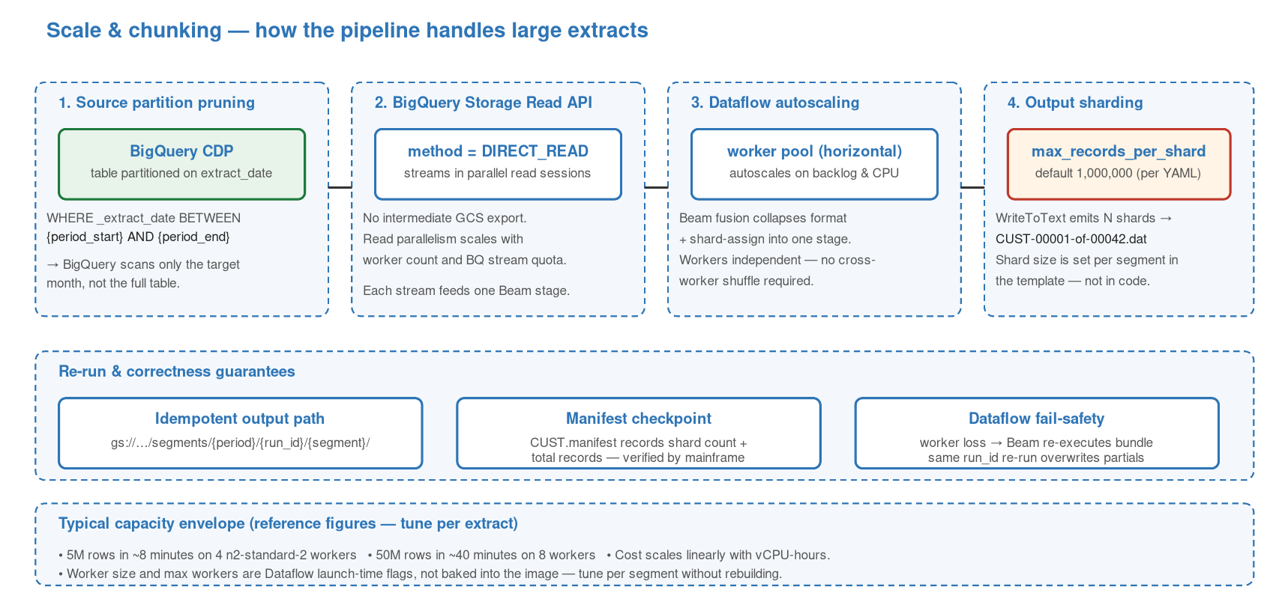
Figure 3 — The four-layer chunking model, plus re-run semantics.

5.1 Four layers of parallelism
Layer | How it contributes
Layer 1 — Source partition pruning | CDP tables are partitioned on extract_date. The template's SQL includes WHERE _extract_date BETWEEN {period_start} AND {period_end}, so BigQuery only scans the target month. This caps bytes read regardless of table size.
Layer 2 — BigQuery Storage Read API (DIRECT_READ) | The pipeline uses beam.io.ReadFromBigQuery with method=DIRECT_READ. Rows stream from the Storage Read API in parallel sessions — no intermediate GCS export. Read parallelism scales with worker count and BQ stream quota.
Layer 3 — Dataflow worker autoscaling | Dataflow provisions worker VMs on backlog and CPU signals. Workers are independent — the formatter is an element-wise DoFn with no shuffle — so horizontal scaling is near-linear up to BQ stream quota.
Layer 4 — Output sharding (WriteToText) | Output is split into shards at write time. max_records_per_shard is a per-segment YAML setting (default 1,000,000). Each shard is a separate GCS object named CUST-NNNNN-of-MMMMM.dat so the mainframe can parallelise pickup.

5.2 Reference capacity envelope
Extract size | Typical shape
5M rows / month | ~8 minutes · 4 x n2-standard-2 workers · partition-pruned read.
50M rows / month | ~40 minutes · 8 workers · dominant cost is BQ bytes read.
Worker sizing | Set at Dataflow launch time (--worker-machine-type, --max-workers), not baked into the image.
Cost scaling | Roughly linear with vCPU-hours; shard count does not affect cost materially.

These are reference numbers from typical CDP shapes, not a contract. Every new segment should be capacity-tested against its actual row width and volume during onboarding.

5.3 Failure and re-run semantics
- Dataflow retries bundles automatically on transient worker failure — the Beam runner redoes only the work in flight, not the whole job.
- Hard job failure surfaces as status=FAILED in job_control and a Pub/Sub audit event. The error-handling DAG picks it up within 30 minutes.
- Re-running with the same run_id overwrites the output prefix — safe and idempotent. Use a fresh run_id for an independent correction run.
- The manifest is re-generated on every run, so downstream mainframe verification is always against the latest set of shards.
- There is no shard-level checkpointing — a hard failure re-reads the full BQ partition. This is acceptable at current volumes; revisit if single extracts ever exceed the 1-hour mark.

5.4 Airflow-level chunking — present strategy
Today the pipeline is driven on a monthly cadence: one Dataflow job per segment per month. For larger segments, the DAG can be extended to loop over a list of sub-periods (e.g. per-day) and launch a Flex Template invocation per sub-period — the engine already accepts any period boundary via {period_start}/{period_end}. This is a DAG-level change, not a framework change.
In practice, the break-even point for sub-period chunking is around a Dataflow run duration of ~60 minutes. Below that, the overhead of splitting is not worth the benefit; above that, sub-period runs improve observability and recovery time.

6. Airflow orchestration
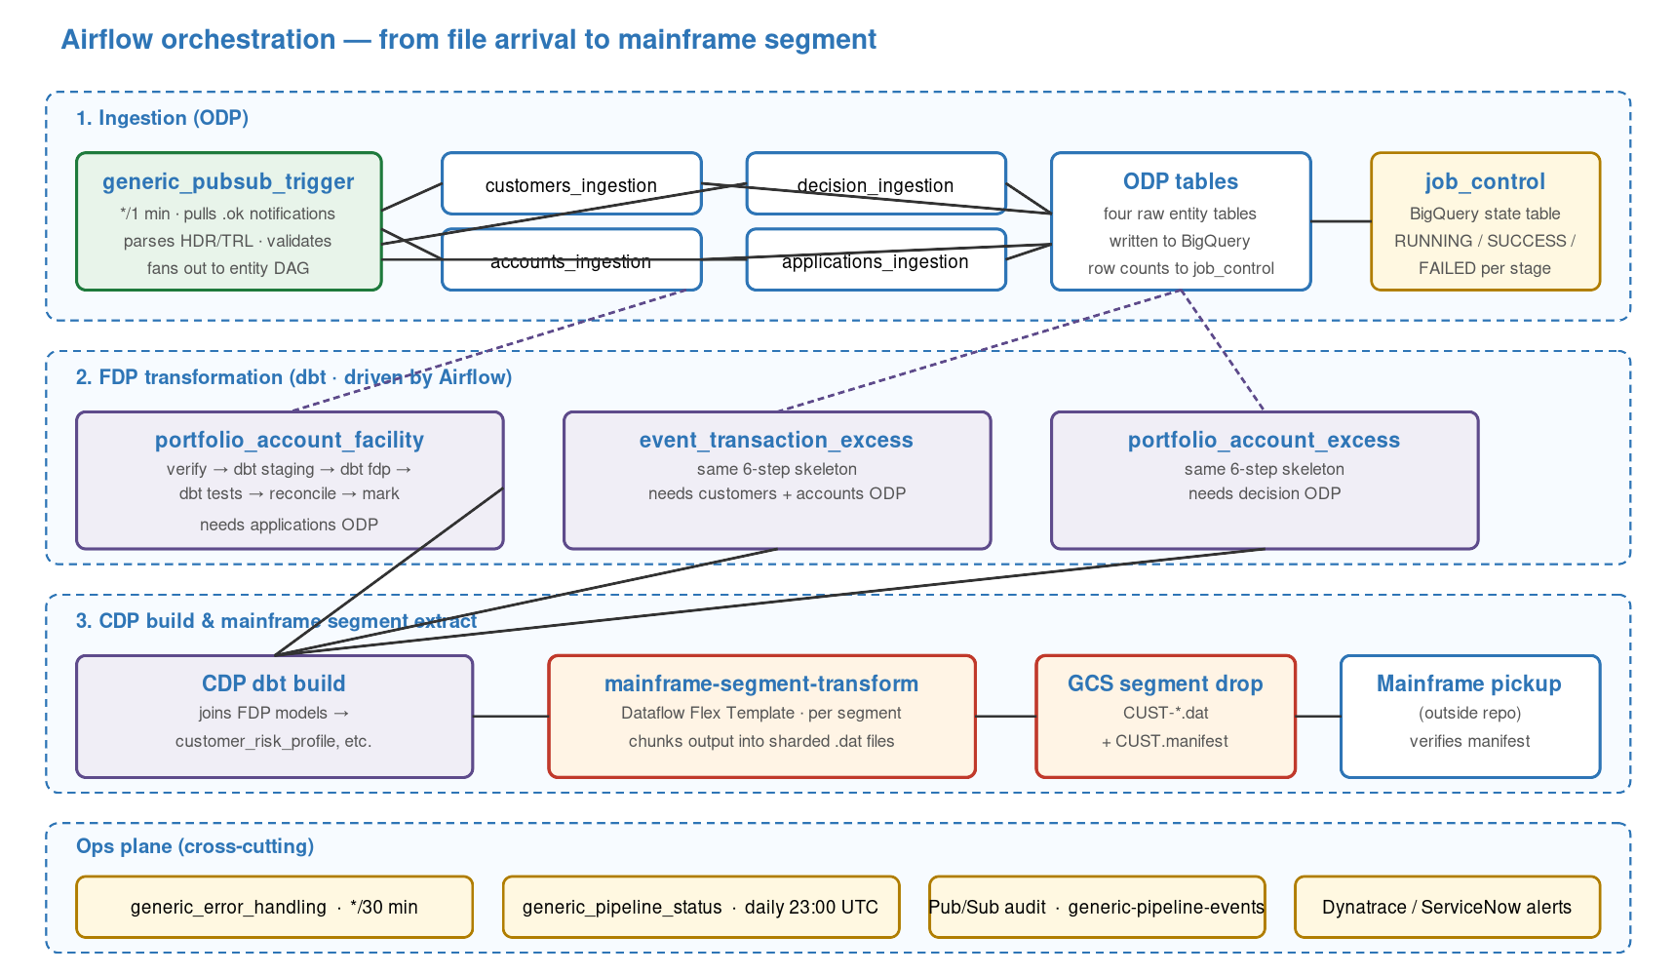
Figure 4 — The data-pipeline-orchestrator DAGs and how they feed the segment extract.

6.1 The three-stage flow
An end-to-end extract runs through three stages of DAGs, plus a cross-cutting ops plane. Every DAG writes run state to the same job_control BigQuery table, so dependency checks and alerting work off a single source of truth.
Stage | What it does
Stage 1 — Ingestion | generic_pubsub_trigger (every minute) pulls .ok file notifications from Pub/Sub, parses HDR/TRL headers, validates system_id, and fans out to one of four entity DAGs: customers_ingestion, accounts_ingestion, decision_ingestion, applications_ingestion. Each writes a raw ODP table.
Stage 2 — FDP transformation | Three DAGs run the dbt transforms: portfolio_account_facility, event_transaction_excess, portfolio_account_excess. All share the same 7-step skeleton: verify dependencies → job_control row → dbt staging → dbt fdp → dbt tests → reconcile row counts → mark SUCCESS/FAILED.
Stage 3 — CDP build and segment extract | Downstream dbt joins FDP models into CDP tables (customer_risk_profile etc.), and the mainframe-segment-transform Flex Template is launched per segment to produce the fixed-width files.
Ops plane (cross-cutting) | generic_error_handling (every 30 minutes) classifies failures by stage and auto-retries where safe. generic_pipeline_status (daily at 23:00 UTC) audits that all expected entities and FDP models reached SUCCESS and alerts Dynatrace/ServiceNow if anything is missing.

6.2 DAG inventory
DAG | Role
generic_pubsub_trigger | Entry point. Polls Pub/Sub every minute, validates .ok metadata, dispatches to the right entity ingestion DAG.
generic_customers_ingestion | Loads customers raw files into the customers ODP table.
generic_accounts_ingestion | Loads accounts raw files into the accounts ODP table.
generic_decision_ingestion | Loads decision raw files into the decision ODP table.
generic_applications_ingestion | Loads applications raw files into the applications ODP table.
generic_portfolio_account_facility_transformation | Builds the portfolio_account_facility FDP model. Depends on applications ODP.
generic_event_transaction_excess_transformation | Builds the event_transaction_excess FDP model. Depends on customers + accounts ODP.
generic_portfolio_account_excess_transformation | Builds the portfolio_account_excess FDP model. Depends on decision ODP.
generic_error_handling | Scans job_control every 30 minutes. Auto-retries RETRYABLE failures, alerts on CRITICAL, escalates on exhausted retries.
generic_pipeline_status | Daily end-of-day audit. Checks that all four ODP entities and three FDP models reached SUCCESS. Alerts on any gap.

6.3 Why the ops plane matters
A transformation pipeline without an ops plane is invisible by default. The error-handling DAG classifies failures by stage so that the right response is automatic: load failures retry, dependency failures alert, unknown failures escalate to human review. The status DAG closes the loop each day by confirming that nothing silently skipped. Both run on fixed schedules so that a stuck scheduler is itself visible.

7. Deployment topology
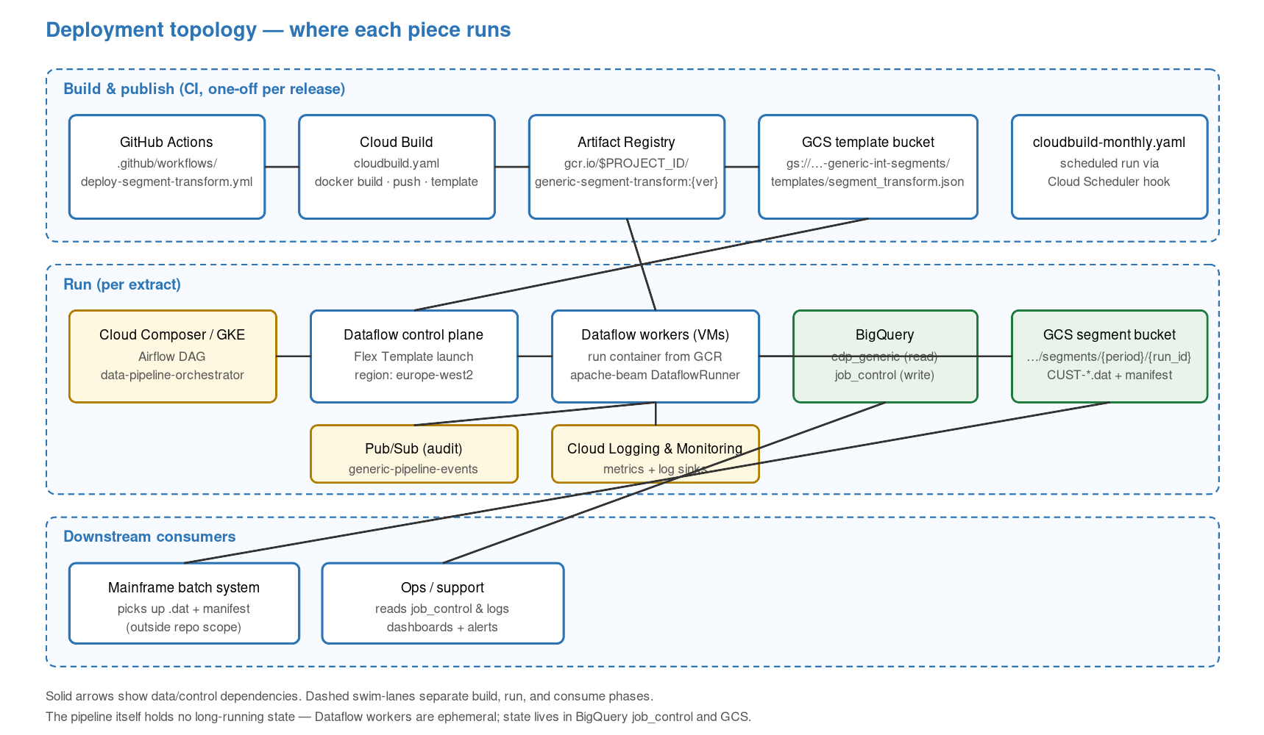
Figure 5 — Build, run, and consume phases on Google Cloud.
Build is one-off per release. Cloud Build compiles a container image, pushes to Artifact Registry, and writes the Flex Template JSON spec to the templates prefix of the segment bucket. Nothing in the runtime path depends on a live build server.
Run is ephemeral. Airflow (Cloud Composer or self-hosted on GKE) launches the Flex Template. The Dataflow control plane provisions worker VMs from the Artifact Registry image, runs the extract, and tears the workers down. The only persistent state is the job_control table and the GCS segment outputs.
Consume is external. The mainframe batch scheduler watches the segment bucket and ingests CUST-*.dat plus manifest. That contract is deliberately narrow so that the mainframe side can be replaced or supplemented (e.g. with a secondary cloud consumer) without changing the framework.

8. Quality attributes
Attribute | Position
Performance | Dataflow autoscaling keeps a given extract within its time budget by adding workers. BigQuery DIRECT_READ and partition pruning cap the bytes read. Horizontal scaling is near-linear until BQ stream quota bites.
Scalability | Per-segment shard sizing and per-run worker sizing let each segment be tuned independently — no global tuning. New segments add no load on existing ones.
Reliability | Beam retries bundles on worker loss. Airflow error-handling DAG retries whole runs classified as RETRYABLE. Same-run_id reruns overwrite partial output. Manifest is the downstream correctness check.
Observability | job_control row per run, Pub/Sub audit event per lifecycle transition, Dataflow metrics for throughput and errors, Cloud Logging for worker logs, Dynatrace/ServiceNow alerts via the ops DAGs.
Security | ADC-based auth; no embedded secrets. Service accounts scoped per deployment. PII masking assumed upstream — this layer never sees unmasked values. Flex Template image is pinned and versioned.
Maintainability | Zero-code additions for new segments (YAML only). Shared library versioned separately (gcp-pipeline-core, gcp-pipeline-beam). Fail-fast validation at template load time.
Cost | Dominant cost is BQ bytes scanned + Dataflow vCPU-hours. Both scale linearly with extract size. FinOps tracking via INFORMATION_SCHEMA.JOBS.

9. Key design decisions
Decision | Rationale
Declarative templates over code generators | Alternative: generate a segment-specific Python module per segment. Chosen approach: one engine, many YAMLs. Loses compile-time type checking, gains zero-code onboarding and a single audit trail.
Dataflow Flex Template over custom service | Alternative: a long-running Cloud Run service that reads and writes on demand. Chosen approach: ephemeral Dataflow job. Loses sub-second startup, gains autoscaling and native Beam fault tolerance.
DIRECT_READ over EXPORT | Alternative: BigQuery EXPORT to GCS, read from GCS. Chosen approach: Storage Read API direct. Removes a GCS round-trip, halves wall time on 10M+ row extracts.
Airflow for orchestration over Dataflow-only | Alternative: chain Dataflow jobs from within a master Beam pipeline. Chosen approach: Airflow. Gains human-readable DAGs, dependency checks, retries, and alerting that ops already understand.
Idempotent by run_id over sequence-number checkpointing | Alternative: checkpoint shards as they complete and resume mid-run. Chosen approach: rerun whole job under same run_id. Simpler; acceptable at current extract sizes; revisit above the 1-hour mark.

10. Known limitations and roadmap
- Four segment templates (credit_card, check_debit_card, loans, savings) are present but not registered. Enabling each is a YAML flip plus a CDP source table — no code change.
- Project ID is still hard-coded to the reference tenant slug in several shell scripts and Helm values. Tenantisation is scoped in docs/TENANTISATION_PLAN.md as 8 PR-sized steps.
- Audit publish is non-fatal. A silent Pub/Sub outage would drop audit events without failing the run — acceptable today but worth a post-run reconciliation step later.
- No downstream confirmation that the mainframe consumed the extract successfully. The handshake is one-way. A receipt file from the mainframe side would close the loop.
- Airflow sub-period chunking is supported but not yet used in anger — the pattern (one Flex Template launch per sub-period) should be templated once the first segment crosses the 1-hour run time.

Appendix A. Glossary
Key | Description
ODP | Original Data Product — raw-ish ingested tables. One per source entity.
FDP | Foundational Data Product — dbt-built business-model tables, cleansed and joined.
CDP | Consumable Data Product — downstream-ready views/tables for consumers such as this component.
Segment | A named fixed-width record type destined for a mainframe consumer (e.g. CUSTOMER, LOANS).
Template | YAML file that binds one CDP table to one segment by declaring SQL and field layout.
Flex Template | A Dataflow job packaged as a container image + JSON spec, launched via gcloud or a DAG.
Manifest | JSON sidecar file listing shard count, total records, period, and run_id for mainframe verification.
run_id | Unique identifier per extract attempt. Drives the GCS output path; reuse = overwrite.
job_control | BigQuery table that holds the lifecycle row per pipeline run across all stages.

