Mainframe Segment Transform
Architecture Reference
Component: deployments/mainframe-segment-transform · Repo: gcp-pipeline-reference · Version: 1.0.29

1. Summary
Mainframe Segment Transform is the last stage of the data platform pipeline. It reads the enriched customer_risk_profile table from the Consumable Data Product (CDP) layer in BigQuery and produces fixed-width, 200-character segment files in Google Cloud Storage. Those files are picked up by downstream mainframe batch systems. The component is a template-driven Apache Beam pipeline, packaged as a Dataflow Flex Template, and launched per extract by the data-pipeline-orchestrator Airflow DAG or by an operator running gcloud dataflow directly.
Everything that varies between segments — the source query, the field layout, the output file naming — lives in YAML under config/templates/. The Python code reads those templates at runtime and drives a generic formatting pipeline. Adding a new segment is a YAML change, not a code change.

2. Purpose and boundaries
This component sits at the boundary between the cloud analytics estate and the mainframe estate. It is responsible for three things and nothing else:
- Read a curated BigQuery view or table that the upstream CDP dbt job has already produced for the relevant period.
- Format each row as a fixed-width record according to a YAML layout definition, with deterministic padding, alignment, and truncation rules.
- Shard the output into manifest-bound GCS files that a mainframe job-control system can consume with no further transformation.
PII masking, enrichment, and business rules are explicitly out of scope — those happen earlier in the platform (FDP to CDP transforms, dbt macros in gcp-pipeline-transform). This component assumes the CDP table is already consumption-ready.

3. Component view
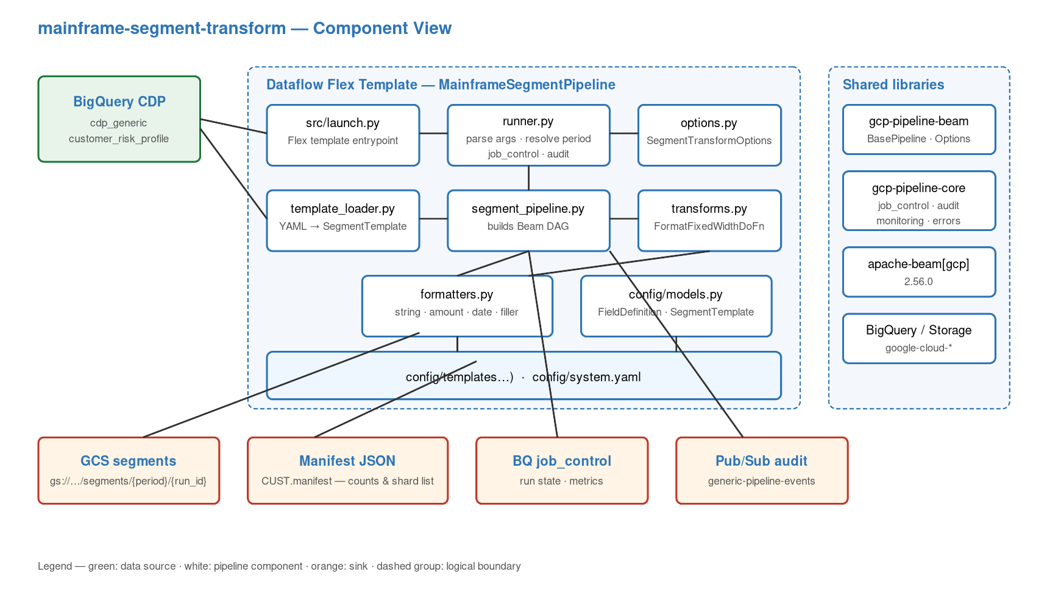
Figure 1 — Component view of mainframe-segment-transform.
Everything inside the dashed Dataflow Flex Template group runs in the same container image on Dataflow workers. The shared libraries on the right are installed from the gcp-pipeline-libraries monorepo (core and beam) and provide the BasePipeline class, options plumbing, job-control, audit, error handling, and monitoring helpers that the deployment reuses verbatim.
The split between runner.py and segment_pipeline.py is deliberate: runner.py owns the run lifecycle (parse args, open job_control, catch errors, publish audit, close run) while segment_pipeline.py owns the Beam DAG. The DAG knows nothing about job control. This makes segment_pipeline unit-testable without a Beam pipeline options harness.

4. End-to-end data flow
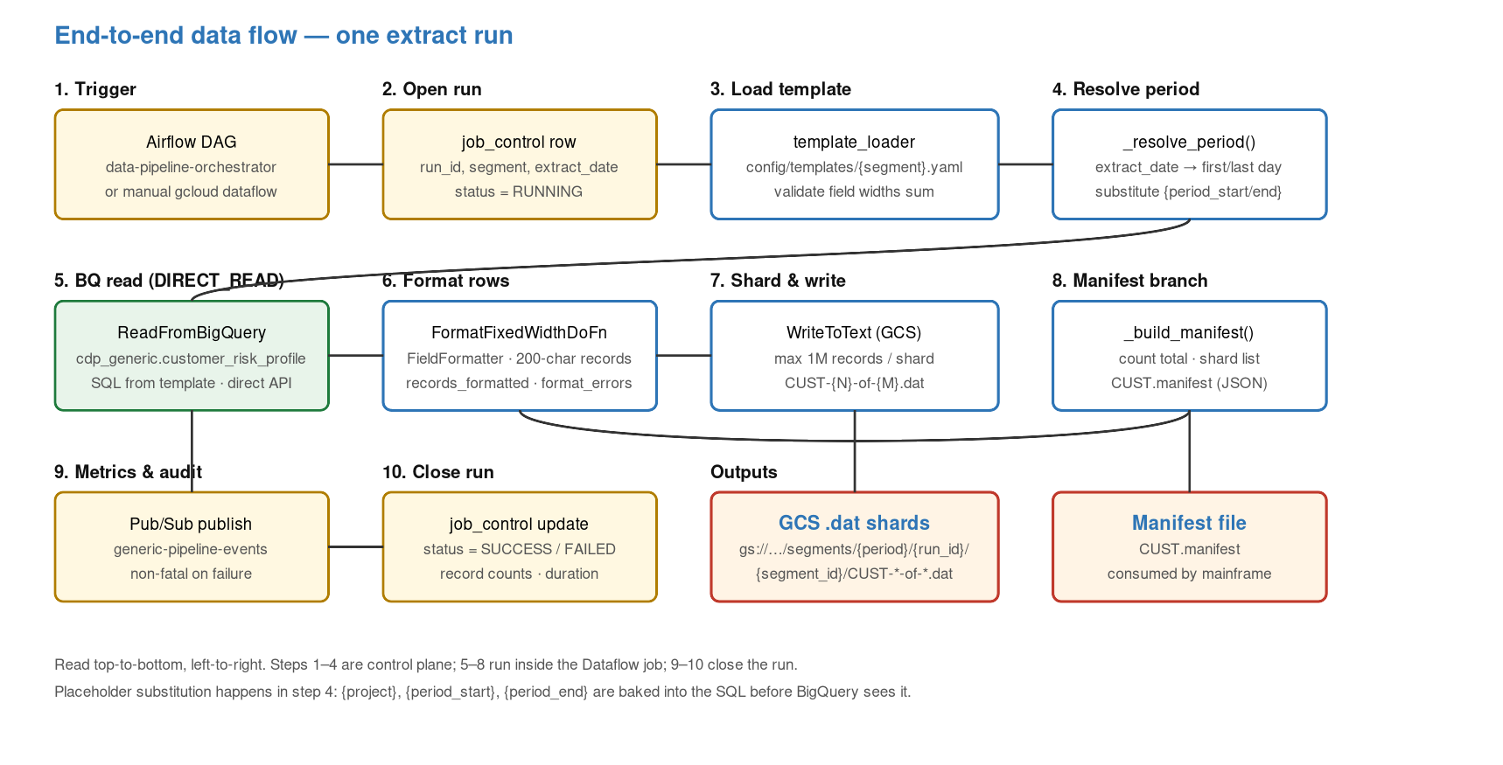
Figure 2 — One extract from trigger to consumable files.

4.1 Step-by-step walk-through
Steps 1 through 4 execute on the orchestrator or the operator's machine — they are the control plane. Steps 5 through 8 run inside the Dataflow job on worker VMs. Steps 9 and 10 close the run.
- 1. Trigger — the Airflow DAG data-pipeline-orchestrator triggers a Dataflow Flex Template job, passing segment, extract_date, output_bucket, run_id.
- 2. Open run — runner.py writes a new row to the job_control BigQuery table with status=RUNNING.
- 3. Load template — template_loader reads config/templates/{segment}.yaml, validates that field widths sum to record_length, and rejects unregistered segments.
- 4. Resolve period — _resolve_period() turns extract_date into a first/last day of month and substitutes {project}, {period_start}, {period_end} into the SQL.
- 5. BigQuery read — Beam's ReadFromBigQuery uses the DIRECT_READ method, so rows stream from the Storage Read API without a GCS temp export.
- 6. Format rows — FormatFixedWidthDoFn calls FieldFormatter for each field and concatenates to a 200-character string; metrics records_formatted and format_errors are incremented.
- 7. Shard and write — Beam's WriteToText shards output at max 1M records per file under gs://.../segments/{period}/{run_id}/{segment_id}/CUST-N-of-M.dat.
- 8. Manifest branch — a parallel branch counts total records and builds CUST.manifest (JSON) with the shard list — this is what the mainframe uses to verify it received the complete extract.
- 9. Audit — runner.py publishes an audit event to Pub/Sub topic generic-pipeline-events. Publish failure is logged as a warning, not raised.
- 10. Close run — the job_control row is updated to SUCCESS or FAILED with record counts and duration.

4.2 Record layout
Each record is a deterministic 200-character string composed of fields declared in the template. The formatter supports six field types:
Field type | Rendering rule
string | Left-aligned, space-padded, truncated on overflow.
integer | Right-aligned, zero-padded; negative values rendered with leading minus.
amount | Right-aligned, zero-padded, fixed decimal places with no separator.
rate | Right-aligned, zero-padded, percentage points with fixed decimals.
date | Formatted via the template's date_format (default YYYYMMDD).
filler | Fixed string (typically spaces) used as padding or as a segment marker.

Null values render as the field's pad character for the whole width, so nulls never corrupt record alignment.

5. Configuration surface

5.1 CLI arguments
Flag | Purpose
--segment | Required. Segment ID, e.g. customer. Must be registered in system.yaml.
--extract_date | Required. YYYYMMDD. Validated by _parse_extract_date().
--extract_month | Optional. YYYYMM. Derived from extract_date when absent.
--output_bucket | Required. GCS bucket name (no gs:// prefix) for segment files.
--config_dir | Optional. Override the bundled config/ directory.
--fdp_project | Optional. Override GCP project for CDP reads; defaults to --gcp_project.
--gcp_project | Inherited. Target project for BigQuery and job_control writes.
--run_id | Inherited. Unique run identifier; used in GCS output path.
--runner | Inherited. DirectRunner for local, DataflowRunner for Flex Template.

5.2 Config files
Path | Role
config/system.yaml | Registers active segments and the shared GCP resource names (default_cdp_dataset, audit_topic, and so on).
config/templates/customer.yaml | Per-segment template: source table, partition column, SQL query with placeholders, output file naming, shard sizing, and ordered field layout.
config/templates/credit_card.yaml | Stub template. Registration is commented out in system.yaml — future segment.
config/templates/loans.yaml, savings.yaml, check_debit_card.yaml | Same pattern — stubs awaiting registration.

5.3 Example invocation
gcloud dataflow flex-template run customer-seg-$(date +%s) \
--template-file-gcs-location=gs://$PROJECT-generic-int-segments/templates/segment_transform.json \
--region=europe-west2 \
--parameters=segment=customer,extract_date=20260131,output_bucket=$PROJECT-generic-int-segments,run_id=manual-$(uuidgen)

6. Deployment topology
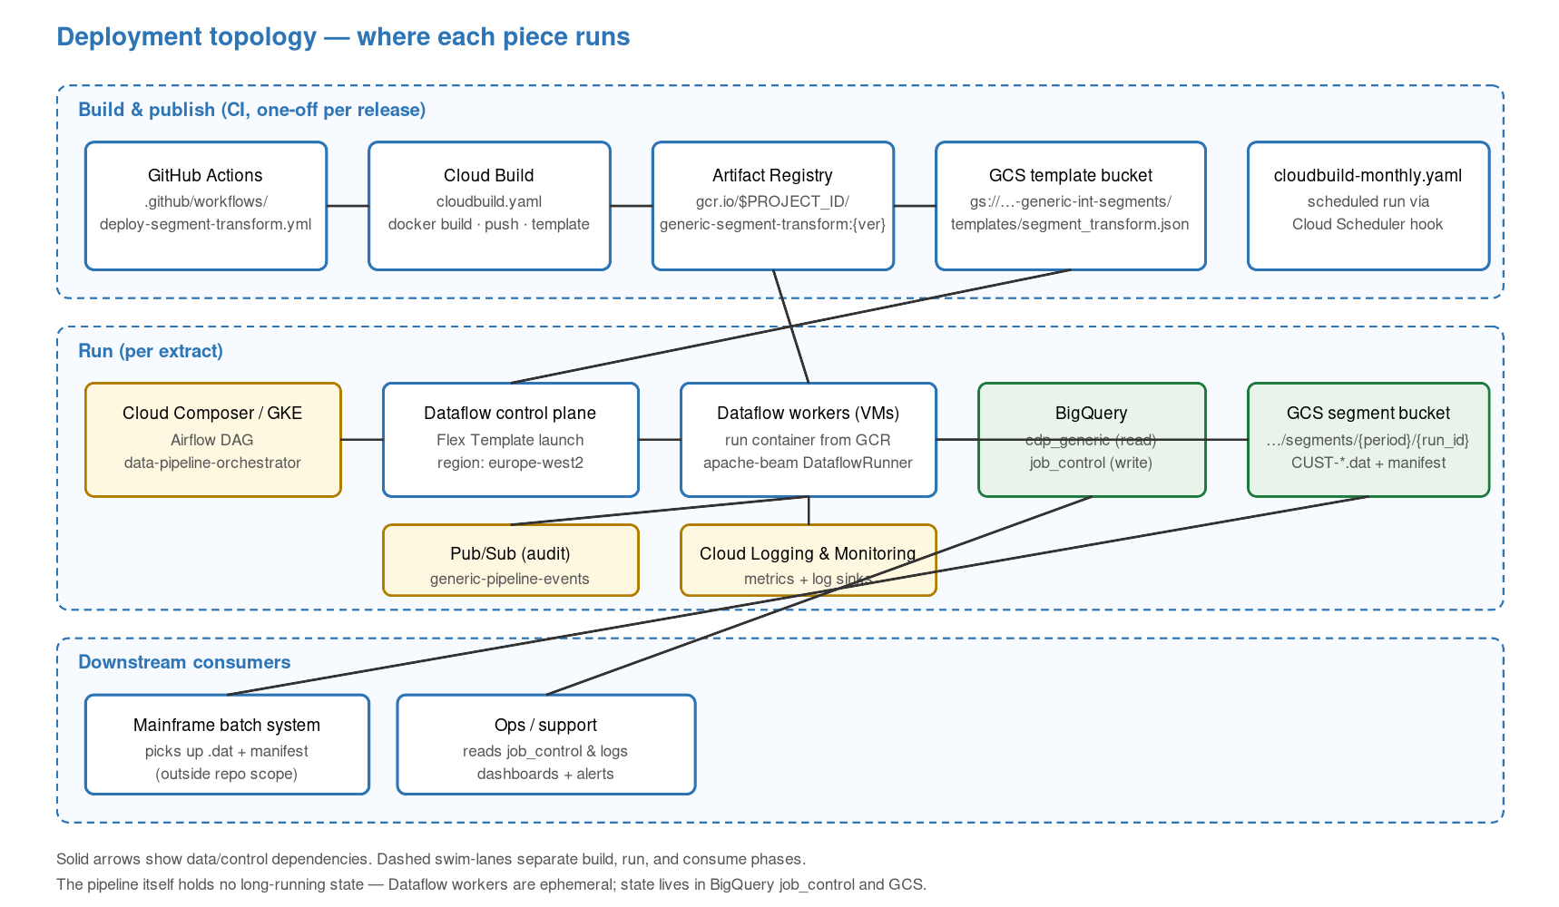
Figure 3 — Build, run, and consume phases.
The pipeline itself holds no long-running state. Dataflow workers are ephemeral and torn down after each run. The only authoritative state lives in two places: the job_control table in BigQuery (run history) and the segment bucket in GCS (extract output). Losing a worker mid-run is recoverable by rerunning with the same run_id — the Beam pipeline is idempotent because each run writes under its own {run_id} prefix.
Build is one-off per release. cloudbuild.yaml builds the Docker image, pushes it to Artifact Registry, and generates the Flex Template JSON spec which is uploaded to the templates/ prefix of the segment bucket. cloudbuild-monthly.yaml is a variant triggered on a Cloud Scheduler hook for monthly runs where the build and the run happen together.

7. Testing story

7.1 What is covered
Test file | What it exercises
tests/unit/pipeline/test_runner.py | _parse_extract_date (format validation) and _resolve_period (month-boundary math). Uses mirrored pure functions to avoid importing Beam at test time.
tests/unit/pipeline/test_segment_pipeline.py | _build_manifest (count to JSON) and SQL placeholder resolution with a mocked Beam.
tests/unit/pipeline/test_options.py | SegmentTransformOptions CLI argument parsing.
tests/unit/config/test_models.py | FieldDefinition and SegmentTemplate dataclass construction; invariant that field widths sum to record_length.
tests/unit/config/test_template_loader.py | YAML loading, unregistered-segment rejection, missing-file handling.
tests/unit/formatting/test_formatters.py | Every formatter type — string, integer, amount, rate, date, filler — including null handling, alignment, pad chars, and overflow truncation.

7.2 What is not covered
- No Beam integration tests — ReadFromBigQuery and WriteToText are mocked. Real BigQuery reads are exercised by the repo-level e2e script scripts/gcp/e2e_pipeline_test.sh.
- No cross-project test for --fdp_project. The code path exists but is not wired into CI.
- No test for the Pub/Sub audit publish. It is called non-fatally, so a silent failure would not block a run but would lose audit history.

8. Key symbols for maintainers
Symbol | Role
runner.run_pipeline (runner.py:91) | Entry point. Owns the run lifecycle: args, job_control, pipeline build, audit, metrics.
MainframeSegmentPipeline (segment_pipeline.py:26) | Builds the Beam DAG. ReadFromBigQuery → FormatFixedWidthDoFn → WriteToText + manifest.
FormatFixedWidthDoFn (transforms.py:19) | Per-element formatter. Delegates to FieldFormatter, increments metrics.
FieldFormatter.format_record (formatters.py:118) | Core formatting loop: iterates the template's field list and concatenates the record.
SegmentTemplate.from_dict / load_segment_template | YAML deserialisation and schema validation entry points.

9. Operations notes
- Monitoring — Beam pipeline metrics records_formatted and format_errors are exported to Cloud Monitoring; job_control is the easier query path for run state and duration.
- Re-runs — same --run_id re-uses the output prefix, overwriting previous shards. Use a fresh run_id for an independent re-run.
- Quotas — Storage Read API has per-project streams quotas; set parallelism via Dataflow autoscaling, not the Beam partitioning arg, to stay within limits.
- Failure modes — format_errors metric above zero means the input schema drifted relative to the YAML layout; rerun is safe only after updating the template.
- Rollback — redeploy the previous Docker image tag and re-upload the matching Flex Template spec from a tagged build.

10. Known gaps
- Four segment templates (credit_card, check_debit_card, loans, savings) are present but not registered in system.yaml. Enabling them is a YAML flip plus a new CDP source table.
- GCP project ID defaults are still the tenant slug joseph-antony-aruja in several shell scripts; see docs/TENANTISATION_PLAN.md.
- No downstream confirmation that the mainframe consumed the manifest successfully — the loop is currently one-way.
- Audit publish is non-fatal; a silent Pub/Sub outage drops audit records without failing the run.

Appendix A. File inventory
Path | Role
src/segment_transform/pipeline/runner.py | CLI entry point and run lifecycle.
src/segment_transform/pipeline/segment_pipeline.py | Beam DAG builder.
src/segment_transform/pipeline/transforms.py | FormatFixedWidthDoFn.
src/segment_transform/pipeline/options.py | SegmentTransformOptions.
src/segment_transform/config/models.py | Dataclasses for template schema.
src/segment_transform/config/template_loader.py | YAML loaders.
src/segment_transform/formatting/formatters.py | FieldFormatter and format_record.
src/launch.py | Flex Template entrypoint.
config/system.yaml | Segment registry, resource names.
config/templates/*.yaml | Per-segment layout definitions.
cloudbuild.yaml | Docker build, GCR push, template spec upload.
cloudbuild-monthly.yaml | Scheduled monthly variant.
Dockerfile | Flex Template launcher base image.
setup.py, requirements.txt | Package metadata and runtime dependencies.
metadata.json | Flex Template parameter metadata shown in the Dataflow UI.
tests/unit/** | Unit tests — see section 7.
README.md | User guide.
DEPLOYMENT_GUIDE.md | CI/CD and infrastructure instructions.

