Transform-Only Architecture
Mainframe Segment Mapper Framework (CDP → Segment)
Audience: Solution Architects, Integration Leads · Scope: transformation layer only · Version: 1.0

Executive summary
This document describes the target architecture when the ODP, FDP and CDP data layers are owned by a separate framework (for example, a tenant-managed data platform). This repository is scoped exclusively to the transformation that turns consumable data (CDP) into mainframe-ready fixed-width segment files.
The key design premise is that CDP already exists and is guaranteed by its producer. Everything this framework does happens after the CDP is declared ready. That single premise collapses the system from eight deployments and ten DAGs to three deployments and two DAGs without changing the Dataflow engine, YAML template contract, chunking strategy or file-format guarantees.
The architecture documented here is a peel-off of the integrated reference pipeline. No code in the core transform library or the Flex Template needs to change. The only new surface is a readiness contract with the upstream framework and a slim orchestrator that consumes it.

1. Scope and boundary
The system is positioned as a pure transformation capability. It reads from BigQuery tables that the upstream framework guarantees are correct and complete for a given reporting period, then produces sharded fixed-width files on Google Cloud Storage for the mainframe to consume.

1.1 In scope
- Reading CDP tables — BigQuery Storage Read API with DIRECT_READ streams.
- Fixed-width formatting — per-segment byte layout driven by YAML templates.
- Output sharding and manifest — max_records_per_shard chunking; CUST.manifest sibling.
- Idempotent GCS output paths — gs://…/segments/{period}/{run_id}/{segment}/.
- Per-framework orchestration — Airflow DAGs that watch readiness and launch Dataflow jobs.
- Scoped ops plane — error-handling, daily status, Pub/Sub audit, alerting — all scoped to this framework.

1.2 Out of scope
- Source ingestion (ODP) — the upstream framework owns file pickup, HDR/TRL validation, raw-table loads.
- Foundational modelling (FDP) — the upstream framework owns the dbt FDP transforms and their tests.
- CDP build — CDP tables are an input contract — this framework does not build them.
- End-to-end data quality — DQ is the producing framework's responsibility; this framework only validates what it directly controls.
- Cross-framework reconciliation — each framework reconciles within its own boundary.

2. Capabilities
Generic segment mapping | Any CDP table can be mapped to a mainframe segment by authoring a single YAML template — no code changes.
Configuration-driven layout | Fixed-width byte layout is declared in YAML; six primitive field types (string, integer, amount, rate, date, filler) cover the mainframe copybook surface.
Horizontal scale | BigQuery Storage Read API streams + Dataflow autoscaling + configurable shard count scale each extract independently.
Idempotent re-runs | Same run_id overwrites partial output atomically; Dataflow re-executes failed bundles automatically.
Manifest-backed integrity | Every output directory ships a JSON manifest with shard count and record totals for mainframe verification.
Schema-contract enforcement | YAML templates declare the source schema; the engine fails fast at template load if CDP drift is detected.

3. Solution context
The framework sits between an upstream CDP producer and a mainframe consumer. Its only input is a CDP table plus a readiness signal per reporting period. Its only output is one or more sharded fixed-width files plus a manifest.
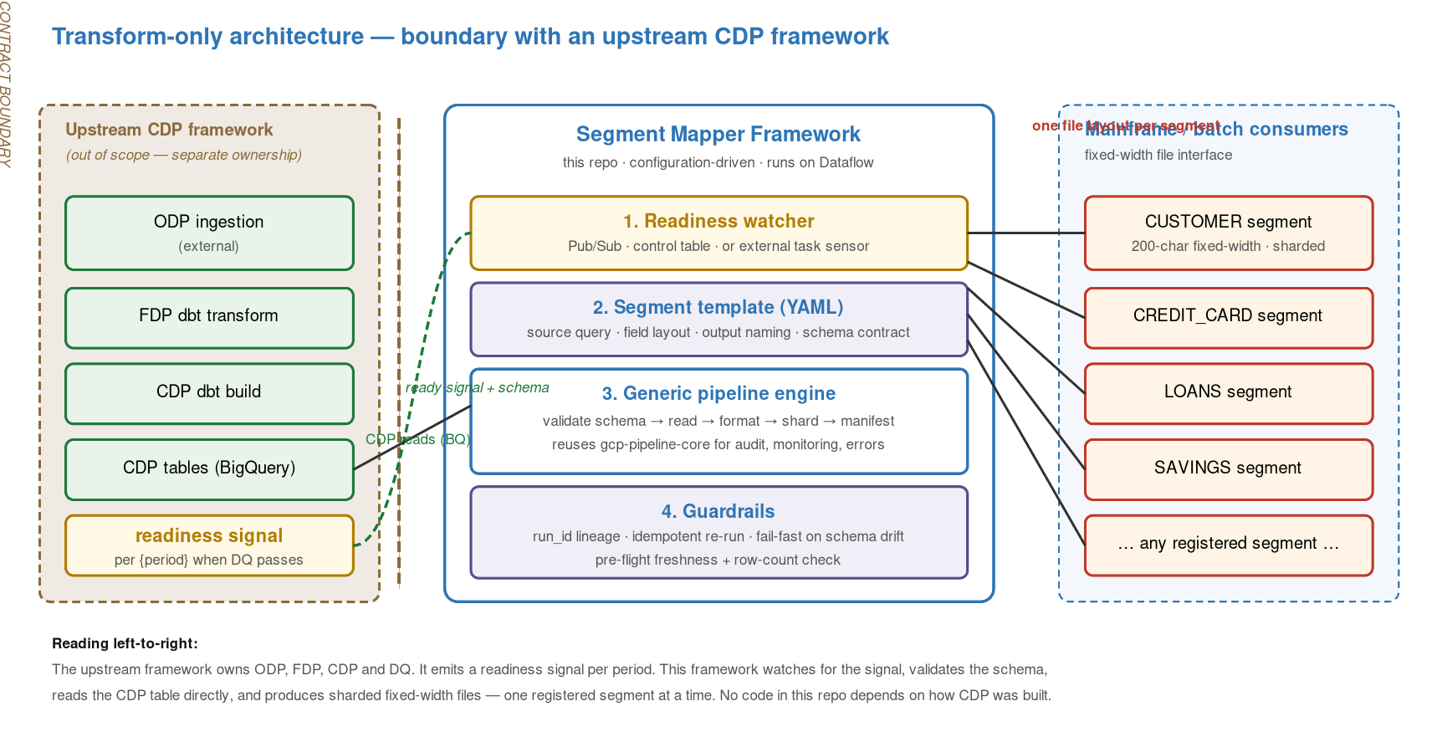
Figure 1 — Solution context with the upstream contract boundary made explicit.

3.1 Contract boundary
The brown dashed line in Figure 1 marks the contract boundary. Everything to the left is out of scope. The contract has two parts: a readiness signal per {period} and a published schema for each CDP table that this framework is wired to.

4. The CDP readiness contract
The readiness contract is the single most important integration point. It is how the two frameworks stay decoupled without losing correctness. The contract has three dimensions: signalling, schema, and quality precondition.

4.1 Signalling options
- Pub/Sub event — cdp.ready.<period> topic; this framework subscribes and the watcher fans out to extract. Preferred for loose coupling and auditability.
- Control table flag — a BigQuery row written by the producer indicating (table, period, state=READY). The watcher polls on a short cadence.
- External task sensor — Airflow ExternalTaskSensor or REST API poll of the producer's DAG run. Works well if both sides run Airflow.

4.2 Schema contract
Each CDP table referenced in a YAML template carries an explicit schema expectation: field names, types, nullability, partition column. At template load time (not at Dataflow runtime) the engine queries BigQuery INFORMATION_SCHEMA and compares. If the contract is violated the extract does not start and the readiness watcher transitions the job to FAILED with a schema-drift diagnostic.

4.3 Quality precondition
The producer emits the readiness signal only when its internal DQ has passed. This framework re-verifies a lightweight subset — row count greater than zero, the extract_date partition contains the expected period — before launching Dataflow. The two checks are intentionally cheap; they protect against obviously wrong signals rather than re-implementing the producer's DQ.

5. The mapping pattern
The mapping from a CDP table to a mainframe segment is declarative. Three artefacts are in play: the CDP table (input), the YAML segment template (contract), and the fixed-width file (output). The template is the single source of truth — it names the source, the query, every output field, and the byte layout.
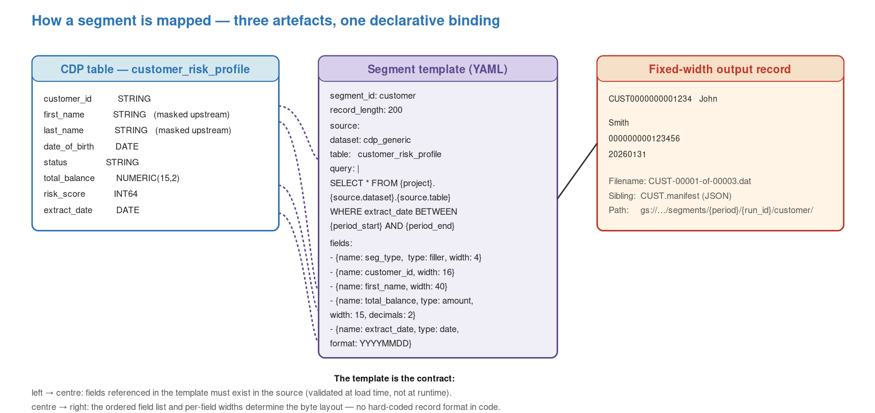
Figure 2 — Three-artefact binding: CDP table ↔ YAML template ↔ fixed-width output.

5.1 Adding a new segment — the end-to-end change
- Step 1 — Confirm the required CDP table is already published by the upstream framework and in the schema catalogue.
- Step 2 — Author a YAML template under config/segments/ — source query, field list with widths, output naming.
- Step 3 — Register the segment in the orchestrator's segment list — one row; no Python change.
- Step 4 — Run the extract DAG in a dev environment for the period; check the manifest matches expected row counts.
- Step 5 — Promote via Terraform. No Flex Template rebuild is required — only the YAML and the segment list change.

6. Scale and chunking
Chunking is the only way to produce mainframe-sized extracts within a useful window. The design uses four independent parallelism layers; none of them require changes when peeling off from the full stack.
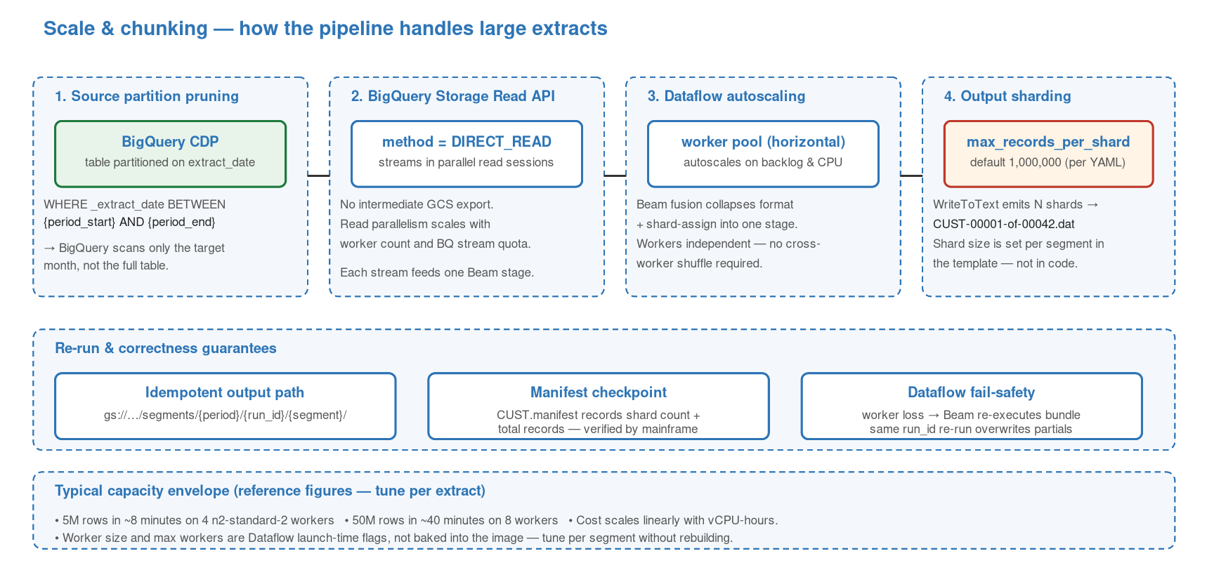
Figure 3 — Four parallelism layers handling large extracts.

6.1 The four layers
- Partition pruning — CDP tables are partitioned on extract_date; the template's WHERE clause scans only the target period.
- Storage Read API streams — DIRECT_READ creates parallel read sessions — no intermediate GCS export stage.
- Dataflow autoscaling — The Flex Template scales workers on backlog and CPU; fusion collapses format + shard-assign into one stage, eliminating cross-worker shuffle.
- Output sharding — max_records_per_shard (default 1,000,000) bounds each .dat file; the engine emits N shards plus one manifest.

6.2 Reference capacity envelope
Use these figures as a starting point only — always profile per segment and tune per reporting period. Worker size and max-workers are launch-time Dataflow flags, not baked into the image; tuning does not require a rebuild.
5M rows | ~8 minutes on 4 x n2-standard-2 workers.
50M rows | ~40 minutes on 8 workers.
Cost | scales linearly with vCPU-hours.
Shard size | default 1,000,000 records — set per segment in YAML.

6.3 Failure and re-run semantics
- Worker loss — Beam re-executes the affected bundle; no data loss.
- Same run_id re-run — Overwrites partial output atomically at the segment directory level.
- New run_id re-run — Produces a sibling directory; old run remains for reconciliation until retention pruning.
- Readiness replay — The readiness watcher can be re-armed for a period without reprocessing the mainframe pickup because the output path includes run_id.

7. Airflow orchestration
The orchestrator collapses to two DAGs plus the standard ops plane. The heavy lifting — transformation, formatting, sharding — is owned by the Dataflow Flex Template; Airflow only decides when to launch it and how to record progress.
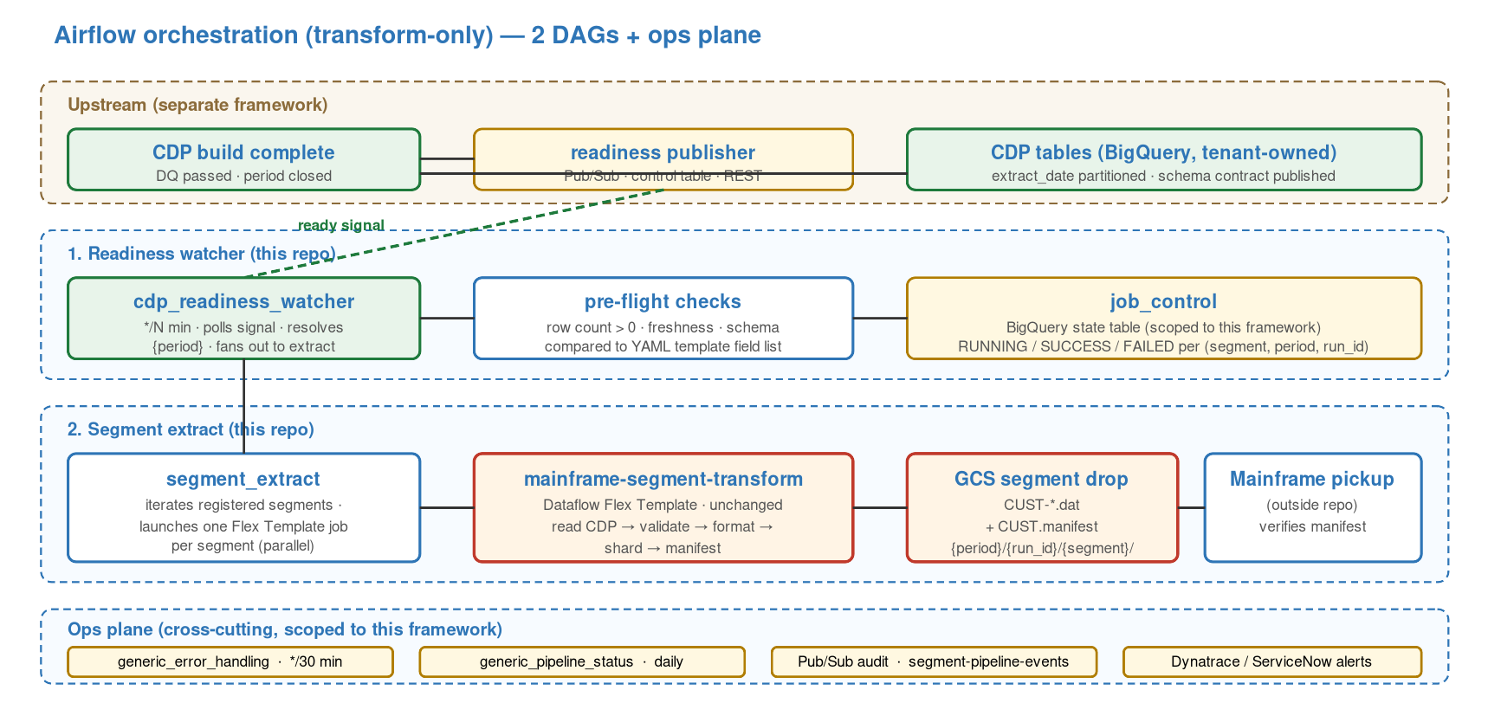
Figure 4 — Transform-only DAG topology.

7.1 DAG inventory
cdp_readiness_watcher | Sensor. Polls the readiness signal at short cadence. Resolves {period}. Runs pre-flight checks. On success, triggers segment_extract.
segment_extract | Iterates the registered segments. Launches one Dataflow Flex Template job per segment in parallel. Writes state to job_control.
generic_error_handling (ops) | Sweeps job_control every 30 minutes. Retries transient failures. Escalates persistent ones via Pub/Sub to ServiceNow.
generic_pipeline_status (ops) | Daily digest at 23:00 UTC. Summarises period coverage, shard counts, duration.
Pub/Sub audit (cross-cutting) | All state transitions published to segment-pipeline-events for downstream observability.

7.2 Why a watcher rather than a direct trigger
A polling watcher is preferred over having the upstream framework directly trigger a DAG run via REST. Three reasons. First, it keeps the two frameworks loosely coupled — the producer does not need credentials into this Airflow. Second, it allows the watcher to carry its own retry semantics independently of the producer. Third, it is trivially testable: replay a recorded signal into a dev environment and observe the downstream.

8. Deployment topology
The deployed footprint shrinks from eight components in the integrated stack to three in the transform-only architecture. Terraform for this repo no longer provisions ODP/FDP/CDP datasets, dbt service accounts, or ingestion Composer workers.
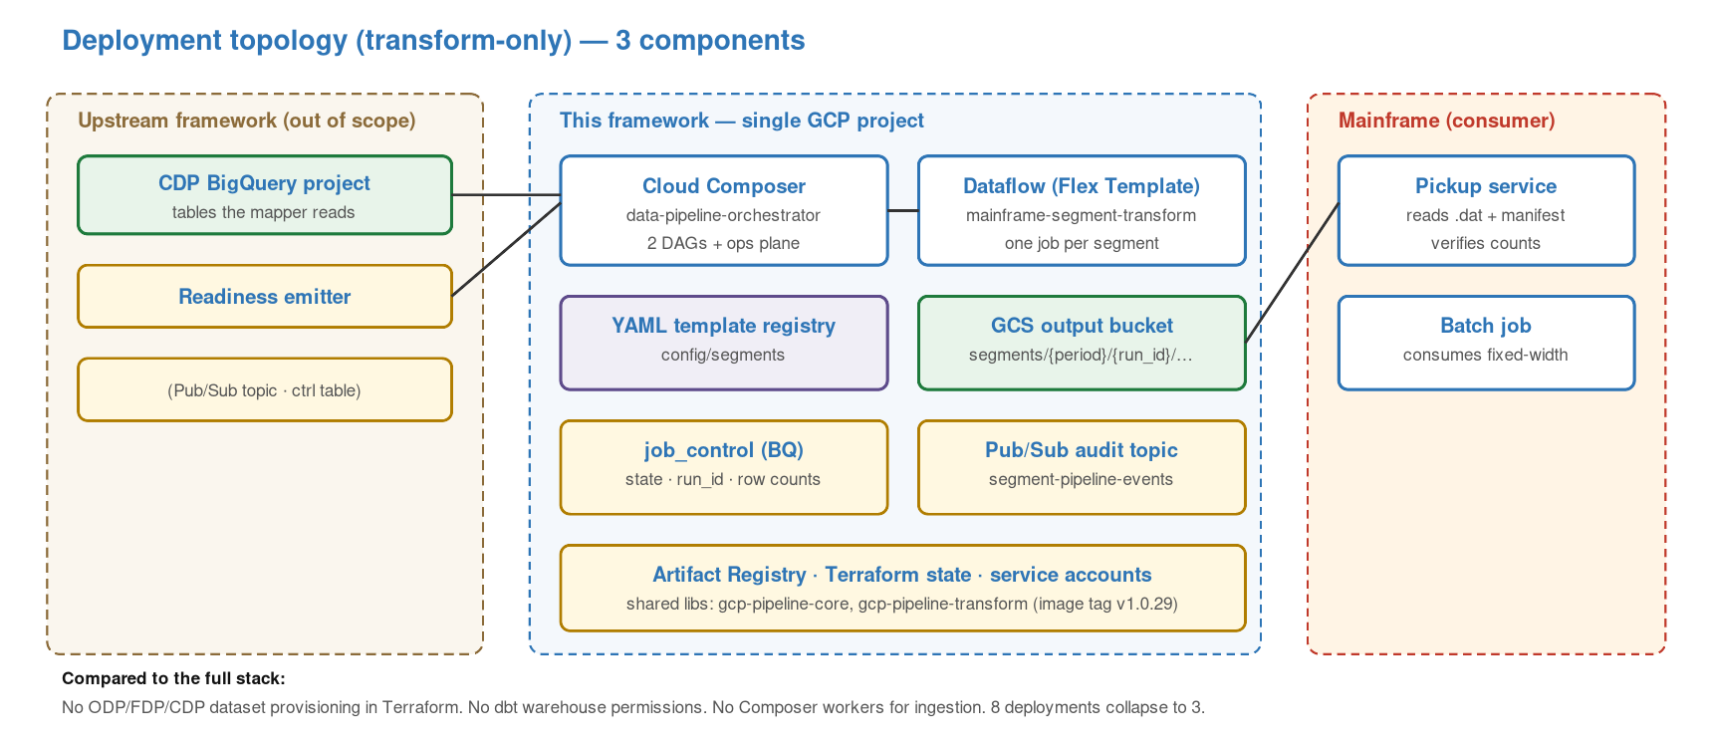
Figure 5 — Deployment topology (transform-only).

8.1 The three deployments
mainframe-segment-transform | Dataflow Flex Template image published to Artifact Registry. Pinned image tag. Built once, parameterised per segment at runtime.
data-pipeline-orchestrator | Cloud Composer environment hosting the two DAGs plus the ops plane. One environment per tenant.
Shared libraries | gcp-pipeline-core and gcp-pipeline-transform published as versioned Python packages; consumed by the Flex Template image and by the orchestrator.

8.2 What disappears from Terraform
- ODP, FDP datasets and the service accounts that write to them.
- dbt project permissions and the BigQuery roles for the dbt runner.
- Ingestion Pub/Sub topics and the Cloud Functions behind HDR/TRL validation.
- Four ingestion DAG environments and three FDP dbt DAG schedules.
- The cross-chain job_control table stays, but the column set shrinks to what this framework writes.

9. Integration with the producing framework
The integration surface between the two frameworks is narrow by design. Everything else is either implementation detail of the producer or implementation detail of this framework.
Contract artefact | A single README in docs/contracts/ naming the ready-signal topic (or table), the schema-catalogue location, and the CDP tables currently subscribed.
Runtime channel | Pub/Sub topic (preferred) or control-table row.
Schema channel | BigQuery INFORMATION_SCHEMA plus, optionally, dbt docs manifest.json from the producer.
Failure channel | Pub/Sub topic for unmet-precondition events; shared with the producer for observability.
Ownership | Contract document co-owned; signal topic owned by producer; watcher owned by this framework.

9.1 Contract versioning
The contract is versioned separately from both frameworks' source repositories. A version bump on the contract is a coordinated change: the producer must emit the new signal payload and this framework's watcher must parse it. Rolling forward is done by running both versions in parallel for one period, then retiring the old signal channel.

10. Quality attributes
Availability | Each framework owns its own SLO. This framework targets >99% successful extract per period.
Performance | Per-segment wall-clock latency from readiness signal to manifest publication is the headline SLI; drops out of the Dataflow job metric trivially.
Scalability | Horizontal via Dataflow autoscaling. Shard size tunable per segment without a rebuild.
Correctness | Manifest verification at the mainframe end provides end-to-end row-count reconciliation within this framework's boundary.
Observability | All state transitions audited to Pub/Sub. job_control exposes SUCCESS / RUNNING / FAILED per (segment, period, run_id). Dynatrace integration unchanged.
Security | PII assumed masked upstream; the schema contract names which fields are masked. Service accounts are workload-identity-bound; no long-lived keys.
Testability | YAML-driven; templates can be unit-tested without launching Dataflow via a template-validation test suite.
Portability | Framework is tenant-agnostic except for Terraform variable values; peeling into a new tenant requires no code change.

11. Key design decisions
Readiness signal over direct trigger | Loose coupling, independent retry, trivially testable.
Schema validation at load time | Fail fast before burning Dataflow minutes; drift is a contract issue, not a runtime issue.
Single Flex Template for all segments | One image, parameterised by YAML; eliminates per-segment image sprawl and rebuilds.
Pre-flight checks stay lightweight | Cheap row-count and partition sanity; DQ is the producer's responsibility.
job_control scoped to this framework | Not shared with upstream; reconciliation happens within each framework's boundary.
run_id baked into the output path | Makes re-runs safe without explicit cleanup; mainframe picks up by path convention.

12. Tradeoffs when decoupled from the full stack
- Lost end-to-end DQ gate — In the integrated stack the dbt-tests → reconcile → mark sequence gates the extract. Decoupled, DQ is the producer's problem. Mitigated by making readiness conditional on producer DQ passing and by running pre-flight checks here.
- Schema drift risk — The producer may change the CDP schema without coordinating. Mitigated by the contract document, schema validation at template load, and a period of signal co-existence during contract version bumps.
- Row-count reconciliation scope narrows — Today row counts propagate ODP → FDP → CDP → segment through job_control. Decoupled, this framework reconciles source-table count vs. sum-of-shard-manifest-counts — still meaningful but stops at the boundary.
- Two runbooks instead of one — Operations need to know which framework owns a given failure. Mitigated by the Pub/Sub audit and by scoping the failure channel explicitly in the contract.

13. Migration path from the integrated stack
For teams moving from the full reference pipeline to the transform-only shape, the migration is additive, staged and reversible.
- Step 1 — Publish a contract document describing the current signal (today implicit in the DAG chain) and the CDP schemas as-is.
- Step 2 — Stand up cdp_readiness_watcher alongside the existing CDP dbt DAG. Do not remove anything yet — both drive the same downstream extract.
- Step 3 — Move the Pub/Sub audit + error-handling DAGs into a scoped namespace for this framework.
- Step 4 — For one reporting period, drive extracts from the watcher only; compare shard and manifest outputs to the legacy run.
- Step 5 — Decommission the ingestion + FDP + CDP-dbt DAGs from this repo. They move to the upstream framework.
- Step 6 — Remove the out-of-scope Terraform assets (ODP/FDP datasets, dbt service accounts, ingestion Pub/Sub topics).
- Step 7 — Freeze the contract version. Any future schema change follows the contract versioning procedure.

14. Known limitations and roadmap
- Single-tenant mapping config — Segment list is baked per environment. A multi-tenant segment registry is on the roadmap.
- Schema validation is structural — Checks types and nullability; does not yet assert semantic rules (e.g., enum domains). dbt-style semantic contracts are planned.
- Watcher has no contract-version negotiation — It parses one signal shape today. Dual-parse support for contract version bumps is planned.
- Retention policy external — GCS lifecycle rules handle retention; there is no in-framework pruner.
- Replay UX is operational — Re-running a period requires an Airflow operator; there is no self-service replay endpoint.

Appendix A. Glossary
CDP | Consumable Data Product. Business-ready BigQuery tables. Owned by the upstream framework in this architecture.
Segment | A logical mainframe entity with a fixed-width byte layout (e.g., CUSTOMER, LOANS).
Readiness signal | The per-period message from the upstream framework declaring CDP is complete and DQ has passed.
Flex Template | Dataflow packaging unit — a container image plus launch metadata. Parameterised at launch time.
Manifest | JSON sibling file listing shards, record counts and hashes. Verified by the mainframe pickup.
run_id | Monotonically-unique identifier for an extract invocation; appears in GCS path for idempotency.
Shard | A single .dat file; each holds up to max_records_per_shard records. Several shards together make one segment.
job_control | BigQuery state table tracking extract progress per (segment, period, run_id).

Appendix B. Reference YAML template (illustrative)
segment_id: customer
record_length: 200
source:
project: {env.project_id}
dataset: cdp_generic
table: customer_risk_profile
schema:
customer_id: STRING NOT NULL
first_name: STRING NULLABLE
last_name: STRING NULLABLE
date_of_birth: DATE NOT NULL
total_balance: NUMERIC NOT NULL
extract_date: DATE NOT NULL PARTITION
query: |
SELECT * FROM {source.project}.{source.dataset}.{source.table}
WHERE extract_date BETWEEN {period_start} AND {period_end}
output:
bucket: {env.output_bucket}
path: segments/{period}/{run_id}/customer/
basename: CUST
max_records_per_shard: 1000000
manifest: true
fields:
- {name: seg_type, type: filler, width: 4, value: "CUST"}
- {name: customer_id, type: string, width: 16, pad: right}
- {name: first_name, type: string, width: 40, pad: right}
- {name: last_name, type: string, width: 40, pad: right}
- {name: date_of_birth, type: date, width: 8, format: YYYYMMDD}
- {name: total_balance, type: amount, width: 15, decimals: 2}
- {name: extract_date, type: date, width: 8, format: YYYYMMDD}

Generated architecture reference — Transform-Only variant. Maintain under docs/architecture/ alongside the integrated-stack doc.

