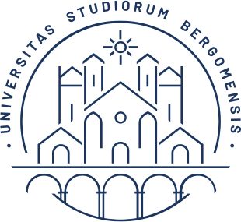

UNIVERSITY OF BERGAMO

School of Doctoral Studies

Doctoral Degree in Engineering and Applied Sciences

XXXII° Cycle

SSD: ING-INF/05

**Protecting Resources and Regulating Access  
in Centralized and Decentralized Cloud Systems**

*– short summary –*

Advisor

Prof. Stefano Paraboschi

Doctoral Thesis

Enrico BACIS

Student ID 1006904

Academic year 2018/2019