timeStamp

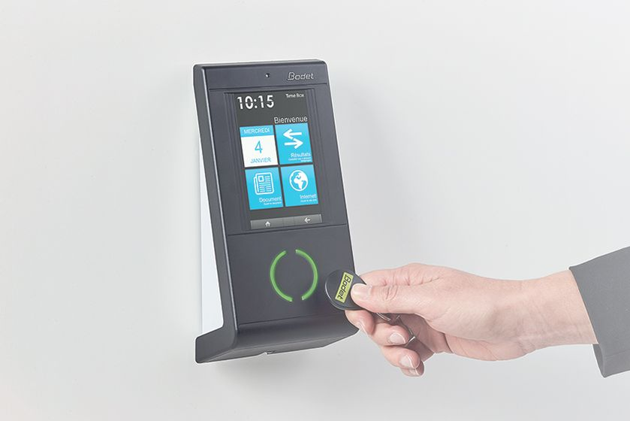

Autor: Enrico Cirignaco

Starts Project: 20.11.2019

Version: 0.1

Abstract: This device is intended to be used for time stamping in the company just by pressing a button or sliding a badge. It avoid waste of time while waiting for the Windows machine to boot up.

Summary

1 Introduction 3

2 Concept 3

3 Main Part 3

3.1 Software 3

3.2 Hardware 3

3.2.1 Microcontroller 3

3.2.2 IR Receiver - Transmitter 3

3.2.3 Pairing Button 4

3.2.4 9V Battery 4

3.2.5 Schema 4

3.3 Software 4

3.3.1 Sleep Mode 4

3.3.2 EEPROM 4

3.3.3 IOs 5

4 Testing 5

5 Costs 5

# Introduction

Since November 2019 the employees are not able anymore to time stamp with a badge or the previously used key. Time stamping now can just be done through a web-app on a PC with internet connection. This practice waste a lot of time and stress the employees that have to rush to their workstation to turn on their PC.

# Concept

A button connected to a GPIO of a Raspberry could simulate mouse and keyboard to access the “time.company_name.ch” website and stamp.

On startup the internet browser should start and get ready for time stamping.

With future iterations could the button be replaced with an RFID reader so that security could be improved.

# Main Part

## Concept

The idea is that the terminal is setting up to open automatically on startup and the main script “timetool.sh” is automatically executed every time that the terminal is opened. So that the main script is executed by the pi user every time the system boot up.

## Software

### Xdotool

With this tool keyboard and mouse actions can be simulated with simple BASH commands. The mouse cursor can be moved by entering the X-Y coordinates and there are specific commands for left and right click. That’s all what is needed for this projekt.

### Open LXTerminal at startup

In order to automatically get the device ready for time stamping on system startup we need to open LXTerminal on startup. This is achieved by adding the “autostart” file that come with this documentation to the “config” folder of the user. In this case “/home/pi/.config/”. In the autostart file there are just a few instructions to open the LXTerminal after boot.

### Bashrc configuration

Action(scripts) that need to be done every time after a bash terminal is opened can be written in the bashrc file situated in the home directory (/home/pi/.bashrc).

So the bashrc file need to be opened and the bash script that come with this documentation need to me run here (attention! Write global path!).

After the system is booted up and the Terminal is automatically opened and the script will automatically run.

### Bash script

This script is executed just once when the terminal is opened. Firstly chromium browser is opened to the page “http:time.company_name.ch” in full-size window. Then the endless loop starts. Here the program just waits for the GPIO 7 to go low (button pressed). Then the mouse cursor is moved on the “Login” button, is clicked, then the script wait X seconds to be sure that the new webpage is loaded. Then the cursor is moved again, on the timestamp button and clicked another time. Afterwards the script start waiting for the button to be pressed again.

### 9V Battery

The device will be powered by a 9V Battery. The battery must be connected to the RAW pin of the Arduino. This is the only pin that support Voltage above 3.3V.

### Schema



## Software

The program is very simple. As long as the Huge Red Button stay pressed the signal will be sent. To enter pairing mode and register a new signal the Huge Red Button and the pairing button must be pressed at the same time. The System stay in pairing mode until a signal is read by the IR-sensor.

### Sleep Mode

To minimize the power consumption the uC will be put to sleep when possible. Also, the Watchdog Timer can be turned off. The processor will wait for an Interrupt on a digital pin (connected with the Huge Red Button) for waking up. If all the tasks are done it will go to sleep again.

### EEPROM

After a new signal is registered, it’s important to save it on the EEPROM so if the device is turned off or restarted, the signal will not get lost. Before escaping pairing mode, the signal is saved in the EEPROM of the Arduino. On boot up in the setup section the signal will be loaded in the right variable.

### IOs

The two Buttons and the IR-boards are connected to the IOs of the Arduino. Also, the power supply of the two board is connected to the IOs. So, no ports are constantly connected to the power supply.

# Testing

After Assembling all the components together some test and a lot of debugging is done.

In the Table below is showed the current consumption in different scenario.

|  |  |  |  |
| --- | --- | --- | --- |
|  | Voltage (VDC) | Current (mA) | Power Consumption (uW) |
| Standby | 9.43 | 0.070 | 660.00 |
| Pressing HRB | 9.43 | 4.600 | 43400 |
| Pairing | 9.43 | 6.000 | 56580 |

Assuming that the system is powered with a 9v battery with 600mAh capacity the device can stay in standby for around 8.573 hours (357 days) after the battery need to be replaced.

# Costs

Here is an account of the costs for all the components needed to assembly the device.

|  |  |  |
| --- | --- | --- |
| Item | Cost in USD | Shop |
| Arduino Pro Mini (8Mhz) | 1.66 | [Aliexpress](https://www.aliexpress.com/item/1pcs-lot-Pro-Mini-Module-Atmega328-5V-16M-with-Arduino-Compatible-With-Nano/32672852945.html?spm=a2g0s.9042311.0.0.27424c4djZFdmN) |
| IR receiver Board | 0.69 | [Aliexpress](https://www.aliexpress.com/item/IR-Infrared-Transmitter-Module-IR-Digital-38KHz-Infrared-Receiver-Sensor-Module-Infrared-Sensor-Module-Electronic-Building/32917596830.html?spm=a2g0s.9042311.0.0.27424c4djZFdmN) |
| IR transmitter Board | 0.73 | [Aliexpress](https://www.aliexpress.com/item/IR-Infrared-Transmitter-Module-IR-Digital-38KHz-Infrared-Receiver-Sensor-Module-Infrared-Sensor-Module-Electronic-Building/32917596830.html?spm=a2g0s.9042311.0.0.27424c4djZFdmN) |
| 9V DC Battery Power Cable | 0.25 | [Aliexpress](https://www.aliexpress.com/item/9V-DC-Battery-Power-Cable-Plug-Clip-Barrel-Jack-Connector-for-Arduino-DIY-I-T-type/32828564174.html?spm=a2g0s.9042311.0.0.27424c4dLmonSd) |
| 9V Battery | 1.52 | [Aliexpress](https://www.aliexpress.com/item/New-6F22-PPP3-6lr61-9V-battery-Super-Heavy-Duty-Dry-Batteries-Non-Rechargeable-For-Radio-Camera/32934607716.html?spm=a2g0s.9042311.0.0.27424c4dLmonSd) |
| Huge Red Button | 1.60 | [Aliexpress](https://www.aliexpress.com/item/5-Colors-LED-Light-Lamp-60MM-Big-Round-Arcade-Video-Game-Player-Push-Button-Switch/32827197328.html?spm=a2g0s.9042311.0.0.27424c4djZFdmN) |
| Enclosure | - | - |

Time Stamping Button

Tutorial:

Copy script “timeTool.sh” to location “home/pi/Documents/bash/”

Copy “autostart” file to “home/pi/.config/lxsession/LXDE-pi/”

Open File home/pi/.bashrc

Insert @lxterminal

Save and close

Open Browser go to time.company_name.ch and login. When browser ask to save login credential click ok

Connect Hardware button between GND and GPIO 7

Reset Pi and you are ready to go