ID | IMG | DETT
0 |  | Class: Jet  Heading: 90  Importance: 3.0  Pilots: 2  Cabin Crew: 0  Staff: 2
1 | 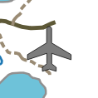 | Class: Biplane  Heading: 0  Importance: 1.0  Pilots: 3  Cabin Crew: 3  Staff: 6
2 | 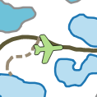 | Class: Jet  Heading: 85  Importance: 3.0  Pilots: 1  Cabin Crew: 1  Staff: 2
3 |  | Class: Jet  Heading: 95  Importance: 3.0  Pilots: 1  Cabin Crew: 1  Staff: 2
4 |  | Class: Jet  Heading: 90  Importance: 3.0  Pilots: 1  Cabin Crew: 0  Staff: 1
5 |  | Class: Biplane  Heading: 340  Importance: 1.0  Pilots: 3  Cabin Crew: 3  Staff: 6
6 |  | Class: Biplane  Heading: 300  Importance: 1.0  Pilots: 3  Cabin Crew: 2  Staff: 5
7 |  | Class: Biplane  Heading: 270  Importance: 1.0  Pilots: 3  Cabin Crew: 4  Staff: 7
8 |  | Class: Biplane  Heading: 240  Importance: 1.0  Pilots: 3  Cabin Crew: 2  Staff: 5
9 |  | Class: B52  Heading: 0  Importance: 10.0  Pilots: 2  Cabin Crew: 1  Staff: 3
10 | 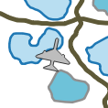 | Class: B52  Heading: 12  Importance: 10.0  Pilots: 1  Cabin Crew: 1  Staff: 2
11 | 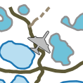 | Class: B52  Heading: 34  Importance: 10.0  Pilots: 2  Cabin Crew: 1  Staff: 3
12 | 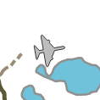 | Class: B52  Heading: 80  Importance: 10.0  Pilots: 2  Cabin Crew: 1  Staff: 3
13 |  | Class: Jet  Heading: 160  Importance: 4.0  Pilots: 2  Cabin Crew: 0  Staff: 2
14 |  | Class: Jet  Heading: 180  Importance: 3.0  Pilots: 1  Cabin Crew: 0  Staff: 1
15 | 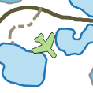 | Class: Jet  Heading: 140  Importance: 10.0  Pilots: 1  Cabin Crew: 1  Staff: 2
16 |  | Class: Jet  Heading: 100  Importance: 20.0  Pilots: 3  Cabin Crew: 0  Staff: 3

