IN MY AWESOME QGIS PROJECT…

THE CURRENT MAP CANVAS IS:    OR FOR A SPECIFIED LOCATION AND SCALE (5000): | BUT YOU CAN CAN GET IT AT A SPECIFIED SCALE (1:10000):  OR AT THE PROJECT EXTENT

The plugin provides to the template four variables populated with data from current project and related elements:
- globals information about project and current visualization on map canvas
- layers information about loaded layers
- features attributes and geometries about a specified vector layer
- layouts information about defined print layouts

globals variable
in the global variable are loaded general informations about the current project
project | The project object instance | 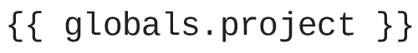 | {{ globals.project }}
canvas | The map canvas object instance | 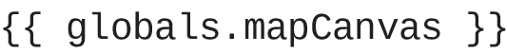  from where you can access all QgsMapCanvas API methods:  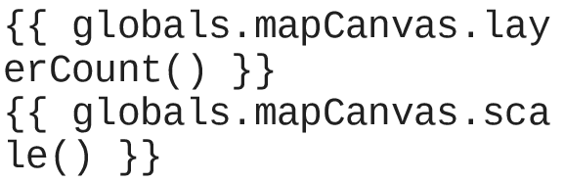 | {{ globals.mapCanvas }}  {{ globals.mapCanvas.layerCount() }}  {{ globals.mapCanvas.scale() }}
extent | The current map canvas extent | 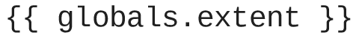 | {{ globals.extent }}
vars | A dictionary with the current global variables | 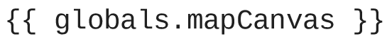 | {{ globals.vars }}

The map images have to be inserted with image filter using a image placeholder. The image tag have to be placed in name slot under option tab in image properties dialog:

image | A jinja2 filter to insert a map imagewith the following parameters:
  dpi | A integer number specifying the output resolution of the image (default = 200)
  extent | A extent object that specify the map context of the image
  center | A point object that specify the center of the map context of the image. To be used in conjunction with scale_denominator
  scale_denominator | A number specifiing the scale_denominator of the output image, for example 5000 for 1:5000
  theme | A string indicating a map canvas theme of representation
  around_border | A floating number representing the amount of a void border around the output image (default = 0.1)
  The image dimension on the paper is defined by a image pleceholder that will be replaced during document rendering.
  The tag has to be placed in name parameter under options slot of image properties
  the filter can be used with many parameters, even comma separated, in conjuntion each other.
  globals|image() | 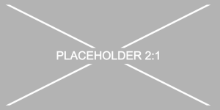
  globals|image(scale_denominator=20000) | 
  globals|image(dpi=600, scale_denominator=20000) | 

