Template tags have to be inserted in odt document as visual field: in LibreOffice Writer from the menu Insert > Fields > Other... (or just press Ctrl+F2), then click on the Functions tab and select Input field. Click Insert. A dialog will appear where you can insert the template tags following general jinja2 rules. Avoid inserting tags as regular text, this is not detected by template engine and may result in encoding error.

For example you can get the project variables list with the following instructions:

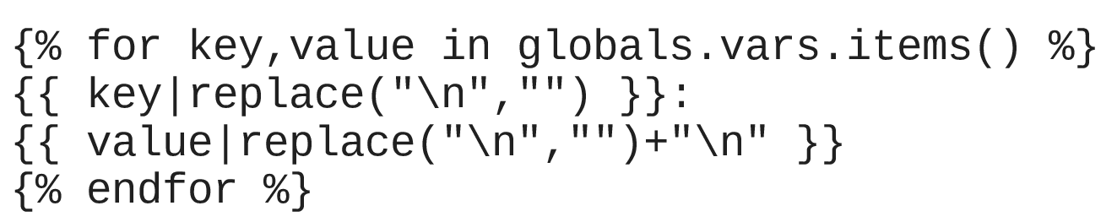

and this is the result:

{% for key,value in globals.vars.items() %} {{ key|replace("\n","") }}:
{{ value|replace("\n","")+"\n" }}{% endfor %}

