GLPI SAML SSO v1.3.0

Technical & Administrator Manual

1. Overview
The SAML SSO plugin allows GLPI to delegate authentication to external SAML 2.0 Identity Providers (IdPs) such as Microsoft Entra ID (Azure AD), Okta, Keycloak, or Ping Identity. It facilitates Just-In-Time (JIT) user provisioning, dynamic claim mapping for profile and group assignments, and strict cryptographic signature verification without requiring custom code. By routing authentication requests to verified IdPs, GLPI ensures a secure and unified single sign-on experience.

2. Installation & Upgrades
Installation via the GLPI Marketplace Administrators can easily install or update the plugin directly through the built-in marketplace.
- Log in to the GLPI console as a super administrator.
- Navigate to Setup and select Plugins.
- Click on the Marketplace tab.
- Search for the "GLPI SAML" plugin in the Discover tab, install, and activate it.
- For future updates, simply find the plugin under the Installed tab and click the Update icon.
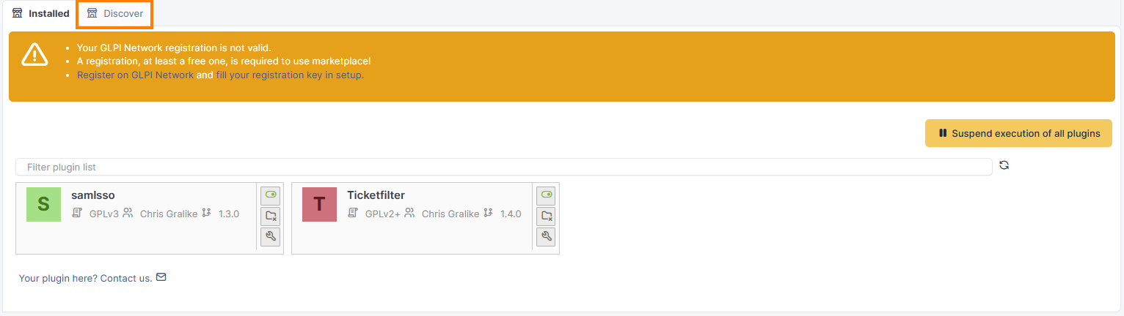
Teclib Hosted Environments (GLPI Network Cloud)
The SAML SSO plugin is officially supported by Teclib. Administrators running GLPI Network Cloud instances can review the official requirements and request its activation in hosted environments through their standard Teclib support channels.
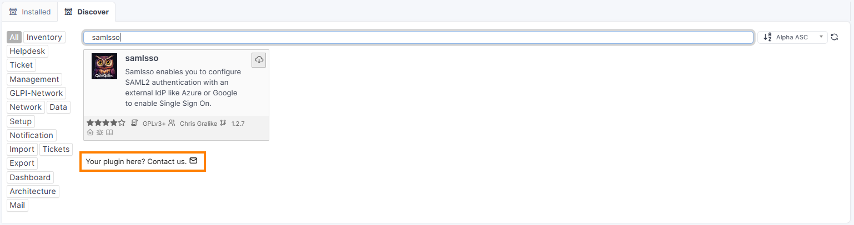
Manual Fresh Installation
Extract the plugin ZIP archive directly into your GLPI plugins directory under the subdirectory named samlsso. Log in to the GLPI console as a super administrator, navigate to Setup > Plugins, locate the SAML SSO plugin, and click Install to run database migrations. Finally, click Activate to enable the authentication routing.
Manual Upgrade
Replace all files inside the plugins/samlsso directory with the new package contents. Navigate to Setup > Plugins, click Upgrade to apply database modifications. The plugin will attempt to clear the GLPI cache but might not be successful. If you get unexpected results in the UI the old Twig template cache might still exist. You can clean it via the command line: php [glpi_root_path]/bin/console cache:clear.

3. Configuration Settings (Administrator Panel)

General Tab
The General tab allows you to configure basic profile identifiers. (See Image: GeneralTab.png)
- Friendly Name: A descriptive name to label the Identity Provider profile, which is highly useful in environments with multiple IdPs.
- Login Icon: Define the visual icon (e.g., FontAwesome fa-brands fa-microsoft) used on the login screen.
- Userdomain: Associates user login suffixes (e.g., quinquies.nl) with the SSO provider. Users entering user@domain.com will be automatically routed to the corresponding IdP, bypassing local password inputs.
- Comments: A field for administrative notes or external documentation links.
- Is Active: Toggles the authentication path on or off.
- Debug: Enables logging of raw SAML transactions. Keep this disabled in production to avoid logging sensitive user attributes in plaintext.
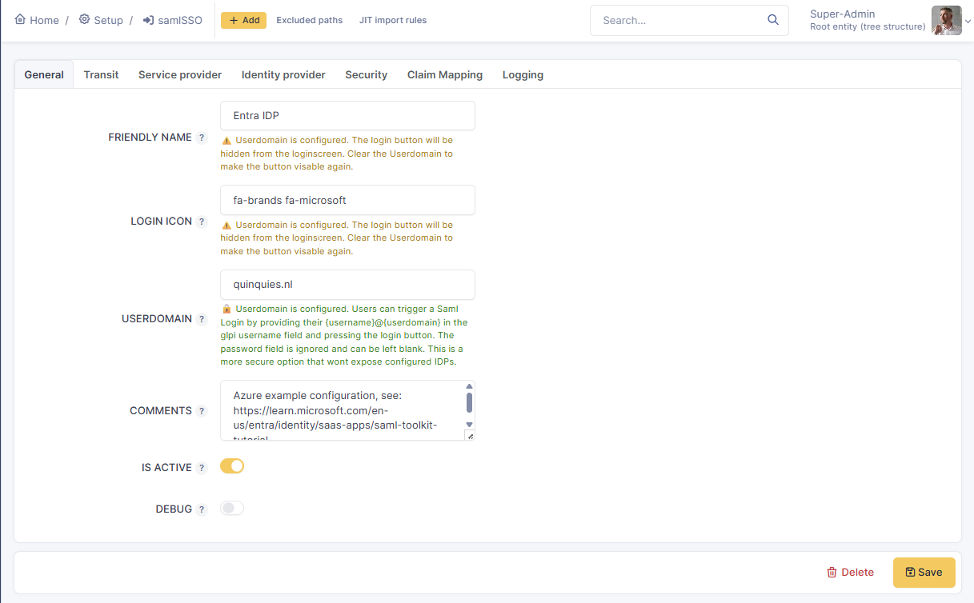

Transit Tab
The Transit tab manages how SAML requests and responses are transmitted and structurally validated. (See Image: TransitTab.png)
- Compress Requests / Responses: Instructs GLPI to compress outbound requests or decode compressed incoming responses (e.g., using deflate compression).
- Requests Proxied: Enable this when GLPI sits behind a reverse proxy or load balancer. It ensures X-Forwarded headers are interpreted correctly, preventing misaligned proxy schemes.
- Validate XML: Performs structural schema validation on incoming SAML XML responses to prevent XML injection attacks.
- Relax Dest Validation: If enabled, it relaxes the verification of the destination URL. Keeping it disabled (meaning validation is active) prevents assertion replay attacks.
- Lower Case Encoding: Enforces lowercase URL character encoding formatting on query strings, which is required for ADFS compatibility.
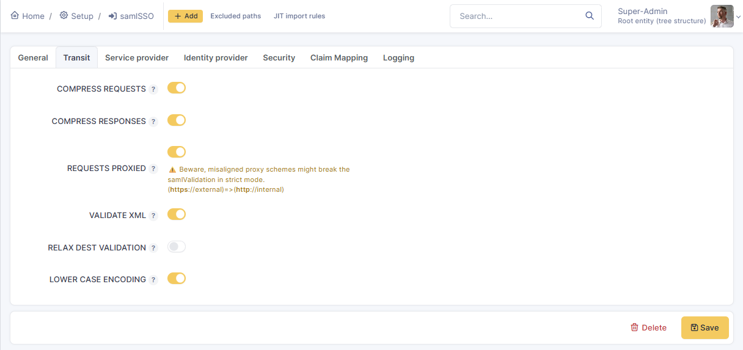

Service Provider (SP) Tab
The SP tab defines GLPI's internal identifiers and cryptographic certificates. (See Image: ServiceproviderTab.png)
- Entity ID, MetaUrl, AcsUrl & SloUrl: Unique identifiers and callback endpoints (such as the Assertion Consumer Service) for GLPI that must be registered in your external IdP. You can use the ‘copy to clipboard’ button to copy the string presented.
- SP Certificate & Private Key: The PEM-formatted X.509 key pair used by GLPI to sign outbound requests and decrypt incoming assertions.
- NameID Format: Defines the requested identifier format (e.g., Email Address) expected for user tracking.
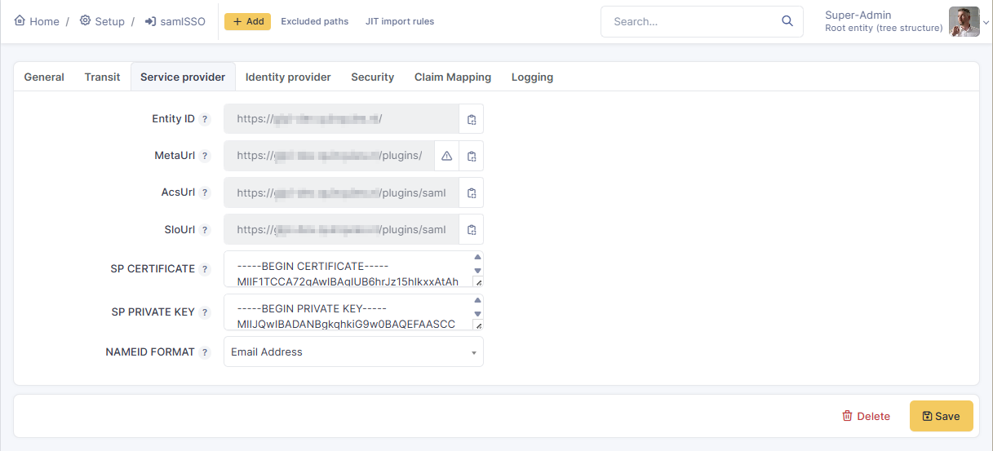

Identity Provider (IdP) Tab
This tab holds the external provider's configuration targets. (See Image: IdentityProviderTab.png)
- Entity ID, SSO URL & SLO URL: The unique identifier and authentication endpoints extracted directly from your external IdP's metadata.
- X509 Certificate: The public certificate generated by the IdP, used to cryptographically verify incoming SAML response signatures.
- Req AuthN Context & AuthN Comparison: Used to request specific authentication context classes (like PasswordProtectedTransport) and define the strictness of the comparison method.
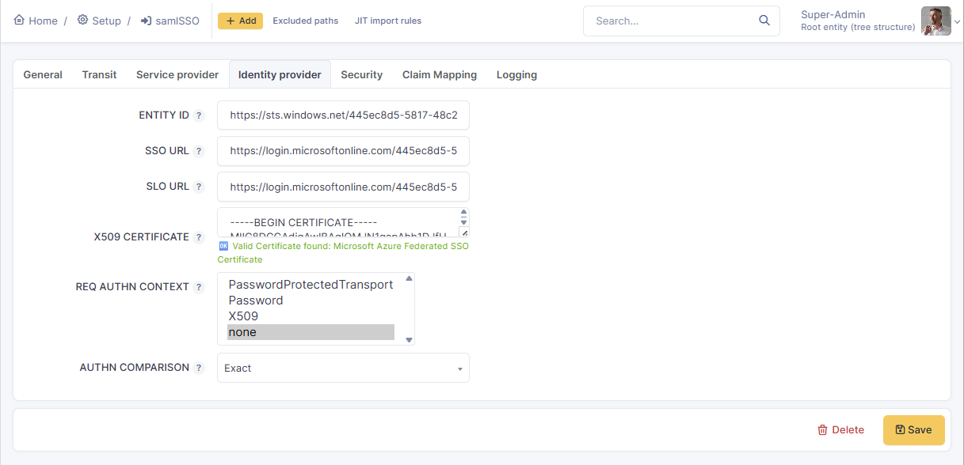

Security Tab
The Security tab houses critical toggles for enforcing SAML protocol strictness and system security parameters. (See Image: SecurityTab.png)
- Enforced: Routes all incoming login traffic to the SSO provider, entirely bypassing the standard GLPI login screen. Note: IDPs cannot be enforced if more than one is present in the list.
- Request Timeout (Minutes): Defines the allowed time window for a SAML request to remain valid (default is usually 15 minutes).
- Strict: Enforces strict signature verification, expiration validations, and issuer checks. Always keep this active in production to prevent attackers from forging assertions.
- JIT User Creation: Dynamically creates GLPI user profiles upon their first successful SSO login.
- Sync on Login: Synchronizes GLPI user properties and re-evaluates rights mapping rules upon every new login.
- Encrypt NameID: Enforces that the NameID element is encrypted.
- Sign AuthN Request: Mandates that outbound authentication requests sent by the SP are signed.
- Sign Logout Request / Response: Dictates whether outbound logout requests and responses must be cryptographically signed.
- Require Signed Messages & Assertions: Instructs GLPI to reject SAML response envelopes or individual assertions that lack valid cryptographic signatures.
- Require Encrypted Assertions: Mandates that incoming assertions must be strictly encrypted by the IdP.
- Sign SP Metadata: Signs the generated Service Provider Metadata file.
- Require NameID: Enforces the presence of the NameID element in the incoming SAML Response payload.
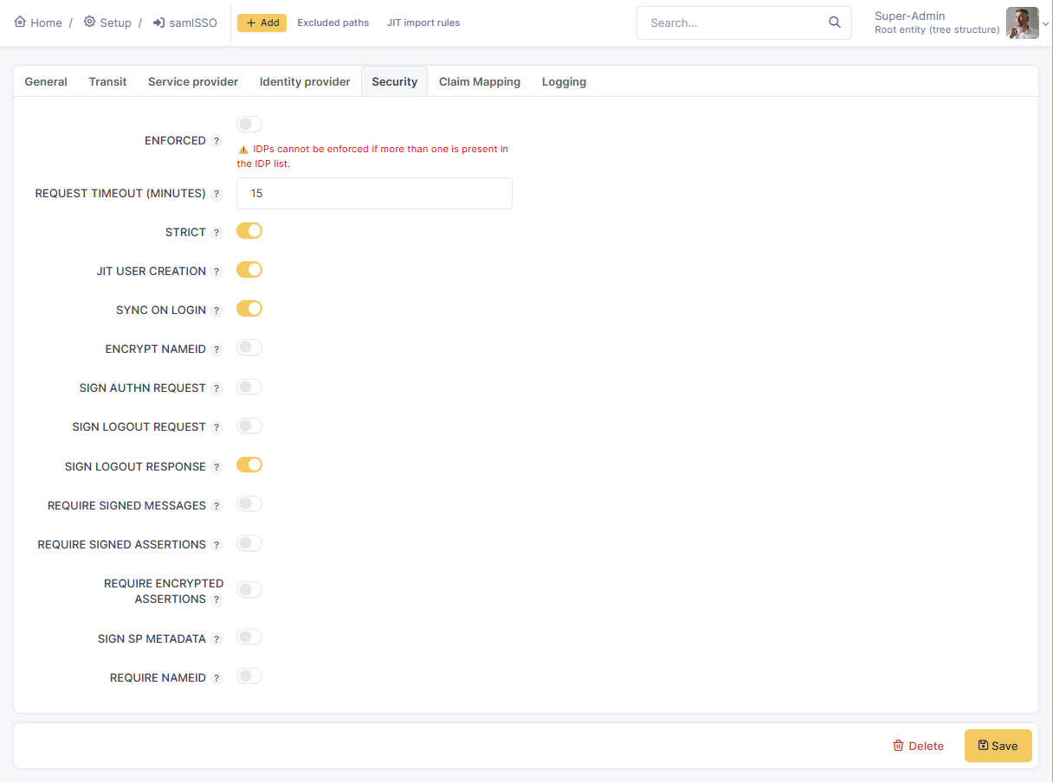

Claim Mapping & JIT Rules
Claim mapping connects SAML attributes sent by the IdP to internal GLPI fields and rules. (See Image: ClaimTab.png)
- Target Type & GLPI Target Field: Select whether an incoming SAML claim maps to a static User Field (e.g., Username, Email) or a Rule Field fed into the rules engine.
- SAML Response Claim Key: The exact XML attribute string returned by the IdP (e.g., http://schemas.xmlsoap.org/ws/2005/05/identity/claims/emailaddress) or just ‘emailaddress’ or what ever the claim key is set to by the IdP.
- Default Fallback Value & Required Flag: Sets fallback values or mandates the presence of specific claims.
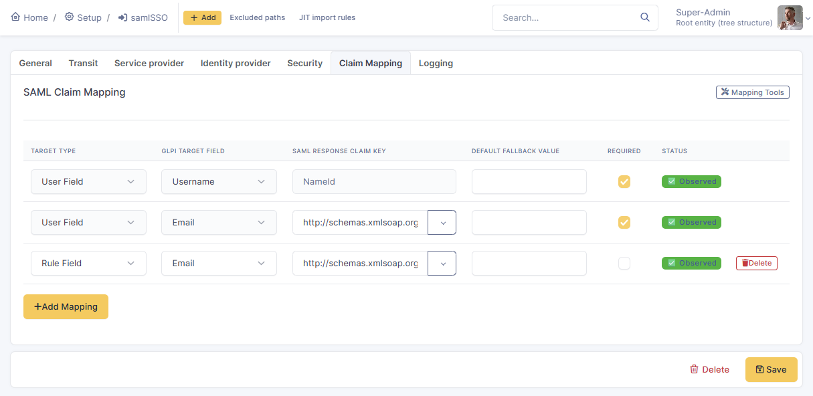
- JIT Import Rules: Found under Administration > Rules > JIT rules, these rules evaluate incoming claims (e.g., if the SAML Claim Email contains quinquies.nl) to automatically assign users to specific GLPI profiles or entities during onboarding.

4. Advanced Configuration: Excluded Paths & Automatic Actions
Excluded Paths (Bypasses) Administrators can configure exclusions to prevent SAML authentication checks from blocking backend API calls, cron jobs, or inventory uploads. By explicitly bypassing paths like /front/cron.php, apirest.php, or fusioninventory endpoints, automated systems remain functional without browser redirects.
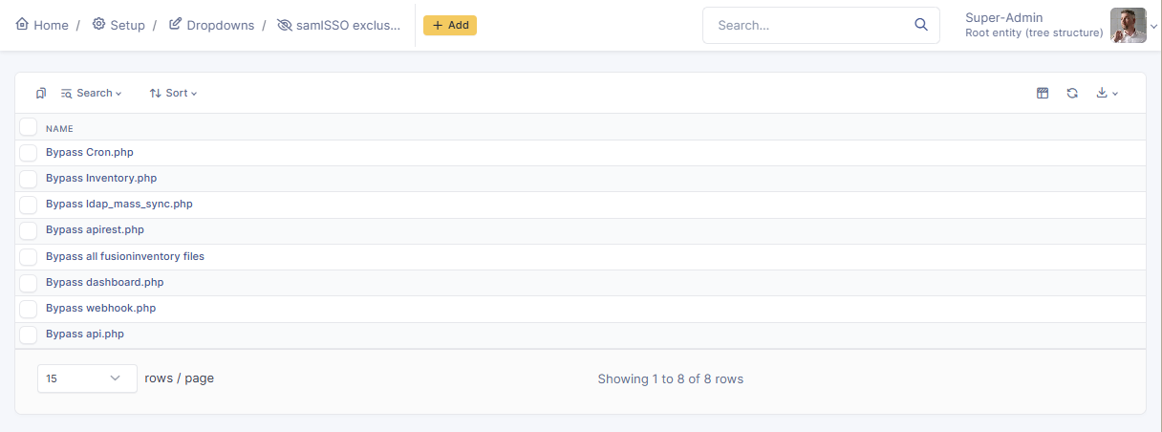
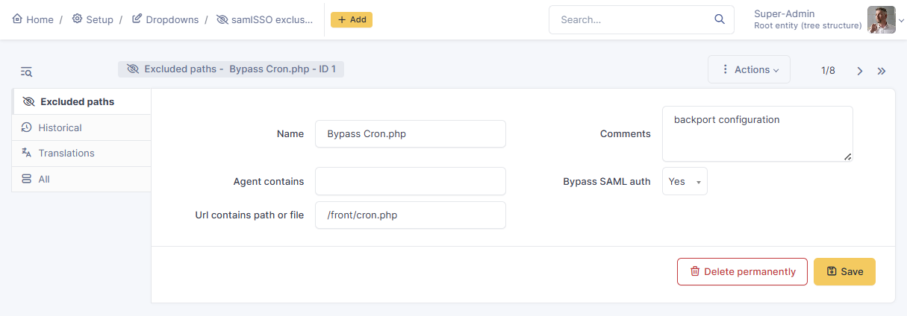
Automatic Actions The plugin automatically registers background tasks under Setup > Automatic actions. The routine task cleanSessionsSAML runs via the CLI to systematically clear out old and expired SAML sessions from the database, maintaining optimal performance and limiting session bloat.
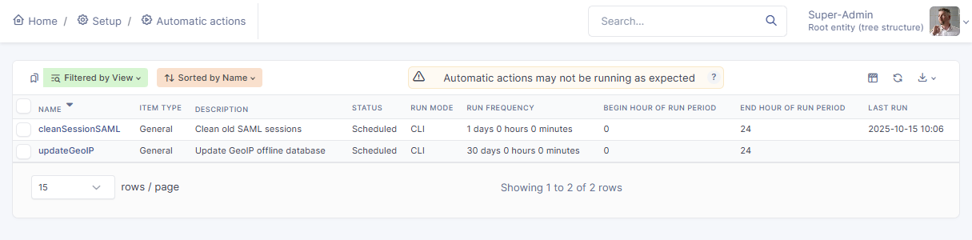

5. Major Identity Provider Scenarios
- Microsoft Entra ID (Azure AD): Create an Enterprise Application, select SAML, and input the GLPI Entity ID and ACS URL in the basic configuration fields. Map the Unique User Identifier to user.userprincipalname and download the Federation Metadata XML to configure GLPI's Identity Provider tab.

- Okta: Create a SAML 2.0 Web Application. Set the Single Sign-On URL to the GLPI ACS URL and the Audience URI to the GLPI Entity ID. Map specific attributes like user.email and pass group details dynamically using a regex filter such as .*.

- Keycloak: Create a new SAML client matching the GLPI Entity ID. Input the ACS URL, ensure the "Sign Assertions" toggle is enabled, and map user attributes (such as email, firstName, and lastName) inside the client mappers section.

6. Troubleshooting & Logging
The built-in Logging tab is an essential diagnostic tool that allows administrators to track authentication attempts, view the phases of a login flow (e.g., SAML ACS Expected, GLPI Authed, Forced Logoff), and force logoff active sessions when necessary.
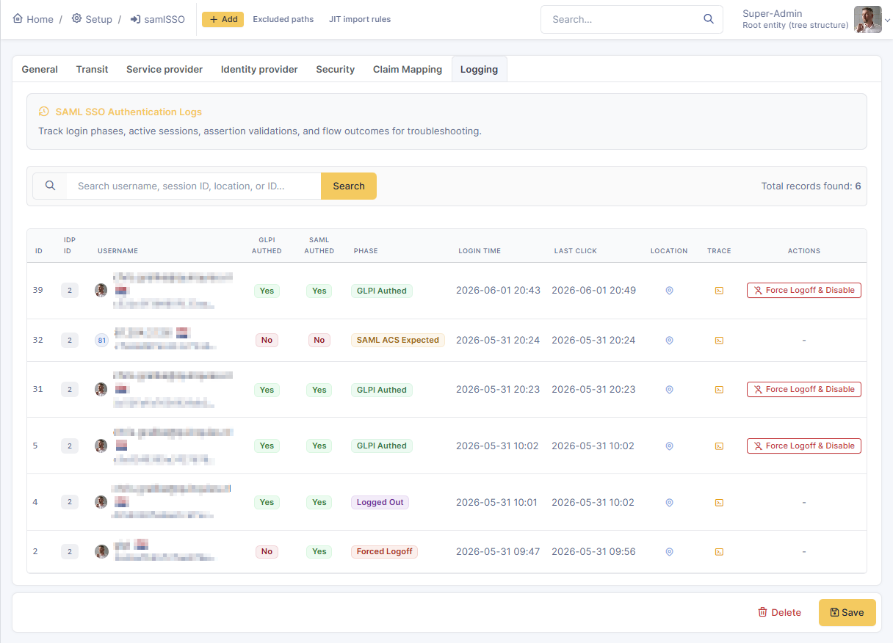
Common Error Conditions:
- SAML Response replay protection: A token was processed twice, typically caused by a user double-clicking the login button or excessively refreshing a redirect page.
- SP private key does not match certificate modulus: The cryptographic certificate and private key in the Service Provider tab do not form a valid pair. You must generate and apply a new pair simultaneously.
- This claim key has not been observed yet: A mapped claim key defined in GLPI is missing from the incoming SAML payload. Check your IdP's attribute export settings.
- Invalid XML response: Corrupted or incorrectly formatted response data. Verify IdP certificates, proxy logs, and network transport configurations.
- Destination validation failed: The destination URL specified by the IdP in the response does not match the actual ACS URL of GLPI. This is common when GLPI runs behind a reverse proxy; ensure the "Requests Proxied" toggle is enabled in the Transit tab to resolve this.

FIX Private key issues (service provider certificate):
The error "SP private key does not match certificate modulus" occurs when the public X.509 certificate and the private key entered in the Service Provider (SP) configuration tab do not belong to the same cryptographic pair. Because they are mismatched, the cryptographic verification fails, and GLPI cannot sign requests or decrypt incoming assertions.
To resolve this issue, you must generate a brand new self-signed X.509 certificate and private key pair, and then update both values inside the SP tab settings at the same time.

CLI Commands for Generating Certificates
For Linux / macOS / Windows (with OpenSSL installed) OpenSSL is the standard, cross-platform tool for generating the PEM-formatted certificates required by the SAML toolkit. Run the following command in your terminal or command prompt:
openssl req -new -newkey rsa:2048 -days 3650 -nodes -x509 -keyout sp_private.key -out sp_certificate.crt

- -newkey rsa:2048: Generates a new 2048-bit RSA private key.
- -days 3650: Makes the certificate valid for 10 years.
- -nodes: Prevents the private key from being encrypted with a passphrase (which is required so the GLPI plugin can read it automatically).
- Output: This will create two files (sp_private.key and sp_certificate.crt). Open these files in a text editor and paste their entire contents (including the -----BEGIN...----- and -----END...----- headers) into the respective fields in the SP tab.
For Windows (Native PowerShell Alternative) While OpenSSL is highly recommended (and available on Windows), administrators can technically generate a self-signed certificate using native PowerShell. However, exporting it to the required plaintext PEM format is complex and requires exporting to a .pfx file first. Therefore, it is strongly advised to install OpenSSL for Windows or use Windows Subsystem for Linux (WSL) to run the openssl command provided above.

Troubleshooting: Destination Validation Failed (SSL Offloading & Reverse Proxies)
When GLPI is deployed behind a reverse proxy or load balancer with SSL offloading—meaning the external connection is HTTPS, but the internal connection to the GLPI server is HTTP—it creates a "misaligned proxy scheme".
The underlying SAML toolkit strictly validates the Destination attribute within the incoming SAML response against the URL that GLPI registers at that moment. If the Identity Provider (IdP) sends the response to an https:// URL, but GLPI internally receives it over http://, the schemas will not match. This causes the destination validation to fail when Strict mode is enabled, subsequently blocking the login attempt for security reasons.
To resolve this issue, a combined configuration on both the GLPI plugin and your proxy server is required:
1. GLPI SAML SSO Plugin Configuration: Navigate to the Transit tab and enable the Requests Proxied toggle. The interface explicitly warns about this scenario: "Beware, misaligned proxy schemes might break the samlValidation in strict mode. (https://external)=>(http://internal)". Enabling this option instructs the SAML plugin to look for and interpret proxy headers rather than relying solely on the internal HTTP protocol.
2. Reverse Proxy Configuration (e.g., Apache or Nginx): Simply enabling the toggle in GLPI is not sufficient if the proxy server does not actively send the necessary headers. You must configure your server so that it is aware of its proxy role and returns the original requested URL. Specifically, ensure your Apache or Nginx configuration explicitly passes the X-Forwarded-Proto (set to https) and X-Forwarded-Port variables to the GLPI backend.
Once the reverse proxy forwards these headers and the plugin is configured to process them, GLPI will correctly interpret the original external URL scheme, and the Destination validation failed error will be resolved.

Technical documentation
The SAML Login Redirection Flow (Init)
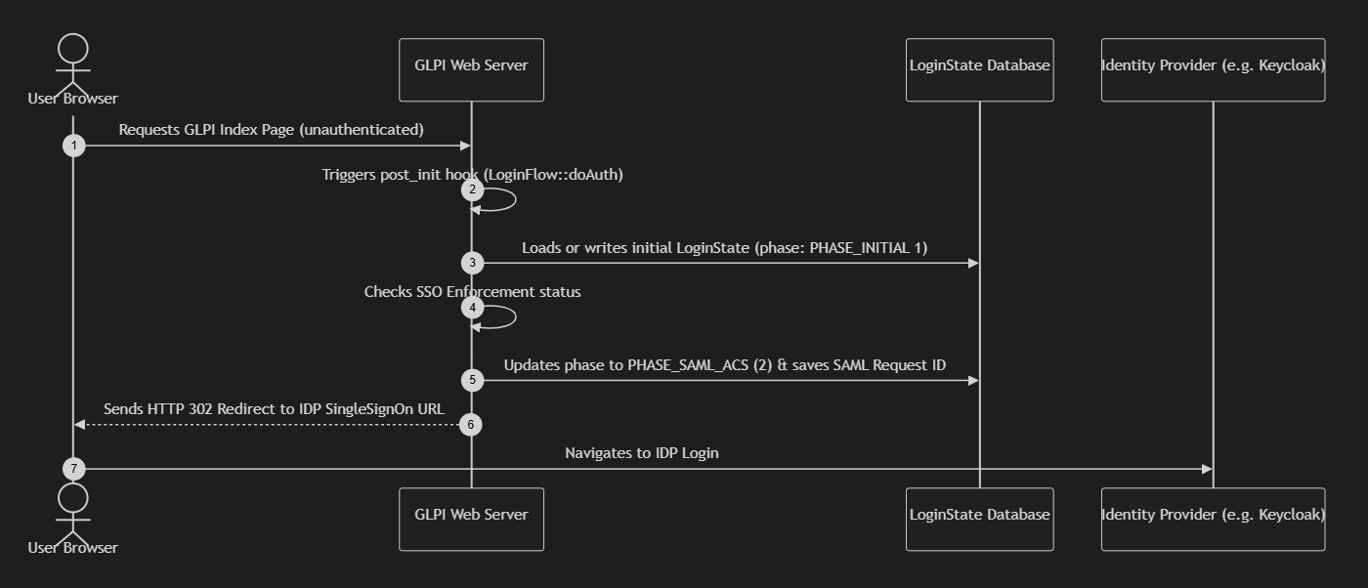
The Assertion Consumer Service (ACS) Flow
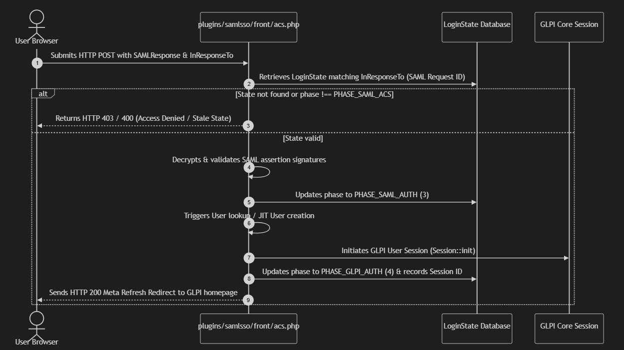
JIT userflow
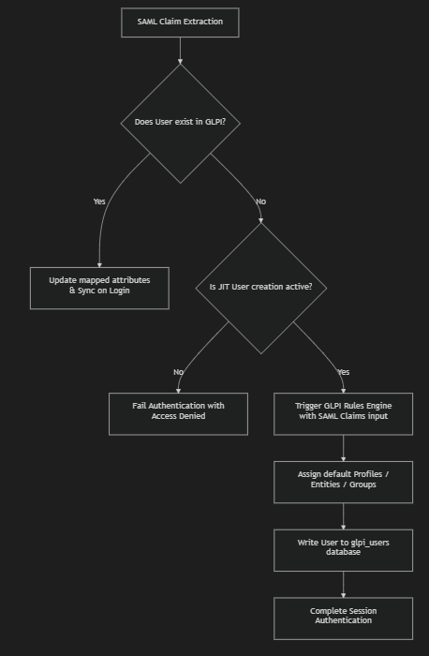
Plugin directory structure
plugins/samlsso/
├── config/ # Configuration files
├── docs/ # Architectural decision records (ADR)
├── src/
│ ├── ClaimMap.php # Parses assertion claims
│ ├── Config.php # Config DB interface wrappers
│ ├── Exclude.php # Route & User-Agent bypass validation
│ ├── GlpiAuth.php # Interface wrapper to GLPI Core Auth system
│ ├── LoginFlow.php # Coordinator of doAuth redirection checks
│ ├── LoginState.php # DB model tracking current session ID & authentication phase
│ ├── RuleSaml.php # Evaluates rules to match SAML roles to GLPI profiles
│ ├── Config/
│ │ ├── ConfigEntity.php # DB configuration loader & active parameters mapper
│ │ ├── ConfigForm.php # Handles saving / UI settings renderers
│ │ └── ConfigItem.php # Validator parameters logic helper
│ └── LoginFlow/
│ ├── Acs.php # Controller class verifying SAMLResponse payloads
│ └── LoginFlowForm.php# Renders SAML buttons on the GLPI login page
├── templates/ # Twig layouts (logout page, configurations)
├── tests/ # Automated unit test suite
├── hook.php # GLPI event handlers
└── setup.php # Plugin lifecycle installation definition

Plugin database schema
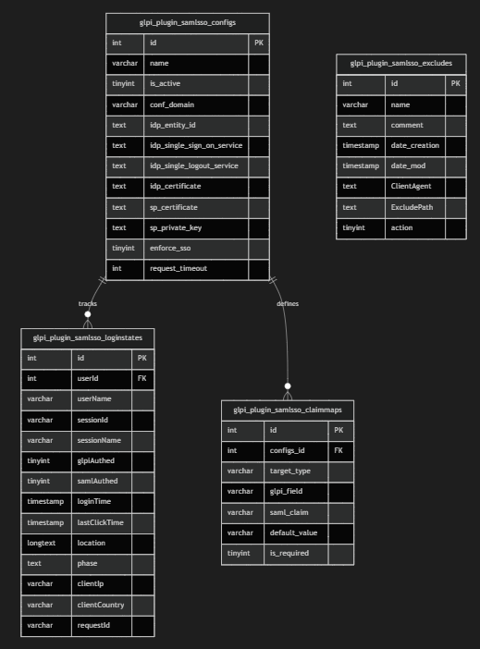
Table Descriptions & Purpose:
glpi_plugin_samlsso_configs: Stores the static configurations of each Identity Provider, metadata URLs, certificates, keys, and security preferences.
glpi_plugin_samlsso_loginstates: Tracks the transient security phases of the active request chain. Helps match incoming SAML responses with outgoing requests to prevent replay and session-fixation attacks.
glpi_plugin_samlsso_claimmaps: Persists mappings between SAML assertion claims and target GLPI user fields used during Just-In-Time (JIT) provisioning.
glpi_plugin_samlsso_excludes: Stores matching routes, URLs, and client user-agents that are configured to bypass the SAML authentication flow.
Plugin Object Model
The plugin's internal state machine coordinates configuration parameters with transient request validation using the following core classes:
ConfigEntity: Instantiated to load specific configuration parameters from glpi_plugin_samlsso_configs. Validates certificates and compiles settings into standard configuration profiles passed to the underlying php-saml library.
LoginState: Represents a row in glpi_plugin_samlsso_loginstates. Tracks properties like $phase (ranges from PHASE_INITIAL to PHASE_LOGOFF), client GeoIP address, request ID, and active PHP session details.
LoginFlow: Coordinator triggered by post-init boot processes. Directs routing logic by checking bypass variables, calling Exclude::isExcluded(), and starting the redirection flow.
Acs: Instantiated inside /front/acs.php to handle postback payloads. Uses the OneLogin library to process signatures, verifies InResponseTo against stored database states, and passes successfully mapped claims to GlpiAuth.

