DQN 20K ITER 256GAMES, LR=0.0003:
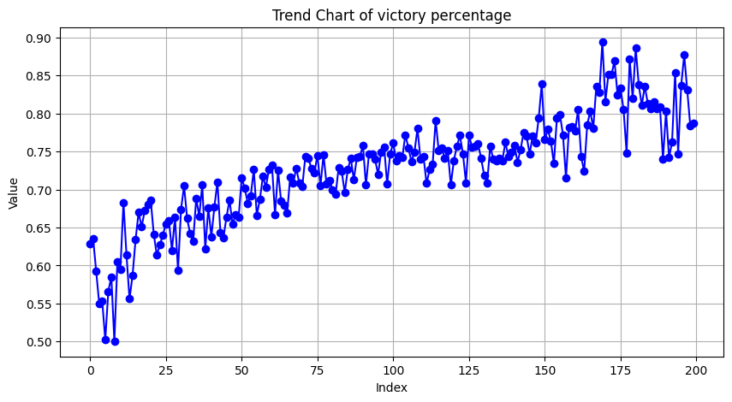
DQN 20K ITER 128 GAMES, LR=0.0003:
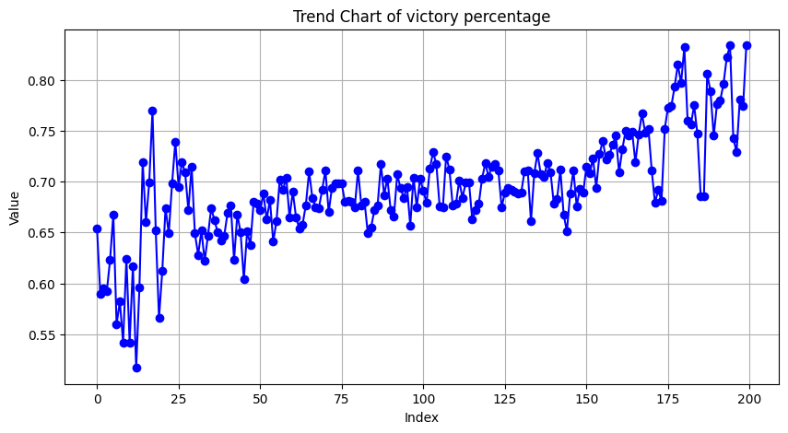
A2C 10K ITER 256 GAMES:
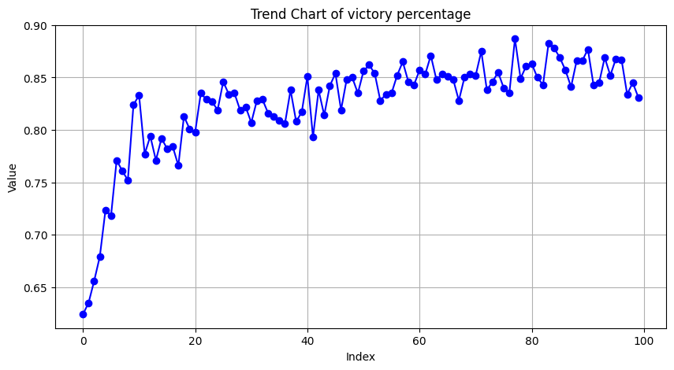
DoubleDQN 30K ITER 256 GAMES, LR=0.0003, SOFT UPDATE:
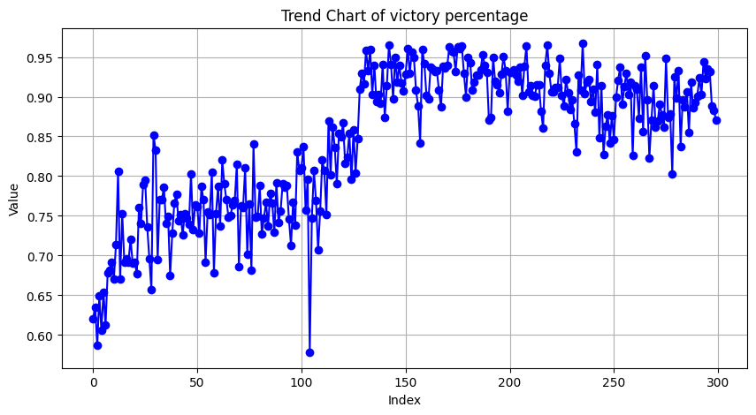
DoubleDQN 10K ITER 128 GAMES:
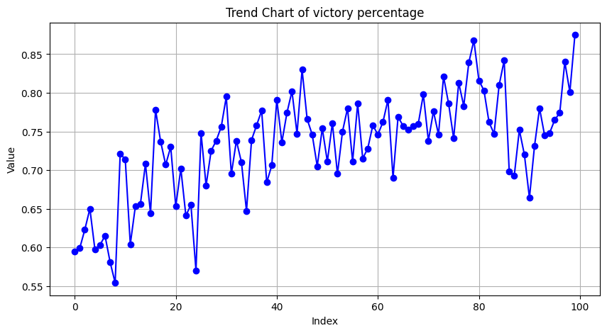
DQN 30K ITER 256 GAMES, LR=0.0003:
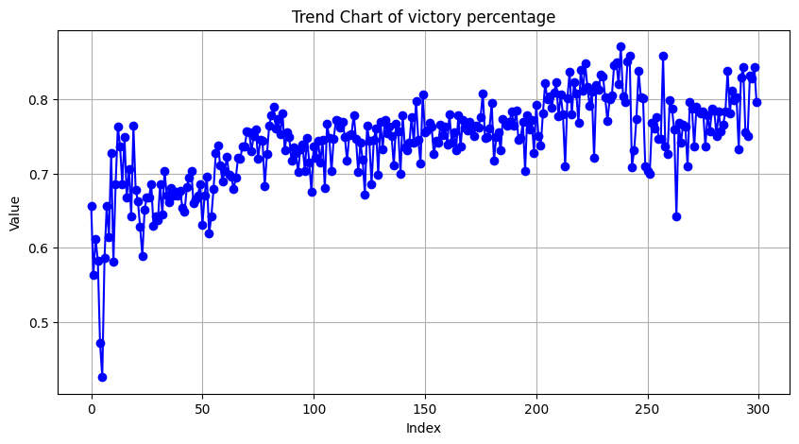
DQN 5K ITER 512 GAMES, LR=0.0003:
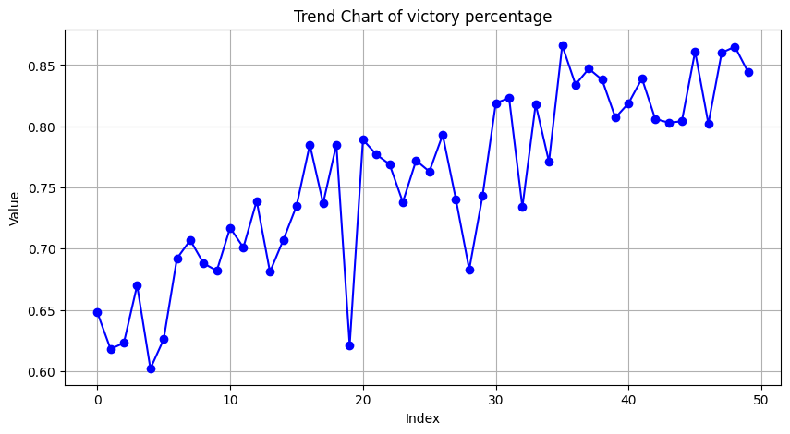
DQN 30K ITER 128 GAMES, LR=0.001:
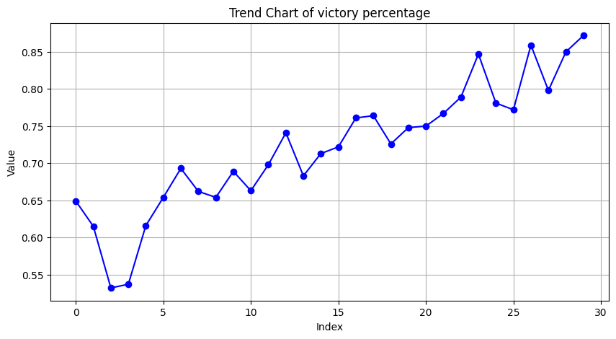
DQN 20K ITER 256 GAMES, LR=0.001:
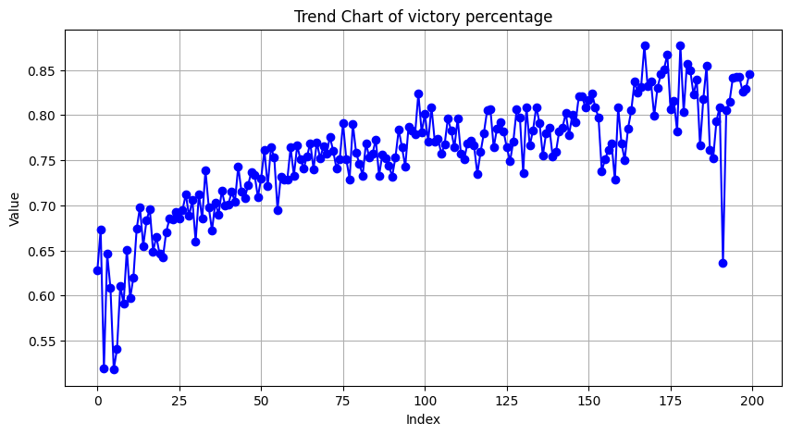
A2C 20K ITER, 256 GAMES:
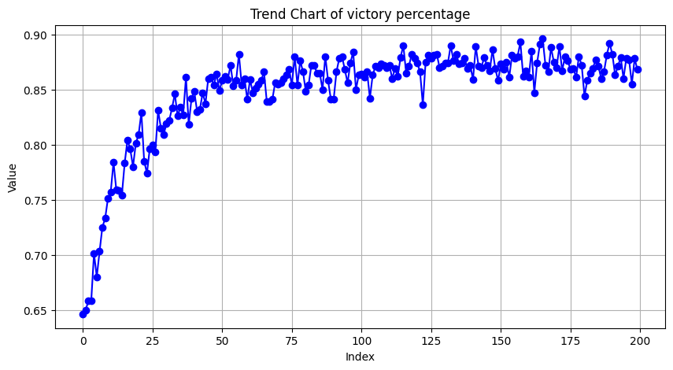
DQN 128 GAMES 5K ITER, LR=0.0001:
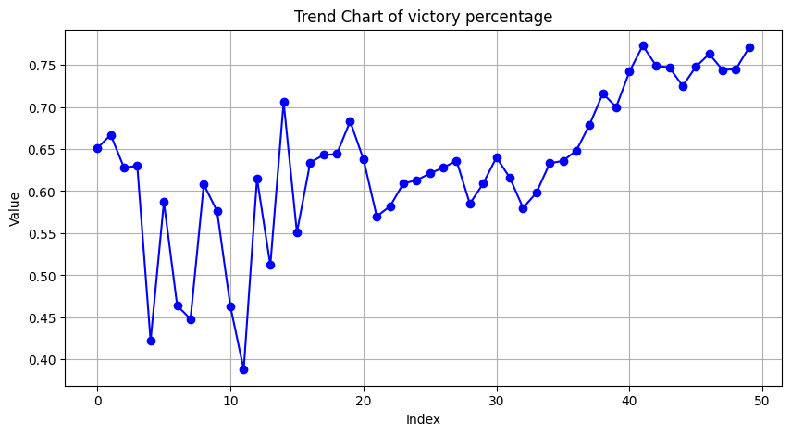
DQN 128 GAMES 50K ITER, LR=0.0001:
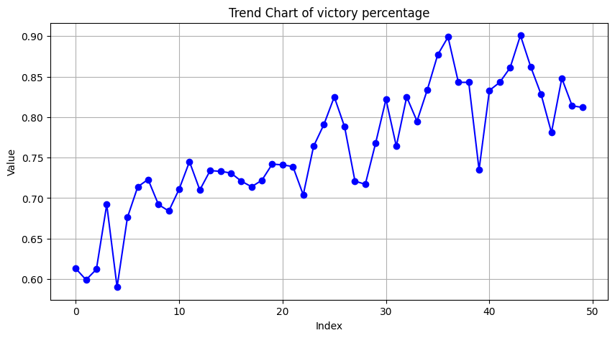
DQN 128 GAMES 20K ITER, LR=0.0003, EXP_RATE=exp_decreasing:
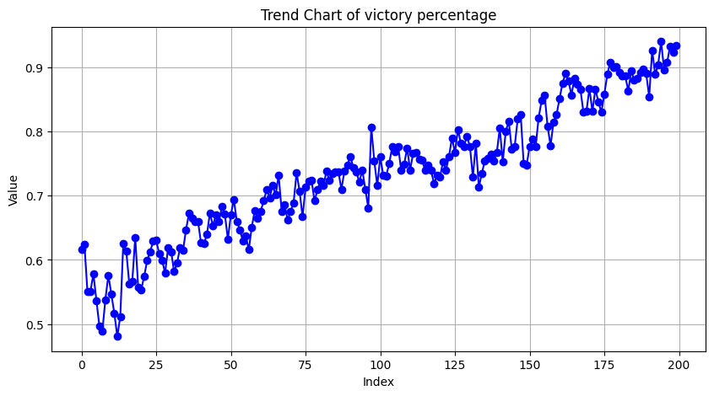
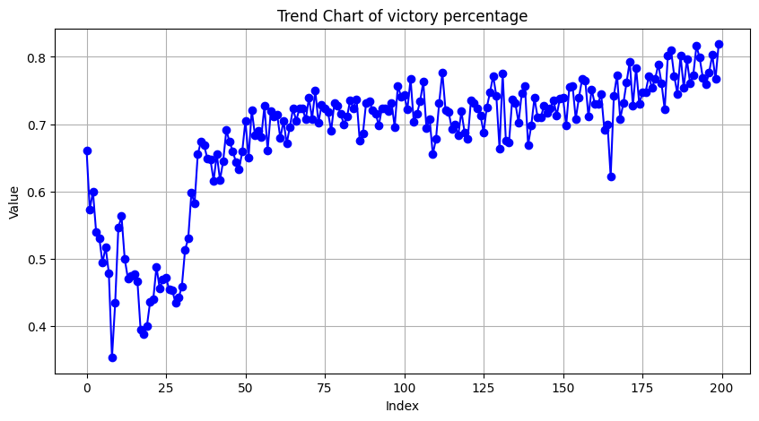
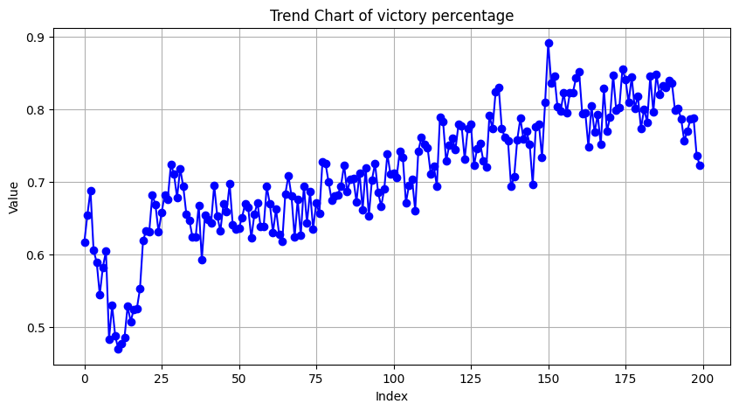
DoubleDQN 128 GAMES 20K ITER, LR=0.0003, EXP_RATE=exp_decreasing:
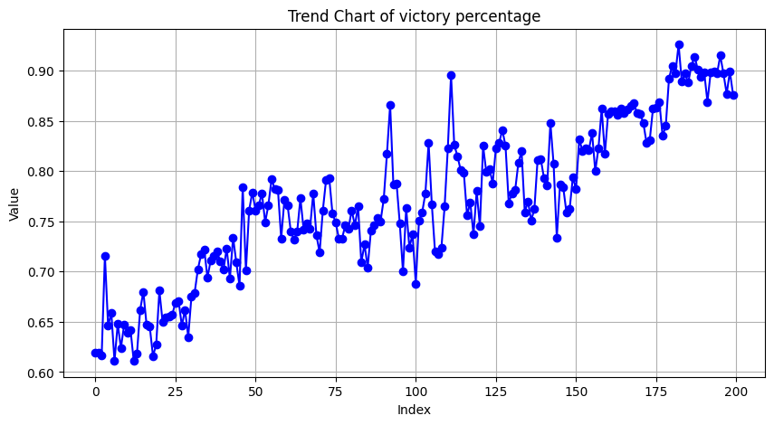
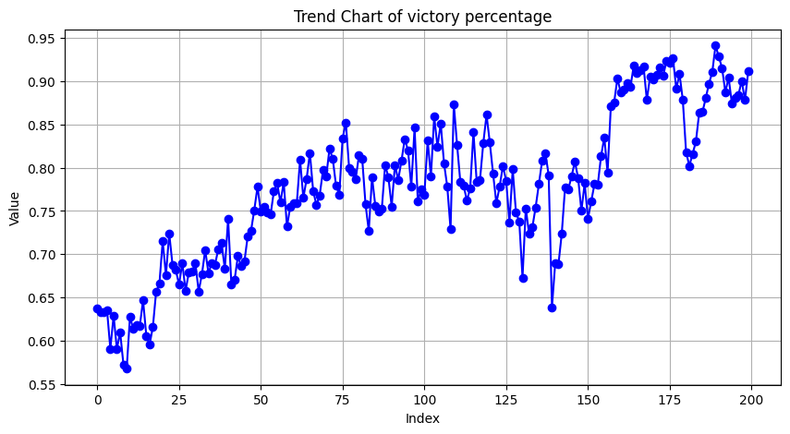
A2C 128 GAMES 10K ITER, fix sampling uniforme:
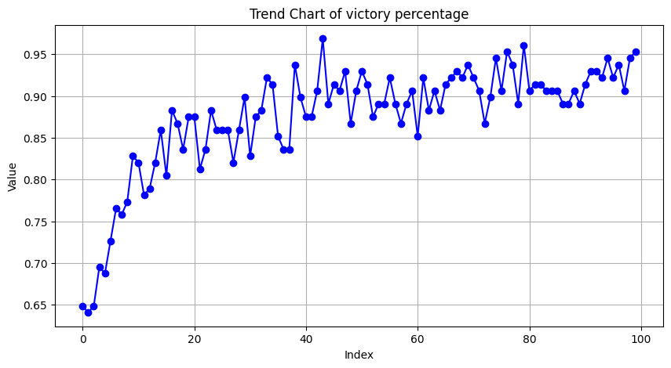
A2C 128 GAMES 40K ITER:
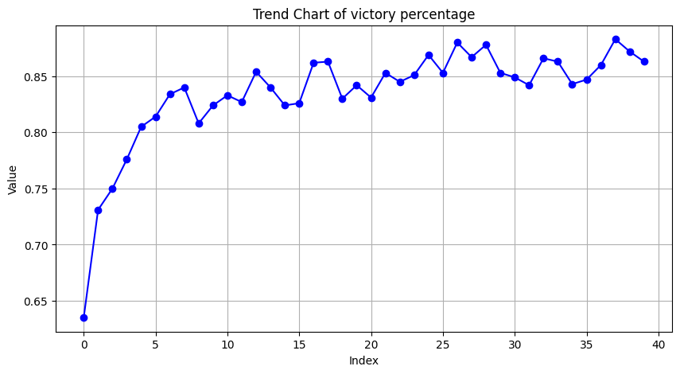

DQN 256 GAMES 50K ITER, LR=0.0003, NN=128/128 ReLu:
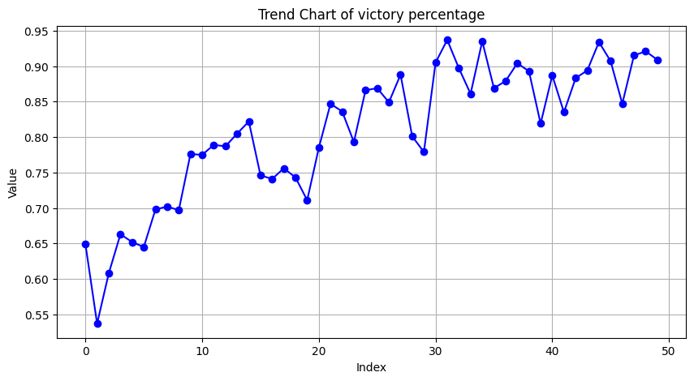
DQN 128 GAMES 100k ITER, LR=0.0003, NN=128/128 ReLu:
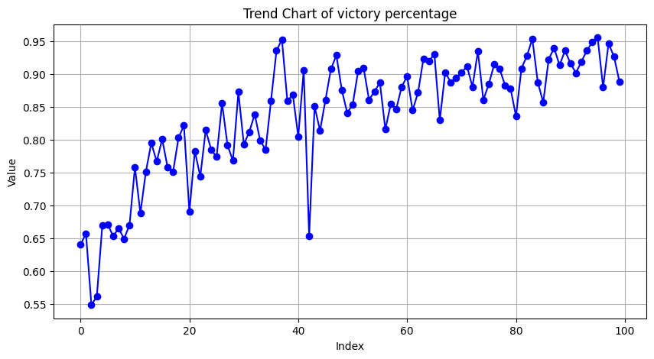
DQN 256 GAMES 100k ITER, LR=0.0003, NN=256/256 ReLu: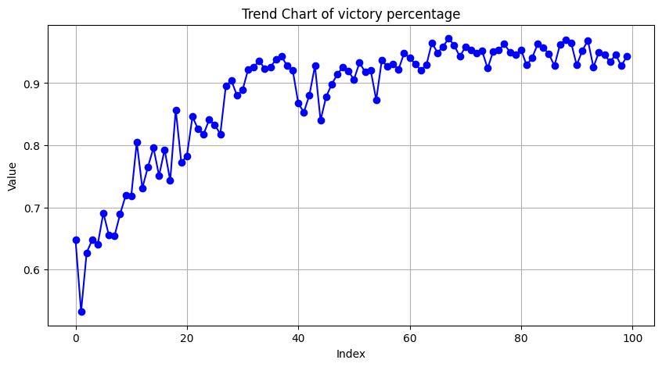
DQN 128 GAMES 150k ITER, LR=0.0003, NN=256/256 ReLu: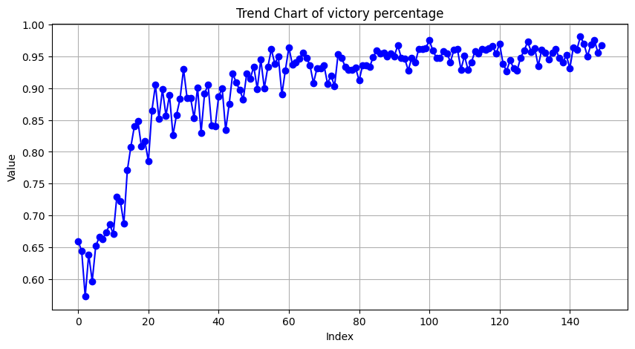
DoubleDQN 128 GAMES 150k ITER, LR=0.0003, NN=256/256 ReLu:
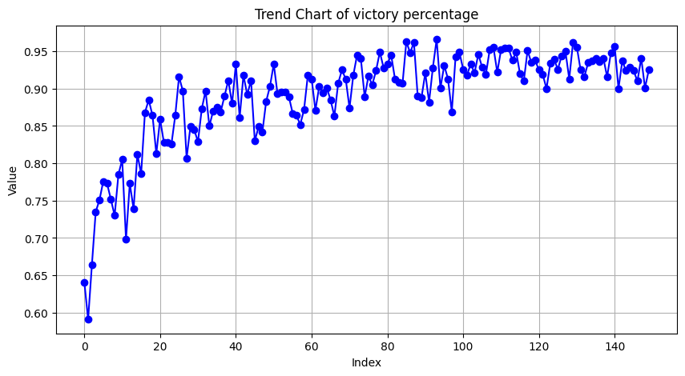
DoubleDQN 256 GAMES 100k ITER, LR=0.0003, NN=512/512 ReLu:
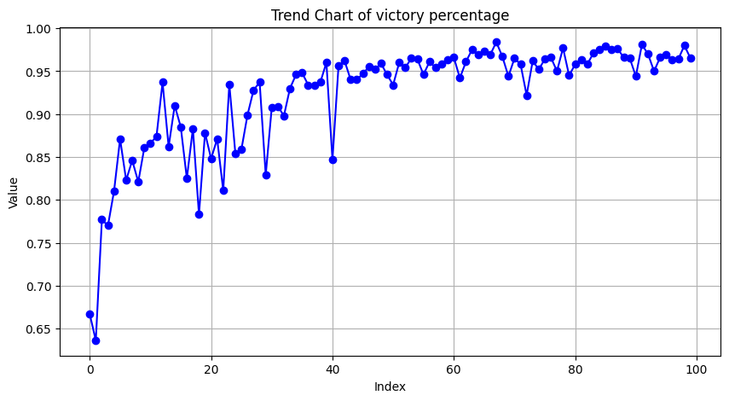
A2C 128 GAMES 150K ITER, LR=0.0001/0.001, NN=256/256 ReLu:
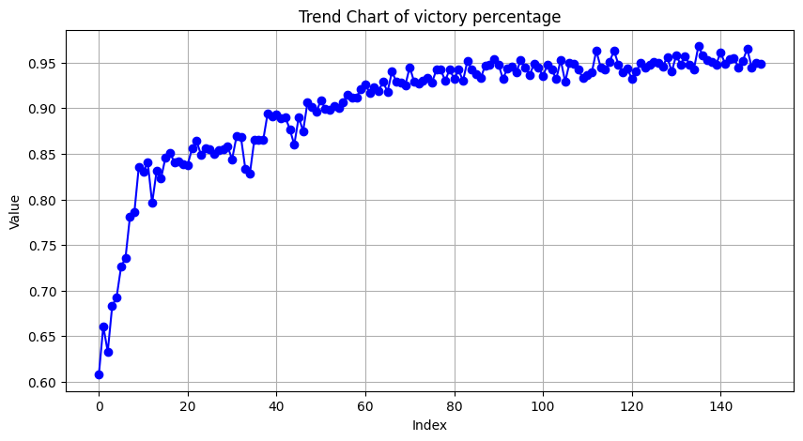
A2C 256 GAMES 100K ITER, LR=0.0001/0.001, NN=256/256 ReLu:
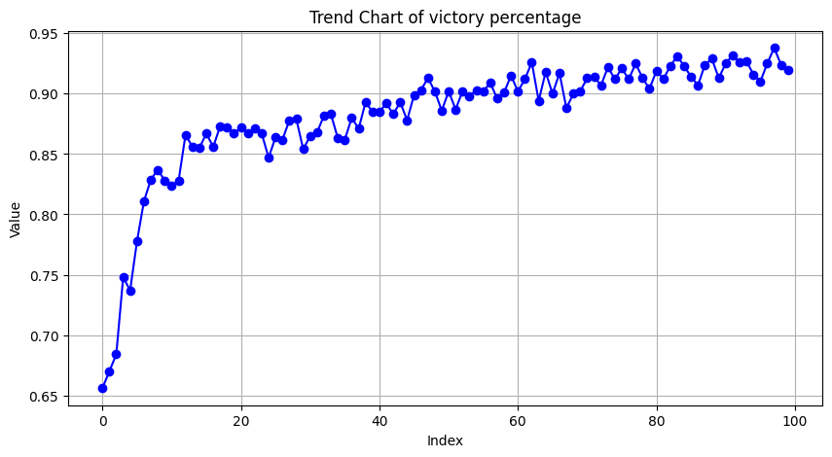
A2C 128 GAMES 150K ITER, LR=0.0001/0.001, NN=256/256 ReLu:

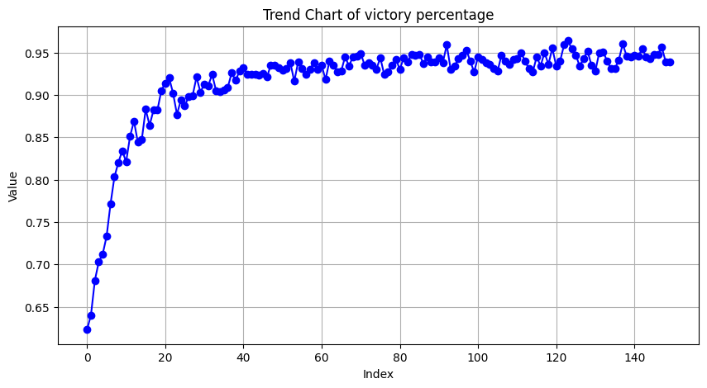
A2C 128 GAMES 300K ITER, LR=0.0001/0.001, NN=256/256 ReLu:

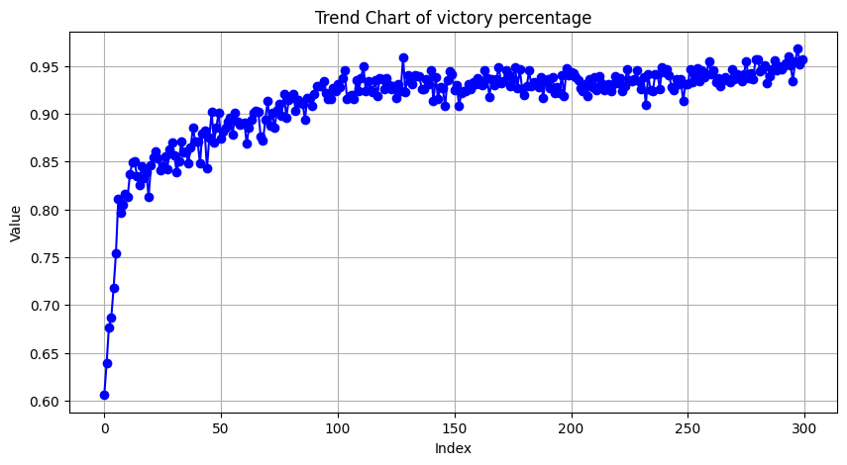
A2C 128 GAMES 600K ITER, LR=0.0001/0.001, NN=256/256 ReLu:
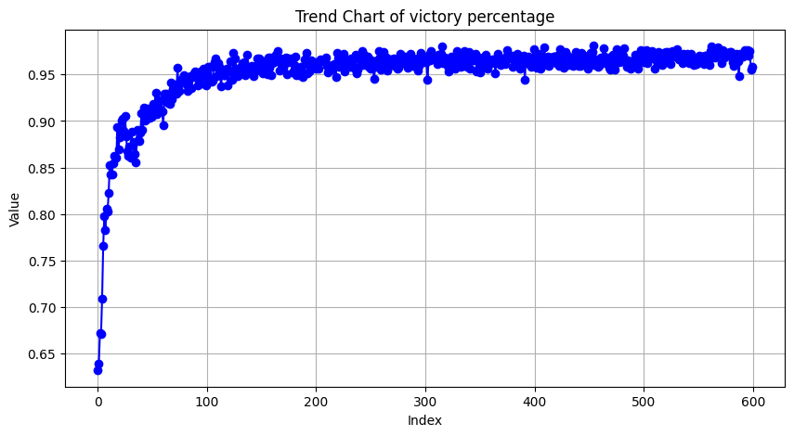
ALTRE 600K:
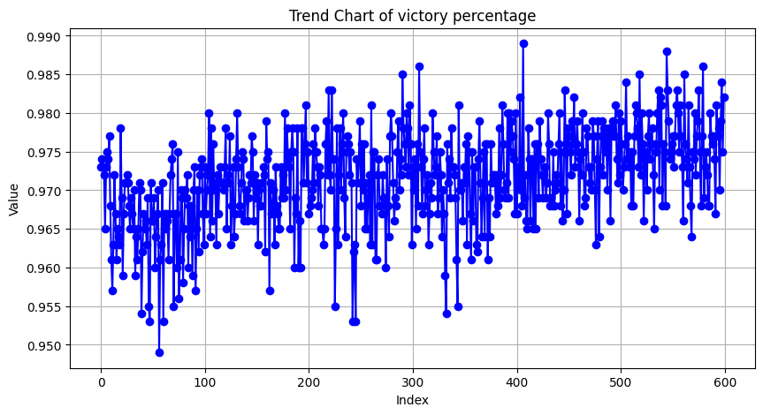
ALTRE 600K:
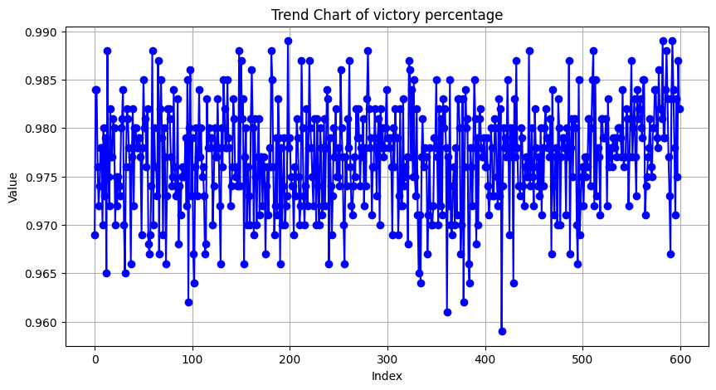
PPO 128 GAMES 600K ITER, LR=0.00005/0.001, NN=128/128 ReLu:

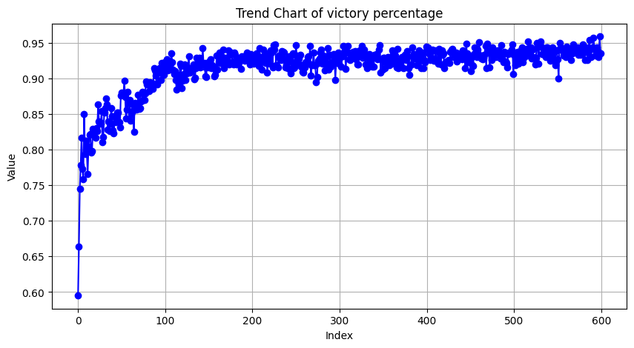
PPO 128 GAMES 600K ITER, LR=0.00001/0.001, NN=256/256 ReLu:
