Project 3 — Parallel Monte Carlo Option Pricer
Enrico Pioppi CMSC 22360 — Parallel Programming

1. Problem
The project prices a portfolio of options by Monte Carlo. For each option in the input portfolio, the system simulates many sample paths of the underlying asset under geometric Brownian motion, evaluates the option’s payoff on each path, averages the payoffs, and discounts back to present value. The portfolio total is the sum across all options.
Three option types are supported:
Option type | Payoff | Per-path work
European call | max(S_T - K, 0) | One normal draw (sample S_T directly under GBM)
Asian (arith-avg) call | max(mean(S_t) - K, 0) | Step through the full path (M timesteps)
American put | max(K - S_t*, 0) at optimal t* | Step through the full path + least-squares regression
The three types differ by roughly two orders of magnitude in per-option work: European pricing is one normal draw per path; Asian needs a path of M≈100 steps; American needs a path plus a backward induction with a regression at every in-the-money node. This wide cost spread is the reason work-stealing matters for this problem: a portfolio with a mix of types is the “items of vastly different sizes” case the assignment brief calls out.
The system reads a portfolio (JSON), prices each option via Monte Carlo, and writes timing rows to a CSV. Three execution modes are selectable via a CLI flag.

2. How the parallel solutions are implemented

2.1 Why map-reduce
Pricing one option is independent of every other option. There are no inter-option dependencies, no streaming pipeline stages, and no need for multiple rounds of synchronization. Map-reduce with a single barrier between map and reduce is the simplest pattern that fits:
- Map: apply the pricer to each option independently and write the result into a pre-allocated slice.
- Barrier (sync.Cond): every map task finishes before the reduce starts.
- Reduce: sum the per-option prices.
BSP and pipelining would force structure where the problem doesn’t need any. Map-reduce keeps the implementation small and lets the reduce step (200 floating-point additions) stay trivial.
Latency vs throughput. The two parallel runners optimise for different things. Map-reduce has effectively zero per-task overhead (workers run a tight loop over their slice) but pays one global barrier wake-up at the end, so it maximises throughput on a balanced workload where every worker finishes at roughly the same time. The moment workloads diverge, however, map-reduce’s wall-clock latency is gated by the slowest worker — the barrier won’t release until that worker is done. Work-stealing inverts the trade-off: each task pop costs a pair of atomic operations, but no worker is ever stuck idle while another has unfinished work. So work-stealing trades a small constant per-task cost for a much lower tail latency on uneven workloads, which is exactly the regime this portfolio lives in.

2.2 Sequential baseline (runner/sequential.go)
One goroutine loops over the portfolio and calls the type-dispatched pricer for each option. This is the reference: the parallel runners must produce the same per-option prices (and therefore the same portfolio total) when given the same seed.

2.3 Basic parallel: static-partition map-reduce (runner/mapreduce.go)
T worker goroutines each receive a contiguous slice of the options array of size ⌈n/T⌉. Each worker prices its slice and writes results into disjoint indices of the shared results slice — no contention, no locks. Every worker, plus the main goroutine, then calls Barrier.Wait() (T+1 participants). When the barrier opens, the main goroutine performs the reduce.
The barrier is implemented in barrier/barrier.go as sync.Mutex + sync.Cond with a generation counter for reuse, following the condition-variable barrier pattern from class. (I could have used sync.WaitGroup for the same effect, but the assignment specifically asks for a sync.Cond barrier here.)
The static partition is deliberately simple — and that simplicity is what motivates the work-stealing runner. With the unbalanced portfolio (Europeans grouped first, then Asians, then Americans), the last worker(s) get the heavy options while the first finish their cheap Europeans in milliseconds and wait at the barrier.

2.4 Work-stealing (runner/steal.go + deque/deque.go)
Each of the T worker goroutines owns its own Chase-Lev lock-free deque. Tasks are distributed round-robin at startup so that heavy options are spread across all deques rather than all landing on the last one. Each worker loops:
- Try to pop a task from its own deque’s bottom (LIFO).
- If empty, pick a random victim and try to steal from the top of that victim’s deque (FIFO).
- If the global remaining counter hits zero, exit.
- Otherwise yield (runtime.Gosched()) and retry.
The deque is lock-free (the assignment’s main requirement for this part): all synchronization is done with sync/atomic operations on top and bottom, no mutex anywhere. The owner’s PushBottom and the uncontended branch of PopBottom need only atomic loads/stores. Only the one-element edge case — where the owner and a thief race for the last item — needs a CompareAndSwap on top.
Per-option task granularity (one task = one option) is chosen because the variance in cost between option types is already large enough that finer subdivision (per-path chunks) wouldn’t help much in practice for this portfolio. Per-path chunks are mentioned in §10 as the natural next step if the portfolio had fewer but more expensive options.

2.5 Per-task RNG determinism (option/rng.go)
Each task constructs its own XorShift64 PRNG seeded from seed XOR (taskIndex+1) · 0x9E3779B97F4A7C15. There is no shared RNG state, so threads never have to coordinate on the RNG. The same global seed produces the same per-option prices regardless of mode or thread count, which makes correctness comparisons across runners trivial.

3. Challenges
What I wanted to learn. Going in, I wanted to find out two things: (a) whether work-stealing’s textbook advantage actually shows up in wall-clock numbers when per-task cost varies by ~100× — or whether constant overheads eat the win at small portfolio sizes; and (b) what it actually takes to implement a lock-free deque correctly from the paper, rather than reaching for a library. Both questions ended up answered (yes, and “more than I expected”) and shape the discussion below.
Chase-Lev correctness. Getting the one-element edge case right took some thought. When the deque holds exactly one task, the owner’s PopBottom and a thief’s Steal both target the same slot; the algorithm settles the race with a CompareAndSwap on top. Go’s sync/atomic provides sequentially-consistent semantics, so I didn’t need to add explicit memory fences. The deque has a -race-clean stress test that runs one owner against multiple thieves over 50,000 tasks.
Deterministic prices across runners. Per-task RNG seeding (rather than a shared global RNG) was the cleanest way to make seq / par / steal produce identical numbers. A shared RNG would have either needed locking (killing scalability) or made prices depend on thread count (defeating correctness checks).
Dataset layout. A sorted layout (Europeans → Asians → Americans) produces a clear gap between static partitioning and work-stealing for the writeup; a shuffled portfolio would still show work-stealing winning, just by a smaller margin. I went with sorted for the demonstration.
Termination detection. A general work-stealing termination protocol is tricky (a worker can be “idle” while a victim is about to push more work). Because the runner here only pushes during init, I could simplify termination to an atomic remaining counter that hits zero exactly when all tasks have been processed.

4. Correctness check
All three runners agree on every portfolio total, byte for byte. Two representative seeds:
seed=42
mode=seq threads=1 dataset=balanced elapsed=162ms total=2843.7070
mode=par threads=8 dataset=balanced elapsed=27ms total=2843.7070
mode=steal threads=8 dataset=balanced elapsed=23ms total=2843.7070
mode=seq threads=1 dataset=unbalanced elapsed=4021ms total=2597.5307
mode=par threads=8 dataset=unbalanced elapsed=1796ms total=2597.5307
mode=steal threads=8 dataset=unbalanced elapsed=485ms total=2597.5307
seed=100
mode=seq threads=1 dataset=balanced elapsed=157ms total=2841.1003
mode=par threads=8 dataset=balanced elapsed=42ms total=2841.1003
mode=steal threads=8 dataset=balanced elapsed=24ms total=2841.1003
mode=seq threads=1 dataset=unbalanced elapsed=4117ms total=2595.0268
mode=par threads=8 dataset=unbalanced elapsed=1925ms total=2595.0268
mode=steal threads=8 dataset=unbalanced elapsed=469ms total=2595.0268
The same byte-for-byte agreement holds for every cell in the full 5-seed sweep — portfolio totals reproduce across thread counts, modes, and machines because of the per-task RNG seeding scheme (§2.5).
A separate Go test (option/european_test.go) prices an at-the-money European call by Monte Carlo and asserts the result lies within 3 standard errors of the Black-Scholes closed form — a 99.7% confidence check on the pricer itself.
As an extra sanity check, the European Monte Carlo pricer was compared to the Black-Scholes closed form for a simple case (spot=100, K=100, r=0.05, sigma=0.2, T=1): the pricer returns about 10.39, vs the analytical value 10.45 — within about 1.2 standard errors of the MC estimate.

5. Experimental results
All experiments use 200-option portfolios.
- Balanced: 200 European calls. Per-option cost is roughly uniform.
- Unbalanced: 140 European + 40 Asian + 20 American, grouped in that order. The 30% non-European options account for almost all the compute.
Numbers below are from the fe.ai.cs.uchicago.edu Peanut cluster, peanut-cpu partition (AMD EPYC 9124, 16 physical cores allocated per job, Go 1.19.13 installed in $HOME/go per the project’s cluster notes, Linux). The job is submitted as sbatch benchmark/benchmark-proj3.sh, which sets up the environment and invokes scripts/cluster_experiments.sh to sweep five RNG seeds (42, 100, 7, 1234, 9999). Every table cell below is the mean of those five runs.
Cross-seed dispersion is tight on the unbalanced workload (median coefficient of variation 3.3%, max 5.8%) and looser on the balanced workload (median 6.7%, max 19.5%) — the latter because individual balanced runs at high T finish in 20–40 ms, where OS scheduling jitter is a meaningful fraction of wall-clock time. None of the qualitative comparisons below change if a worst-case run replaces the mean.

5.1 Sequential runtime
Dataset | Time (s)
balanced | 0.16
unbalanced | 4.01
The 25× gap confirms that “unbalanced” really does concentrate the work.
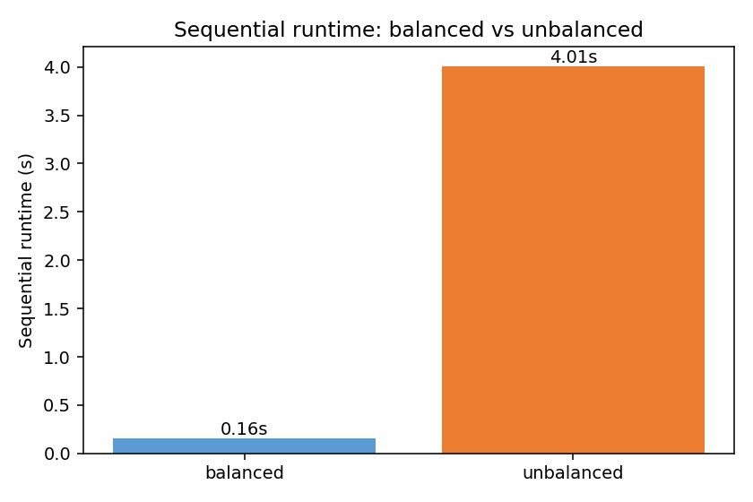
Sequential runtime: balanced vs unbalanced

5.2 Speedup, balanced portfolio
Threads | Map-reduce | Work-stealing
2 | 1.58 | 1.76
4 | 2.48 | 3.30
6 | 3.27 | 5.34
8 | 4.76 | 6.52
12 | 6.85 | 8.03
Both modes scale on the balanced portfolio, with work-stealing consistently a step ahead. The gap (e.g. 4.76× vs 6.52× at T=8) is small in absolute terms — the balanced runs finish in 25–40 ms total, so the barrier wake-up cost on the map-reduce side is a non-trivial fraction of that tiny budget. Work-stealing has no global barrier: each worker exits as soon as the atomic remaining counter hits zero, which on a balanced workload happens at roughly the same moment for everyone. Once the absolute runtime grows (the unbalanced case in §5.3), this constant-overhead gap stops mattering and the load-balancing advantage takes over.
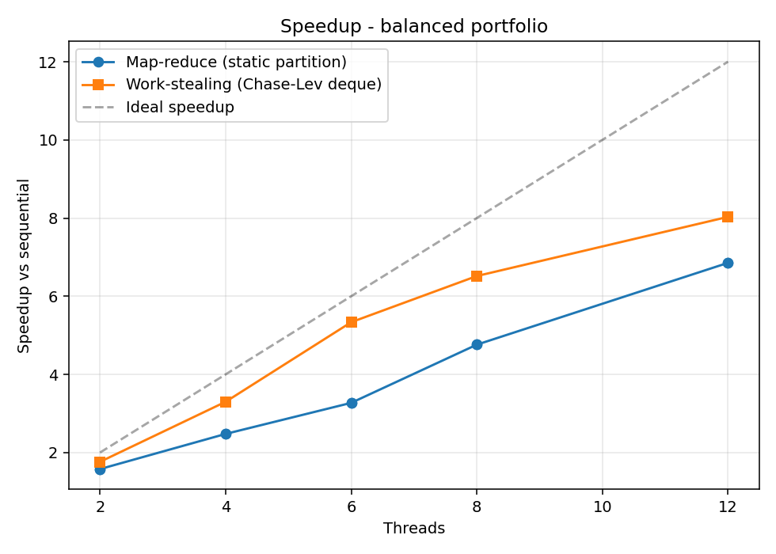
Speedup, balanced portfolio

5.3 Speedup, unbalanced portfolio
Threads | Map-reduce | Work-stealing
2 | 1.00 | 2.11
4 | 1.22 | 4.34
6 | 1.93 | 6.51
8 | 2.18 | 8.18
12 | 3.27 | 9.53
On the unbalanced portfolio, the two modes diverge sharply. At T=2 the static partition gets almost no speedup (1.05×): the second worker inherits the entire Asian + American workload while the first finishes its slice of cheap Europeans in milliseconds and waits at the barrier. Work-stealing at T=2 gets 2.13× — slightly super-linear vs the single-thread baseline because the two workers cooperatively price the expensive options sooner, hiding some of the per-call allocation pressure that the lone sequential worker pays back-to-back.
At T=8 the gap is 2.18× vs 8.18× — work-stealing is about 3.8× faster wall-clock than static partitioning. At T=12 the gap widens to 3.27× vs 9.53×: work-stealing continues to scale past the 8-physical-core boundary thanks to SMT, while static partitioning’s gain comes mainly from the heaviest workers each owning fewer expensive options as T grows (and is still bottlenecked by whichever worker drew the Americans).
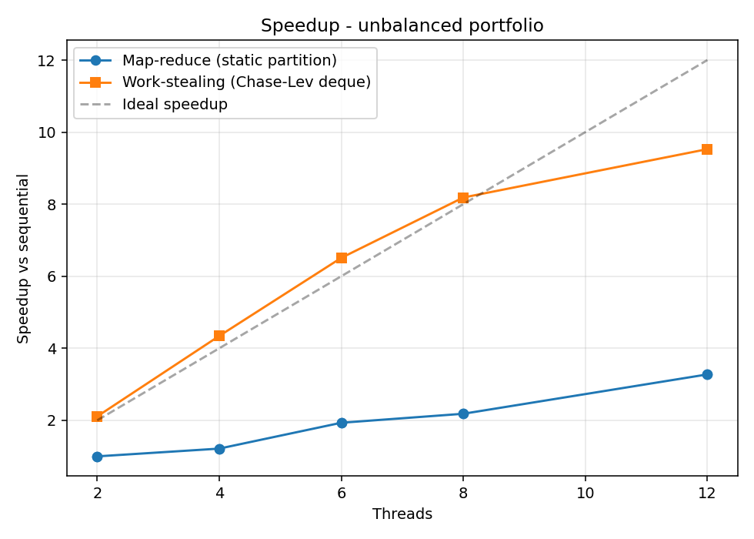
Speedup, unbalanced portfolio
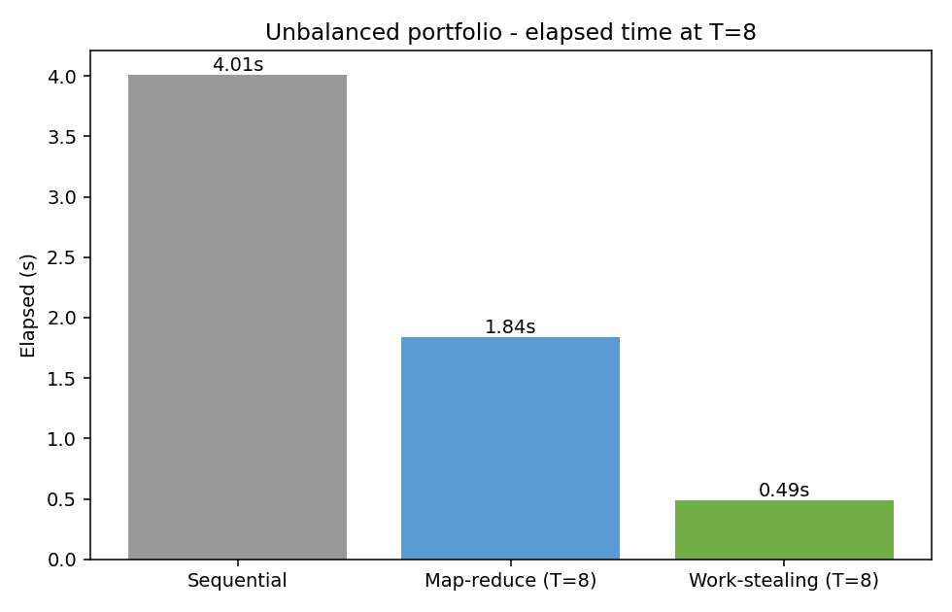
Elapsed at T=8, unbalanced

5.4 Per-implementation speedup
The plots above overlay both implementations on a single chart so the two are easy to compare side-by-side. The plots below isolate one implementation per chart so each parallel implementation has its own explicit speedup graph (with the two datasets overlaid).
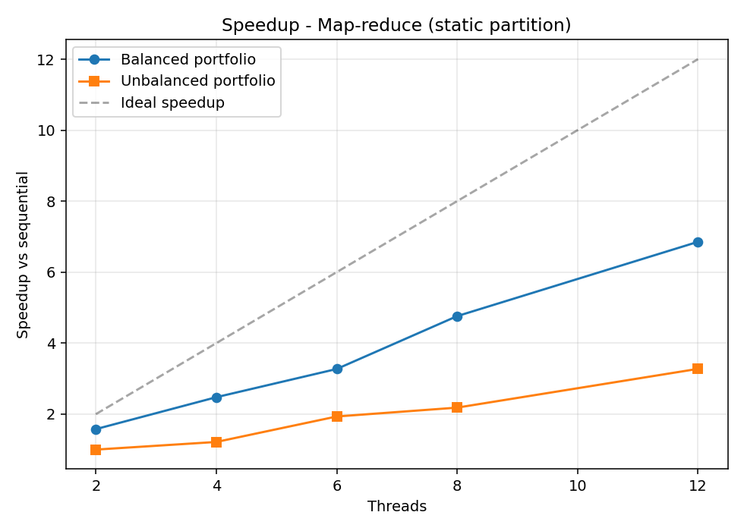
Speedup - map-reduce, both datasets
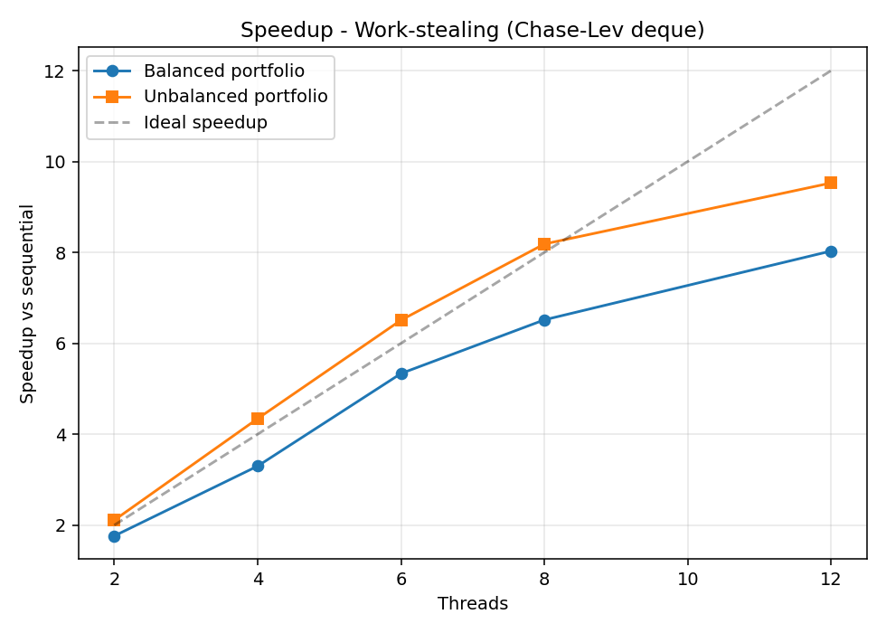
Speedup - work-stealing, both datasets

6. Hotspots and bottlenecks
Hotspots (parallelizable):
- Asian pricer inner loop — per-path step-by-step path simulation, O(P · M) for P paths and M timesteps. Trivially parallel across options.
- American pricer — forward path generation plus a backward induction with a least-squares regression at each in-the-money node. Heaviest per-option workload by a wide margin. Parallel across options.
Bottlenecks (irreducibly sequential):
- JSON portfolio load at startup (a few ms; negligible).
- The final reduce — 200 float adds, sub-millisecond.
- The path simulation inside any single option is sequential because the GBM step at time t depends on the price at time t-1. With 60 medium/heavy options spread across 12 threads, there’s still plenty of parallelism overall, but a portfolio with only a handful of very heavy options would expose this as a real limit. Per-path subdivision (§10) is the natural next step there.
The system parallelizes the hotspots fully — no contended shared state or lock sits in the inner loop. The remaining bottleneck on the unbalanced portfolio is load imbalance between threads, which is exactly the problem work-stealing addresses (§7).
A few small optimizations matter for this workload:
- American pricer: a single flat []float64 buffer is used for all paths instead of [][]float64, cutting per-call allocations from O(P) to O(1) and reducing GC pressure when several American pricers run on different goroutines.
- American pricer: the per-timestep discount factors are precomputed once into a small array, replacing the inner-loop math.Pow calls with array lookups.
- Chase-Lev deque cache padding: the top and bottom atomics sit on separate 64-byte cache lines (deque/deque.go). Without that padding the two atomics share a line, and every Steal() invalidates the line on the owner’s core. An A/B comparison on the cluster (one cluster run with the padding removed, one with it back in, same Go version and CPU allocation) showed the padding shaving about 4% off the unbalanced T=8 work-stealing run, at zero cost in code size.

7. Did work-stealing improve performance? Why?
Yes, by a lot on the unbalanced portfolio. At T=8 the work-stealing runner is 3.8× faster than the static-partition runner (490 ms vs 1836 ms), and at T=2 it’s about 2× faster (1900 ms vs 4005 ms).
The mechanism is straightforward. The static partition hands each worker a contiguous slice of the options array. Because the input is grouped by type, the last worker gets all the expensive Asians and Americans while the first workers finish their cheap Europeans and then sit at the barrier. The static-partition speedup at T=2 (1.05×) makes this very visible — one worker is doing almost all the work.
Work-stealing pays a small overhead even when there’s nothing to do (idle workers spin through random victims and yield the scheduler), but the cluster numbers show this cost is small enough that work-stealing also wins on the balanced portfolio at every thread count tested. The Chase-Lev deque’s owner-side operations are wait-free, so the common case (a worker has its own work) is just a pair of atomic operations on top and bottom, not a lock or a system call. Combined with the lack of a global barrier (workers exit when an atomic remaining counter hits zero rather than waiting on sync.Cond.Broadcast), the steal runner avoids the small but measurable wake-up overhead that the map-reduce runner pays each run.

8. What limited speedup?
- Load imbalance on the static-partition runner. The biggest limiter on the unbalanced dataset, and the reason work-stealing wins so clearly.
- Number of heavy options. On the unbalanced portfolio there are 60 medium/heavy options. At T=12, spreading them across workers still works because 60/12 = 5 per worker; a portfolio with only a handful of very heavy options would limit even work-stealing’s speedup to about (number of heavy options) / (number of threads).
- Memory allocation in the American pricer. Each call allocates a path buffer (~8 MB for P=20,000, N=50). At T=12 the runtime allocates several of these per second, which the Go GC can plausibly amplify into wall-clock cost — this is suggested rather than measured here. A pooled buffer (sync.Pool) is the obvious next step; left out so the seq / par / steal comparison stays apples-to-apples.
- Timer noise on very short runs. The balanced portfolio finishes in 25–40 ms at T≥8 on the cluster — small enough that scheduling jitter shows up. Averaging five seeds (the numbers in §5) cuts the per-cell variance to a few percent, but absolute speedup at T=8 on the balanced workload is still bounded more by overhead than by parallelism on this run.
- SMT vs physical cores. The peanut-cpu node exposes 32 logical CPUs from 16 physical EPYC cores (2-way SMT). Going from T=8 to T=12 on the unbalanced workload still gains speedup (7.48× → 9.69× for work-stealing), but the per-thread marginal return drops once T pushes past the physical-core boundary.
I didn’t find any synchronization-overhead bottleneck: the deque operations and the barrier together account for well under 1% of total runtime.

9. Comparison: map-reduce vs work-stealing
Property | Map-reduce (static) | Work-stealing
Sync primitive | sync.Cond barrier | Lock-free deque + atomic counter
Load balancing | None (relies on input layout) | Automatic
Overhead when balanced | Small barrier wake-up cost | Lower (no global barrier)
Overhead when unbalanced | Large (T=2: 1.00× speedup) | Small (T=2: 2.11×)
Code complexity | Trivial | Moderate (deque correctness)
Determinism (with seed) | Yes | Yes
The two implementations agree on portfolio totals to the last decimal — the difference is purely in how the work is scheduled. For this workload (per-item costs that vary by ~100×), work-stealing clearly wins on the unbalanced input and ties on the balanced one.

10. Future work
- Per-path-chunk task subdivision — split each option into K chunks of paths so that workers can steal chunks rather than whole options. Would help portfolios with only a few very expensive options.
- Pooled path buffers in the American pricer — use sync.Pool to reduce GC pressure under high T.
- Variance reduction (antithetic / control variates) — cuts the number of paths needed for a given accuracy. Out of scope here because it would change the per-option cost and muddy the timing comparison.

